BEIJING – Capital city of China | 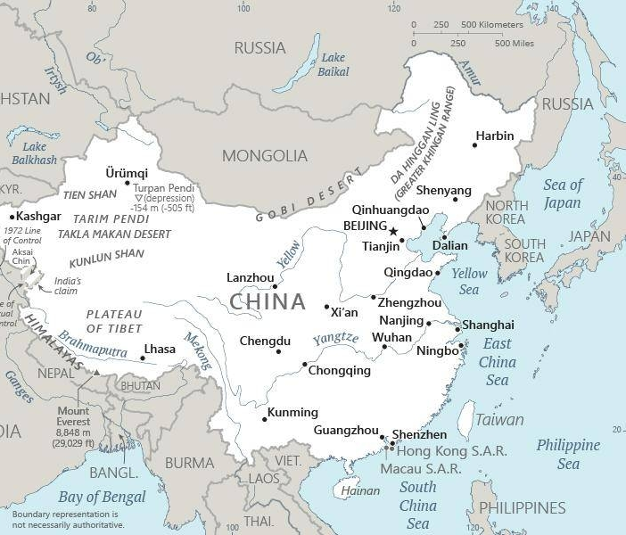  Taken from CIA World Fact Book
Population: 21 mil – the world’s most populous capital city
DID YOU KNOW? The Han represent the majority of China’s people & in many senses dictate what is & is not considered Chinese. The Han is the majority ethnic group in China, making up 92% of the mainland’s population. They also constitute the world’s largest ethnic group, with 18% of all people on earth being Han. The Han take their name from the Han dynasty, which, though not the dynasty to first unite China. The Halcyon era of politics & art is the dynasty during which China’s most influential historian lived & wrote, & the dynasty that would continue to be romanticized through literature for thousands of years to come. Han people are adherents of a wide variety of religious traditions. Many are Buddhists, others follow Confucius, or are Taoist. However there are many Catholic & Protestant Christians among the Han people. (Taken from Buddhist World Prayer Guide)
Please pray :  - For many house churches to be established amongst the people groups of Beijing.  - For the hundreds of millions of rural dwellers that have relocated to Beijing where they end up being unemployed.  - For God to restrain the lawlessness & stronghold of abortion (13 mil abortions every year in China.)  Don't go after false gods; they cannot help you or save you, ….  (1Sam 12:21) |   SAAWE  Patrys 083 973 4011

XINING – Capital city of Qinghai province in Western China | Taken from CIA World Fact Book
Population: 1,6 mil - The largest city on the Tibetan plateau
DID YOU KNOW? The Chinese government does not recognize the Wutun as a separate people group but includes them under the Tu nationality. The Wutun resists this classification & insists on their own status. Tibetan Buddhism is the only religion among the Wutun. They are fanatical believers. Their whole ethnic identity is bound up in their religion. Like all Buddhists, the Wutun believe they will end up in a state of bliss after death. But being better & more privileged, they believe they will go there directly, while other Buddhists achieve enlightenment only after going through many trials & testings. Many of the Wutun are skilled artists. Buddhist scenes & the Buddha himself are the most common subjects of their paintings. The Wutun have an almost complete lack of knowledge about the existence of Christianity. (Taken from Buddhist World Prayer Guide)
Please pray :  - For many house churches amongst the 10 people groups of the city.  - For the Bible in Tibetan, Amdo, Tibetan Khams & Tu.  - For Jesus to break the power of Tibetan Buddhism over this city.  …. From every part of the world they will turn to him; (Ps 22:27) | SAAWE  Patrys 083 973 4011

CHENGDU – Capital of Sichuan province | Taken from CIA World Fact Book
Population: 16,5 mil

DID YOU KNOW? The Mianchi Qiang People: At one time in history there were 62 unique Qiang tribes. Most of these have been assimilated into larger people or have simply vanished. The name “qiang” means herdsmen & for centuries was a generic description for a large number of nomadic tribes. Today there are nine distinct Qiang languages & groups, all living primarily in Sichuan province. The Mianchi Qiang number around 30 000, with 200 known Jesus followers. Many of these have moved to Wenchuan to avoid persecution in their home areas. Chengdu is the largest city in Sichuan, with a population of Qiang peoples living in tight knit communities within the city. (Taken from Buddhist World Prayer Guide)
Please pray :  - For Spirit-led house churches in each of the 19 people groups in this city.  - For a Bible in Mawo & Mianchi Qiang languages.  - For God to bind the spirit of fear & intimidation.  See to it that no one takes you captive by philosophy and empty deceit,…. (Col 2:8 ESV) | SAAWE  Patrys 083 973 4011

NANNING – Capital city of Guangxi region | Taken from CIA World Fact Book
Population: 7,3 mil

DID YOU KNOW? For centuries the Chinese preferred to ignore the Bunuo; they considered the Bunuo to be ignorant barbarians living in the remote mountains. They were described as “a treacherous & aggressive people.” With a population of just 23 000 the Bunuo are a practically untouched people group, separated from the Gospel by geographical, political, cultural, & linguistic barriers. Because they are not officially recognized by the Chinese government, the Bunuo are unknown to both Chinese & Western Christians. There are very few believers of any kind in the part of Guangxi inhabited by the Bunuo. Their religious beliefs include many different rituals borrowed from Daoism & Buddhism. It is not known if the Bunuo worship Pan Hu, as do many other Yao groups in Guangxi. (Taken from Buddhist World Prayer Guide)
Please pray:  - For massive Bible translation: 17 out of the 28 people groups in the city still need a Bible translation.  - For a spiritual awakening at the large Guangxi University, Medical School & School of Agriculture.  - For God to send labourers to the harvest fields of this city.  I revealed myself to those who did not ask for me: …(Is 65:1) | SAAWE  Patrys 083 973 4011

