LIBYA – Colonised by Italy 1911-1940 | 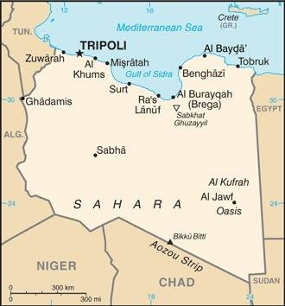  Taken from CIA World Fact Book
Population: 7,1 mil
Religion: Muslims 97%; Christians 2,7%;
Official language: Arabic; Literacy 91.3%
DID YOU KNOW? This water-poor but oil-rich country’s earliest inhabitants were Berber Tribes, who have blended into the Arab majority. Italy colonized Libya in 1911. One of Mussolini’s top fascist generals, nicknamed “the Butcher of Fezzan” used brutal methods to quell resistance to Italian control in the 1930s. He erected concentration camps where malnutrition & starvation ran rampant – an estimated 70 000 Libyans died. Today vast oil reserves make Libya one of Africa’s wealthiest nations, yet nearly 1/3 of its people live in poverty. The death of dictator Muammar Gaddafi, in 2011, exacerbated a history of conflict. Libya’s people suffered greatly during this time. A permanent ceasefire was signed in 2020. The political chaos allows large numbers of migrants from all over Africa to attempt dangerous desert crossings to gain access to Europe. This gives traffickers freedom to exploit vulnerable people & black-market slave trade abounds. This nation is one of the most dangerous countries in the world to be a Christian.
Please pray :  - For healing of the wounds of slavery & colonialism.  - For greater religious freedom so that more might hear the Gospel.  - That those involved in the slave trade to recognize its evil & that it will be put to an end.  Don't go after false gods; they cannot help you or save you, ….  (1Sam 12:21) |   SAAWE  Patrys 083 973 4011

MALI – Colonised by France 1892-1960 | 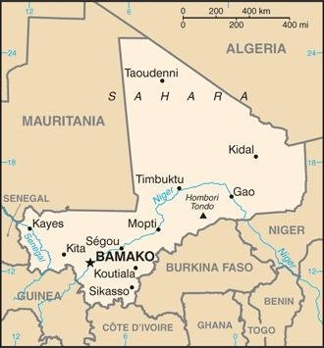  Taken from CIA World Fact Book
Population: 21,5 mil
Religion: Muslims 94%; Christians 2%; Animists 2%
Official language: French; Literacy 36,8%
DID YOU KNOW? The Mali Empire was the 2nd largest & most successful empire between 1230 & 1600. In the 19th century Mali was a major transit zone of slave caravans. The slave trade was officially abolished in colonial Mali in 1905. But a form of slavery continues today: victims of “descent-based slavery” face discrimination & abuse. Mali fell under French colonial rule in 1892. Mali supplied labour to France’s colonies on the coast of West Africa. In 1960 Mali gained independence. Today Mali is the largest cotton producer in Africa. There have been 3 military coups since 2012. Mali also has to overcome huge challenges of high child mortality rates. Evangelism is risky. Islamic extremist groups have kidnapped several missionaries & Christians & burnt down churches. Thus Christians fled for their lives & this trauma still lingers.
Please pray :  - For healing of the wounds of slavery & colonialism.  - For peace, stability & normalization of life in Mali.  - For wisdom in handling extreme issues of poverty, especially the child mortality rates.  …. From every part of the world they will turn to him; (Ps 22:27) | SAAWE  Patrys 083 973 4011

MAURITANIA – Colonised by France 1904-1960 | 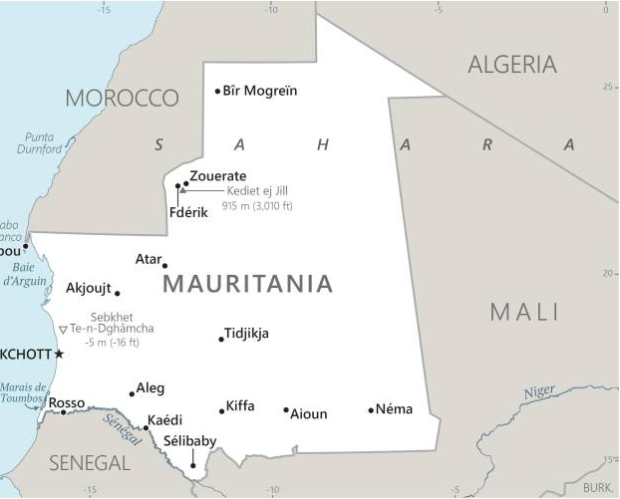  Taken from CIA World Fact Book
Population 4,9 mil; Religion: Muslims 100%; Christians 10,900
Official language: Arabic; Literacy 67%
DID YOU KNOW? Mauritania is made up entirely of Sahar desert. For centuries, Arabic-Speaking Moors raided African villages, resulting in a rigid caste system that still exists to this day, with darker-skinned inhabitants beholden to their lighter-skinned “Masters”. Slave status is passed down from mother to child & anti-slavery activists are regularly tortured & detained. Yet the government routinely denies that slavery exits. In 1981 Mauritania made slavery illegal, the last country to do so. There is an estimated 20% of the population enslaved, as bonded labourers, domestic servants or child brides. It became a French protectorate in 1904 & gained independence in 1960. Mauritania has been under military rule for more than 30 years, with only a short democratic interlude in 2007. It is both one of the least industrialized nations & one of the largest recipients of foreign aid in the world. Christianity came to the country in 1442 through Portuguese mariners. It is illegal to convert from Islam to another faith in this country.
Please pray :  - For healing of the wounds of slavery & colonialism.  - For freedom & justice for all those oppressed & still enslaved.  - For godly indigenous leadership & increasing freedom of religion.  - For God’s mercy in the wake of severe drought & a poor economy that plagues the people.  See to it that no one takes you captive by philosophy and empty deceit,…. (Col 2:8 ESV) | SAAWE  Patrys 083 973 4011

MOROCCO – Colonised by France & Spain 1912-1956 | 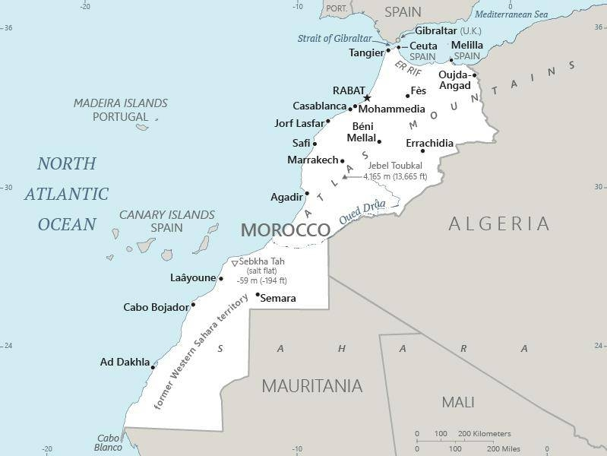  Taken from CIA World Fact Book
Population: 37,8 mil; Religion: Muslims 99%; Other 1%;
Official language: Moroccan Arabic; Literacy 75,9%
DID YOU KNOW? Morocco was once believed to be the westernmost part of the world – the name Morocco means “where the sun sets”. The nation was originally inhabited by Berbers, who were then conquered by Muslim Arabs after 684AD. Late 19th century Marrakesh market statistics suggest that Morocco was the largest outlet in North Africa for black slaves traded across the Sahara. Morocco was colonized by France & Spain in 1912, became independent in 1956, & established a constitutional monarchy in 1972. The king is both the head of state & religion & has declared all those born in Morocco to be Sunni Muslim. Morocco is the world leader in the production & export of phosphates & has 70% of the world’s reserves. Christianity was practiced by Berbers in Roman times but disappeared after the Islamic conquests. Moroccans have a strong prejudice against Christians & are resistant to the Gospel.
Please pray:  - For healing of the wounds of slavery & colonialism.  - For widespread distribution of evangelistic materials among the many unreached peoples.  - That they will come to know the true Saviour, Jesus Christ.  I revealed myself to those who did not ask for me: …(Is 65:1) | SAAWE  Patrys 083 973 4011

