BHUTAN – Prime Minister Lotay Tshering | 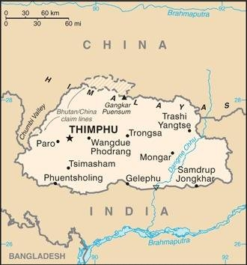  Taken from CIA World Fact Book
Popultation: 805 050
Religion: Buddhists 75,3%; Hindus 22,1%; Other 2,6%
Official Language: Dzonghka Literacy: 73,1%
DID YOU KNOW ? Tibetan Buddhism is woven into every fiber of Bhutanese culture. Bhutan is portrayed as one of the happiest places on earth, yet the people’s lives are filled with fear centered around appeasing local deities & warding off evil with religious rituals. The elderly can often be found in trance-like states spinning prayer wheels & reciting mantras in hope of a better after life. To convert to Christianity could mean losing jobs & being disowned by family & friends. Having a “house church” or even a meeting with friends with the intent of sharing the Gospel can result in imprisonment. Bhutan is isolated from the rest of the world not just by its terrain, but also because of being suspicious of outsiders. There are less than 1000 Christians in Bhutan. (Taken from Buddhist World Prayer Guide)
Please pray :  - That the small, but growing, group of Jesus followers will stay firm in their faith & be bold to share the Good News with those who are most broken.  - For dreams & visions of Jesus among the Bhutanese.  - For the Gospel to be taught through oral stories & traditional art as literacy is low in Bhutan.  Don't go after false gods; they cannot help you or save you, ….  (1Sam 12:21) |   SAAWE  Patrys 083 973 4011

SRI LANKA – Pres Ranil Wickremesinghe | 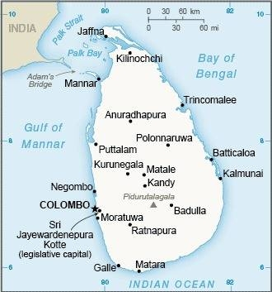  Taken from CIA World Fact Book
Population: 23,3 mil
Religion: Buddhists 70,2%: Hindus 12,6%; Muslims 9,7%: Christians 7,4%; Official Language: Sinhala; Literacy: 92,6%
DID YOU KNOW? Buddhism arrived on the shores of Sri Lanka in the 3rd cent BC. Sinhalese speakers, who adopted the new religion, were the first to record Buddha’s teachings. Over the centuries, when Buddhist practice ebbed significantly, Sinhalese kings sent envoys to Burma & Thailand requesting help to reignite the Buddhist flame. During the British colonial era, the Sinhalese Buddhist majority & the Tamil Hindu minority united against foreign rule. A law was passed in 1956 recognizing Sinhala as the official language of the nation. This set the stage for conflict with the country’s Tamil Hindu population that escalated into a 25-yr war in which tens of thousands were displaced &/or killed. The end of the war coincided with a rising movement associating Buddhism with national culture & persecuting religious minorities. Buddhists, turning to Jesus is equated with a return to western culture. (Taken from Buddhist World Prayer Guide)
Please pray :  - That Christians will share the Gospel using Sri Lankan cultural patterns.  - For a spirit of humility in Sinhalese Buddhist communities, resulting in hearts that seek spiritual truth & families that respond to the love of the Father through Jesus.  …. From every part of the world they will turn to him; (Ps 22:27) | SAAWE  Patrys 083 973 4011

GUANGZHOU – City in China | 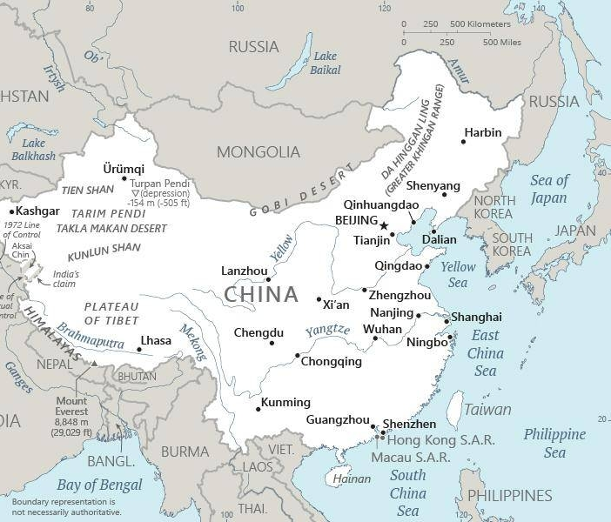  Taken from CIA World Fact Book
Population: 15,5 mil
DID YOU KNOW? The Zaomin are part of the large Yao nationality & have lived in Guangdong province since the 13th century. There are approximately 50 000 people that identify as Zaomin. Their primary language is Dzao Min. Today most Zaomin adhere to a religious mixture that includes Daoist, animist & Buddhist elements. The Zaomin believe that when they die their moral conduct will have to be accounted for. Numerous songs & chants record what they will be asked. Their answers determine whether their soul will be able to enter into rest or not, An interesting tradition that is maintained in the rural villages is that the job of women is to gather firewood. Men say a quick way to find out whether a woman is industrious is to check the fuel piles outside her home. (Taken from Buddhist World Prayer Guide)
Please pray :  - For 50 multiplying house churches among each of the 8 people groups in this city.  - That God will shine the Light of Christ in all the dark places in this oppressed city.  - That the strongholds of tradition, wealth & false knowledge would be broken.  See to it that no one takes you captive by philosophy and empty deceit,…. (Col 2:8 ESV) | SAAWE  Patrys 083 973 4011

WUHAN - City in China | Taken from CIA World Fact Book
Population:11,4 mil
DID YOU KNOW? The Tujia, whose name means “natives” or “original inhabitants,” are one of China’s officially recognized nationalities. 170 000 Tujia are able to speak their language. They practice nuo (exorcism) ceremonies. They evoke the spirits of Fuxi & Nuwa – the first human beings according to Chinese legend. The ceremony includes supernatural feats such as climbing ladders of sharp knives & walking on hot coals or glass. The Tujian regard the bull’s eye as a symbol of the victory of good over evil. Other common motifs include the snake & the white tiger. Roman Catholic & Protestant missionaries first entered Tujia areas with the gospel near the end of the nineteenth century & established a small number of churches, schools & medical clinics among the Tujian. Today it is estimated that there are between 13,000 & 30 000 Tujia Christians. (Taken from Buddhist World Prayer Guide)
Please pray:  - For 50 multiplying house churches in the 5 people groups in this city.  - For Christians to have influence in the sciences, healthcare & marketplace for the sake of the Gospel.  - For God to dismantle the power of Buddhism in the 4 major Buddhist temples in this city.  I revealed myself to those who did not ask for me: …(Is 65:1) | SAAWE  Patrys 083 973 4011

