SIERRA LEONE – Colonised by Britain 1808-1961,, | 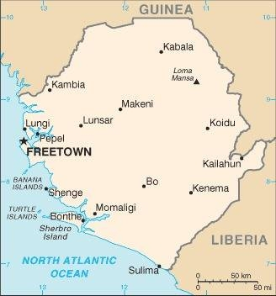  Taken from CIA World Fact Book
Population: 8,3mil; Religion: Muslims 67%; Christians 11%; Official language: English; Literacy 43%
DID YOU KNOW? The Atlantic slave trade had a significant impact on Sierra Leone, as this trade flourished in the 17th & 18th centuries & later it became a centre of anti-slavery efforts when the trade was abolished in 1807. The colony quickly grew as liberated Africans were released, joined by Afro-Caribbean & African soldiers. The liberated Africans & British worked together to suppress slave-trading & inter-chiefdom war. Sierra Leone gained independence from Britain in 1961. Between 1991 & 2001 the nation was plagued by civil war & in 2014/2015 by the Ebola. The nation is recovering, though unemployment is high (80%) & only 43% of the nation is literate. It has ranked as the world’s poorest country for 10 years. Christianity was brought to Sierra Leone in 1792. Various occult practices & other ethnic religions are commonly combined with both Islam & Christianity.
Please pray :  - For the healing of the wounds of slavery & colonialism.  - That the bond of dark powers & the influence of secret societies will be broken over the nation & especially over the church.  - For true stability, sustained peace, & a decisive end to all corruption.  Don't go after false gods; they cannot help you or save you, ….  (1Sam 12:21) |   SAAWE  Patrys 083 973 4011

SOMALIA & SOMALILAND – Colonised by Britain & Italy 1884-1960 | 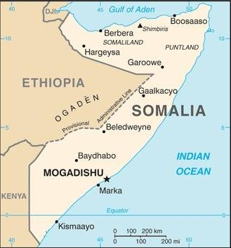  Taken from CIA World Fact Book
Population: 16,8 mil; Religion: Muslims 99%; Christians <1%;
Official language: Somali & Arabic; Literacy 5,4% & 92,5%
DID YOU KNOW? Britain & Italy colonized the area splitting Somalia until the lands were united & gained independence in 1960. The newly elected government was overthrown a few years later & replaced by an autocratic regime. The southern part of Somalia has been overrun with civil war, violence & clan leaders craving power. Civil war in 1991 toppled the dictatorship, but no viable leadership alternative emerged until 2022. It is Africa’s most failed state. Decades of chaos provided a cover for smugglers, bandits, pirates & terrorists. Most Somali women suffer female genital mutilation & many endure rape, then divorce & abandonment by their husbands. Christianity came to the coastal areas in the 7th century. The Somali Church was driven underground during the Islamist uprising of 1991. Christians practice their faith in secret under extremely dangerous conditions.
Please pray :  - For the healing of the wounds of slavery & colonialism.  - That Somalia’s rulers will learn from the past, govern for the good of the people, & respect human rights & religious freedom.  - That terrorists will encounter Jesus who died for them.  …. From every part of the world they will turn to him; (Ps 22:27) | SAAWE  Patrys 083 973 4011

SOUTH AFRICA – Colonised by the Netherlands 1652-1795 & 1803-1806 & Britain 1795-1803 & 1806-1961 | 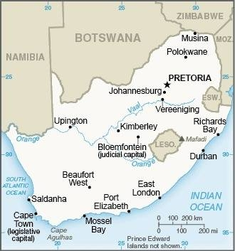  Taken from CIA World Fact Book
Population: 60,9 mil
Religion: Christians 81%; Muslims 2%; Non Religious 15%;
Official language: 11 languages; Literacy 95,3%
DID YOU KNOW? Known as the “Rainbow Nation” a reference to the many ethnicities that make up the population. It has a long history of racial tensions. With colonialism came the Slavery & Forced Labour Model. The indigenous Khoikhoi were an unwilling labour force & so the Dutch imported slaves from all over the world. Many South Africans are the descendants of slaves brought to the Cape Colony from 1653 to 1822. During the 3 decades of white supremacy 14 000 South Africans died in political violence & many suffered humiliation & cruelty. The country not only faces great racial tension, but also high murder rates, corruption, HIV/AIDS, high crime, unemployment & poverty rates. Christianity arrived in the Cape with Dutch Settlers in 1652. Even though Christianity is 81%, much nominalism exists in the church as well as syncretism.
Please pray :  - For the healing of the wounds of slavery & colonialism.  - That the widespread corruption in government will be exposed, for justice to be done & for righteous leaders to take the lead.  - For deep Biblical discipling in the church so deception, syncretism & prosperity gospel will be rooted out.  See to it that no one takes you captive by philosophy and empty deceit,…. (Col 2:8 ESV) | SAAWE  Patrys 083 973 4011

SOUTH SUDAN -Colonised by Britain 1899-1956 | 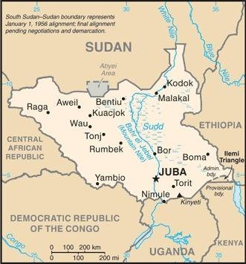  Taken from CIA World Fact Book
Population: 11,4 mil;
Religion: Christians 60%; Indigenous Religions 33%; Muslims 6%
Official language: English; Literacy 70%
DID YOU KNOW? South Sudan, was once a part of Sudan. The conflicts between what is now Sudan & South Sudan are to be understood through their historical roots: Centuries of exploitation & slave-raiding by the “Arab” north against the “African” south, followed by Britain & Egypt’s imperialist meddling. British officials focused their resources on the predominantly Muslim & Arabic-speaking north, to the exclusion of the historically-marginalised multi-ethnic & multilingual south, which left the territory chronically underdeveloped. South Sudan gained independence in 2011 which ended a 21 year long civil war. Most of the almost 2 mil killed were from the South. 2,3 mil South Sudanese refugees are hosted by neighbouring countries. South Sudan is one of the world’s poorest countries. Catholic missionaries arrived in 1842 & were followed by the Anglican & Presbyterian churches 50 years later. Christians of the South have risen to be the hands & feet of Jesus in a hurting nation.
Please pray:  - For the healing of the wounds of slavery & colonialism.  - For the leadership of this country to be just & righteous leaders.  - For a deep growth & strengthening of the Church.  I revealed myself to those who did not ask for me: …(Is 65:1) | SAAWE  Patrys 083 973 4011

