JIN PEOPLE OF CHINA & MONGOLIA | 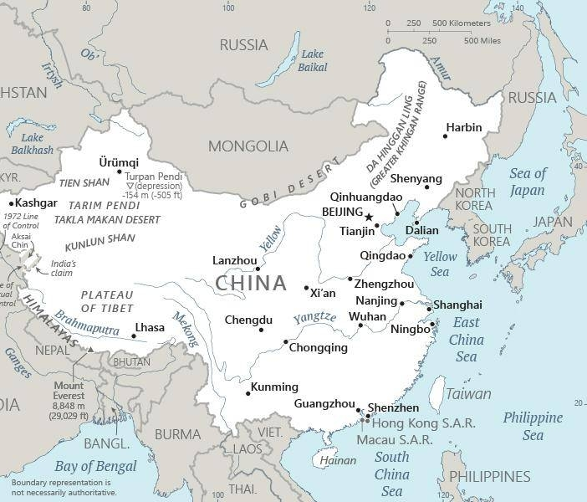  Taken from CIA World Fact Book
DID YOU KNOW? The Jin is part of the larger Han Chinese population, but separated by their “heart” language, Jinyu. Many live in what is historically considered one of the most backward & far-flung parts of China. Jin is spoken in a total of 175 cities & countries throughout Northern China. There are estimated to be 1,2 mil Jin believers throughout China. One city, Hebei, where more than 10 mil Jin speakers live – is the strongest Catholic region in China with more than 800 000 Church members. Two-thirds of the population of Shanxi Province are Jin. Recent research indicates that there are 200 000 Protestants in Shanxi Province alone. (Taken from Buddhist World Prayer Guide)
Please pray :  - For a Bible in Jinyu  - For indigenous missionaries to be raised up & sent to inner Mongolia to share the Gospel.  - For God to bind the powers of Buddhism located at the Da Zhao Temple, in Hohhot, & release the light of the Gospel.  Don't go after false gods; they cannot help you or save you, ….  (1Sam 12:21) |   SAAWE  Patrys 083 973 4011

THAILAND | 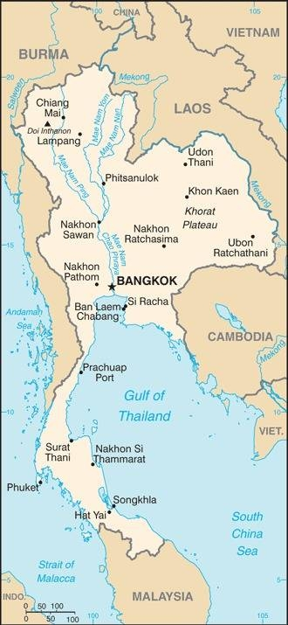  Taken from CIA World Fact Book
Population: 71,5 mil
Religion: Buddhists 94,6%; Muslims 4,3% Christians 1%;
Official language: Thai; Literacy 94%
DID YOU KNOW? In North-east Thailand, Christians have held evangelistic meetings for about three decades. The result has been thousands of “raisedhands for Christ” but less than a few hundred lasting disciples. In 2018, by contrast, 14 ministry teams of ordinary church members regularly went out prayer walking, sharing their testimony and giving simple Jesus presentations. By mid-2019 these teams had started 35 new discipleship groups, with 240 new disciples regularly attending. In Central Thailand a completely different group of Christians went house to house talking about Jesus. Interested people from a single village were invited to hear the gospel as a group. Those who responded to Jesus were formed into faith communities, which met in that village. By mid-2019 they had planted 423 simple village churches. Most Buddhists in Asia live in rural societies that maintain strong community bonds. Good news must include God’s care not just for individuals but also for families & villages. (Taken from Buddhist World Prayer Guide)
Please pray :  - That Buddhist background believers will not rely on famous preachers or tracts but will share their testimonies of Jesus personally with neighbours & friends.  - That new believers will be filled with the Holy Spirit & witness with boldness.  …. From every part of the world they will turn to him; (Ps 22:27) | SAAWE  Patrys 083 973 4011

SENEGAL – Colonised by France (1659-1960) | 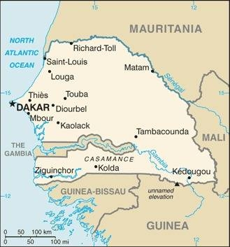  Taken from CIA World Fact Book
Population: 17,7 mil
Religion: Muslims 91%; Christians 5%; Ethnic 3%;
Official language: French; Literacy 55,4%
DID YOU KNOW? The French conquest of Senegal began in the early 17th Century. Gorée, an island off the coast of Dakar, was used as a base for French trading companies that bought slaves, gold & acacia gum. Today there’s a museum on the island. In it is a door called “the door of no return”; tens of thousands of Africans passed through this door that opened up to the ocean, onto the ships that carried them to the New World as slaves. In 1960 Senegal became independent. In 1992 Pope John Paul ll asked for forgiveness at this door. Christianity came with the arrival of Portuguese Catholic traders in the 15th century. The faith reached most areas of Senegal through French missionaries in the mid- 1800s. Almost all Senegalese people subscribe to a syncretized religious system that combine African traditional religious practices with some forms of Islam. Daily life is dominated by superstitions & often includes power encounters with the spirit world.
Please pray :  - For the healing of the wounds of slavery & colonialism.  - For the small body of believers to boldly live out their faith in a way that draws all to Christ.  - For spiritual breakthroughs among the Muslim majority.  See to it that no one takes you captive by philosophy and empty deceit,…. (Col 2:8 ESV) | SAAWE  Patrys 083 973 4011

SEYCHELLE – Colonised by Britain (1814-1976) | 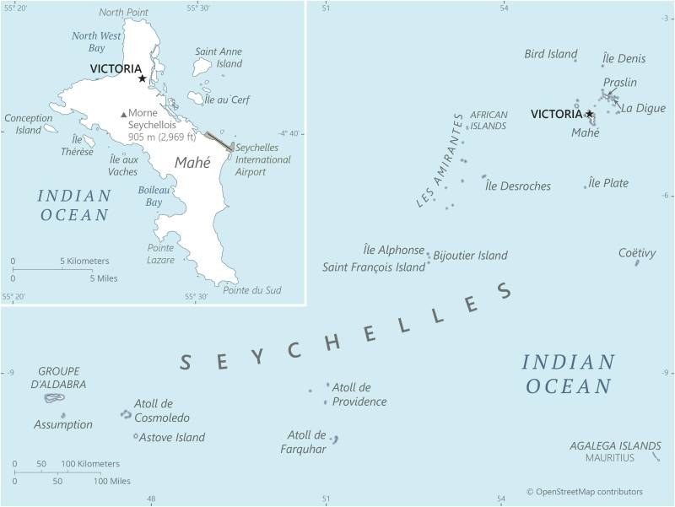  Taken from CIA World Fact Book
Population: 99 650
Religion: Christians 96%;
Official language: English & French; Literacy 96,2%
DID YOU KNOW? The Seychelles are a group of over a hundred granitic & coralline islands. Having first become a French colony, then a British one, the Seychelles saw the arrival, along with the settlers, of numerous slaves from various parts of Africa. This mix of nationalities gave birth to a multicultural & multi-ethnic nation. In 1814 the French ceded the islands to Britain, but the French culture & language remained dominant. Slaves were used for the cultivation of coconut palms, cotton, & spices until slavery was abolished by Britain in 1835. During British rule the islands were also a place of exile for political prisoners. They became independent in 1976. Tourism is very important to the economy as is the tuna fishing industry. The French brought Christianity through the Catholic church in the 18th century. The majority of Seychellois are Christian – 96% (Mostly Roman Catholic). Only 2% of the population believe Jesus is the Son of God & 95% mix Christianity with animistic concepts.
Please pray:  - For the healing of the wounds of slavery & colonialism.  - That so called ‘Christians’ bound by deception & syncretism will be set free.  - That the Holy Spirit may bring new life evidenced by repentance & sustained fruit.  I revealed myself to those who did not ask for me: …(Is 65:1) | SAAWE  Patrys 083 973 4011

