NIGER -Colonised by France 1922-1960 | 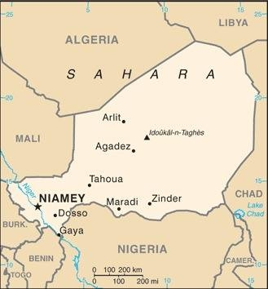  Taken from CIA World Fact Book
Population: 26,1 mil
Religion: Muslim 97% Christians <1%;
Official language: French; Literacy 37,3%
DID YOU KNOW? The first Europeans were explorers, searching for the source of the Niger River. Niger was incorporated into French West Africa in 1896 & colonized in 1922. A French commander in1899 is believed to have killed tens of thousands of Nigerians as he sought to take control of Lake Chad for France, before the British arrived. Niger’s main highway follows the exact route of his massacres. The country gained independence in 1960. Niger succumbed to brutal military rule & politics remain unstable. Slavery has been practiced for many centuries & persists to this day. Slavery was abolished in Niger in 1960, prohibited in 1999 & criminalized in 2003. The minimum estimation is that there are still 43 000 slaves across Niger. The UN raked Niger as the second least developed country in the world in 2016. Christianity was brought with French colonists.
Please pray :  - For the healing of the wounds of slavery & colonialism.  - That Niger will remain open for Christian Mission.  - For all forms of modern day slavery & trafficking to be eradicated.  Don't go after false gods; they cannot help you or save you, ….  (1Sam 12:21) |   SAAWE  Patrys 083 973 4011

NIGERIA – Colonised by Britain 1884-1960 | 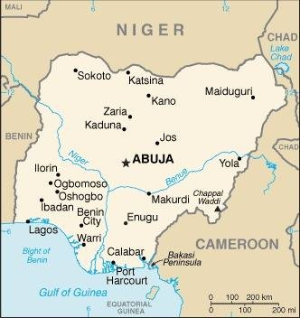  Taken from CIA World Fact Book
Population: 217 mil
Religion: Muslims 54%; Christians 46%;
Official language: English; Literacy 62%
DID YOU KNOW? The Colonial period in Nigeria began with the Portuguese, who paved the way for the slave trade in the 15th century. The British targeted Nigeria for colonization because of its resources. They wanted products like palm oil & palm kernel & export trade in tin, cotton, cocoa & groundnuts. Nigeria gained independence in 1960. Northern Nigeria is largely Muslim, feudalist & impoverished, with over 80% of the nation’s poor. Southern Nigeria is more developed & majority Christian. Deep ethnic & religious divisions threaten the nation as a whole. In 2009, Boko Haram, one of Africa’s largest Muslim extremist groups, launched an insurgency in Nigeria declaring their intention to root out corruption & establish Muslim rule. As of 2016, there are 1,4 mil people subject to modern slavery. Nigeria is Africa’s larges oil producer, but half the population remains in poverty.
Please pray :  - For healing of the wounds from slavery & colonialism.  - Praise God for the massive church growth.  - That leaders & politicians will rule with Godly wisdom & in righteousness.  - For the eradication of modern-day slavery & trafficking.  …. From every part of the world they will turn to him; (Ps 22:27) | SAAWE  Patrys 083 973 4011

RWANDA – Colonised by Germany & Belgium 1890-1962 | 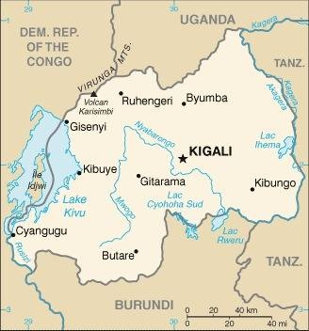  Taken from CIA World Fact Book
Population: 13,6 mil; Religion: Christians 91%;
Official language: French, English, Swahili, Kinyarwanda; Literacy 70,6%
DID YOU KNOW? Rwanda is one of the few countries that never contributed manpower to the slave trade. Rwanda was part of German East Africa until 1918, when Belgium took over. The ruling Belgians favoured the minority Tutsis over the Hutus, creating tension that exploded into violence before Rwanda gained its independence in 1962. It became famous in 1994 when the genocide broke out. In just three short months at least 800 000 people were brutally massacred - mostly Tutsis & moderate Hutus. Rwanda has made great progress since 1994. Its economy is now one of the fastest growing in Afrika. Rwanda was one of the last areas of Africa to receive Christian missionaries. Tragically, this nation predominantly claiming Christianity allowed the massacre of 1994. The genocide has caused some to turn from their faith. Some have turned to Islam others have been ensnared by prosperity theology, legalism & syncretism.
Please pray :  - For the healing of the wounds of colonialism & the genocide.  - For provision & hope for widows, orphans & other victims of the genocide.  - For righteous leaders in all spheres of society. Pray that God will guide them by His Spirit.  See to it that no one takes you captive by philosophy and empty deceit,…. (Col 2:8 ESV) | SAAWE  Patrys 083 973 4011

SAO TOME & PRINCIPE – Colonised by Protugal 1486-1975 | 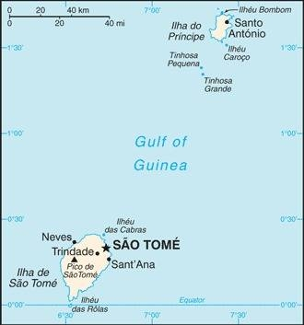  Taken from CIA World Fact Book
Population: 228 000; Religion: Christians 87%;
Official language: Portuguese; Literacy 93,8%
DID YOU KNOW? Portuguese explorers stumbled upon Sao
Tome in the 1470s. A wave of Portuguese settlers came to the islands in the 1480s, consisting of several thousand Jewish children forcibly taken from their parents & converted to Christianity. There were also undesirables in Portuguese society who were banished there. These two islands are Africa’s smallest state. The settlers brought Africans from the mainland as slaves. The islands became a prosperous slave & spice trade centre & an early producer of sugar. Today it is an isolated & underdeveloped nation due to poor communication & infrastructure. Once Africa’s largest exporter of sugar & the world’s largest producer of cacao. Today the economy is greatly affected by market fluctuations & inflation. The Catholic Church was established in the country in 1534 & the first Protestant Church was established in 1935. Most people are Catholic, but syncretism is very prevalent in the Church.
Please pray:  - For healing of the wounds from slavery & colonialism.  - For the Holy Spirit to move through the islands’ church to bring renewal.  - For the growth of the nations’ economy.  I revealed myself to those who did not ask for me: …(Is 65:1) | SAAWE  Patrys 083 973 4011

