SUDAN (Colonised by Britain & Egypt 1899-1956) | 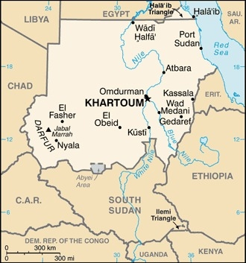  Taken from CIA World Fact Book
Population: 46.1mil; Religion: Muslims 90,7%; Christians 5.4%; Official language: Arabic & English; Literacy 60,7%
DID YOU KNOW? Sudan used to be the largest African Country.
What is now Sudan was in ancient times the kingdom of Nubia & came under Egyptian rule. Sudan was a major source of slaves for Egypt for many centuries. Missionaries converted the region to Christianity in the 6th century, but an influx of Muslim Arabs, who had already conquered Egypt, eventually controlled the area & replaced Christianity with Islam. Egypt conquered Sudan in 1874 & Britain occupied Egypt in 1882. Both countries ruled Sudan till 1956. After independence the country has been ruled by unstable governments & regimes. Its darkest years was its 2 civil wars. When the country split in 2011 an estimated 35 000 South Sudanese remained as modern-day slaves in Sudan. Its future remains bleak with 14,3 mil people in need of humanitarian aid. Conversion to Christianity is punishable by death. Sudan is no 13 on the Open Doors World Watch list of the most persecuted Christians.
Please pray :  - For the healing of the wounds of slavery & colonialism.  - That the legacy of oppressive & militaristic rule in Sudan might be ended in Jesus’ name.  - That Sudanese believers will remain faithful to Christ & pray for their protection.  He will wipe away every tear from their eyes, and death shall be no more,… (Rev 21:4 ESV) |   SAAWE  Patrys 083 973 4011

TANZANIA (Colonised by Germany & Britain 1885-1961) | 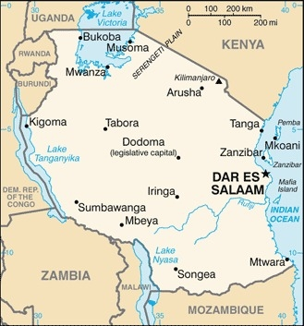  Taken from CIA World Fact Book
Population: 63,5 mil; Religion: Christians 63%; Muslims 34%;
Official language: Swahili & English; Literacy 81,8%
DID YOU KNOW? Arab traders first began to colonize the area. Zanzibar was one of the largest slave ports in the Indian Ocean slave trade. The slavers hacked their way from the coast into the African interior. They bribed chiefs, pillaged & kidnapped to meet the high demand for slaves. Portuguese took control until the 17th cent when Oman took power. In 1885 Germany declared East Africa a protectorate. Tens of thousands of people were starved, tortured & killed by German soldiers as they sought to put down rebellious tribes (1905-1907). After Germany’s defeat in WWII Britain took control until independence in 1963. Gold mining & tourism are the country’s main sources of income. Religious freedom is thought to be one of the motivating factors in Tanzania’s peaceful history, but the peaceful coexistence is changing with conflicts between Muslims & Christians. Witchcraft, the occult & superstitious spiritual practices are becoming part of the mainline religions.
Please pray :  - For the healing of the wounds of slavery & colonialism.  - For the government to be bold to confront evil, & wise to bring community harmony & religious freedom.  - That mature Christians will evangelize the unreached  Rural population.  …. From every part of the world they will turn to him; (Ps 22:27) | SAAWE  Patrys 083 973 4011

CAMEROON (Colonised by Germany 1884-1961) | 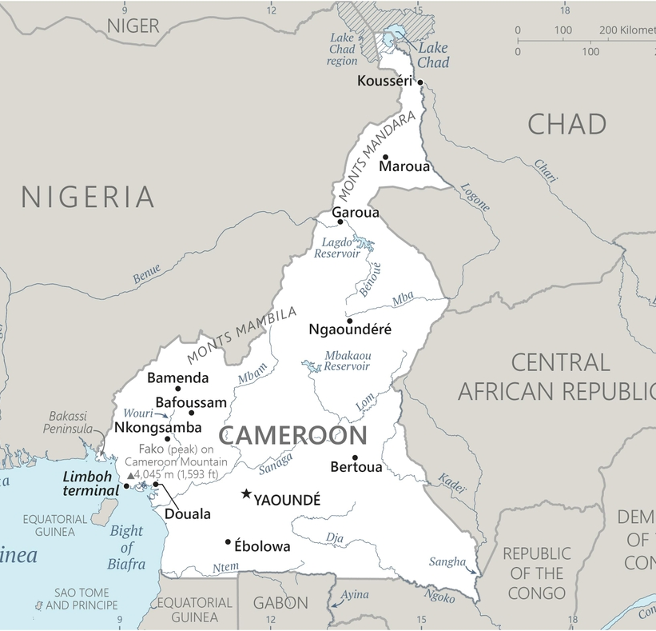  Taken from CIA World Fact Book
Population: 27,8 mil
Religion: Christians 60%; Muslims 30%;
Official language: French & English; Literacy 78,2%
DID YOU KNOW? The international slave trade in this region began with the Portuguese on Cameroon’s west coast; around 1,5 mil slaves left Africa from here. In 1884 the area became a German colony. After WWI, Cameroon was divided between France & Britain until independence in 1961. The Anglophone crisis in modern-day Cameroon is a legacy of colonialism. Armed groups & government forces committed human rights abuses, including mass killing, across Cameroon’s Anglophone & far northern regions. More than 712 000 people were internally displaced & at least 2,2 mil are in need of humanitarian aid. The constitution provides for the right to choose, practice & change religion. However Boko Haram, have warned the Cameroon people to return to Islam or face persecution. Boko Haram frequently crosses the boarder into Northern Cameroon & kidnap/murder missionaries & families.
Please pray :  - For the healing of the wounds of slavery & colonialism.  - For God to raise up reconcilers & peacemakers in this divided country.  - That all occult strongholds in Cameroon will be broken.  - For effective Christian discipling in churches.  See to it that no one takes you captive by philosophy and empty deceit,…. (Col 2:8 ESV) | SAAWE  Patrys 083 973 4011

BURUNDI (Colonised by Germany & Belgium 1890-1962) | 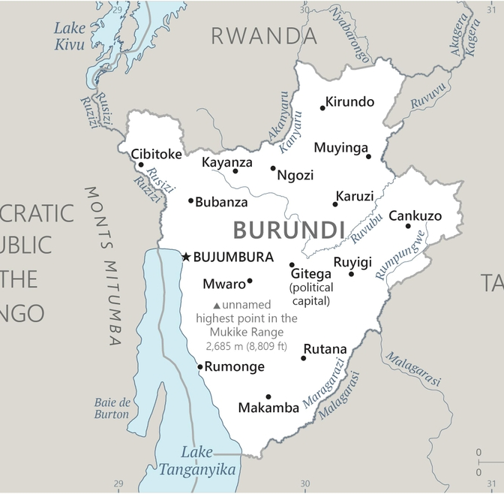  Taken from CIA World Fact Book
Population: 12,5 mil;
Religion: Christians 67%; Indigenous Religions 32%; Muslims 1%
Official language: Kirundi, English & French; Literacy 74,4%
DID YOU KNOW? The Hutu & Tutsi peoples have lived in Burundi for at least 500 years. In 1890 Germany colonized the region. After WWI & Germany’s defeat it ceded the territory to Belgium. The European intervention exacerbated social differences between the two groups & contributed to political unrest. A system of identity cards was set in place & the top jobs for administrators & official were reserved for Tutsi people. The whole colonial period was a process of creating inequality & strict ethnic & economic separation between Hutu & Tutsi people. The strict division fueled the deadly ethnic conflict between them in the 1970s & then another civil war for 12 yrs from 1993, which killed 300,000 people & displace 800 000. Refugees are now returning, but they often lack basic services, are denied claims to their former land, & will spend years in tent cities. During the 1940s & 1950s, the Belgium government carried out a program of kidnapping biracial children from Burundi.
Please pray:  - For the healing of the wounds of slavery & colonialism.  - That ethnic groups will be reconciled & united.  - That many will come to faith in Christ.  - For purification & repentance in the Church of Burundi, also for all the bloodshed of the past.  I revealed myself to those who did not ask for me: …(Is 65:1) | SAAWE  Patrys 083 973 4011

