ZAMBIA (Colonised by Britain 1888-1964) | 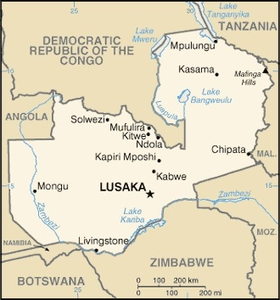  Taken from CIA World Fact Book
Population: 19,5 mil; Religion: Christians 95,5%; Muslims 2,7%
Official language: English; Literacy 87,5%
DID YOU KNOW? The name Zambezi comes from the Lunda expression Nzambi enzi which literally means “God Came”. During the second half of the 19th cent Zambia was thrown into political upheaval by traders, raiders & invader mainly for ivory & slaves. At the end of the 19th cent Zambia came under British rule. British interest in the region had first been aroused by the missionary & explorer David Livingstone. His reports of the expanding slave trade inspired other missionaries to come to central Africa & continue the struggle against it. It was Cecil John Rhodes who ensured that so much country north as well as south of the Zambezi came within a British sphere of influence during the “Scramble for Africa.” Zambia became independent in 1964 & is one of the few countries that transitioned peacefully from colonial rule to independence. Its economy is heavily dependent on copper. David Livingston led the way in Central Africa for missionaries who initiated education & health care projects for Africans. Many people combine Christianity & indigenous beliefs.
Please pray :  - For healing & restoration from slavery & colonialism.  - For an ongoing commitment by Zambians to be a Christian nation that honours God.  - That God will raise up good teachers & trained pastors.  Don't go after false gods; they cannot help you or save you, ….  (1Sam 12:21) |   SAAWE  Patrys 083 973 4011

ZIMBABWE (Colonised by Britain 1890-1965) | 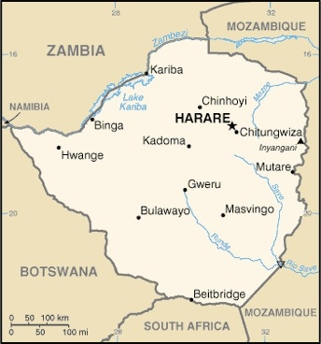  Taken from CIA World Fact Book
Population: 15,3 mil; Religion: Christians 86%; Non Religious 11%; Official language: 16 official languages; Literacy 89,7%
DID YOU KNOW? Historians & archaeologists have found that Zimbabwe was a major trade route. Before colonialism the Shona people had long been subjected to slave raids. In 1890 the country became a British colony. In 1965 the white minority declared independence from Britain. Racism in Zimbabwe began during the colonial era when white colonisers begin discriminating against the indigenous Africans. Zimbabweans were frustrated by their continued subjugation & so in July 1964 a civil war broke out against the white minority government. In 1980 the country gained independence after 15 yrs of civil war. Land redistribution caused the collapse of the agriculture-based economy. It had once exported food but was no longer able to feed its own people. Mugabe ruled Zimbabwe for 37 yrs. Zimbabwe remains in severe humanitarian crisis. Poverty grips millions & they have one of the world’s worst AIDS crises.
Please pray :  - For healing & restoration from slavery & colonialism.  - For God to restore this once-prosperous land & to use His people to bring relief from the decades of suffering.  - Ask the Lord to raise up righteous leaders.  …. From every part of the world they will turn to him; (Ps 22:27) | SAAWE  Patrys 083 973 4011

TUNISIA (Colonised by France 1881-1956) | 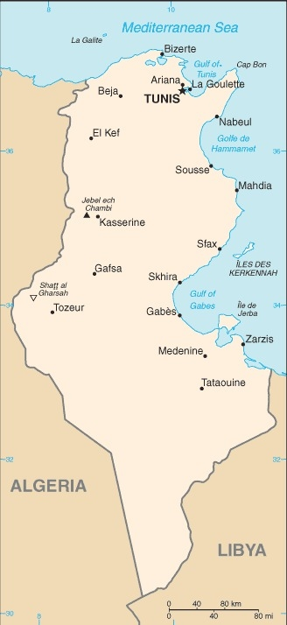  Taken from CIA World Fact Book
Population: 12,1 mil
Religion: Muslims 99%;
Official language: Arabic; Literacy 81,8%
DID YOU KNOW? Modern Tunisians are the descendants of indigenous Berbers & people from numerous civilizations that have invaded, migrated to & been assimilated into the population over the millennia. The history of Tunisia begins with the arrival of the Phoenicians. Later Rome captured it & ruled until the 5th century when European tribes invaded it. The Muslim conquest in the 7th cent transformed Tunisia & its population with subsequent waves of migration from around the Arab & Ottoman world. It became a French protectorate from 1881 until independence in 1956 & retains close political economic & cultural ties with France. Tunisia’s economic growth historically depended on oil, phosphates, agri-food products, car part manufacturing & tourism. Christianity came to Tunisia during Roman rule. Church fathers, such as St Augustine, Tertullian & Cyprian developed Christian theology in modern day Tunisia. Christians face persecution from family & friends & authorities.
Please pray :  - For healing & restoration from slavery & colonialism.  - That God will raise up workers to reach the millions of unevangelized in Tunisia.  - That the government will officially recognize the Tunisian Church.  See to it that no one takes you captive by philosophy and empty deceit,…. (Col 2:8 ESV) | SAAWE  Patrys 083 973 4011

UGANDA (Colonised by Britain (1885-1962) | 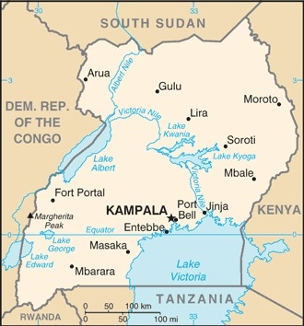  Taken from CIA World Fact Book
Population: 49 mil
Religion: Christians 84%; Muslims 14%
Official language: Swahili & English; Literacy 79%
DID YOU KNOW? Winston Churchill dubbed Uganda “the pearl of Africa” for its breath-taking scenery. However, Uganda’s history is stained by violence. Uganda was colonized in 1885 by the British before gaining their independence with little struggle in 1962. Independence was followed by political conflict. Uganda suffered devastating political instability, genocide & economic failure, under the rule of Milton Obote & Gen Idi Amin. 400 000 citizens were slaughtered during their rule. British colonialism has been blamed for these tragedies. In 1987, the Lord’s Resistance Army devastated Uganda with terror & violence. They killed more than 10 000 people & captured children to use as soldiers, porters & sex slaves. President Yoweri Museveni came to power in 1986. Moderate peace was achieved & he introduced democratic reforms & improved human rights in Uganda.
Please pray:  - For healing & restoration from slavery & colonialism.  - For restoration, peace & healing after many years of war & conflict.  - For relief for the many poor people especially for the destitute street children in Kampala.  I revealed myself to those who did not ask for me: …(Is 65:1) | SAAWE  Patrys 083 973 4011

