DEM REP OF CONGO – Colonised by Belgium 1885 -1960 | 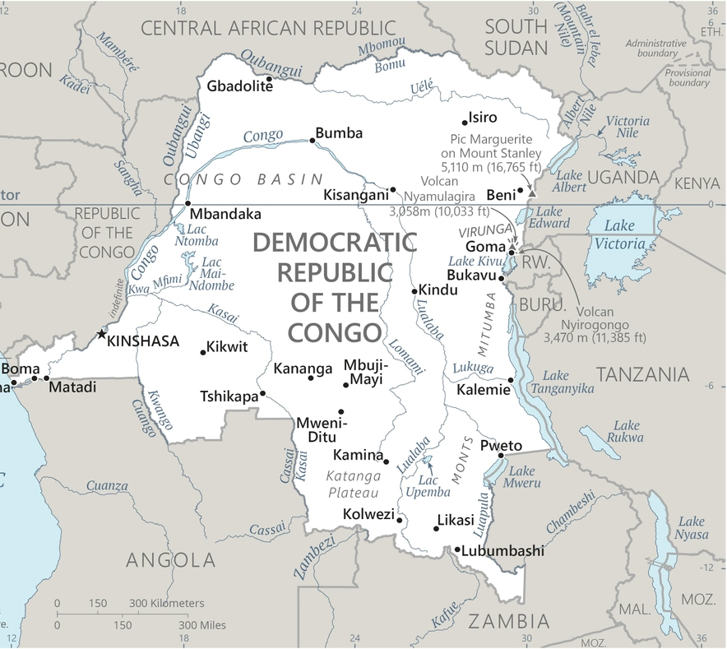  Taken from CIA World Fact Book
Population: 95,8 mil; Religion: Christians 96%; Muslims 9%;
Official language: French; Literacy 80,5%
DID YOU KNOW? The Democratic Rep of Congo is potentially one of the richest countries on earth, but colonialism, slavery & corruption have turned it into one of the poorest. In the 1480’s Portuguese traders discovered an inexhaustible supply of strong, disease-resistant slaves. In the 19th century Arabs raided the country for slaves. During King Leopold II of Belgium’s rule (1885-1908) an estimated 10mil died from punishment & malnutrition, & many more suffered from disease & torture. The Country gained its independence in 1960. Natural resources led to mass conflict & successive civil wars in the 1990s. This resulted in an economic slump & a tragic 6mil lives lost to brutality & disease. Congo’s leaders have redirected billions of dollars from the country & have used brutal violence to gain or maintain the control of the state & its vast natural resources. Christianity is the majority religion in the country.
Please pray :  - For healing of wounds caused by slavery & colonialism.  - Praise the Lord that King Phillipe has expressed his “deepest regrets” for his country’s colonial abuses. Pray that he & Belgium will do restitution.  - For a stable national government rooted in righteousness.  The Lord kills and brings to life:… (1 Sam 2:6) |   SAAWE  Patrys 083 973 4011

GHANA – Colonised by Britain (1874-1957) | 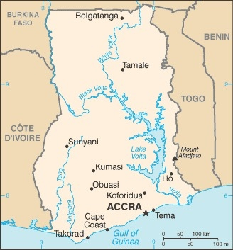  Taken from CIA World Fact Book
Population: 32,4 mil; Religion: Christians 63%; Muslim 20%;
Official language: English; Literacy 80,4%
DID YOU KNOW? Ghana has the dark history of being one of Africa’s main shipping points for slaves. Cape Coast is home to more than 30 dungeons where slaves were held by colonists before being transported. In the 15th century, the Portuguese found so much gold in the region that it became known as the Gold Coast. In 1874 Britain made the Gold Coast a crown colony & spent 80 years extracting resources. Ghana’s independence in 1957 was followed by a time of corruption & a series of military coups. In 1992 a new constitution established a democratic government & Ghana transitioned successfully to a democratic system. Today, gold, cocoa, timber products & oil reserves generate income. This well-run country is often used as a model for reform in Africa. It has also become a high-profile peacekeeper with troops deployed in many countries. Although 63% of Ghanaians are Christian, a duel spirituality, influenced by African religions, challenges the church.
Please pray :  - For healing of the wounds caused by slavery & colonialism.  - That God will reveal himself to the unreached peoples in the North of Ghana.  - For a clear break from all bondage to the occult.  …. From every part of the world they will turn to him; (Ps 22:27) | SAAWE  Patrys 083 973 4011

MALAWI – Colonised by Britain 1891-1964 | 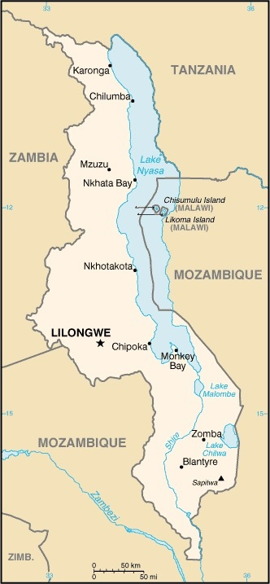  Taken from CIA World Fact Book
Population: 20,2 mil; Religion: Christians 77%; Muslim 13%; Official language: English; Literacy 67,3%
DID YOU KNOW? The slave trade was introduced by the Swahili-Arab traders in the 19th cent, due to a great demand for ivory & slaves. Dr Livingston, a missionary, was instrumental in stopping slave trade in Malawi. In 1891 the British established the Nyasaland Districts Protectorate. Under British rule, roads & railways were built & the cultivation of cash crops was introduced, but the colonial administration did little to enhance the welfare of the African majority. Malawi became independent in 1964. Although the nation went through a period of economic growth in the 1970s & ‘80s, it came at the cost of an oppressive dictatorship that ended in 1994. Since then it has remained a stable & peaceful land in a region troubled by wars & violence. Dr David Livingston made so many converts in this country that his legacy is a church in every village in the country.
Please pray :  - For healing of the wounds caused by slavery & colonialism.  - Praise God for the peace in Malawi that allows Christian ministry & national development to continue.  - That God will help Christian leaders to act with wisdom, humility, & establish long-term plans based on biblical principles.  …..he has put eternity into man's heart,…. (Ecc 3:11) | SAAWE  Patrys 083 973 4011

KENYA– Colonised by Britain (1888-1962) | 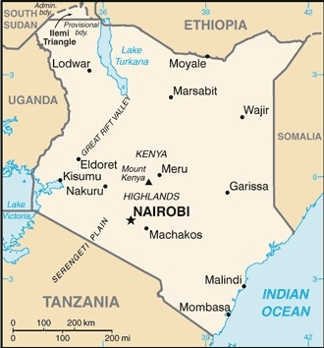  Taken from CIA World Fact Book
Population: 56,2 mil
Religion: Muslims 11,1%; Christians 82,5%;
Official language: Swahili & English; Literacy 82,9%
DID YOU KNOW?
The slave trade grew exponentially at the end of the 17th cent with a large slave market based at Zanzibar. Slave caravan routs soon reached far into the interior of Kenya. Kenya has one of the highest literacy rates in Africa today. The fast-growing population, wide-spread poverty, spreading urban slums & urgent need for land reform create tension in Kenyan society. There is an estimated 328 000 people that are held in conditions of modern slavery in Kenya – Child trafficking being the most prevalent form. The first Christians to come to East Africa were Vasco da Gama & his crew. In 1564 the Portuguese Viceroy of India ordered that the Gospel be preached around Mombasa. Converts from Islam are subject to harassment, persecution & violence. Somali Islamic militants have committed acts of violence within Kenya’s borders.
Please pray:  - For healing of the wounds caused by slavery & colonialism.  - That God would raise up more workers to take the Gospel to the unreached.  - That child traffickers will come to faith in Jesus & stop their operations.  I revealed myself to those who did not ask for me: I was found by those who did not seek me….. (Is 65:1) | SAAWE  Patrys 083 973 4011

