College Football Database

IST 659 Project

Jonah Witt

Section 72410

**Summary**

The goal of this project was to create a database to store data on NCAA Football teams. This is a personal database that will not be used by any member of the teams involved. Due to this, I am the only stakeholder in the project. This database will eventually serve as a basis to run predictive analysis. A large variety of data and statistics were collected on each team. Initially, data was collected from the 2017 Tennessee Volunteers. Next, the scope was expanded to every team in the Southeastern Conference for the 2017 Season. After this project is complete, the database will expand to include other conferences and seasons. However, this project only included teams from the SEC during the 2017 season. The data included categorical data on the teams, conferences, and players as well as quantitative statistics, by game, for each player.

In order for the database to be relevant, it had to be able to answer the following questions:

1. Who had the most rushing yards for the Tennessee Volunteers in 2017?
2. What team in the SEC had the kicker with the highest Field Goal Percentage in 2017?
3. What teams in the SEC won 6 or more games in 2017?
4. Who is the coach of the team that won the National Championship in 2017?
5. Did the Florida Gators beat the Georgia Bulldogs in 2017?

The database was created using SQL Server and then was connected to Microsoft Access for the user interface. I chose Microsoft Access because there was not a ton of time to create a GUI from scratch, and I was already familiar with the software. I input some of the data using SQL commands for demonstration purposes, but the remainder of the data was imported into access using the external data functionality in access to import the data from excel. I coded views in SQL to answer all of my data questions and they were imported as queries into Microsoft Access. These queries were then turned into reports for clean presentation and easy access.

**Conceptual Model**

Since this is a personal database for recreational analysis, I am the only stakeholder in the project. The business rules collected for the database are as follows:

* A Team can belong to only one Conference per Season.
* A Team can only be a National Champion if that team has a Win result in the National Championship Game type.
* A Team can only be a Conference Champion if that team has a Win result in the Conference Championship Game type.
* A Team can have multiple Coaches in a Season, but may only have one Coach per Game.
* A Player is assigned one Position and one Class per Season.
* A Player can play for only one Team per Season.
* A Coach can coach for only one Team per Season.
* A Game can only have one winner and one loser.
* The Team with the most points is the winner of the Game.
* There is only one National Champion per Division per Season.
* There is only one Conference Champion per Conference per Season.
* Only two teams may play in the same Bowl Game per Season.
* A team can only play a game against another Team once per Game Type per Season.

Again, none of the data collected is intended to be used by any of the teams included in the database. Data will be collected from multiple sources and input into the database. Below are some examples of unrefined data that will be input into the database.

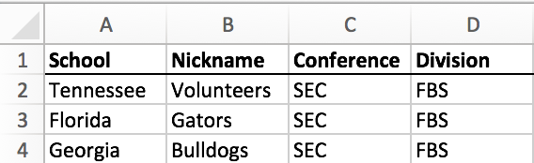

Figure 1: Sample Categorical Data on Teams

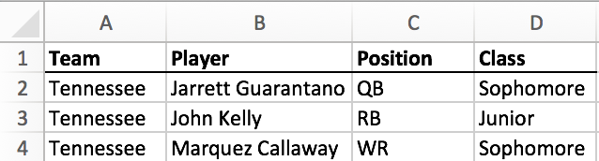

Figure 2: Sample Categorical Data on Players

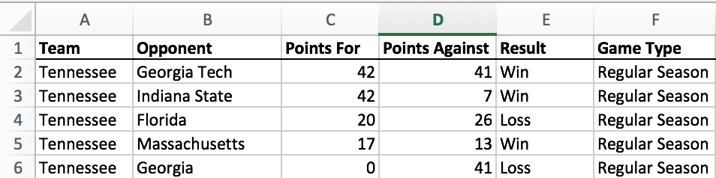

Figure 3: Sample Data from Games

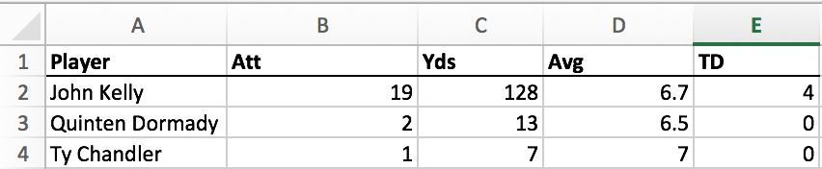

Figure 4: Sample Example of Rushing Statistics for a Game

Here is a glossary of the entities, attributes, and relationships for the database:

|  |  |
| --- | --- |
| **Entity** | **Attribute** |
| Division | Name [ru] |
| Conference | Name [ru] |
| Team | School [ru]  Nickname [r]  Wins [d]  Losses [d]  Conference Championships [d]  National Championships [d] |
| Season | Year [r]  Wins [d]  Losses [d]  Conference Championship [d]  National Championship [d]  Bowl Game [d] |
| Game | Opponent [r]  Points For [r]  Points Against [r]  Result [r]  Game Type [r] |
| Coach | Name [r]  Wins [d]  Losses [d]  First Season [r]  Final Season  Status [r]  National Championships [d]  Conference Championships [d] |
| Player | Name [r]  Position [r]  Class [r] |
| Stats | Pass Completions Pass Attempts Pass Completion Percentage Passing Yards Passing Yards Per Attempt Adjusted Passing Yards Per Attempt Passing Touchdowns Passing Interceptions Passing Efficiency Rating Rushing Attempts Rushing Yards Rushing Yards Per Attempt  Rushing Touchdowns Receptions Receiving Yards Receiving Yards Per Reception Receiving Touchdowns Plays From Scrimmage Yards From Scrimmage  Yards From Scrimmage Per Play Touchdowns From Scrimmage Solo Tackles Assisted Tackles Total Tackles Tackles For Loss Interceptions Interception Return Yards Interception Return Yards Per Interception Interception Return Touchdowns Passes Defended Fumbles Recovered Fumble Recovery Return Yards Fumble Recovery Return Touchdowns Fumbles Forced Kickoff Returns Kickoff Return Yards Kickoff Return Yards Per Return Kickoff Return Touchdowns Punt Returns  Punt Return Yards Punt Return Yards Per Return Punt Return Touchdowns Extra Points Made Extra Point Attempts Extra Point Percentage Field Goals Made Field Goal Attempts Field Goal Percentage Kicking Points Punts Punting Yards Punting Yards Per Punt |
| **Relationships** | |
| Each Division contains 1 or more Conference, each Conference belongs to 1 and only 1 Division  Each Conference has 1 or more Team, each Team belongs to zero or 1 Conference  Each Team participates in 1 or more Season, each Season has 1 or more Team  Each Season contains 1 or more Game, each Game belongs to 1 and only 1 Season  Each Game is coached by 1 and only 1 Coach, each Coach coaches 1 or more Game  Each Game contains 1 or more Stats, each Stats belongs to 1 and only 1 Game  Each Player has zero or more Stats, each Stats belongs to 1 and only 1 Player | |

Figure 5: Entity-Relationship Diagram Glossary

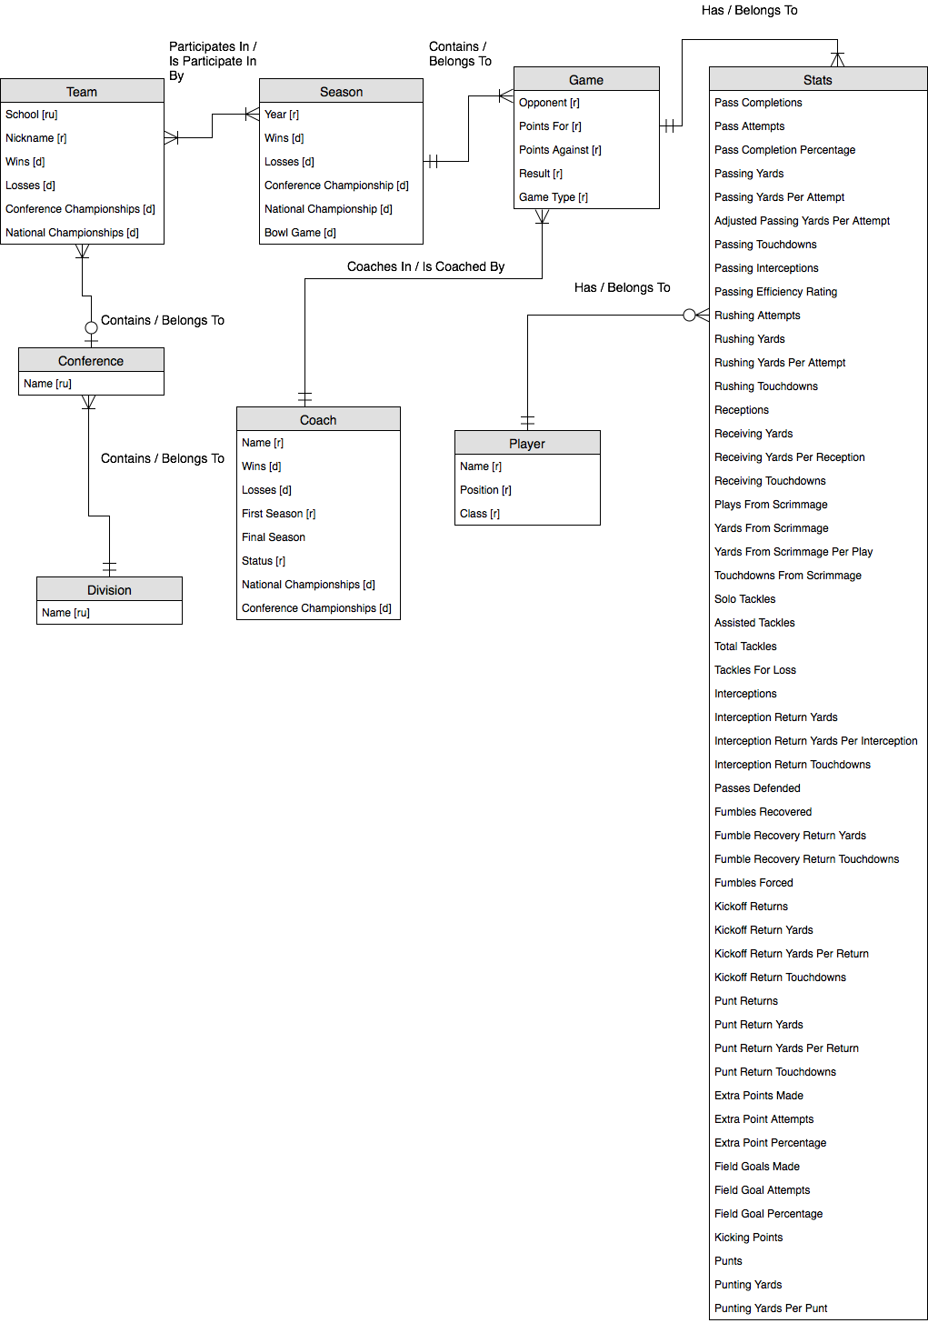

Figure 6: Entity-Relationship Diagram

**Normalized Logical Model**

The conceptual model was decomposed into relations in 3NF as follows:

* division (division id, name)
* conference (conference id, name, *division id*)
* team (team id, school, nickname, wins, losses, conference championships, national championships, *conference id*)
* season (season id, year, wins, losses, conference championship, national championship, bowl game)
* game (game id, opponent, points for, points against, result, game type, *coach id*, *season id*)
* coach (coach id, first name, last name, wins, losses, first season, final season, status, national championships, conference championships)
* player (player id, first name, last name, position, class)
* game_stats (game_stats id, pass completions, pass attempts, pass completion percentage, passing yards, passing yards per attempt, adjusted passing yards per attempt, passing touchdowns, passing interceptions, passing efficiency rating, rushing attempts, rushing yards, rushing yards per attempt , rushing touchdowns, receptions, receiving yards, receiving yards per reception, receiving touchdowns, plays from scrimmage, yards from scrimmage, yards from scrimmage per play, touchdowns from scrimmage, solo tackles, assisted tackles, total tackles, tackles for loss, interceptions, interception return yards, interception return yards per interception, interception return touchdowns, passes defended, fumbles recovered, fumble recovery return yards, fumble recovery return touchdowns, fumbles forced, kickoff returns, kickoff return yards, kickoff return yards per return, kickoff return touchdowns, punt returns, punt return yards, punt return yards per return, punt return touchdowns, extra points made, extra point attempts, extra point percentage, field goals made, field goal attempts, field goal percentage, kicking points, punts, punting yards, punting yards per punt, *game id*, *player id*)

Once the relations were normalized they were put into the logical model. In this step, several attributes were added and data types were selected. For each entity, a surrogate key was added as the primary key. Surrogate keys were chosen because some entities (players and coaches) could have the same name. Since surrogate keys were going to need to be used, I chose to streamline that across each entity to keep the database consistent. In addition, the name attributes for Player and Coach were decomposed into first names and last names in case they needed to be accessed or sorted individually.

The data type for each attribute was chosen on the following criteria:

* Name attributes were chosen as varchar to accommodate names of different character sizes. Size for each attribute was chosen based on the estimated amount of characters needed for each type of attribute.
* Year attributes were chosen as char with a character size 4 because no arithmetic will need to be done on the year attributes.
* All of the statistics that are counts were chosen as int type so that arithmetic can be done on them.
* All of the statistics that were averages or percentages were chosen as decimals to show the precise value of each entity.
* Wins and losses were chosen as int type so that they can be kept as counts.
* Championships for every entity except for Season were chosen as int so that they can be kept as counts.
* Championships for Season were chosen as varchar with size 3 to contain “Yes” or “No”
* Coach Status was chosen as varchar with size 7 because that is the largest size value it will hold (“Current”).
* Player position and class were chosen as char with size 2 because each value is an abbreviation with two letters.
* Points for and against were chosen as int so that arithmetic can be done on them.
* Result was chosen as varchar with size 4 since that is the largest size value it will hold (“Loss”).
* Game type was chosen as varchar with size 25 as an estimate of the largest value that it will hold.

Below is the completed database diagram:

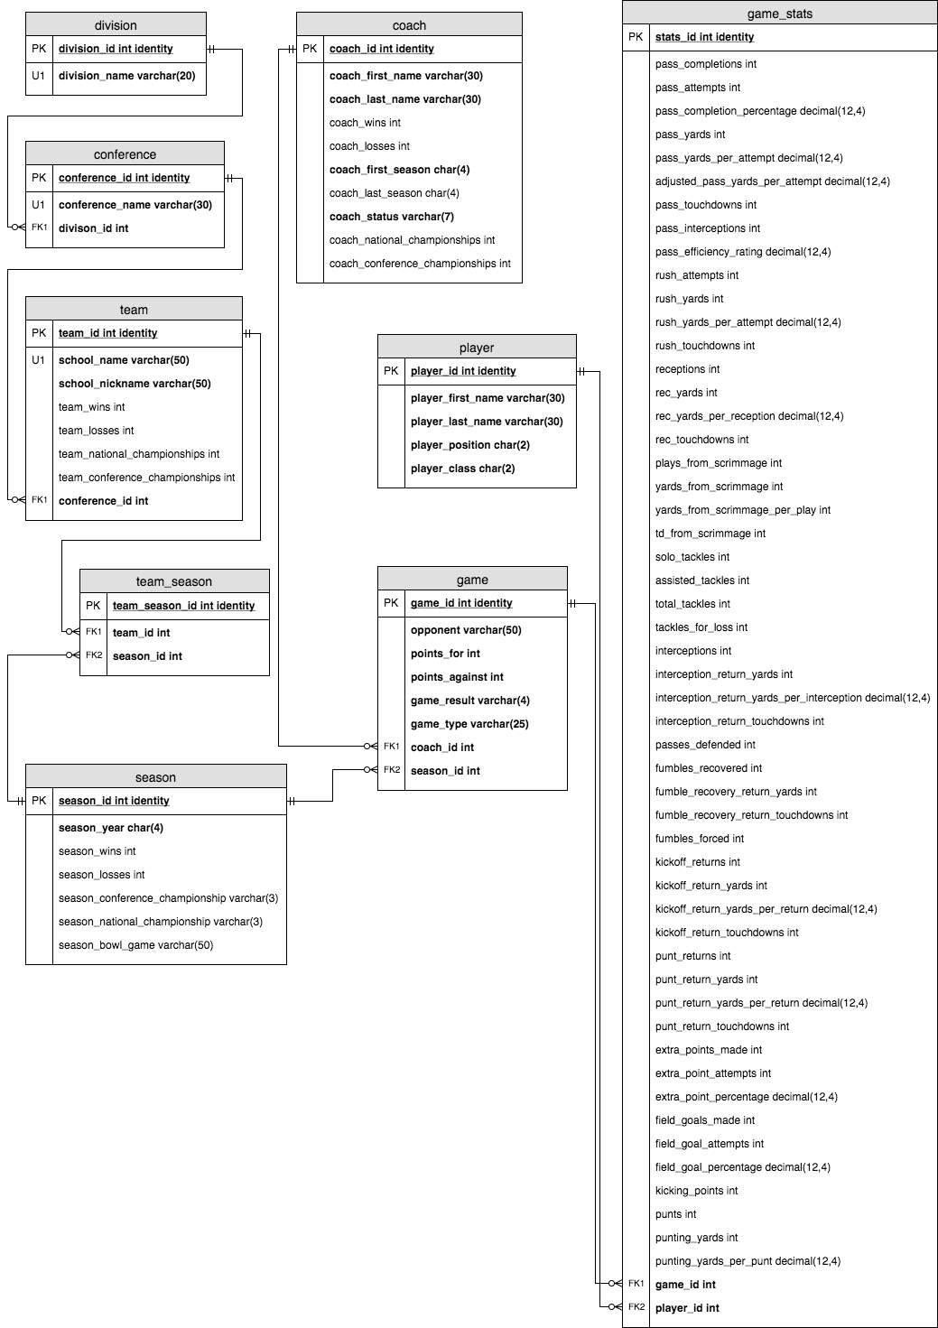

Figure 7: Database Diagram

**Physical Database Design**

Below is the Data Definition Language (DDL) used to in creating the database:

------RESET DATABASE------

--Select Database

USE CollegeFootball

--Remove all Tables

DROP TABLE IF EXISTS game_stats, game, coach, player, team_season, season, team, conference, division;

--Remove all Procedures

DROP PROCEDURE IF EXISTS addDivision, addConference, addTeam, addSeason, addCoach, fireCoach, addGame, addPlayer, addStats, updateResults, updateChampionships;

--Drop all Views

DROP VIEW IF EXISTS field_goal_totals, sec_bowl_eligible, field_goal_percentage, game_results, national_championship_coaches, rushing_yard_totals

--Drop all Functions

DROP FUNCTION IF EXISTS getFieldGoalPercentage

------CREATE TABLES------

--Create Division Table

CREATE TABLE division(

division_id INT IDENTITY NOT NULL,

division_name VARCHAR(20) NOT NULL,

CONSTRAINT division_PK PRIMARY KEY (division_id));

--Create Conference Table

CREATE TABLE conference(

conference_id INT IDENTITY NOT NULL,

conference_name VARCHAR(30) NOT NULL,

division_id INT NOT NULL,

CONSTRAINT conference_PK PRIMARY KEY (conference_id),

CONSTRAINT conference_FK1 FOREIGN KEY (division_id) REFERENCES division(division_id));

--Create Team Table

CREATE TABLE team(

team_id INT IDENTITY NOT NULL,

school_name VARCHAR(50) NOT NULL,

school_nickname VARCHAR(50) NOT NULL,

team_wins INT,

team_losses INT,

team_national_championships INT,

team_conference_championships INT,

conference_id INT NOT NULL,

CONSTRAINT team_PK PRIMARY KEY (team_id),

CONSTRAINT team_FK1 FOREIGN KEY (conference_id) REFERENCES conference(conference_id));

--Create Season Table

CREATE TABLE season(

season_id INT IDENTITY NOT NULL,

season_year CHAR(4) NOT NULL,

season_wins INT,

season_losses INT,

season_conference_championship VARCHAR(3),

season_national_championship VARCHAR(3),

season_bowl_game VARCHAR(50),

CONSTRAINT season_PK PRIMARY KEY (season_id));

--Create Team_Season Table

CREATE TABLE team_season(

team_season_id INT IDENTITY NOT NULL,

team_id INT NOT NULL,

season_id INT NOT NULL,

CONSTRAINT team_season_PK PRIMARY KEY (team_season_id),

CONSTRAINT team_season_FK1 FOREIGN KEY (team_id) REFERENCES team(team_id),

CONSTRAINT team_season_FK2 FOREIGN KEY (season_id) REFERENCES season(season_id));

--Create Coach Table

CREATE TABLE coach(

coach_id INT IDENTITY NOT NULL,

coach_first_name VARCHAR(30) NOT NULL,

coach_last_name VARCHAR(30) NOT NULL,

coach_wins INT,

coach_losses INT,

coach_first_season CHAR(4) NOT NULL,

coach_last_season CHAR(4),

coach_status VARCHAR(7) NOT NULL,

coach_national_championships INT,

coach_conference_championships INT,

CONSTRAINT coach_PK PRIMARY KEY (coach_id));

--Create Game Table

CREATE TABLE game(

game_id INT IDENTITY NOT NULL,

opponent VARCHAR(50) NOT NULL,

points_For INT NOT NULL,

points_against INT NOT NULL,

game_result VARCHAR(4) NOT NULL,

game_type VARCHAR(25) NOT NULL,

coach_id INT NOT NULL,

season_id INT NOT NULL,

CONSTRAINT game_PK PRIMARY KEY (game_id),

CONSTRAINT game_FK1 FOREIGN KEY (coach_id) REFERENCES coach(coach_id),

CONSTRAINT game_FK2 FOREIGN KEY (season_id) REFERENCES season(season_id));

--Create Player Table

CREATE TABLE player(

player_id INT IDENTITY NOT NULL,

player_first_name VARCHAR(30) NOT NULL,

player_last_name VARCHAR(30) NOT NULL,

player_position CHAR(2) NOT NULL,

player_class CHAR(2) NOT NULL,

CONSTRAINT player_PK PRIMARY KEY (player_id));

--Create Game_Stats Table

CREATE TABLE game_stats(

game_stats_id INT IDENTITY NOT NULL,

pass_completions INT,

pass_attempts INT,

pass_completion_percentage DECIMAL(12,4),

pass_yards INT,

pass_yards_per_attempt DECIMAL(12,4),

adjusted_pass_yards_per_attempt DECIMAL(12,4),

pass_touchdowns INT,

pass_interceptions INT,

pass_efficiency_rating DECIMAL(12,4),

rush_attempts INT,

rush_yards INT,

rush_yards_per_attempt DECIMAL(12,4),

rush_touchdowns INT,

receptions INT,

rec_yards INT,

rec_yards_per_reception DECIMAL(12,4),

rec_touchdowns INT,

plays_from_scrimmage INT,

yards_from_scrimmage INT,

yards_from_scrimmage_per_play DECIMAL(12,4),

td_from_scrimmage INT,

solo_tackles INT,

assisted_tackles INT,

total_tackles INT,

tackles_for_loss INT,

interceptions INT,

interception_return_yards INT,

interception_return_yards_per_interception DECIMAL(12,4),

interception_return_touchdowns INT,

passes_defended INT,

fumbles_recovered INT,

fumble_recovery_return_yards INT,

fumble_recovery_return_touchdowns INT,

fumbles_forced INT,

kickoff_returns INT,

kickoff_return_yards INT,

kickoff_return_yards_per_return DECIMAL(12,4),

kickoff_return_touchdowns INT,

punt_returns INT,

punt_return_yards INT,

punt_return_yards_per_return DECIMAL(12,4),

punt_return_touchdowns INT,

extra_points_made INT,

extra_point_attempts INT,

extra_point_percentage DECIMAL(12,4),

field_goals_made INT,

field_goal_attempts INT,

field_goal_percentage DECIMAL(12,4),

kicking_points INT,

punts INT,

punting_yards INT,

punting_yards_per_punt DECIMAL(12,4),

game_id INT NOT NULL,

player_id INT NOT NULL,

CONSTRAINT game_stats_PK PRIMARY KEY (game_stats_id),

CONSTRAINT game_stats_FK1 FOREIGN KEY (game_id) REFERENCES game(game_id),

CONSTRAINT game_stats_FK2 FOREIGN KEY (player_id) REFERENCES player(player_id));

------CREATE PROCEDURES------

--Add Division

GO

CREATE PROCEDURE addDivision(@division_name varchar(20))

AS

BEGIN

--Create Division

INSERT INTO division(division_name)

VALUES (@division_name)

END

GO

--Add Conference

CREATE PROCEDURE addConference(@conference_name varchar(30), @division_name varchar(20))

AS

BEGIN

--Get Division ID

DECLARE @division_id int

SELECT @division_id = division_id FROM division

WHERE @division_name = division_name

--Create Conference

INSERT INTO conference(conference_name, division_id)

VALUES (@conference_name, @division_id)

END

GO

--Add Team

CREATE PROCEDURE addTeam(@school_name varchar(50), @school_nickname varchar(50), @conference_name varchar(30))

AS

BEGIN

--Get Conference ID

DECLARE @conference_id int

SELECT @conference_id = conference_id FROM conference

WHERE @conference_name =conference_name

--Create Team

INSERT INTO team(school_name, school_nickname, conference_id)

VALUES (@school_name, @school_nickname, @conference_id)

END

GO

--Add Season

CREATE PROCEDURE addSeason(@school_name varchar(50), @season_year char(4))

AS

BEGIN

--Create Season

INSERT INTO season(season_year)

VALUES (@season_year)

--Get Season ID

DECLARE @season_id int

SET @season_id = @@IDENTITY

--Get Team ID

DECLARE @team_id int

SELECT @team_id = team_id FROM team

WHERE school_name = @school_name

--Create Team_Season

INSERT INTO team_season(team_id, season_id)

VALUES (@team_id, @season_id)

END

GO

--Add Coach

CREATE PROCEDURE addCoach(@coach_first_name varchar(30), @coach_last_name varchar(30), @coach_first_season char(4))

AS

BEGIN

INSERT INTO coach(coach_first_name, coach_last_name, coach_first_season, coach_status)

VALUES (@coach_first_name, @coach_last_name, @coach_first_season, 'Current')

END

GO

--Add Game

CREATE PROCEDURE addGame(@team varchar(50), @opponent varchar(50), @year char(4), @game_type varchar(25), @coach_first_name varchar(30), @coach_last_name varchar(30), @points_for int, @points_against int)

AS

BEGIN

--Get Coach ID

DECLARE @coach_id int

SELECT @coach_id = coach_id FROM coach WHERE coach_first_name = @coach_first_name AND coach_last_name = @coach_last_name

--Get Team ID

DECLARE @team_id INT

SELECT @team_id = team_id FROM team WHERE school_name = @team

--Get Season

DECLARE @season_id int

--Get All Team_Season for Team

--Create temporary table

CREATE TABLE one_team(

one_team_id INT IDENTITY,

season_id INT,

season_year char(4))

--Add Season ID's to temporary table

INSERT INTO one_team(season_id)

SELECT season_id FROM team_season WHERE team_id = (SELECT team_id FROM team WHERE school_name like '%' + @team + '%')

--Add Season Years to temporary table

UPDATE one_team

SET season_year = season.season_year

FROM one_team

JOIN season

ON season.season_id = one_team.season_id

--Get Correct Year

SELECT @season_id = season_id FROM one_team

WHERE season_year = @year

--Delete temporary Table

DROP TABLE one_team

--Get Result

DECLARE @game_result varchar(4)

IF (@points_for > @points_against)

BEGIN

SET @game_result = 'Win'

--Update Season

Update Season

SET season_wins = season_wins + 1

WHERE season_id = @season_id

--Update Team

Update Team

SET team_wins = team_wins + 1

WHERE team_id = @team_id

--Update Update Coach

UPDATE Coach

SET coach_wins = coach_wins + 1

WHERE coach_id = @coach_id

--Update National Championship

IF @game_type = 'National Championship'

BEGIN

Update Season

SET season_national_championship = ‘Yes’

WHERE season_id = @season_id

--Update Team

Update Team

SET team_national_championships = team_national_championships + 1

WHERE team_id = @team_id

--Update Update Coach

UPDATE Coach

SET coach_national_championships = coach_national_championships + 1

WHERE coach_id = @coach_id

END

ELSE IF @game_type = 'Conference Championship'

BEGIN

--Update Conference Championship

Update Season

SET season_conference_championship = ‘Yes’

WHERE season_id = @season_id

--Update Team

Update Team

SET team_conference_championships = team_conference_championships + 1

WHERE team_id = @team_id

--Update Update Coach

UPDATE Coach

SET coach_conference_championships = coach_conference_championships + 1

WHERE coach_id = @coach_id

END

END

ELSE

BEGIN

SET @game_result = 'Loss'

--Update Season

Update Season

SET season_losses = season_losses + 1

WHERE season_id = @season_id

--Update Team

Update Team

SET team_losses = team_losses + 1

WHERE team_id = @team_id

--Update Update Coach

UPDATE Coach

SET coach_losses = coach_losses + 1

WHERE coach_id = @coach_id

END

--CREATE Game

INSERT INTO game(season_id, opponent, points_For, points_against, game_result, game_type, coach_id)

VALUES (@season_id, @opponent, @points_for, @points_against, @game_result, @game_type, @coach_id)

END

GO

--Add Player

CREATE PROCEDURE addPlayer(@player_first_name varchar(30), @player_last_name varchar(30), @player_class char(2), @player_position char(2))

AS

BEGIN

--CREATE Player

INSERT INTO player(player_first_name, player_last_name, player_position, player_class)

VALUES(@player_first_name, @player_last_name, @player_class, @player_position)

END

GO

--Add Stats

CREATE PROCEDURE addStats(@player_first_name varchar(30), @player_last_name varchar(30), @team varchar(50), @year CHAR(4), @opponent varchar(50), @pass_completions INT,

@pass_attempts INT,

@pass_completion_percentage DECIMAL(12,4),

@pass_yards INT,

@pass_yards_per_attempt DECIMAL(12,4),

@adjusted_pass_yards_per_attempt DECIMAL(12,4),

@pass_touchdowns INT,

@pass_interceptions INT,

@pass_efficiency_rating DECIMAL(12,4),

@rush_attempts INT,

@rush_yards INT,

@rush_yards_per_attempt DECIMAL(12,4),

@rush_touchdowns INT,

@receptions INT,

@rec_yards INT,

@rec_yards_per_reception DECIMAL(12,4),

@rec_touchdowns INT,

@plays_from_scrimmage INT,

@yards_from_scrimmage INT,

@yards_from_scrimmage_per_play DECIMAL(12,4),

@td_from_scrimmage INT,

@solo_tackles INT,

@assisted_tackles INT,

@total_tackles INT,

@tackles_for_loss INT,

@interceptions INT,

@interception_return_yards INT,

@interception_return_yards_per_interception DECIMAL(12,4),

@interception_return_touchdowns INT,

@passes_defended INT,

@fumbles_recovered INT,

@fumble_recovery_return_yards INT,

@fumble_recovery_return_touchdowns INT,

@fumbles_forced INT,

@kickoff_returns INT,

@kickoff_return_yards INT,

@kickoff_return_yards_per_return DECIMAL(12,4),

@kickoff_return_touchdowns INT,

@punt_returns INT,

@punt_return_yards INT,

@punt_return_yards_per_return DECIMAL(12,4),

@punt_return_touchdowns INT,

@extra_points_made INT,

@extra_point_attempts INT,

@extra_point_percentage DECIMAL(12,4),

@field_goals_made INT,

@field_goal_attempts INT,

@field_goal_percentage DECIMAL(12,4),

@kicking_points INT,

@punts INT,

@punting_yards INT,

@punting_yards_per_punt DECIMAL(12,4))

AS

BEGIN

--Get Player ID

Declare @player_id int

SELECT @player_id = player_id FROM player WHERE player_first_name = @player_first_name AND player_last_name = @player_last_name

--Get Season

DECLARE @season_id int

--Get All Team_Season for Team

--Create temporary table

CREATE TABLE one_team(

one_team_id INT IDENTITY,

season_id INT,

season_year char(4))

--Add Season ID's to temporary table

INSERT INTO one_team(season_id)

SELECT season_id FROM team_season WHERE team_id = (SELECT team_id FROM team WHERE school_name like '%' + @team + '%')

--Add Season Years to temporary table

UPDATE one_team

SET season_year = season.season_year

FROM one_team

JOIN season

ON season.season_id = one_team.season_id

--Get Correct Year

SELECT @season_id = season_id FROM one_team

WHERE season_year = @year

--Delete temporary Table

DROP TABLE one_team

--Get Game ID

Declare @game_id int

SELECT @game_id = game_id FROM game WHERE season_id = @season_id AND opponent = @opponent

--Create Stats

INSERT INTO game_stats (pass_completions,

pass_attempts,

pass_completion_percentage,

pass_yards,

pass_yards_per_attempt,

adjusted_pass_yards_per_attempt,

pass_touchdowns,

pass_interceptions,

pass_efficiency_rating,

rush_attempts,

rush_yards,

rush_yards_per_attempt,

rush_touchdowns,

receptions,

rec_yards,

rec_yards_per_reception,

rec_touchdowns,

plays_from_scrimmage,

yards_from_scrimmage,

yards_from_scrimmage_per_play,

td_from_scrimmage,

solo_tackles,

assisted_tackles,

total_tackles,

tackles_for_loss,

interceptions,

interception_return_yards,

interception_return_yards_per_interception,

interception_return_touchdowns,

passes_defended,

fumbles_recovered,

fumble_recovery_return_yards,

fumble_recovery_return_touchdowns,

fumbles_forced,

kickoff_returns,

kickoff_return_yards,

kickoff_return_yards_per_return,

kickoff_return_touchdowns,

punt_returns,

punt_return_yards,

punt_return_yards_per_return,

punt_return_touchdowns,

extra_points_made,

extra_point_attempts,

extra_point_percentage,

field_goals_made,

field_goal_attempts,

field_goal_percentage,

kicking_points,

punts,

punting_yards,

punting_yards_per_punt,

game_id,

player_id)

VALUES (@pass_completions,

@pass_attempts,

@pass_completion_percentage,

@pass_yards,

@pass_yards_per_attempt,

@adjusted_pass_yards_per_attempt,

@pass_touchdowns,

@pass_interceptions,

@pass_efficiency_rating,

@rush_attempts,

@rush_yards,

@rush_yards_per_attempt,

@rush_touchdowns,

@receptions,

@rec_yards,

@rec_yards_per_reception,

@rec_touchdowns,

@plays_from_scrimmage,

@yards_from_scrimmage,

@yards_from_scrimmage_per_play,

@td_from_scrimmage,

@solo_tackles,

@assisted_tackles,

@total_tackles,

@tackles_for_loss,

@interceptions,

@interception_return_yards,

@interception_return_yards_per_interception,

@interception_return_touchdowns,

@passes_defended,

@fumbles_recovered,

@fumble_recovery_return_yards,

@fumble_recovery_return_touchdowns,

@fumbles_forced,

@kickoff_returns,

@kickoff_return_yards,

@kickoff_return_yards_per_return,

@kickoff_return_touchdowns,

@punt_returns,

@punt_return_yards,

@punt_return_yards_per_return,

@punt_return_touchdowns,

@extra_points_made,

@extra_point_attempts,

@extra_point_percentage,

@field_goals_made,

@field_goal_attempts,

@field_goal_percentage,

@kicking_points,

@punts,

@punting_yards,

@punting_yards_per_punt,

@game_id,

@player_id)

END

GO

--Fire Coach

CREATE PROCEDURE fireCoach(@coach_first_name varchar(30), @coach_last_name varchar(30), @coach_last_season char(4))

AS

BEGIN

--Get Coach ID

DECLARE @coach_id int

SELECT @coach_id = coach_id FROM coach

WHERE coach_first_name = @coach_first_name AND coach_last_name = @coach_last_name

--Set Status to Former

UPDATE coach SET coach_status = 'Former'

WHERE coach_id = @coach_id

--Set Last Season

UPDATE coach SET coach_last_season = @coach_last_season

WHERE coach_id = @coach_id

END

GO

------CREATE VIEWS------

--Get Field Goal Totals

CREATE VIEW field_goal_totals

AS SELECT season.season_id, player_first_name, player_last_name, Sum(field_goal_attempts) AS sum_field_goal_attempts, Sum(field_goals_made) AS sum_field_goals_made

FROM ((game_stats INNER JOIN player ON game_stats.player_id = player.player_id) INNER JOIN game ON game_stats.game_id = game.game_id) INNER JOIN ((team_season INNER JOIN season ON team_season.season_id = season.season_id) INNER JOIN team ON team_season.team_id = team.team_id) ON game.season_id = season.season_id

WHERE (((game_stats.field_goal_attempts)>0))

GROUP BY player.player_first_name, player.player_last_name, season.season_id;

GO

--Get Bowl Eligible Teams

CREATE VIEW sec_bowl_eligible

AS SELECT school_name, season_wins, season_losses

FROM (team_season INNER JOIN season ON team_season.season_id = season.season_id) INNER JOIN (team INNER JOIN conference ON team.conference_id = conference.conference_id) ON team_season.team_id = team.team_id

WHERE season_wins >= 6

GO

--Get Best Field Goal Percentage

CREATE VIEW field_goal_percentage

AS

SELECT player_first_name, player_last_name, CONVERT(DECIMAL(12,4), sum_field_goals_made)/CONVERT(DECIMAL(12,4),sum_field_goal_attempts) AS FieldGoalPercentage

FROM field_goal_totals;

GO

--Get Game Results

CREATE VIEW game_results

AS

SELECT school_name, opponent, game_result, points_For, points_against, season_year

FROM game INNER JOIN ((team_season INNER JOIN season ON team_season.season_id = season.season_id) INNER JOIN team ON team_season.team_id = team.team_id) ON game.season_id = season.season_id

GO

--Get National Championship Coaches

CREATE VIEW national_championship_coaches

AS

SELECT season_year, coach_first_name, coach_last_name, school_name

FROM (team_season INNER JOIN ((game INNER JOIN coach ON game.coach_id = coach.coach_id) INNER JOIN season ON game.season_id = season.season_id) ON team_season.season_id = season.season_id) INNER JOIN team ON team_season.team_id = team.team_id

WHERE game_result='Win' AND game_type='National Championship'

GO

--Get Rushing Yard Totals

CREATE VIEW rushing_yard_totals

AS

SELECT Sum(rush_yards) AS sum_rush_yards, player_first_name, player_last_name, school_name

FROM ((((game_stats INNER JOIN player ON game_stats.player_id = player.player_id) INNER JOIN game ON game_stats.game_id = game.game_id) INNER JOIN season ON game.season_id = season.season_id) INNER JOIN team_season ON season.season_id = team_season.season_id) INNER JOIN team ON team_season.team_id = team.team_id

GROUP BY player.player_first_name, player.player_last_name, team.school_name

GO

------CREATE FUNCTIONS------

--Get Field Goal Percentage for Season

CREATE FUNCTION getFieldGoalPercentage(@player_first_name varchar(30), @player_last_name varchar(30), @team varchar(50), @season_year char(4))

RETURNS DECIMAL(12,4)

AS

BEGIN

--get season

DECLARE @season_id INT

SELECT @season_id = season_id FROM team_season WHERE season_id = (SELECT season_id FROM season WHERE season_year = @season_year) AND team_id = (SELECT team_id FROM team WHERE school_name = @team)

--get field goal percentage

DECLARE @field_goal_percentage DECIMAL(12,4)

SELECT @field_goal_percentage = sum_field_goals_made/sum_field_goal_attempts

FROM field_goal_totals

WHERE player_first_name = @player_first_name AND player_last_name = @player_last_name AND season_id = @season_id

RETURN @field_goal_percentage

END

GO

**Data Creation**

Below are ten examples of data being entered into the database using SQL insert statments:

--add a division

INSERT INTO division(division_name)

VALUES ('FBS');

--add a conference

INSERT INTO conference(conference_name, division_id)

VALUES ('SEC', (SELECT division_id FROM division WHERE division_name = 'FBS'));

--add a team

INSERT INTO team(school_name, school_nickname, conference_id)

VALUES ('Tennessee', 'Volunteers', (SELECT conference_id FROM conference WHERE conference_name = 'SEC'));

--add a season

INSERT INTO season(season_year)

VALUES ('2017');

--add a season

INSERT INTO team_season(team_id, season_id)

VALUES ((SELECT team_id FROM team WHERE school_name = 'Tennessee'), (SELECT season_id FROM season WHERE season_year = '2017'));

--add a coach

INSERT INTO coach(coach_first_name, coach_last_name, coach_first_season, coach_status)

VALUES('Butch', 'Jones', '2013', 'Current')

--add a game

INSERT INTO game(opponent, points_for, points_against, game_result, game_type, coach_id, season_id)

VALUES ('Georgia Tech', 42, 41, 'Win', 'Regular Season', (SELECT coach_id FROM coach WHERE coach_first_name = 'Butch' AND coach_last_name = 'Jones'), (SELECT season_id FROM season WHERE season_year = '2017'));

--add a player

INSERT INTO player(player_first_name, player_last_name, player_position, player_class)

VALUES ('Quinten', 'Dormady', 'QB', 'JR');

--add stats from a game

INSERT INTO game_stats(pass_completions, pass_attempts, pass_completion_percentage, pass_yards, pass_yards_per_attempt, adjusted_pass_yards_per_attempt, pass_touchdowns, pass_interceptions, pass_efficiency_rating, player_id, game_id)

VALUES (20, 37, 54.1, 221, 6, 7.1, 2, 0, 122.1, (SELECT player_id FROM player WHERE player_first_name = 'Quinten' AND player_last_name = 'Dormady'), (SELECT game_id FROM game WHERE opponent = 'Georgia Tech'));

Below are several examples of data being entered into the database using stored procedures:

--add a division

EXEC addDivision('FBS')

--add a conference

EXEC addConference('SEC','FBS')

--add a team

EXEC addTeam('Tennessee', 'Volunteers', 'SEC')

--add a season

EXEC addSeason('Tennessee','2017')

--add a coach

EXEC addCoach('Butch', 'Jones', '2013')

--add a game

EXEC addGame('Tennessee', 'Georgia', '2017', 'Regular Season', 'Butch', 'Jones', 0, 41)

--add a player

EXEC addPlayer('John', 'Kelly', 'JR', 'RB')

**Data Manipulation**

Data manipulation in this database is done using stored procedures. The statement below, *fireCoach*, will update a coach’s record when he is fired or quits a team. The procedure changes the coach’s status from ‘Current’ to ‘Former’ and sets the coach’s last season to the season input by the user. This relates to the business rule that a team may only have one coach at a time, but may have multiple coaches in a season.

SQL Code:

--Fire Coach

CREATE PROCEDURE fireCoach(@coach_first_name varchar(30), @coach_last_name varchar(30), @coach_last_season char(4))

AS

BEGIN

--Get Coach ID

DECLARE @coach_id int

SELECT @coach_id = coach_id FROM coach

WHERE coach_first_name = @coach_first_name AND coach_last_name = @coach_last_name

--Set Status to Former

UPDATE coach SET coach_status = 'Former'

WHERE coach_id = @coach_id

--Set Last Season

UPDATE coach SET coach_last_season = @coach_last_season

WHERE coach_id = @coach_id

END

GO

The following code is from the *addGame* procedure. This first statement checks to see if the game was a win or a loss and sets the game_result variable. An if statement is used to update the win and loss totals for each season, team, and coach. In addition, another if statement is used to check to see if the game was either a national championship or a conference championship. If either of these is true, the total championships is updated for each season, team and coach. This affirms our business rule that the team with the most points in a game is the winner and the team with the fewest points in a game is the loser. This also affirms the rule that the team is the conference champion when that team has a win in the conference championship game type, and it affirms the rule that the team is the national champion when that team has a win in the national championship game type.

DECLARE @game_result varchar(4)

IF (@points_for > @points_against)

BEGIN

SET @game_result = 'Win'

--Update Season

Update Season

SET season_wins = season_wins + 1

WHERE season_id = @season_id

--Update Team

Update Team

SET team_wins = team_wins + 1

WHERE team_id = @team_id

--Update Update Coach

UPDATE Coach

SET coach_wins = coach_wins + 1

WHERE coach_id = @coach_id

--Update National Championship

IF @game_type = 'National Championship'

BEGIN

Update Season

SET season_national_championship = ‘Yes’

WHERE season_id = @season_id

--Update Team

Update Team

SET team_national_championships = team_national_championships + 1

WHERE team_id = @team_id

--Update Update Coach

UPDATE Coach

SET coach_national_championships = coach_national_championships + 1

WHERE coach_id = @coach_id

END

ELSE IF @game_type = 'Conference Championship'

BEGIN

--Update Conference Championship

Update Season

SET season_conference_championship = ‘Yes’

WHERE season_id = @season_id

--Update Team

Update Team

SET team_conference_championships = team_conference_championships + 1

WHERE team_id = @team_id

--Update Update Coach

UPDATE Coach

SET coach_conference_championships = coach_conference_championships + 1

WHERE coach_id = @coach_id

END

END

ELSE

BEGIN

SET @game_result = 'Loss'

--Update Season

Update Season

SET season_losses = season_losses + 1

WHERE season_id = @season_id

--Update Team

Update Team

SET team_losses = team_losses + 1

WHERE team_id = @team_id

--Update Update Coach

UPDATE Coach

SET coach_losses = coach_losses + 1

WHERE coach_id = @coach_id

END

**Answering Data Questions**

Below are the select statements that answer the data questions posed in the summary. These queries all reference views, but the views were left vague so that they could be used for multiple queries (different players, teams, etc).

Who had the most rushing yards for the Tennessee Volunteers in 2017?

Business Rule:

*A player can only play for one team per season.* All of John Kelly’s rushing yards were for the Tennessee Volunteers.

SQL Code:

SELECT TOP 1 sum_rush_yards, player_first_name, player_last_name, school_name

FROM rushing_yard_totals

WHERE school_name = 'Tennessee'

ORDER BY sum_rush_yards DESC

Results:



Figure 8: Results from Query for Data Question 1

What team in the SEC had the kicker with the highest Field Goal Percentage in 2017?

Business Rule:

*A player can only play for one team per season.* All of David Marvin’s field goals were for the Georgia Bulldogs.

SQL Code:

SELECT school_name FROM team WHERE team_id =

(SELECT team_id FROM team_season WHERE season_id =

(SELECT season_id FROM game WHERE game_id =

(SELECT TOP 1 game_id FROM game_stats WHERE player_id =

(SELECT player_id FROM player WHERE player_first_name =

(SELECT TOP 1 player_first_name FROM field_goal_percentage ORDER BY FieldGoalPercentage

DESC) AND player_last_name = (SELECT TOP 1 player_last_name FROM

field_goal_percentage ORDER BY FieldGoalPercentage DESC )))))

Results:



Figure 9: Results from Query for Data Question 2

What teams in the SEC won 6 or more games in 2017?

Business Rule:

*A team can only belong to one conference per season.* All of these teams were a part of the SEC and only the SEC for the 2017 season.

SQL Code:

SELECT *

FROM sec_bowl_eligible

ORDER BY season_wins DESC

Results:

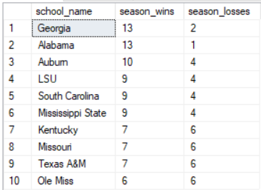

Figure 10: Results from Query for Data Question 3

Who is the coach of the team that won the National Championship in 2017?

Business Rule:

*A team can only have one coach per game.* Nick Saban was the only head coach of the Alabama Crimson Tide during the National Championship Game.

SQL Code:

SELECT *

FROM national_championship_coaches

WHERE season_year = '2017'

Results:



Figure 11: Results from Query for Data Question 4

Did the Florida Gators beat the Georgia Bulldogs in 2017?

Business Rule:

*A game can only have one winner and one loser.* The Florida Gators lost the game, and the Georgia Bulldogs won the game.

SQL Code:

SELECT *

FROM game_results

WHERE school_name = 'Florida' AND opponent = 'Georgia'

Results:



Figure 12: Results from Query for Data Question 5

**Implementation**

The GUI for the college football database was created using Microsoft Access. I created a form that would serve as a “Main Menu” for the database. This main menu has links to game results, stats, conference standings, stats, season results, championship lookup, and coaching records. The menu also has a link for data entry.

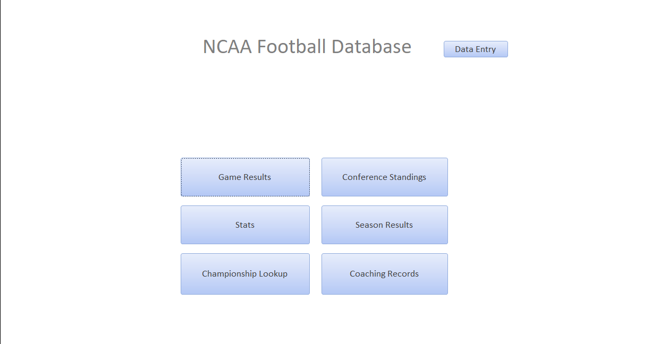

Figure 13: Main Menu of User Interface

The link to data entry takes the user to a data entry menu. From here the user can access a form to input data into each table in the database.

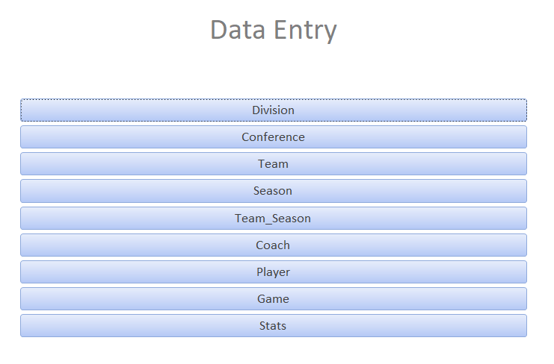

Figure 14: Data Entry Menu

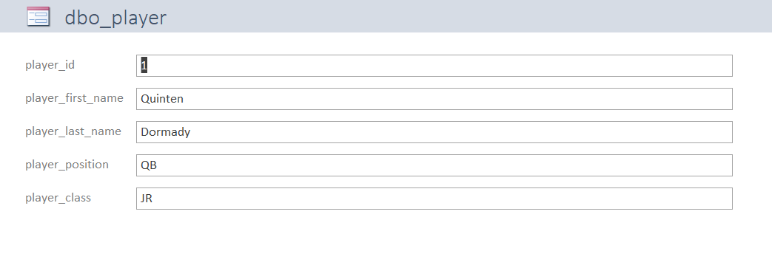

Figure 15: Example Data Entry Form

From the main menu, the user can also access a sub menu for each type of data. For this example, I have provided the sub menu for the championships data. From here the user has the choice to lookup data from conference championships or national championships.

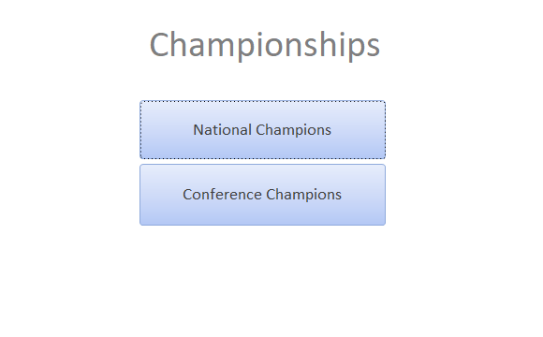

Figure 16: Example Sub Menu

The user will be prompted to enter the year of the data that he or she wishes to access.

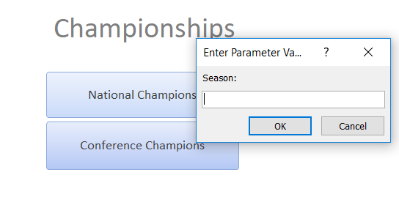

Figure 17: Example Prompt

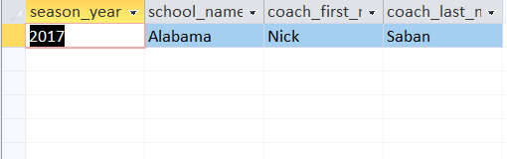

Figure 18: Example Results

Answering Data Questions in Microsoft Access:

From the views I coded in SQL Server, I created a query in access to answer all of my data questions. Below are the results of the access output for each of my data questions:

Who had the most rushing yards for the Tennessee Volunteers in 2017?

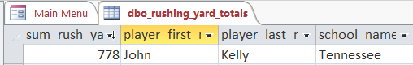

Figure 19: Output for Data Question 1

What team in the SEC had the kicker with the highest Field Goal Percentage in 2017?

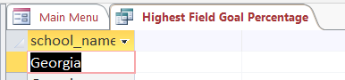

Figure 20: Output for Data Question 2

What teams in the SEC won 6 or more games in 2017?

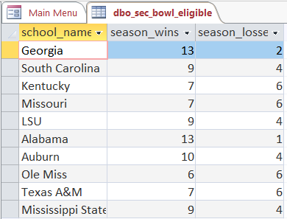

Figure 21: Output for Data Question 3

Who is the coach of the team that won the National Championship in 2017?

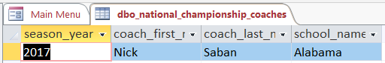

Figure 22: Output For Data Question 4

Did the Florida Gators beat the Georgia Bulldogs in 2017?

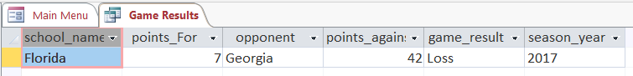

Figure 23: Output for Data Question 5

**Reflection**

At the start of this project, I expected that most of my time would be spent with the coding of the database creation. I found that this was the shortest step in the entire process. I severely underestimated how much time would be spent gathering the data and inserting it into the database. This was by far the longest step in my process. Part of this was because I designed my database without doing enough research on how the data would be gathered. I had to spend a lot of time manipulating my data to get it into the format that I needed to append to my database. Going forward, I will be sure to do thorough research on the data I will be gathering before I begin to create my conceptual model. This should save a lot of time in my next project.

This project has given me a new perspective on how I will use data as an information professional. If sufficient steps are taken in the creation and maintenance of the database, I will have clean data that can be analyzed and used in any capacity that I need. This will save valuable time that can be better spent adding value to my stakeholders. I now have the knowledge and abilities that I will need to accomplish this goal.