Reinforcement Learning for Stock Trading

1. Problem and Environment
This project models a simplified stock-trading problem as a finite-horizon, finite-state Markov decision process (MDP). The environment parameters are fixed as follows:

- Time horizon: H = 20
- Initial stock price: S₀ = 100
- Up factor: u = 1.1 (with probability p = 0.5)
- Down factor: d = 0.9 (with probability 1 − p = 0.5)
- Discount factor: γ = 1

State Representation
The state is represented in code as a tuple:
s_t = (t, k, h)
where t is the current time step (0 ≤ t ≤ H), k is the number of upward price moves so far (0 ≤ k ≤ t), and h ∈ {0, 1} is the holding status (0 = cash, 1 = stock). Since the stock price follows a binomial tree, the current price is fully determined by (t, k):
S_t = S₀ × u^k × d^(t−k)
so the price does not need to be stored separately in the state.

Actions and Validity
The action set is A = {buy, hold, sell}. Invalid actions are never allowed:

- If h = 0 (cash): valid actions are hold and buy
- If h = 1 (stock): valid actions are hold and sell
This constraint is enforced in both value iteration and Q-learning. In particular, random exploration samples uniformly from valid actions only.

Reward
The action is chosen at time t before the price moves to t+1. The reward is determined by the resulting holding position and the realized price movement:

- r = log(u) ≈ 0.0953 if holding stock and price moves up
- r = log(d) ≈ −0.1054 if holding stock and price moves down
- r = 0 if holding cash
Equivalently, the reward is the one-step log-return of the portfolio. Episodes terminate when t = H; no further reward is received.

2. Exact Solution by Value Iteration
Because this is a finite-horizon MDP, the exact benchmark is computed by backward dynamic programming. The terminal value is initialized as V_H(s) = 0 for all states. Then, for t = H-1, H-2, ..., 0, the Q-function is computed over valid actions only:

Q*(s, a) = Σ_{s'} P(s' | s, a) × [r(s, a, s') + γ × V*(s')]
V*(s) = max_a Q*(s, a)
π*(s) = argmax_a Q*(s, a)

When multiple actions tie, ties are broken in the fixed order: hold > buy > sell. This same tie-breaking rule is used in Q-learning policy extraction so that policy mismatch is measured consistently.

Optimal Value Function
An important observation is that V*(s) = 0 for every non-terminal state in this problem. This is not a bug but a direct mathematical consequence of the environment parameters.
The one-step expected reward of holding stock is:
E[r] = p·log(u) + (1−p)·log(d)
= 0.5 × log(1.1) + 0.5 × log(0.9)
= 0.5 × 0.0953 + 0.5 × (−0.1054) = −0.0025 < 0
This is negative because u × d = 1.1 × 0.9 = 0.99 < 1: the geometric mean of the stock price is slightly decreasing at every step. Holding stock therefore has a negative expected log-return per step, while holding cash always yields exactly 0. Since 0 > −0.0025, the optimal strategy is to never buy the stock at all, and the maximum achievable expected cumulative reward is 0. Backward dynamic programming confirms this: the optimal value function is V*(s) = 0 for every non-terminal state, and the optimal policy is to hold cash (H) in all states where h = 0. Figure 1 shows the optimal value function in a compact side-by-side layout. Since every optimal value equals 0, the figure emphasizes that the value function is uniform across cash and stock states.

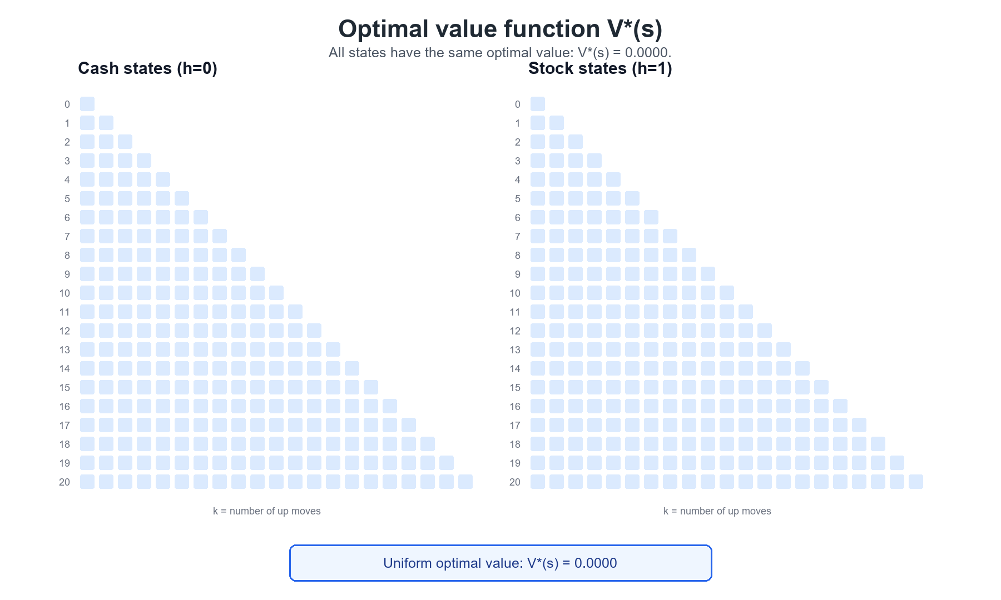
Figure 1: Optimal value function V*(s). Left panel: h=0 (cash). Right panel: h=1 (stock).

Optimal Policy
Figure 2 shows the optimal policy. Blue (B) = buy, green (H) = hold, red (S) = sell.

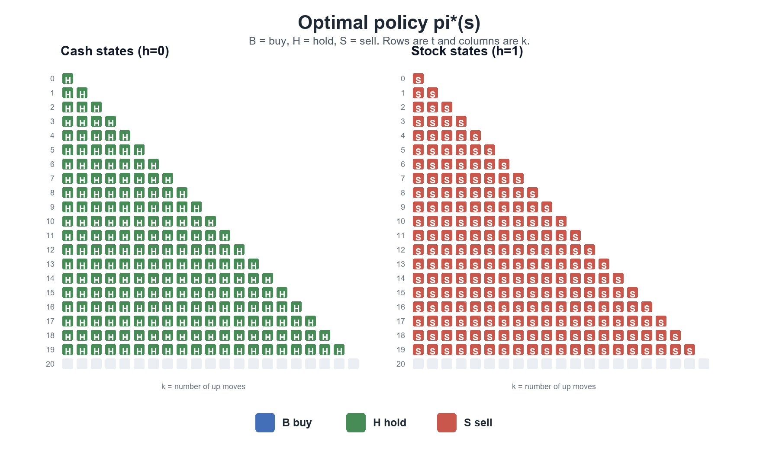
Figure 2: Optimal policy pi*(s). Left panel: h=0 (cash). Right panel: h=1 (stock).

3. Tabular Q-learning
The Q-learning implementation uses a tabular array Q(s, a) initialized to zero for all state-action pairs. Since the time index t is already embedded in the state tuple, no separate time-dependent table is required.

Update Rule
At each non-terminal state, the agent selects an action using ε-greedy exploration over valid actions only. The update rule is:

Q(s, a) ← Q(s, a) + α × [r + max_{a'} Q(s', a') − Q(s, a)]

The maximization over a’ uses only valid actions at the next state s’. If s’ is terminal (t = H), the bootstrap term is zero.

Handling Valid/Invalid Actions
Both during exploration and policy extraction, the implementation strictly restricts action selection to the valid action set determined by the holding status h. Specifically:

- Exploration: random action is sampled uniformly from valid actions only
- Greedy action: argmax is taken over valid actions only
- Bootstrap target: max Q(s’, a’) is computed over valid actions at s’

4. Experimental Setup
The experiment tests 3 exploration schedules × 3 learning-rate schedules = 9 total combinations. Each combination is evaluated with 50 random seeds (0 through 49) and up to 5,000 episodes per seed. The same code supports 100,000 episodes via --episodes 100000.

Exploration Schedules (ε)
- eps_linear_1_to_001: linear decay from ε = 1.0 to ε = 0.01 over all episodes.
- eps_exp_slow: exponential decay from 1.0 to 0.01 with rate λ = 3×10⁻⁵.
- eps_exp_fast: exponential decay from 1.0 to 0.01 with rate λ = 2×10⁻⁴.

Learning-rate Schedules (α)
- alpha_const_01: constant α = 0.1.
- alpha_sqrt: αₙ = 0.7 / √(1 + n), where n is the state-action visit count.
- alpha_harmonic: αₙ = 1.0 / (10 + n).

Evaluation Metrics
For each final Q-table, three metrics are computed against the value-iteration benchmark:

- Q-function error: max_{s,a} |Q_VI(s,a) − Q_QL(s,a)|
- Value-function error: max_s |V_VI(s) − V_QL(s)| where V_QL(s) = max_a Q_QL(s,a)
- Policy mismatch ratio: fraction of non-terminal states where π_VI(s) ≠ π_QL(s)
Mean and standard deviation are reported over the 50 seeds.

5. Results

Best Configuration
The best setting by mean Q-error was eps_linear_1_to_001__alpha_harmonic:

- Q-error mean / std: 0.040756 / 0.005026
- Value-error mean / std: 0.035183 / 0.005590
- Policy mismatch mean / std: 0.224619 / 0.018911

Full Summary Table
Table 1 shows all 9 settings sorted by mean Q-error (best to worst). Results are averaged over 50 seeds.

Setting | Q-err mean | Q-err std | V-err mean | V-err std | Mismatch mean | Mismatch std
eps_linear + alpha_harmonic | 0.0408 | 0.0050 | 0.0352 | 0.0056 | 0.2246 | 0.0189
eps_exp_fast + alpha_harmonic | 0.0415 | 0.0043 | 0.0361 | 0.0046 | 0.2594 | 0.0196
eps_exp_slow + alpha_harmonic | 0.0432 | 0.0061 | 0.0379 | 0.0063 | 0.3290 | 0.0241
eps_linear + alpha_const_0.1 | 0.0745 | 0.0124 | 0.0693 | 0.0123 | 0.1727 | 0.0145
eps_exp_fast + alpha_const_0.1 | 0.0961 | 0.0132 | 0.0912 | 0.0130 | 0.2403 | 0.0173
eps_linear + alpha_sqrt | 0.1276 | 0.0169 | 0.1228 | 0.0166 | 0.2061 | 0.0163
eps_exp_fast + alpha_sqrt | 0.1331 | 0.0140 | 0.1282 | 0.0139 | 0.2618 | 0.0181
eps_exp_slow + alpha_const_0.1 | 0.1479 | 0.0136 | 0.1430 | 0.0136 | 0.3925 | 0.0244
eps_exp_slow + alpha_sqrt | 0.1492 | 0.0109 | 0.1441 | 0.0109 | 0.3872 | 0.0259
Table 1: Experiment summary — all 9 hyperparameter combinations, sorted by Q-error mean.

Learning Curves
Figure 3 shows the Q-error versus number of training episodes for the top 5 settings using a compact log-scale episode axis. The harmonic learning-rate variants converge to much lower final errors than the constant learning-rate variants.

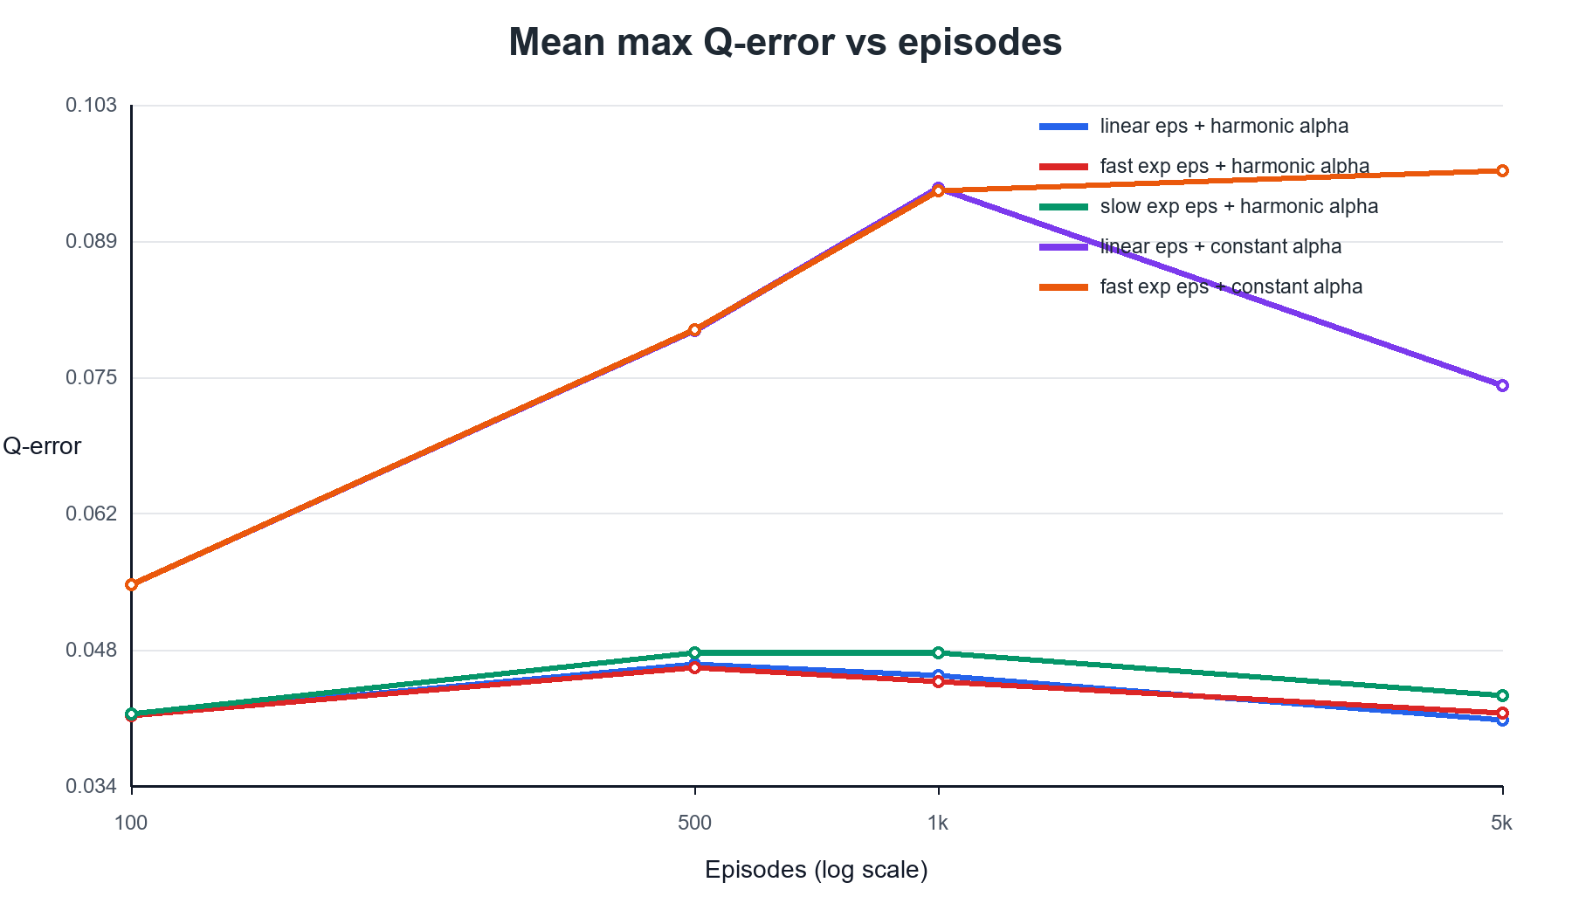
Figure 3: Mean max Q-error vs. episodes for the top 5 configurations (50 seeds).

Policy Comparison
Figure 4 compares the optimal policy from value iteration with the policy extracted from the best Q-learning run. Thick black borders mark states where the two policies disagree.

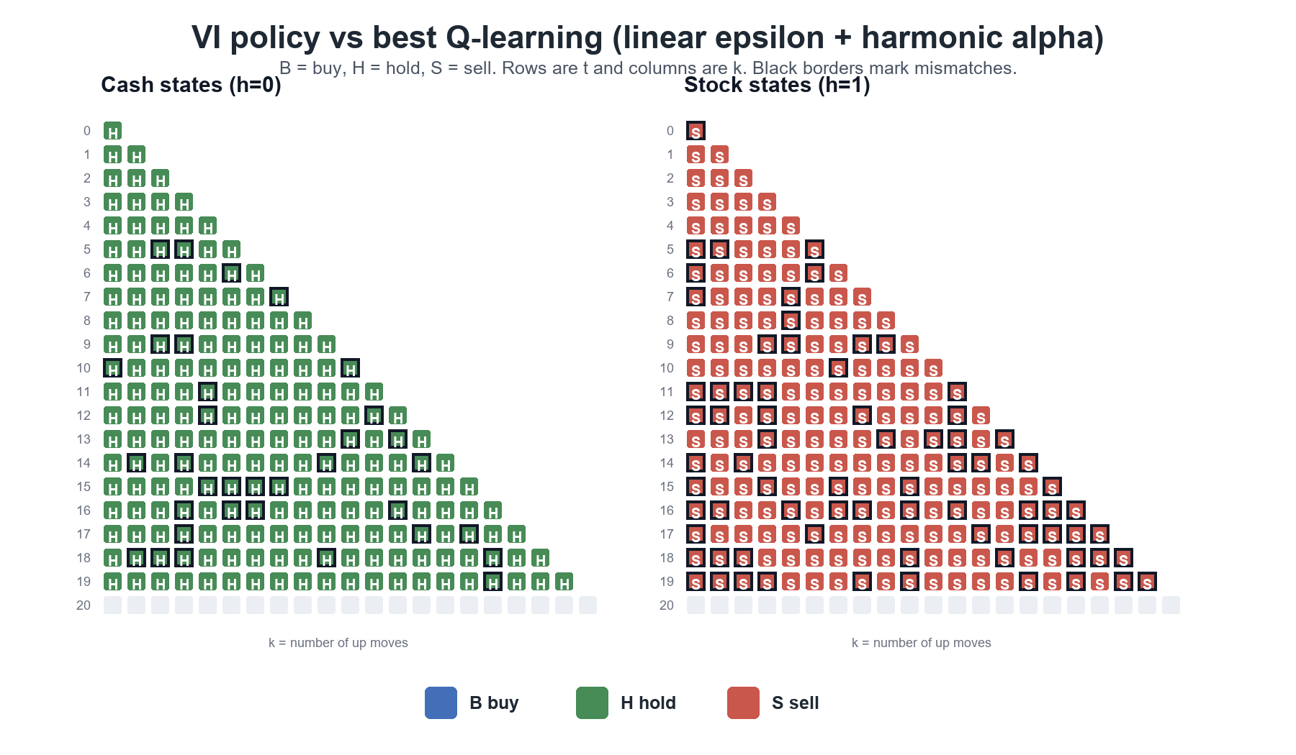
Figure 4: VI policy with thick borders marking mismatches with best Q-learning (eps_linear + alpha_harmonic).

6. Analysis

Why Harmonic Learning Rate Works Best
The harmonic learning-rate schedule (alpha_n = 1/(10+n)) gave the smallest Q-function approximation errors across all three exploration schedules. This schedule updates aggressively early in training when visit counts n are small, but becomes increasingly conservative as more samples are collected. In a finite tabular MDP where the exact optimal Q-values are stable targets, this reduction in step size helps stabilize estimates once they are close to the dynamic-programming benchmark. The classical Robbins-Monro conditions for Q-learning convergence require Σα = ∞ and Σα² < ∞; the harmonic schedule satisfies both.

Constant vs. Sqrt Learning Rate
The constant learning rate (alpha = 0.1) sometimes produced a lower policy mismatch ratio than the harmonic schedule, particularly with linear epsilon decay. However, its Q-error and value-error were significantly larger. This means the greedy action was often correct, but the Q-values themselves remained numerically inaccurate. Since the project goal is approximation of the value-iteration solution (not just behavioral matching), Q-error and value-error are the more informative metrics, and the harmonic schedule dominates on both.

The square-root schedule (alpha_n = 0.7/sqrt(1+n)) performed worse than harmonic in these experiments. Its step size decays more slowly, so Q-estimates continue to shift substantially even after many visits. In a small finite MDP where optimal Q-values are well-defined constants, this slower decay leads to noisier final estimates.

Effect of Epsilon Schedule
The slow exponential exploration schedule performed poorly regardless of learning rate. With only 5,000 episodes and a low decay rate (λ = 3×10⁻⁵), epsilon remains near 1.0 for the majority of training, so the agent continues taking many random actions late in the learning phase. This slows convergence of both the Q-values and the greedy policy.

The fast exponential schedule (λ = 2×10⁻⁴) performed better than the slow one, but still slightly worse than linear decay when paired with harmonic learning rates. Linear decay provides a more predictable trade-off between exploration and exploitation, which appears to be beneficial in this structured finite MDP.

Overall Conclusion
The best-performing configuration was linear epsilon decay combined with harmonic state-action learning rates (eps_linear_1_to_001__alpha_harmonic). It achieved a mean Q-error of 0.0408 and a mean value-function error of 0.0352 over 50 seeds. This combination balanced sufficient early exploration with effective exploitation later, and reduced the learning rate enough for the final Q-table to closely approximate the value-iteration benchmark.

