Yeager_Lab3
Joel Yeager
2026-02-26

Lab 3: Conjugate Priors
For each scenario below:
- a. Identify appropriate conjugate distributions
- b. Plot both the posterior and the prior distributions for the modeled quantity and interpret in the same figure.
- c. Using the posterior distribution, determine the 95% credible interval for the parameter in each scenario.
- d. Comment on the informative nature of the prior in terms of its relationship to the posterior.
Scenarios
- Climate Referendum Voting
- You are conducting a political opinion poll and have data from 100 voters at random. Each voter whether they will vote “yes” in an upcoming referendum on funding for local climate adaptation. Little is known about how people might vote. Estimate the probability that the referendum passes. The poll results showed that 38 people voted yes. Answer questions a-d. In addition, estimate the probability that the referendum passes as Pr(ϕ≥.5).
y <- 38
n <- 100
aPrior <- 1
bPrior <- 1
(aPost <- aPrior + y)
## [1] 39
(bPost <- bPrior + n - y)
## [1] 63
phi <- seq(0, 1, length = 1000)
prior <- dbeta(phi, aPrior, bPrior)
post <- dbeta(phi, aPost, bPost)
# A) Prior: uniform beta; Liklihood: binomial; Posterior: Beta-binomial
# B) Plot posterior and prior:
plot(phi, post, type="l", lwd=3, col="blue",
ylab="Density", xlab=expression(phi),
main="Prior vs Posterior Distribution")
lines(phi, prior, lwd=3, col="red", lty=2)
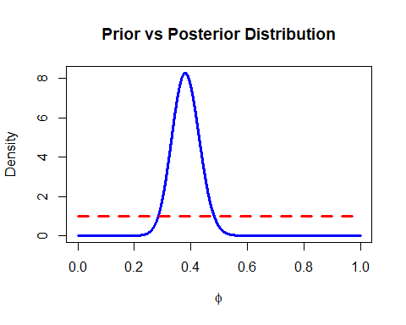
# flat prior means no prior knowledge, posterior maxes around 0.38 like observed data
# C) 95% CI
qbeta(c(0.025, 0.975), aPost, bPost)
## [1] 0.2909055 0.4781716
#[1] 0.2909055 0.4781716
# Probability of passing
1 - pbeta(0.5, aPost, bPost)
## [1] 0.008252928
# [1] 0.008252928, or roughly 1% chance
# D) Because prior is uninformative, the posterior is driven predominately by the data. With 100 obs, the liklihood dominates prior, with a posterior centered near the observed proportion 38/100 = 0.38.
- Lobster Catch!
- A group of fishermen go lobster fishing for an hour. The fishermen catch 15, 8, 6, 11, and 4 lobsters. Estimate average catch, given that, prior to this fishing trip, we believed fishermen catch an average of 3 lobsters per hour (μ=3) an hour with a standard deviation of 1.5 lobsters per hour (σ=1.5).
y <- c(15, 8, 6, 11, 4)
n <- length(y)
sum.y <- sum(y)
aPrior <- 4
bPrior <- 1.333
aPost <- aPrior + sum.y
bPost <- bPrior + n
lambda <- seq(0, 15, length = 1000)
prior <- dgamma(lambda, aPrior, bPrior)
post <- dgamma(lambda, aPost, bPost)
# A) Prior: Lambda ∼ Gamma(4,1.333)
# Posterior: Lambda|y ∼ Gamma(48,6.333)
# B) Plot:
plot(lambda, post, type="l", lwd=3, col="blue",
xlab=expression(lambda),
ylab="Density",
main="Prior vs Posterior Distribution")
lines(lambda, prior, col="red", lwd=3, lty=2)
legend("topright",
legend=c("Posterior","Prior"),
col=c("blue","red"),
lwd=3,
lty=c(1,2))
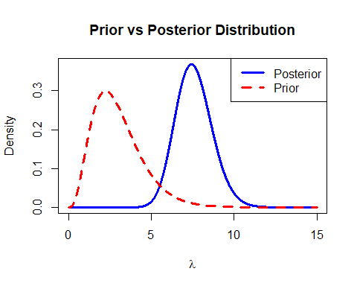
# C) 95% CI
qgamma(c(0.025, 0.975), aPost, bPost)
## [1] 5.588412 9.868946
#[1] 5.588412 9.868946
# D) Prior suggested an average catch of 3 lobsters per hour, but the data show a higher average catch, so the posterior moved toward the data. Prior was moderately informative, but data dominated by the posterior
- Solstice temperature
- You have collected temperature data on the December solstice for the last 50 years in Maryland. The known standard deviation for these measurements is 15 (σ=15). In a previous study researchers found mean temperature to be 30 (μprior=30) with a standard deviation of 12 (σprior=12). The solstice temperature measurements are stored in the data SolsticeTemp.csv.
temps <- read_csv('SolsticeTemp.csv')
n <- 50
sigma <- 15
mu.prior <- 30
sigma.prior <- 12
(mu.temps <- mean(temps$temp))
## [1] 30.77098
(sigma.post <- sqrt(1 / (1 / sigma.prior^2 + n/sigma^2)))
## [1] 2.088932
(mu.post <- sigma.post^2 * (mu.prior / sigma.prior^2 + n * mu.temps/sigma^2))
## [1] 30.74762
x <- seq(-30, 100, 0.1)
prior <- dnorm(x, mean=mu.prior, sd=sigma.prior)
post <- dnorm(x, mean=mu.post, sd=sigma.post)
# B) Plot
plot(x, post, type = 'l')
lines(x, prior, col = 'red')
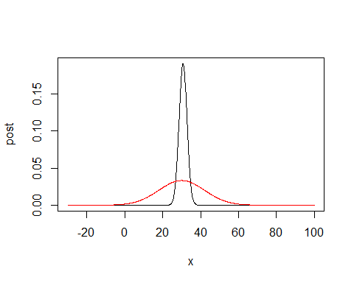
# Prior curve (red) is earlier estimates centered around 30 but is flatter given the relatively large st. deviation, while posterior (black) is still centered around 30, it is much narrower with a st. deviation of 2.088 and thus appears more like a sharp peak. Thus more information resulted in a better estimate of the mean temperature.
# C) 95% CI
qnorm(c(0.025,0.975), mu.post, sigma.post)
## [1] 26.65338 34.84185
#[1] 26.65338 34.84185
#D) Prior was only somewhat informative given its much larger st. deviation, however, the prior mean and sample mean are very close, indicating that the data provided more information that allowed for a stronger estimate of mean temperature than the prior despite the estimates functionally being in alignment.

