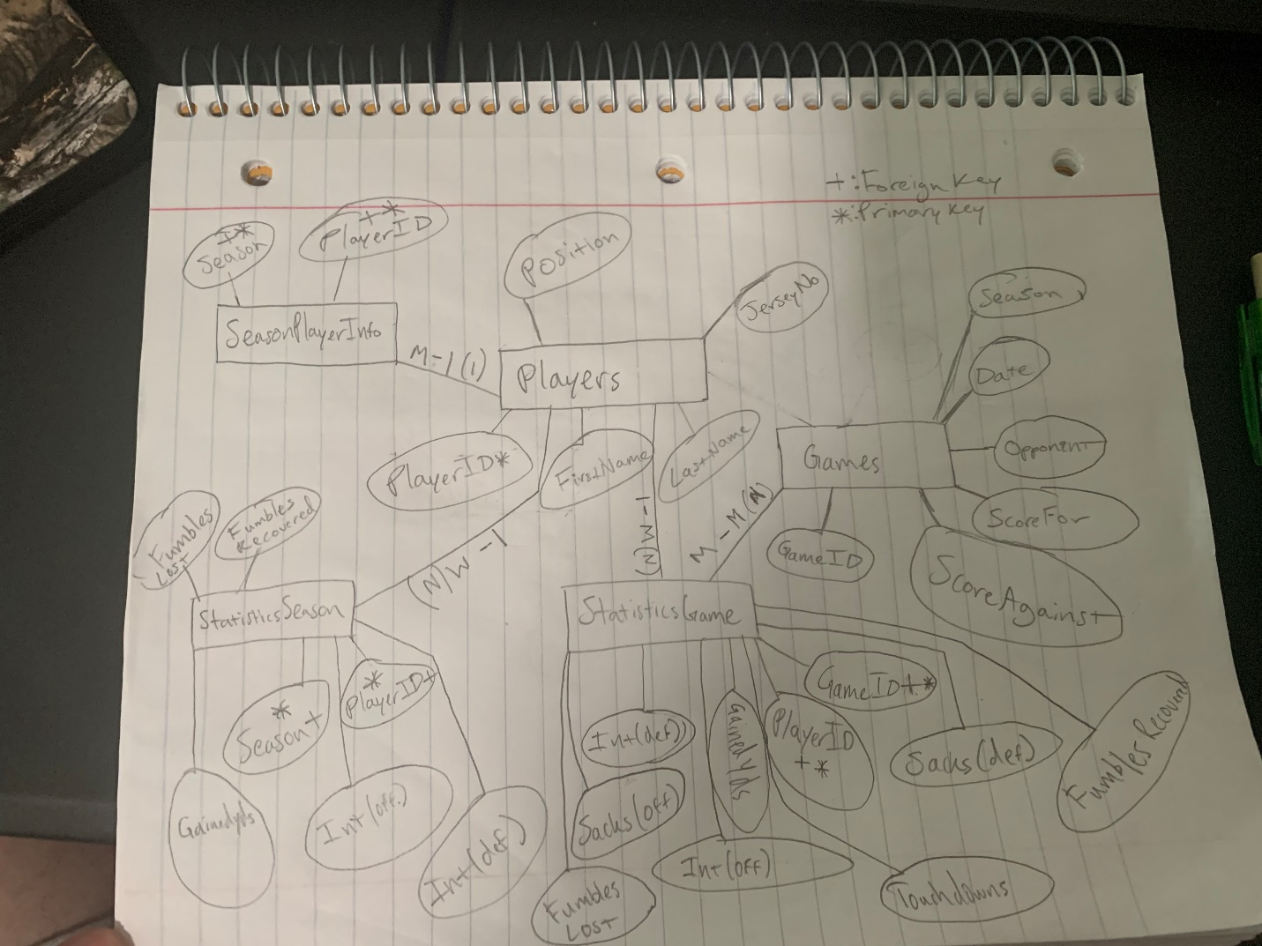

Changes:  
In SeasonPlayerInfo, firstname, lastname, jerseyno, and position were previously dependent on PlayerID, so they were removed from this table and left in Players