AI Driven Tourism Opportunity Gap Analysis

and Local Experience Discovery in Malaysia
by
404 NOT FOUND

Thng Yi Hui • Lim Jia Xuan
Chia Yi Yu • Law Hong Yik

Faculty of Engineering and Information Technology, Southern University College
PTD 64888, Jalan Selatan Utama, KM 15
Off Skudai Highway, 81300 Skudai
Johor Darul Ta’zim, Malaysia

Under the Guidance of
So Yong Quay
Department of Computer Science
Southern University College

Date of Submission
22nd September 2026

Table of Contents
CONTENTS | PAGE
Front Page | 1
Table of Contents | 2
1.0 Introduction | 3
1.1 Background of the Study | 3
1.2 Problem Statement | 4
1.3 Objectives | 4
2.0 Literature Review | 5
3.0 Methodology | 7
4.0 Findings | 12
5.0 Output (Dashboard) | 16
6.0 Conclusion | 22
References | 23

Introduction

1.1 Background of the Study
Malaysia recorded 290.1 million domestic visitors and RM121.3 billion in domestic tourism expenditure in 2025. These represented increases of 11.5% and 13.6%, respectively, compared with 2024. The Department of Statistics Malaysia (DOSM, 2026a) also reported differences between states in visitor volumes, tourism spending and length of stay. These statistics provide a basis for examining where tourism activity is concentrated and how it changes over time.
Comparing states only by visitor totals can obscure differences in their size and observable characteristics. Population, economic conditions, accommodation supply and accessibility may be relevant to tourism performance, but their availability and usefulness must be assessed using consistent data. A smaller visitor total alone does not establish that a state is underperforming or that additional promotion would increase demand.
This project develops a Tourism Opportunity Gap framework for Malaysia using nine OpenDOSM-listed dataset groups. The analytical model estimates the share of domestic visitors associated with a state’s population, economy, employment and accommodation capacity. The result is compared with the state’s observed share of national domestic visitors. A positive gap means the observed share is below the model-expected share; it does not represent guaranteed additional visitors or revenue.
The project combines an evaluated structural-demand model, JejakLestari Intelligence, a five-page Streamlit dashboard, and the separate JalanJalan 2026 Flutter prototype. The dashboard reads the final feature and prediction CSVs and presents the share-based Tourism Opportunity Gap with training, holdout and reliability labels. Its optional Ollie tiger assistant uses validated page context to help users examine implications and ask follow-up questions. The visitor app illustrates a possible local-discovery pathway, not a measured outcome. This combination addresses the Technology and Governance dimension of DOSM Datathon 2026 (DOSM, 2026d).

1.2 Problem Statement
Official tourism statistics describe realized activity. They do not, by themselves, indicate how much activity a state would be expected to record given a selected set of characteristics. A useful planning tool therefore needs to distinguish descriptive comparisons from model-based benchmarks, and to explain the uncertainty and assumptions behind each.
Forecasting and benchmarking also answer different questions. Lagged tourism values can help forecast future demand because they describe recent activity. However, a benchmark built mainly from past visitor totals may reproduce historical differences between states. It would then be difficult to interpret the resulting residual as a comparison based on structural conditions. Excluding lagged outcomes from the structural model supports this distinction, although it does not make that model causal or eliminate all possible bias.
At the product level, local cultural events and experiences are often fragmented across multiple channels, making them difficult for travellers to discover during their stay. This is a separate design problem rather than a causal conclusion from the model. The project therefore treats local-experience discovery as a proposed application to be evaluated separately. It does not assume that poor discoverability causes a positive opportunity gap, or that displaying more experiences will close it.

1.3 Objectives
- Analyze tourism performance across Malaysian states using official and publicly accessible data with documented definitions, periods and units.
- Integrate nine OpenDOSM-listed dataset groups and develop an interpretable structural model of expected state-level domestic visitor share.
- Evaluate the model on the unseen 2024–2025 holdout period and derive a share-based Tourism Opportunity Gap that is not confounded by national growth.
- Present the analysis in an interactive dashboard with page-grounded decision support and develop a separate local-experience prototype whose practical value can be evaluated.

Literature Review

2.1 Data and Smart Tourism
Gretzel, Sigala, Xiang and Koo (2015) describe smart tourism in terms of the relationship between data, technology, tourism experiences and business ecosystems. Their discussion goes beyond the presence of a digital interface and considers how information is connected and used. They also identify research needs concerning the assumptions and possible drawbacks of smart tourism. This provides a basis for evaluating the proposed platform through the decisions it supports, rather than through the number of features it contains.
For this project, the planning dashboard and visitor prototype serve different users. The dashboard enables analysts to compare state-level tourism patterns and examine model outputs. The prototype provides an interface for exploring illustrative local experiences. The relationship between these components is a design proposition; claims about usability, improved discovery or tourism impact require separate evaluation.

2.2 Tourism Demand Forecasting
Song and Li (2008) review tourism demand modelling and forecasting research and report that no single model consistently provides the best forecasting accuracy in every situation. Their review supports comparing candidate methods against credible baselines. It does not justify choosing a complex algorithm before establishing the size, frequency and quality of the available Malaysian data.
Hyndman and Athanasopoulos (2021, Section 5.10) explain time-series cross-validation using successive forecast origins, where the training observations precede the observations being predicted. This principle informs the chronological split used in this study because allowing future information into training would not represent a real holdout evaluation. Any forecast horizon shown in the dashboard should likewise match the horizon used for validation.

2.3 Structural Benchmarking and Interpretation
The structural benchmark in this project is a proposed analytical definition. It estimates the tourism outcome associated with measured state characteristics in the available data. The estimate is conditional on the chosen variables, sample, model and validation design. It should therefore be described as model-expected performance rather than as a state’s maximum tourism capacity.
A residual may reflect omitted variables, measurement differences, unusual events or model error, as well as patterns that warrant investigation. The analysis therefore treats a stable difference as a reason for closer review, not as proof of the cause of that difference or the benefit of a particular intervention.

2.4 Implications for the Proposed System
The reviewed sources support three design choices: evaluate models out of sample, compare methods rather than assume one is superior, and connect tourism technology to a defined user need. This project combines these choices in a Malaysian state-level workflow. Its contribution is an explicit separation between the evaluated structural benchmark, the naive forecast layer and the visitor-facing discovery application. Model validation is reported in Section 4, while the practical effectiveness of the dashboard and application still requires user evaluation.

Methodology

3.1 Study Design and Analytical Scope
The study uses annual Malaysian state-level data for 16 state and federal-territory units. The analytical output contains 90 state-year predictions covering 2017–2019 and 2023–2025. The years 2017–2019 and 2023 are training or in-sample periods, while 2024 and 2025 are held out from model fitting and used as unseen evaluation years. After dataset matching and quality checks, 58 observations were available for model training.
The workflow consists of source selection, data validation, cleaning and harmonization, feature engineering, baseline construction, model comparison, chronological holdout evaluation, expected-share estimation, opportunity-gap calculation and dashboard delivery. All analytical records come from real, publicly accessible Malaysian sources. The final dashboard reads the 90-row state_features.csv and sample_predictions.csv handoff files directly and checks their columns, state-year keys and analytical years before displaying results.

3.2 Data Sources and Preparation
Nine OpenDOSM-listed dataset groups (D1–D9) were inventoried, consistent with the Datathon booklet's preference for official Malaysian data (Department of Statistics Malaysia, 2026b, p. 9). The selected model used D2 and D4 for domestic-visitor outcomes and accommodation supply, and D5–D8 for state-level structural predictors. D1 and D3 provided national context. D9 water consumption, jointly sourced from SPAN, NRES and DOSM, was profiled but excluded. A tenth data.gov.my arrivals series was also excluded because it measures state of entry rather than destination and ends in 2024. Table 3.2 gives each group's analytical role; the official source pages are identified below and in References.

Table 3.1. Analytical data groups
Data group | Role in the analysis | Coverage note
Domestic tourism by state | Observed domestic visitors and descriptive context | Annual state-level outcome
Origin–destination travel flows | In-state and interstate visitor-flow analysis | State origin and destination
Population and GDP | Structural scale indicators | Matched by state and year
Employment | Economic-activity indicator | Matched by state and year
Hotel-room capacity | Accommodation-supply indicator | Available only for 2022 and 2023
Two CPI indicators | Limited price proxies | Not a complete measure of tourism prices

Table 3.2. Official data inventory and analytical role
No. | Official dataset group | Years, unit and analytical role
1 | D1 Tourism Satellite Account | 2000–2024; national annual; context/profile only
2 | D2 Domestic Tourism (annual) | 2016–2025; state visitors ('000), OD flows; model target/context
3 | D3 Domestic Tourism (quarterly) | 2021 Q1–2026 Q1; national visitors and expenditure; context only
4 | D4 Domestic Tourism by State | 2017–2023 statistics; rooms/hotels 2022–2023; model input
5 | D5 Monthly CPI by State & Division | 2010-01–2026-07; divisions 09 and 11; model input
6 | D6 Population Table: States | 1970–2026; annual population ('000); model input
7 | D7 Annual Real GDP by State & Sector | 2015–2025; RM million at constant 2015 prices; model input
8 | D8 Quarterly Labour Force by State | 2017 Q1–2025 Q3; annual means used; model input
9 | D9 Water Consumption by State & Sector | 2003–2022; 14 states; profiled, excluded from final model
Data provenance: D1–D4 were obtained from DOSM's OpenDOSM Publications (Tourism Satellite Account; Domestic Tourism Survey, annual and quarterly; Domestic Tourism by State). D5–D9 were located in the OpenDOSM Data Catalogue (state CPI; population; real GDP; quarterly labour force; water consumption). Dataset-specific official URLs are listed in References; edition-level download links and file checksums are documented in ml/data/raw/SOURCES.md.
Cleaning standardized state names, dates and units before joining all predictors to the state-year visitor target. Duplicate published values were resolved by preferring the latest edition, and missing values were retained rather than silently converted to zero. The final checks found exact agreement for all 128 overlapping state-year values, 111 exact matches out of 112 against a second DOSM publication with one rounding difference, and reconciliation of quarterly and annual figures for all five tested years.
Visitors, tourists, excursionists and trips must remain distinct where the sources distinguish them. Aggregate visitor counts must not be relabelled as unique individuals. Monetary values should state whether they are nominal or adjusted for prices. Changes in survey definition or geographic coverage should be documented before years are combined.

3.3 Baseline, Model Comparison and Holdout Evaluation
Model A1 tested linear regression, Ridge, random forest and gradient boosting for year-ahead forecasting. None beat the naive same-as-last-year baseline across rolling-origin folds, so the forecast layer uses the naive baseline. Model A2 estimates structural expected demand without lagged visitor outcomes. Gradient boosting was selected using validation folds before the 2024–2025 holdout was opened, then tuned and frozen for final evaluation.

Table 3.3. Final structural-model implementation
Implementation item | Final value
Final algorithm | GradientBoostingRegressor (scikit-learn)
Selected features | 12: population, total/services GDP, services share, GDP per capita, rooms, rooms per 1,000 residents, employment, unemployment, participation, and two relative CPI indicators (log transforms where specified)
Hyperparameters and random seed | 400 estimators; max_depth=2; learning_rate=0.03; min_samples_leaf=3; subsample=1.0; random_state=42
Software and library versions | Python 3.13.14; pandas 3.0.5; NumPy 2.5.3; scikit-learn 1.9.1; joblib 1.6.0
Model file or reproducibility path | ml/models/a2_gap_model.joblib; scripts in ml/src/; GitHub main commit 4990d62

Two error measures were retained. MAE on the log scale measures the typical absolute difference after transforming the highly skewed visitor outcome. Mean absolute percentage error (MAPE) expresses the typical error relative to the observed value. Performance is reported only for the 2024–2025 holdout when making claims about generalization. Values for 2017–2019 and 2023 remain useful for descriptive context but are in-sample.

3.4 Expected Share and Tourism Opportunity Gap
Absolute visitor counts increased nationally from 213.7 million in 2023 to 290.1 million in 2025. Because the structural model excludes time effects, comparing its expected visitor count directly with the observed count would confound national growth with a state’s relative performance. The final metric therefore compares shares of national domestic visitors.
Opportunity gap in percentage points = expected national share − actual national share
Opportunity gap percentage = 100 × (expected national share ÷ actual national share − 1)
A positive value means the model-expected national share exceeds the observed share. A negative value means the observed share exceeds the model expectation. The percentage-point version is expected share minus actual share and is suitable for a diverging map scale; the percentage version expresses how much higher or lower the benchmark is relative to the observed share. Both remain relative model outputs rather than estimates of causal impact or guaranteed demand.

3.5 Refinement of the Opportunity Gap Metric
The first formulation used expected visitors minus actual visitors. It produced a positive gap for 15 of the 16 state-level units and the model underpredicted 91% of the holdout observations. This pattern was not interpreted as evidence that almost every state was underperforming. It reflected the strong national recovery and growth that the structural model was intentionally not designed to reproduce.
The metric was redesigned to compare each state’s actual and model-expected shares of the national total. This removes the common national growth component and makes the gap a relative comparison between states. The revision is part of the analytical result: it records how an implausible first output was diagnosed and corrected rather than being accepted at face value.

3.6 Reproducibility and Interpretation Limits
The ML handoff provides sample_predictions.csv with 90 state-year outputs and explicit fields for benchmark visitors, percentage and percentage-point gaps, holdout status and the naive next-year forecast. The current Streamlit dashboard joins this output to state_features.csv by state and year, validates required fields, and exposes actual versus expected shares, the relative gap, training/holdout labels and state reliability notes. It treats values within ±5% as close to expectation. These safeguards make the interactive figures consistent with the report's share-based definition.

Findings

4.1 Tourism Concentration and Intensity
Figure 4.1 compares state shares of domestic visitors in 2019 and 2025. The combined share of the three largest state-level units was 32.7% in 2019 and 32.8% in 2025. This similarity applies to the two endpoints and does not establish that concentration was unchanged in the intervening years.
Figure 4.2 shows that visitor volume and visitors per resident produce different state profiles. W.P. Putrajaya recorded 26.1 domestic visitors per resident and Melaka recorded 19.8, compared with 4.9 in Selangor and 4.3 in Johor. Putrajaya's small resident denominator and administrative context make its ratio sensitive to interpretation; the ratio alone does not establish superior tourism performance.
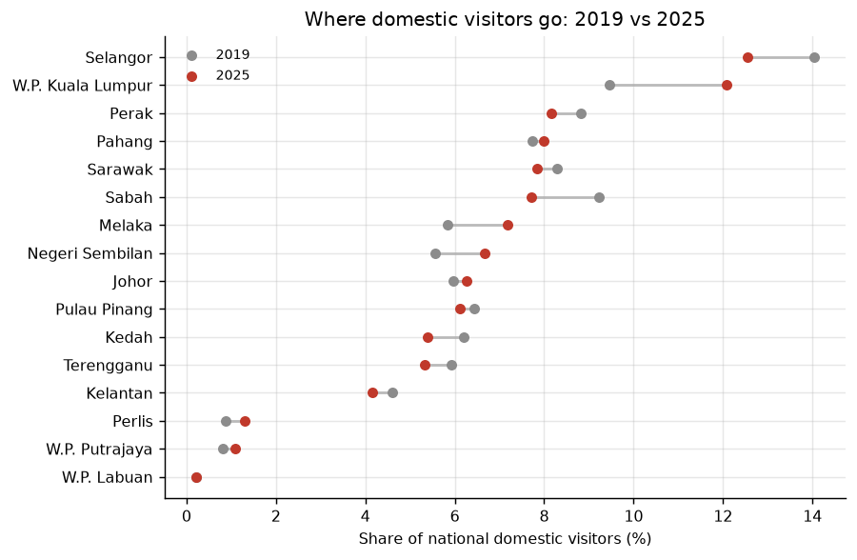
Figure 4.1. State shares of domestic visitors, 2019 and 2025 (Source: DOSM Domestic Tourism Survey; team calculations)
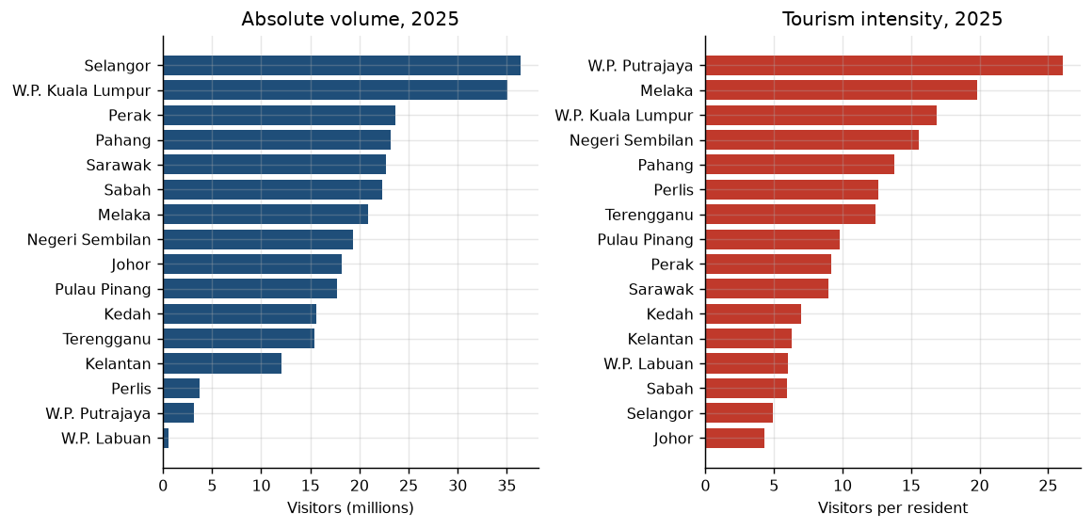
Figure 4.2. Visitor volume and visitors per resident, 2025 (Source: DOSM domestic tourism and population data; team calculations)

4.2 Model Validation Results
Table 4.1. Structural-model performance on the 2024–2025 holdout
Method | MAE log | MAPE | Evaluation period
Naive baseline | 0.4467 | 41.4% | 2024–2025 unseen holdout
Selected structural model | 0.2648 | 22.5% | 2024–2025 unseen holdout

Table 4.1 reports the unseen 2024–2025 holdout results. The selected model reduced log-scale MAE from 0.4467 to 0.2648 and MAPE from 41.4% to 22.5%. The 40.7% relative reduction in MAE is a reduction in error, not a measure of model accuracy. The remaining 22.5% MAPE indicates substantial predictive uncertainty.

4.3 Opportunity Gap Results
Figure 4.3 and Table 4.2 identify Kedah, Johor and Terengganu as the states with the largest positive Tourism Opportunity Gaps in 2025. Their model-expected national visitor shares exceeded their observed shares by 42.6%, 27.0% and 16.3%, respectively. Across 2024 and 2025, 81% of states retained the same gap sign and Spearman's rank correlation was 0.732. This indicates broad rank stability across the two holdout years, subject to model error.
Table 4.2. Largest positive Tourism Opportunity Gaps in 2025
State | 2025 opportunity gap | Interpretation
Kedah | +42.6% | Actual national visitor share below model-expected share
Johor | +27.0% | Actual national visitor share below model-expected share
Terengganu | +16.3% | Actual national visitor share below model-expected share

These values identify where further investigation may be useful; they do not show that discoverability, marketing or transport caused the gaps. The current dashboard calls them positive relative opportunity gaps, uses a ±5% neutral band, and warns that Perlis and W.P. Putrajaya have less reliable holdout results. For a selected state and year it shows actual and expected visitor shares beside the relative gap.
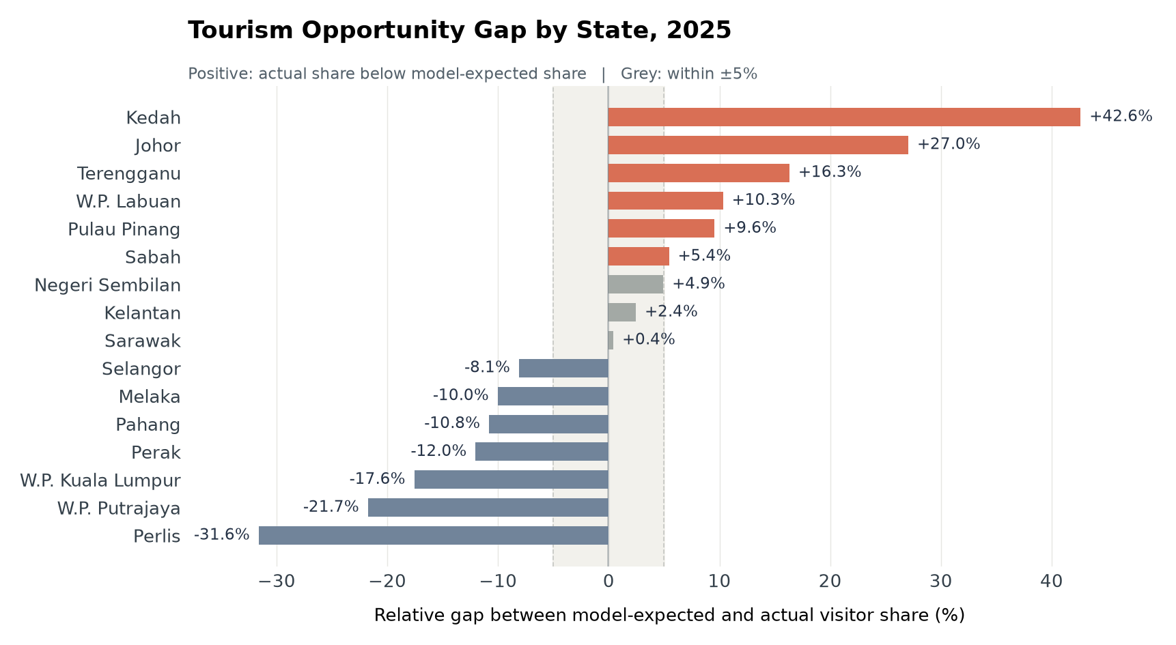
Figure 4.3. Share-based Tourism Opportunity Gap, 2025 (Source: DOSM inputs; team model and calculations)

4.4 Interstate Travel and Predictor Contributions
Figure 4.4 indicates that the in-state share of domestic travel fell from 36.4% in 2023 to 22.6% in 2025. The ten largest interstate origin–destination flows in 2025 originated in Selangor or Kuala Lumpur. This pattern concerns the largest observed flows; it does not imply that other states were absent as origin markets.
Figure 4.5 reports holdout permutation importance, measured as the increase in MAE when a feature is shuffled. Population had the largest value (0.175), followed by GDP, employment and room count. The two CPI-based indicators had values of 0.0000 and −0.0010. Within this model and sample, structural scale indicators supplied more predictive information than the available CPI measures; this does not establish that prices are irrelevant to travel choices.
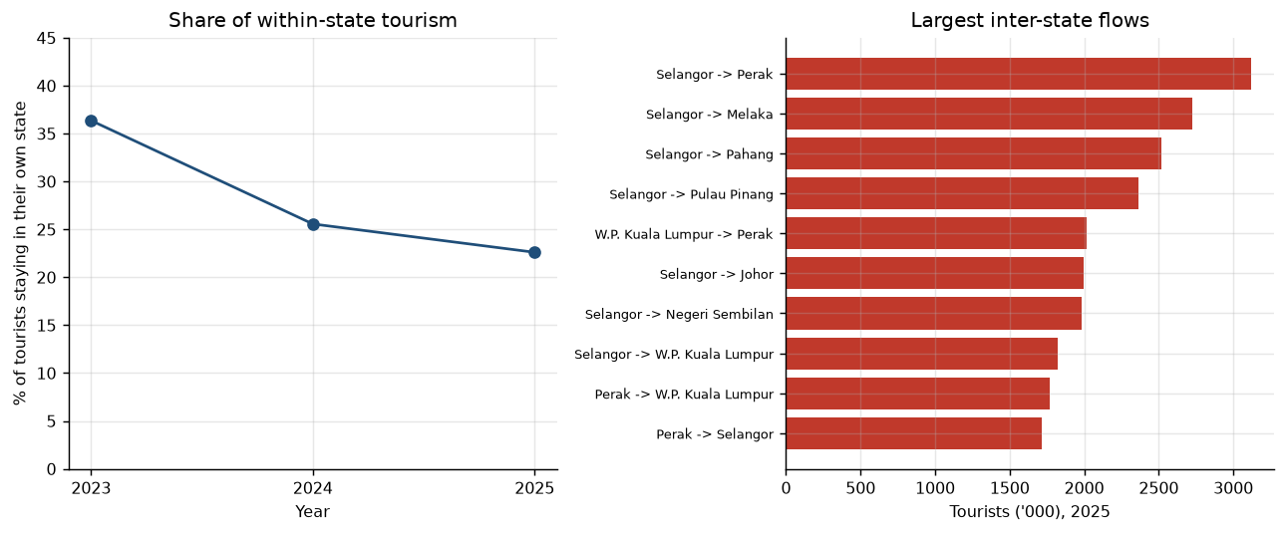
Figure 4.4. In-state share and largest interstate flows, 2023–2025 (Source: DOSM domestic tourism data; team calculations)

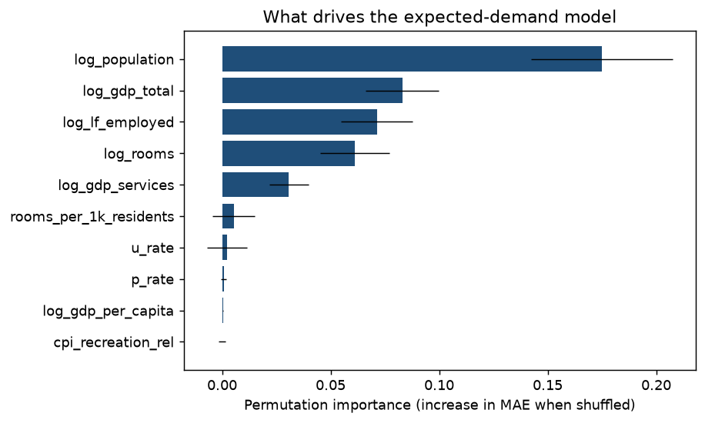
Figure 4.5. Holdout permutation feature importance (Source: team model using DOSM data)

Output (Dashboard)

5.1 Data Delivery and Dashboard Architecture
GitHub main commit 4990d62 (22 September 2026) implements JejakLestari Intelligence in backend/app.py. The dashboard validates and reads state_features.csv and sample_predictions.csv by state and year, then displays the final share-normalised gap. Its 90 records cover 14 units in 2017–2019 and all 16 units in 2023–2025.
The 2025 default has a global year filter and national/state focus. Overview compares observed and model-expected visitor shares; Evidence exposes source and ML tables. Visitor Flows breaks lines across missing 2020–2022 observations, and Scenario Lab keeps the illustrative national total unchanged. Ollie is optional: the five analytical pages use local data without Gemini, while AI questions require a configured key and network access.

5.2 Implemented Dashboard Pages
Page | Purpose and main content
1. Overview | National/state indicators, shares and gap; Ollie receives selected region, year, benchmark and caveats.
2. Visitor Flows | Observed state trends with 2020–2022 disconnected; Ollie receives trajectories and concentration.
3. Sustainability | GDP, rooms and visitor bubbles; Ollie receives median comparisons, not a carrying-capacity measure.
4. Scenario Lab | Source, target and shift controls; Ollie receives updated volumes, gaps, readiness proxies and limits.
5. Evidence | Source/model tables, holdout and reliability notes; Ollie receives selected-year evidence and limits.

The five dashboard pages connect national context, state trajectories, accommodation capacity, illustrative redistribution and source/model tables. On Overview, the selected state and year change the displayed shares and gap. Evidence identifies the training period, the 2024–2025 holdout years, the ±5% neutral band and lower-reliability results for Perlis and W.P. Putrajaya. The active controls also determine the validated context available to Ollie for the next question.
The Ollie assistant appears in the sidebar beneath the DOSM data notice. Users may type a question, select a suggested starter prompt or use browser speech recognition where supported. The microphone control starts and stops live transcription into an editable input; a separate send action submits the reviewed question. The interface displays a tiger animation while the response is pending and retains a scrollable conversation history. A validated response may include up to two short, selectable follow-up questions. These prompts are produced after a response, rather than after each keystroke or speech fragment.
Each page constructs structured context from validated CSV data and active controls. Changes to the page, year, Overview region or Scenario parameters update the evidence available for a subsequent question; chart-hover events are not transmitted to the assistant. Gemini receives the question, recent dialogue and page context, and returns a direct response with optional implications, follow-up prompts and a caveat. Prompt constraints and numeric validation reduce unsupported numerical, causal and forecasting claims. The analytical pages remain usable if the optional service is unavailable. Live API and microphone performance have not been systematically evaluated in this report.

5.3 JalanJalan 2026 Visitor Application Prototype
JalanJalan 2026 is a separate Flutter visitor prototype supported by FastAPI v0.6 and SQLite. Its event feed, OpenStreetMap-based discovery view, saved plan, photo postcard and mascot chat illustrate a possible local-experience discovery workflow. Figure 5.4 shows implemented interface states for these functions. The displayed event content and mascot response are prototype examples, not DOSM observations or evidence that the application changes tourism behaviour. The app's mascot chat is distinct from the data-grounded Ollie assistant in JejakLestari.

5.4 Dashboard Evidence and Access
Table 5.1. Dashboard access and verification details
Item | Details
Dashboard access | Local Streamlit build; no public URL. Run on the evaluation computer and open http://localhost:8501 in its browser.
Source filename | backend/app.py and backend/ai_service.py — jx273/malaysia_tourism_app, main commit 4990d62
Software and version | Python 3.12; pandas 3.0.5; Streamlit >=1.64,<2; Plotly >=6,<7 (specified in ml/requirements.txt).
Access or login instructions | No login. From the repository root, install ml/requirements.txt and launch backend/app.py with Streamlit; see README.md.
Last verification date | 22 September 2026 (local run from GitHub main)

5.5 Dashboard Screenshots from GitHub Main
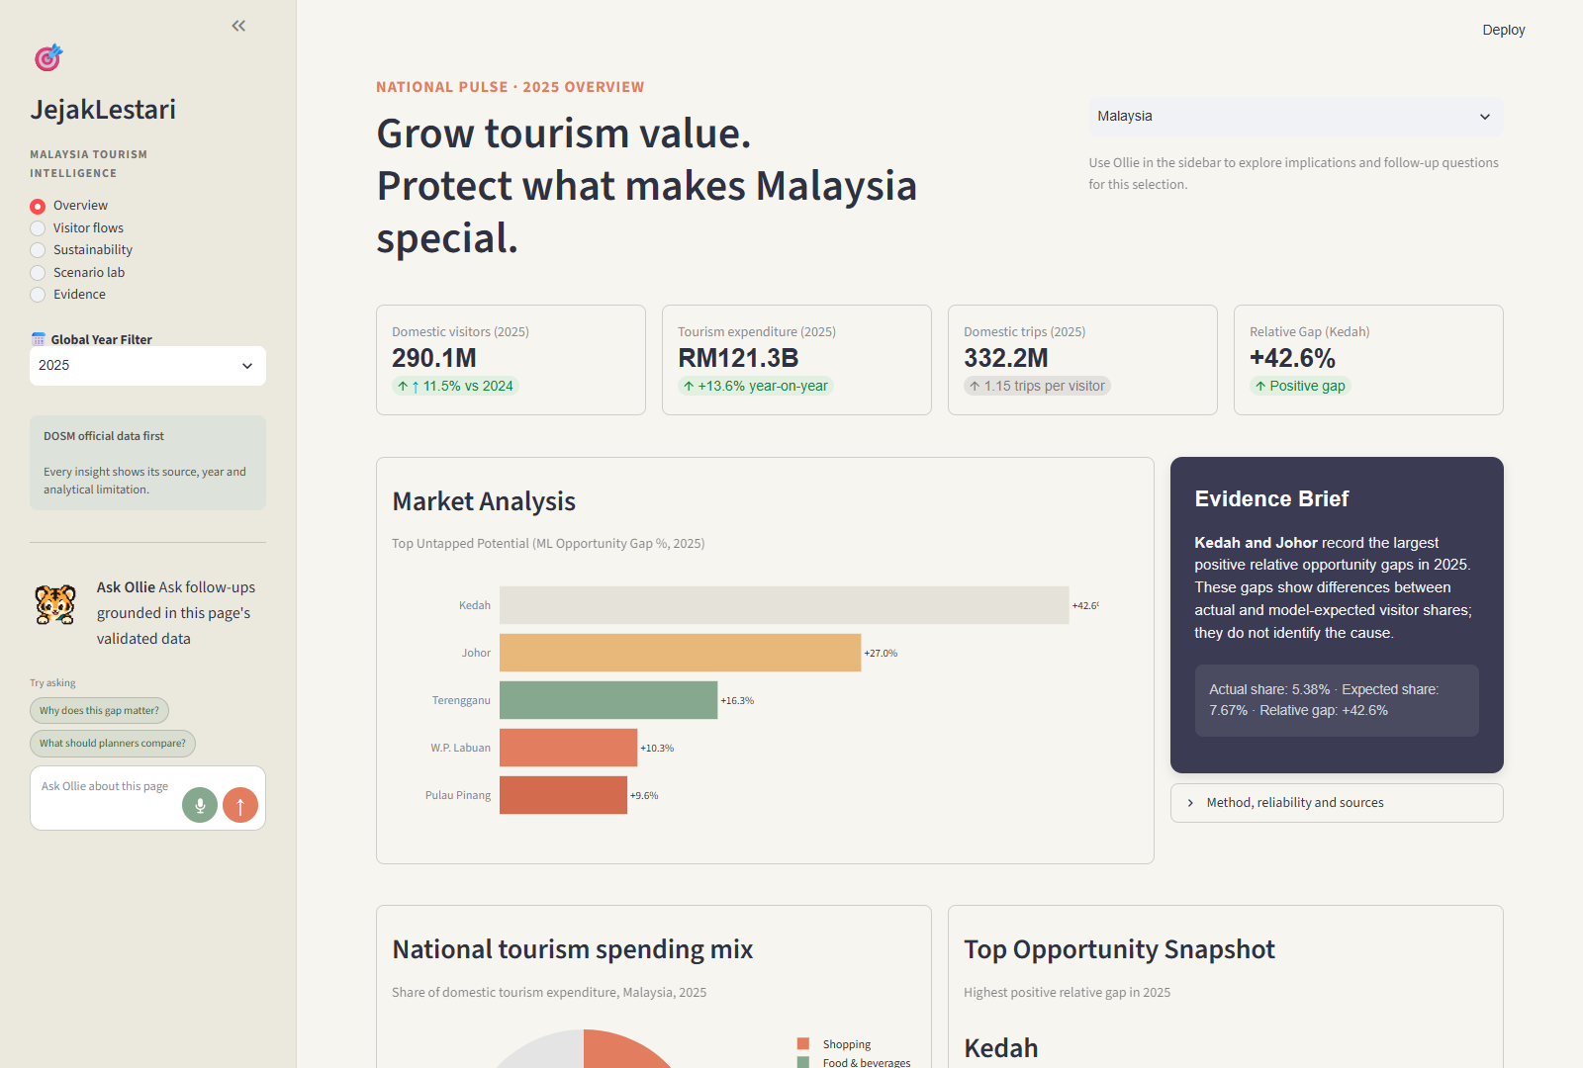
Figure 5.1. Overview and Ollie sidebar, 2025 (local build)
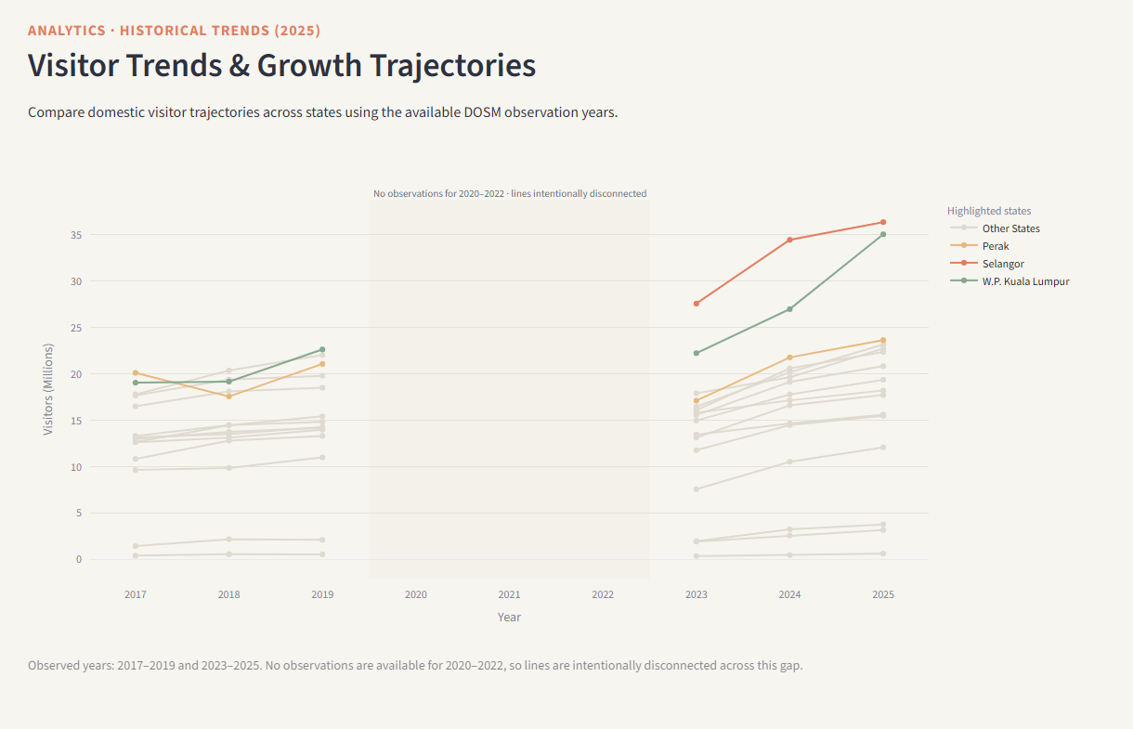
Figure 5.2. Visitor trends across observed years (local build)

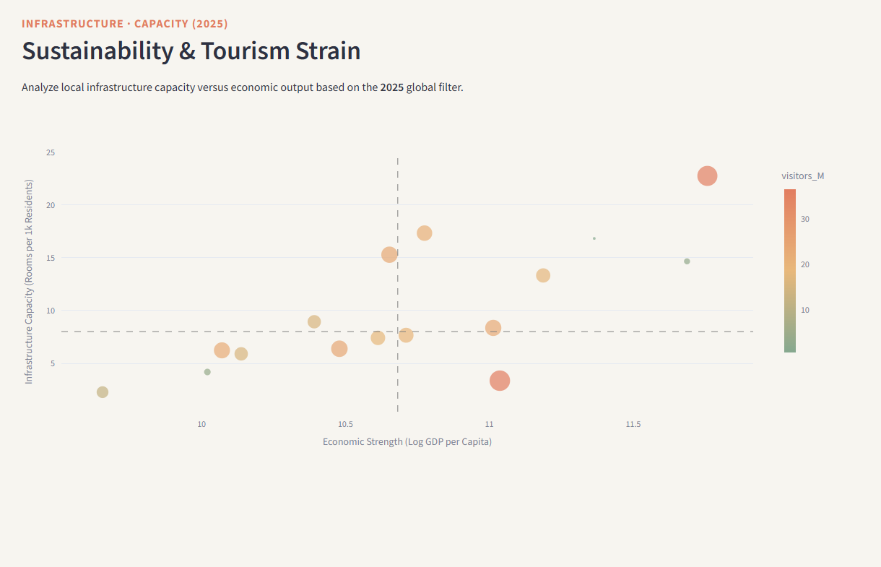
Figure 5.3. GDP, accommodation and visitor-volume comparison, 2025 (local build)
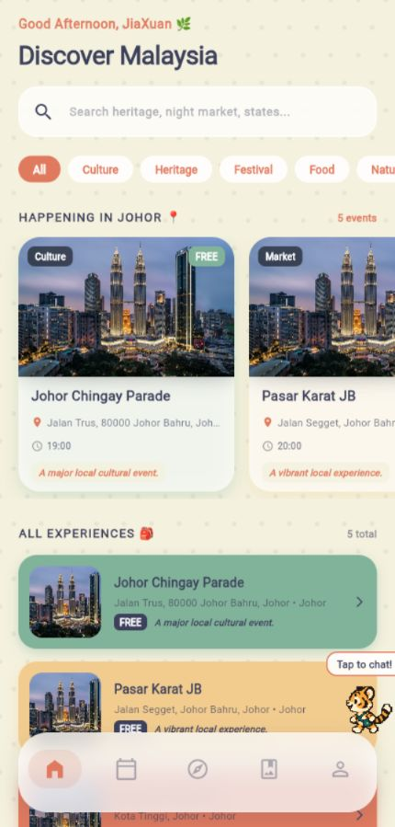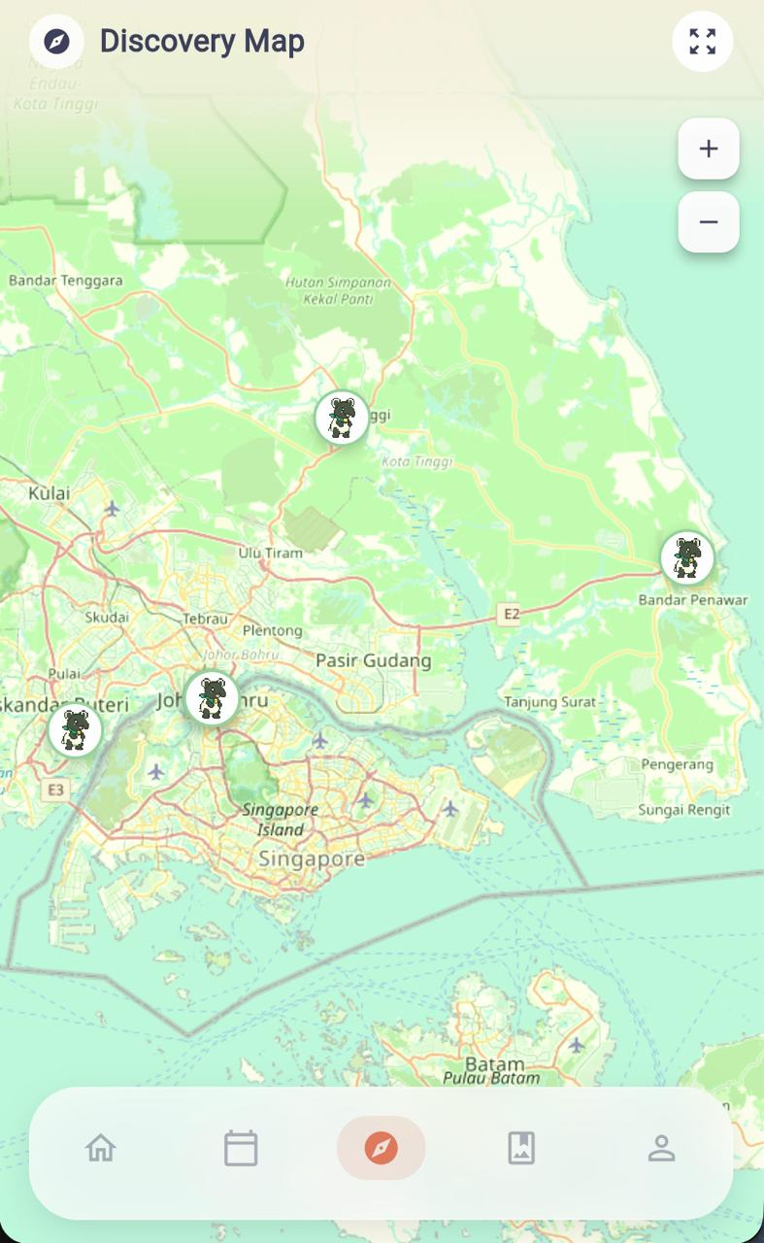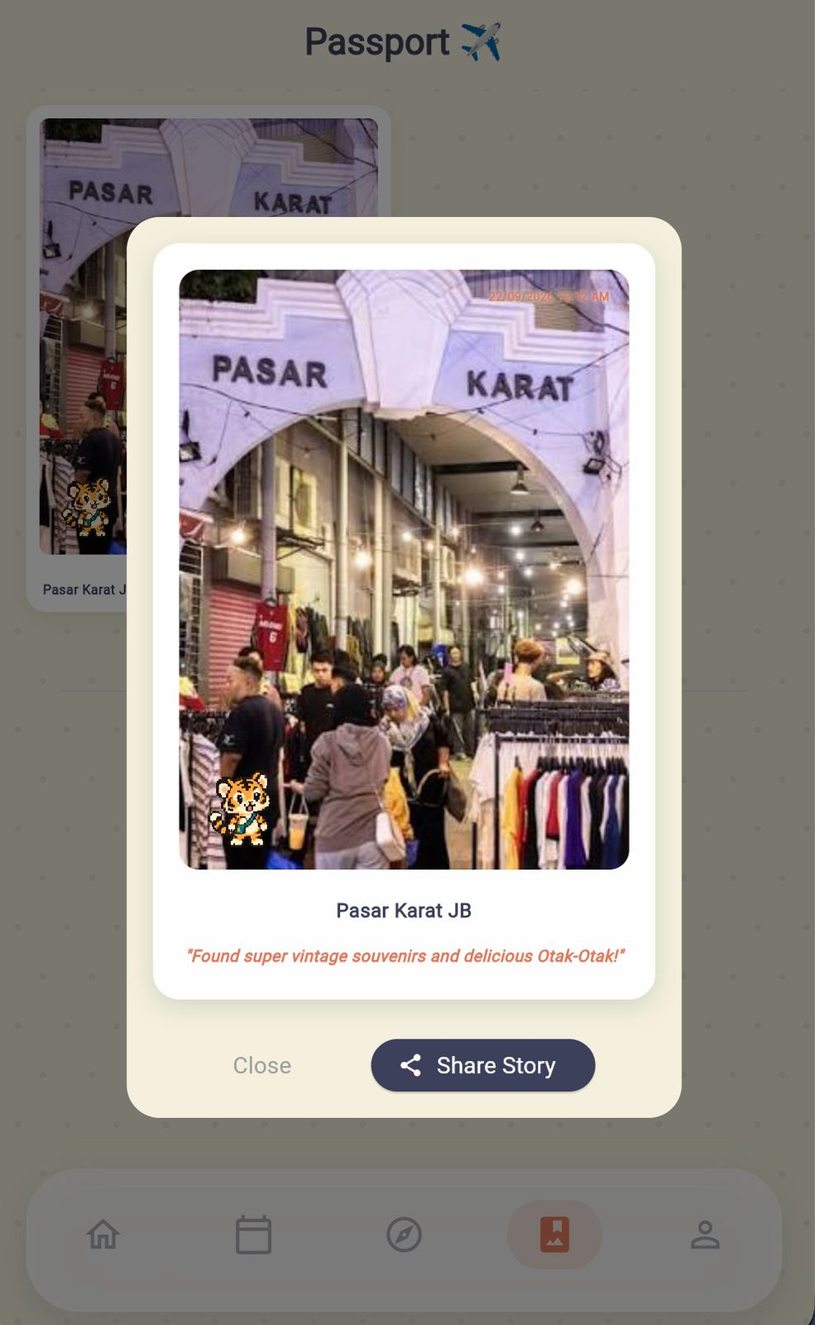
Figure 5.4. JalanJalan prototype screens: Home and Discovery Map (top); Passport and Companion (bottom). Source: team screenshots.

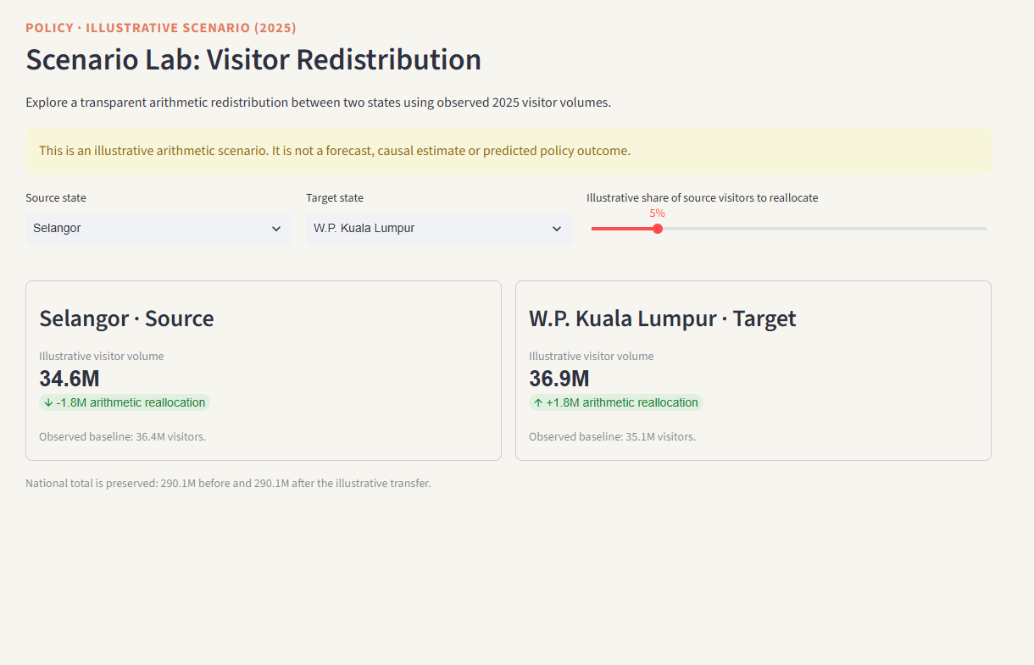
Figure 5.5. Scenario Lab: illustrative 5% redistribution from Selangor to W.P. Kuala Lumpur (local build)

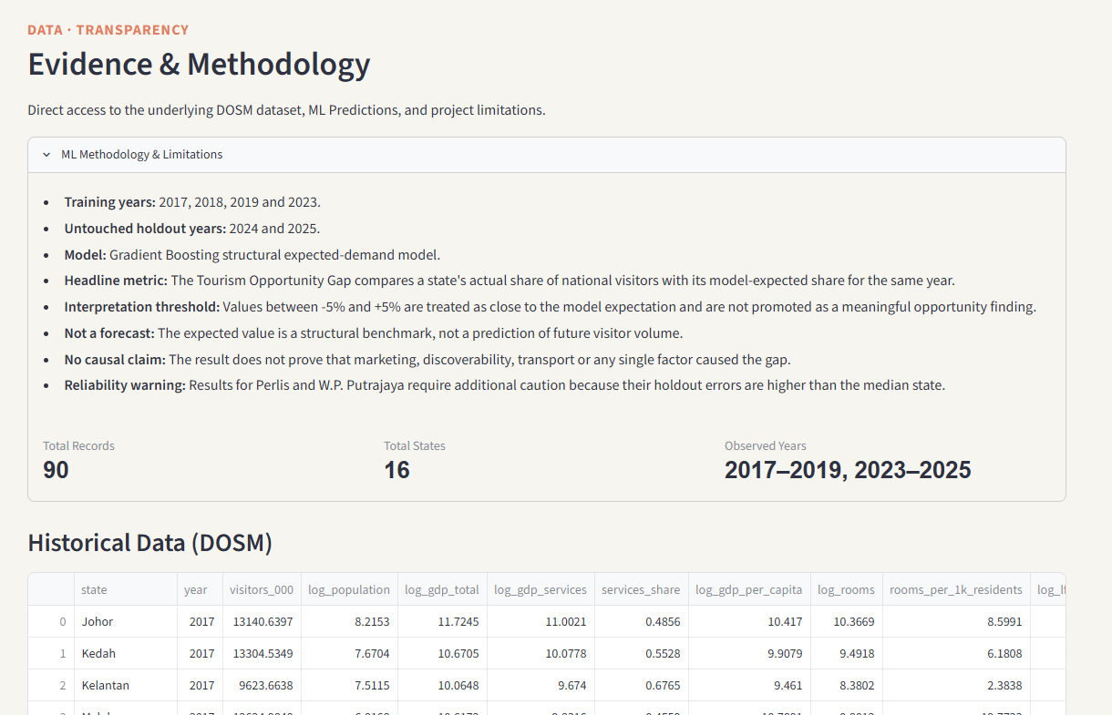
Figure 5.6. Evidence page: source and model tables (local build)

Figures 5.1–5.3 and 5.5–5.6 document the implemented analytical dashboard, while Figure 5.4 presents the separate JalanJalan prototype. These screenshots demonstrate interface states rather than measured effectiveness. The dashboard is distributed as a local Streamlit build without a public deployment. External evaluation requires the application, data, dependency file and run instructions; live Gemini and microphone behaviour require separate verification.

Conclusion
This study inventoried nine OpenDOSM-listed dataset groups and used six state-level groups to estimate how observed domestic visitor shares compare with model-expected shares based on measured structural conditions. On the unseen 2024–2025 holdout, the selected model reduced log-scale MAE by 40.7% relative to the baseline and reduced MAPE from 41.4% to 22.5%. In the separate forecasting comparison, none of the tested ML models outperformed the naive same-as-last-year baseline across rolling-origin folds.
The analysis found nearly identical top three concentration at the 2019 and 2025 endpoints, strong differences between tourism volume and visitors per resident, a shift toward interstate travel, and positive 2025 opportunity gaps for Kedah, Johor and Terengganu. For these states, the model benchmark shares exceeded the observed shares. The gaps do not establish why the difference occurred or prove that a particular intervention will close it.
The five-page JejakLestari dashboard presents the ML outputs alongside holdout framing and reliability warnings. Its optional assistant provides a question-driven interface for examining implications, trade-offs and missing evidence, although generated responses remain subject to validation. JalanJalan provides a distinct visitor-facing prototype rather than an evaluated intervention. Future work should improve geographic and seasonal detail, extend accommodation coverage, maintain an event dataset and evaluate actual visitor engagement.

References
Department of Statistics Malaysia. (2010–2024). Tourism Satellite Account [Annual Excel publications]. https://open.dosm.gov.my/publications/tourism_2024
Department of Statistics Malaysia. (2024–2026). Domestic Tourism Survey [Annual 2023–2025 Excel publications]. https://open.dosm.gov.my/publications/tourism_domestic_annual_2025
Department of Statistics Malaysia. (2025–2026). Domestic Tourism Survey [Quarterly publications]. https://open.dosm.gov.my/publications/tourism_domestic_2026-q1
Department of Statistics Malaysia. (2023–2024). Domestic Tourism Survey (States), 2022–2023 [State Excel workbooks]. https://open.dosm.gov.my/publications/tourism_domestic_state_2023
Department of Statistics Malaysia. (2026). Monthly CPI by State & Division. https://open.dosm.gov.my/data-catalogue/cpi_state
Department of Statistics Malaysia. (2026). Population Table: States. https://open.dosm.gov.my/data-catalogue/population_state
Department of Statistics Malaysia. (2026). Annual Real GDP by State & Economic Sector. https://open.dosm.gov.my/data-catalogue/gdp_state_real_supply
Department of Statistics Malaysia. (2025). Quarterly Principal Labour Force Statistics by State. https://open.dosm.gov.my/data-catalogue/lfs_qtr_state
SPAN, NRES, & Department of Statistics Malaysia. (2022). Water Consumption by State and Sector. https://open.dosm.gov.my/data-catalogue/water_consumption
JX273. (2026). malaysia_tourism_app (main commit 4990d62, 22 September 2026) [GitHub repository]. https://github.com/jx273/malaysia_tourism_app
Department of Statistics Malaysia. (2026a). Domestic Tourism Survey, 2025. Released 16 June 2026.
https://www.dosm.gov.my/portal-main/release-content/domestic-tourism-survey-2025
Department of Statistics Malaysia. (2026b). Datathon 2026 – Booklet Final. Data sources rule, p. 9; written report format, p. 13; submission rules, p. 12; dashboard, pp. 14–16.
https://drive.google.com/file/d/1eS1RwvBJW64I5j1BRaHwS9mlwVKgW5QB/view
Department of Statistics Malaysia. (2026c). DOSM Datathon 2026 briefing slides. 8 September 2026. Report format, slide 13.
https://datathon.dosm.gov.my/briefing/DOSM-Datathon-2026-Briefing-Slides.pdf
Department of Statistics Malaysia. (2026d). DOSM Datathon 2026 official website. Competition theme and dimensions. Accessed 22 September 2026.
https://datathon.dosm.gov.my/
Gretzel, U., Sigala, M., Xiang, Z., & Koo, C. (2015). Smart tourism: Foundations and developments. Electronic Markets, 25, 179–188.
https://doi.org/10.1007/s12525-015-0196-8
Hyndman, R. J., & Athanasopoulos, G. (2021). Forecasting: Principles and practice (3rd ed.). OTexts. Section 5.10, Time series cross-validation. Accessed 16 September 2026.
https://otexts.com/fpp3/tscv.html
Song, H., & Li, G. (2008). Tourism demand modelling and forecasting—A review of recent research. Tourism Management, 29(2), 203–220.
https://doi.org/10.1016/j.tourman.2007.07.016

