ITIS 6200/8200 Principles of Information Security and Privacy

Final Exam

If the questions ask for explanations, please **briefly** explain the **key reasons**.

**Notation**: here are some of techniques and notations that may be useful.

* AES: Enc(K, M) and Dec(K, C) where K, M, and C denote the key, plaintext, and ciphertext
* MAC: MAC(K, V) where K, V are the inputs to the MAC function
* HMAC: HMAC(K, V) where K, V are the inputs to the HMAC function
* Hash: Hash(M) where M is the input to the hash function
* RSA: Ekey(M), and Dkey(C). The key here could be pub_[name], pri_[name] with the corresponding names. For example, Epub_alice(M).
* c1 || c2: String concatenation of c1 and c2.

**Question 1**. **Cryptography Fundamentals (10 points)**

Q 1.1: Fill the following table. The first row shows security properties, and first column shows cryptographic techniques. Put a mark $×$ in a cell if its corresponding technique is designed for the corresponding security property.

|  |  |  |
| --- | --- | --- |
|  | Confidentiality | Integrity |
| AES-CBC |  |  |
| MAC |  |  |
| RSA encryption |  |  |
| RSA signature |  |  |

Q 1.2: Fill the following table. The first row shows cryptographic techniques, and the first column shows a few mechanisms/building blocks for these techniques. Put a mark $×$ in a cell if its corresponding mechanism is used in the corresponding technique. (Note that multiple mechanisms can be used in one mechanism, i.e., one column may have more than one $×$)

|  |  |  |  |  |
| --- | --- | --- | --- | --- |
|  | AES-CBC | MAC | RSA Encryption | RSA Signature |
| Hash |  |  |  |  |
| PRNG |  |  |  |  |
| Modulo operation |  |  |  |  |
| XOR |  |  |  |  |

**Question 2**. **Encryption (10 points)**

Alice wants to send a large size message M to Bob. Their public keys are known to each other.

Q 2.1: Alice wants to use AES to encrypt M. To do that, Alice first needs to share a symmetric key K with Bob. How can Alice send K to Bob with confidentiality? Write down the formula for sending K.

Q 2.2: What can go wrong (with the scheme from Q 2.1) if a powerful attacker Mallory can intercept messages passing between Alice and Bob? Can you design a scheme so that Alice can send K to Bob with both confidentiality and integrity?

**Question 3**. **Confidentiality and Integrity (15 points)**

Alice is sending a message M to Bob in the following way:

Ciphertext c = c1 || c2 where c1 = Enc(K1, M) and c2 = MAC(K2, M)

Where K1 and K2 are two secret keys known only to Alice and Bob.

Q 3.1: Does the scheme provide both confidentiality and integrity. Briefly explain why.

Q 3.2: Design a scheme that provides both confidentiality and integrity.

Q 3.3: Assume AES-CBC for Enc(K1, M), but the same IV is reused for all encryptions. Does the scheme you design provide IND-CPA? If not, explain how an eavesdropper Eve can correctly guess which message was encrypted by Alice, given that Alice randomly encrypts one of two messages Eve tricks Alice to encrypt.

**Question 4**. **Hash (15 points)**

The ecommerce website *Zmazon.com* decides to store all its users’ username and password as Hash(**username**) **||** Hash(**password**): for every pair of username and password, the website calculates the hash value of **username**, concatenates it with the hash value of **password**, and stores the result in a database. Every time when a user logs in, the website computes such a value with user-provided login information, and checks if the value exists in the database.

Assume Hash() is the cryptographic hash function SHA-256. MAC is a secure MAC. And *Zmazon.com*’s secret key k is confidential. And usernames are all alphabetic (no numbers or special characters) and password can have numbers, special characters, and letters.

Q 4.1: Assume an attacker is able to modify entries in the database. Can the attacker modify a record without being detected? If yes, how? If no, why?

Q 4.2: Assume the website stores MAC(k, **username**) || MAC(k, **password**), can the attacker modify a record without being detected? If yes, how? If no, why?

Q 4.3: Design an approach that the website can prevent or detect changes by an attacker.

**Question 5. Access Control (10 points)**

Assume that CCI has a file **F** that stores all students’ information. Only the SIS department chair Alice has read and write access to **F**. A powerful attacker Mallory was able to infiltrate Alice’s laptop with a Trojan Horse program, with an intention to give Mallory access to the contents of file **F**. The Trojan Horse attack works in the following steps:

1. creates a new file **G**
2. give Alice write access to **G**
3. give Mallory read access to **G**
4. copy the contents from **F** to **G**

Q 5.1: Write the access control lists for objects **F** and **G** andsubjects Alice and Mallory, given the Trojan Horse attack succeeds.

Q 5.2: How can Mandatory Access Control (or the BLP model) stop Mallory from accessing the contents of **F**? Design the security levels for each subject and object. And explain the main policy.

**Question 6. Web Security (15 points)**

A website uses a Go handler to process HTTP requests to URL **https://vulnerable.com/hello** that takes an argument of name. The website is vulnerable to XSS attacks.

**func handleSayHello(w http.ResponseWriter, r *http.Request) {**

**name := r.URL.Query()["name"][0]**

**fmt.Fprintf(w, "<html><body>Hello %s!</body></html>", name)**

**}**

Q 6.1: Design a GET request that can launch an attack to *Zmazon.com* to reset password to **abc**. The function for resetting password is: http://Zmazon.com/resetPassword?password=abc.

Q 6.2: Assume *Zmazon.com* does not check user inputs. What cookies would be attached to the request to *Zmazon.com*? Write down their values for the fields of **Domain** and **Path**.Whatif the cookie’s **Secure** field is sent to True?

Q 6.3: To log into *Zmazon.com*, you must go through authentication on *login.Zmazon.com*, and set a cookie to keep track of your authenticated status. The session token cookie should be secure against network attackers, and should get sent to as many pages on *Zmazon.com* as possible. What values should be set for the fields of **Domain**, **Path**, **Secure**, and **HttpOnly** in session token cookie?

**Question 7. Network Security (15 points)**



***Standard TCP handshake***

The new ITIS6200 course decides to use a server to send messages to its students, but the students only respond with ACKs and don’t send any data after the initial handshake. We design an ITIS-TCP protocol which provides TCP’s properties for communications from the server to the student, but not for communications from the student to the server. This is accomplished using a modified version of the standard three step handshake.

Q 7.1: What information we **no longer need** in the 3-way handshake of the ITIS-TCP protocol?

Q 7.2: Consider an on-path attacker Eve who can observe the traffic but cannot modify it. Is it easier for Eve to launch attacks on ITIS-TCP compare with the standard TCP?

Q 7.3: Consider an off-path attacker David who cannot observe and modify the traffic. Is it easier for David to launch attacks on ITIS-TCP compare with the standard TCP?

**Question 8. Memory Vulnerability (10 points)**

Consider the following vulnerable C code. Assume you are on a little-endian 32-bit x86 system and no memory safety defenses are enabled.

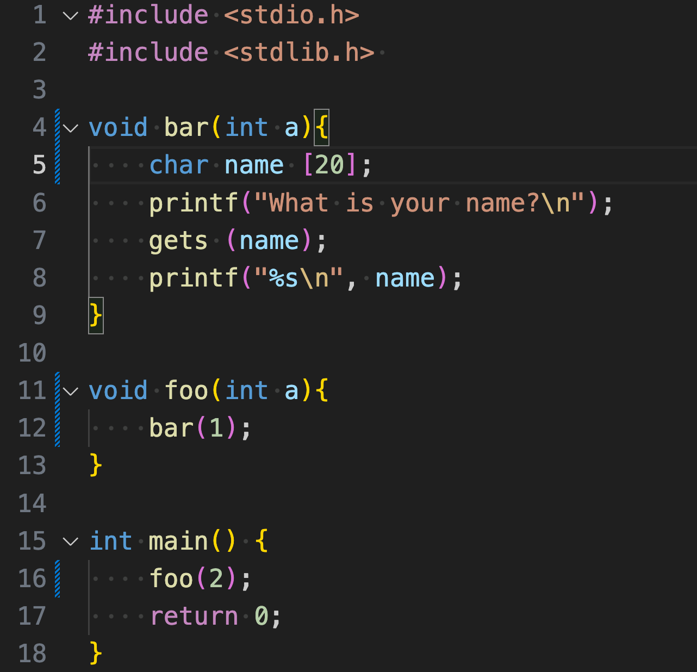

Q 8.1: Assume that execution has reached line 6. Fill in the following stack diagram. Assume that each row represents 4 bytes. Note that arrays are filled from lower addresses to higher addresses and are zero-indexed.

***Stack***

|  |
| --- |
|  |
|  |
|  |
| RIP of **bar** |
| SFP of **bar** |
|  |
|  |
|  |
|  |
|  |

Q 8.2: Assume that the address of the RIP of **bar** is 0x12345678.

Construct an input to *gets* that would cause the program to execute malicious shellcode. You may reference SHELLCODE as a 16-byte shellcode.