ITIS 6200/8200 Principles of Information Security and Privacy

Homework 4

Please **briefly** explain your answer.

**Question 1. ARP Attack (15 points)**

ARP, the Address Resolution Protocol, translates Layer 3 IP addresses into Layer 2 MAC addresses. Assume that Alice wants to communicate with Bob, whose computer is on the same LAN network. Alice knows Bob’s IP address but wants to learn his MAC address.

An attacker, Mallory, wants to convince Alice that your MAC address (and not Bob’s) corresponds to Bob’s IP address, causing messages intended for Bob to be sent to you instead. Mallory, Alice, and Bob all use the same LAN network. Assume that (1) Mallory computer has IP address 1.2.3.6 and Mallory’s MAC address is 66:66:66:66:66:66, (2) Alice’s IP address is 1.2.3.77 and her MAC address is 77:77:77:77:77:77, and (3) Bob’s IP address is 1.2.3.8 and his MAC address is 88:88:88:88:88:88. The network LAN router’s IP address is 1.2.3.4.

Q 1.1: Alice broadcasts to everyone else on the LAN: “What is the MAC address of 1.2.3.8 (Bob)?" What values for the IP and MAC address can Mallory include in her response to Alice to cause her messages intended for Bob to be sent to you instead?

Q 1.2: How would Mallory’s spoofed response to Alice change if Bob was outside the LAN?

Q 1.3: A network switch is deployed to prevent ARP spoof attacks. Describe what would the switch do in the following two cases: (1) the switch knows Bob’s IP to MAC address mapping and (2) the switch does not know Bob’s IP to MAC address mapping. Explain in one sentence why that helps with ARP spoof attacks.

**Question 2. TCP Spoofing (25 points)**

The left diagram below shows how TCP handshake works. The right diagram some initial data have been transferred between the Client and the Server.



***TCP handshake*** ***Initial data transfer after handshake***

Q 2.1: Assume that the next transmission will be some data sent from Client to Server. What are the sequence number and ACK for this packet?

Q 2.2: Consider a on-path attacker Eve who can observe the traffic but cannot modify it. Can Eve hijack the TCP connection between the Client and the Server? What can she do?

Q 2.3: Consider a off-path attacker David who cannot observe and modify the traffic. Can David do anything malicious to the connection? If so, what can he do?

Q 2.4: The Client wants to send a message M to the Server. Consider a modified version of TCP where the Server no longer sends an ACK to the Client for messages the Server receives. If the Client sends a message M using this modified version of TCP and M was dropped during delivery, can the Server know that M is lost? Would the message M be resent by the client?

Q 2.5: The Client wants to send a message M to the Server. Consider a modified version of TCP where the Client no longer sends an ACK to the Server for messages the Client receives. If the client sends a message M using this modified version of TCP and M was dropped during delivery, can the Server know that M is lost? Would the message M be resent by the Client?

**Question 3. Denial of Service Attack and Firewalls (20 points)**

SYN flooding attack is a DoS attack that attacks a server by sending a large amount of SYN requests to the server.

Q 3.1: Explain in two sentences how this DoS attack works. (What resources are being consumed at the server?)

Q 3.2: The server wants to defend against SYN flooding attack by SYN cookies: it encodes the state needed for each SYN request as the sequence number of the SYN-ACK message sent back from the server. Assume the server needs to track the following information (or state) for each SYN request: (a) Source IP, (b) Source Port, (c) Destination IP, and (d) Destination Port. Design a scheme to generate a sequence number from the information. Explain how to validate the connection if with such a sequence number.

Q 3.3: Assume we want to use stateful packet filter to help with SYN flooding. Write a rule that allows inbound connections to IP address 1.2.3.4 with port 8080.

Q 3.4: Reconsider Q 3.2 about encoding the information needed for a SYN request with a sequence number. How to use the generated sequence number to help with filtering SYN flooding packets?

**Question 4. Intrusion Detection (15 points)**

Q 4.1: Explain the difference between specification-based detection and anomaly-based detection. Which has better false positive rate? Explain why in one sentence.

Q 4.2: Name an example system where the false positive rate may be more important than the false negative rate. Explain why in one sentence.

Q 4.3: Name your favorite detection style, and explain why with an example system.

Q 4.4: Explain how to deal with the path traversal attack with the four different detection style. Make a bullet and explain how for each of the four different detection styles.

**Question 5. Memory Vulnerability (25 points)**

Consider the following vulnerable C code. Assume you are on a little-endian 32-bit x86 system. Assume that there is no compiler padding or additional saved registers in all questions. For the first 4 parts, assume that no memory safety defenses are enabled.

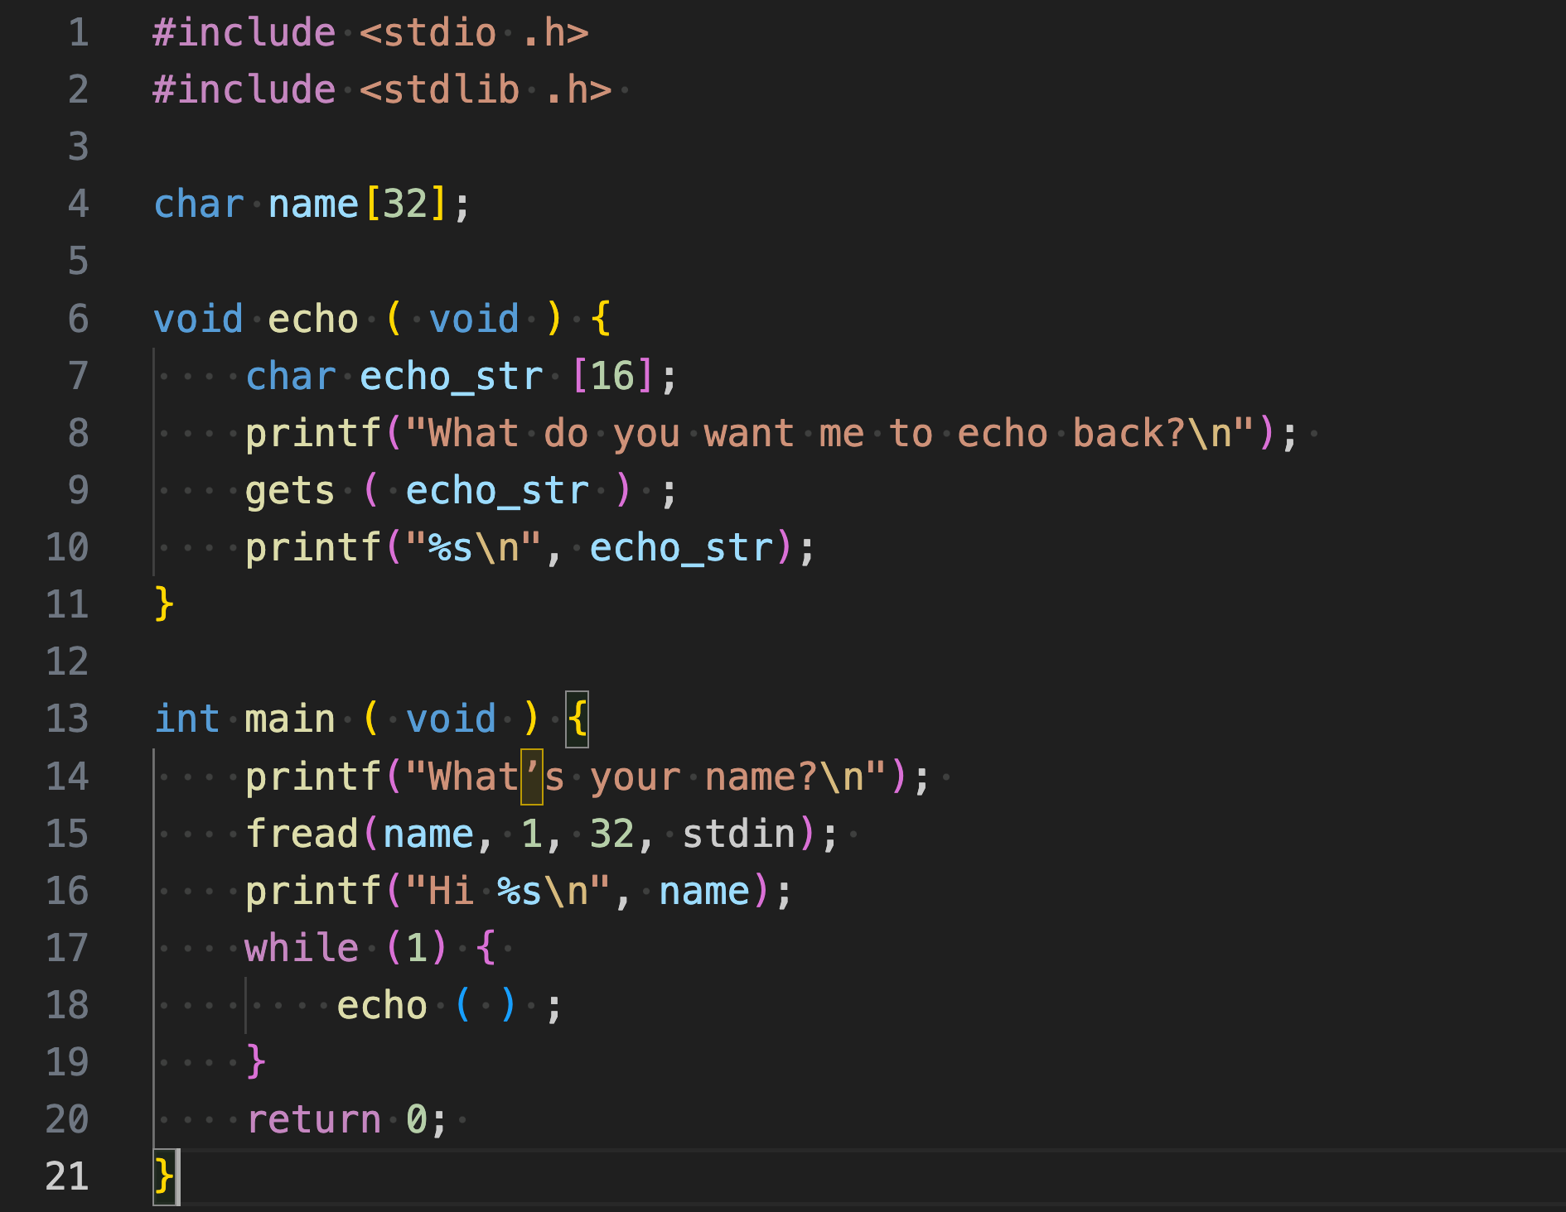

Q 5.1: Assume that execution has reached line 8. Fill in the following stack diagram. Assume that each row represents 4 bytes.

***Stack***

|  |
| --- |
|  |
|  |
|  |
|  |
|  |
|  |

Q 5.2: Using GDB, you find that the address of the RIP of echo is 0x9ff61fc4.

Construct an input to gets that would cause the program to execute malicious shellcode. Write your answer in Python syntax (like in Project 1). You may reference SHELLCODE as a 16-byte shellcode.

Q 5.3: Assume that non-executable pages are enabled so we cannot execute SHELLCODE on stack. We would like to exploit the **system (char *command)** function to start a shell. This function executes the string pointed to by **command** as a shell command. For example, **system("ls")** will list files in the current directory.

Construct an input to gets that would cause the program to execute the function call **system("sh")**. Assume that the address of system is **0xdeadbeef** and that the address of the RIP of echo is **0x9ff61fc4**. Write your answer in Python 2 syntax (like in Project 1).