ITIS 6200/8200 Principles of Information Security and Privacy

Project 2: Digital Footprint and Privacy

Handout Date: Nov 14th, 2018

Due Date: Nov 28th, 2018 before 11:59 pm

**Objective**:

The objective of the project is to help students to learn about digital footprint on the Internet and how different companies collect their user information. Now there are much more comprehensive and powerful user profile analysis tools. This project is just a start. The students need to learn about their digital privacy and how they can enforce it.

**Acknowledgement:**

The project is using materials developed by Dr. Wenliang Du and his team at Syracuse University. With his permission, we are using the virtual machines captured by the team. We would like to thank him and his team, as well as the funding agencies that support the development of the series of experiments.

**Tasks of the Project**

**Task 1**:

Before you start on the project, you need to set up your environment with a hypervisor and corresponding virtual machine. Go to:

<http://www.cis.syr.edu/~wedu/seed/lab_env.html>

and download the Oracle VirtualBox and the SeedUbuntu12.04 virtual machine. If you already have VMWare or other virtual machine manager on your computer, it should be fine as well. Note that the Ubuntu virtual machine is about 2.2 GB and you need some time to download it. So do not wait until the last minute.

The following two figures provide you some useful information when you launch and configure your VirtualBox and virtual machine.

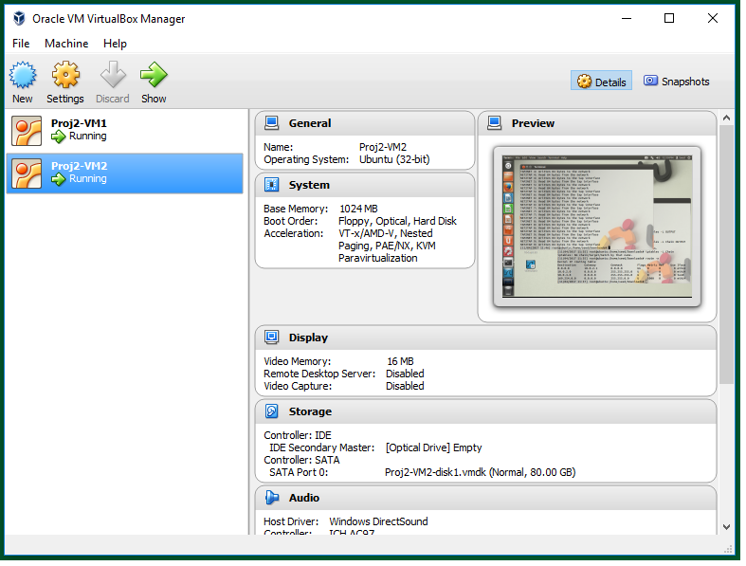

Fig 1. In this figure, we show the VirtualBox running two VMs with the names Proj2-VM1 and Proj2-VM2. We need only one VM in this project.

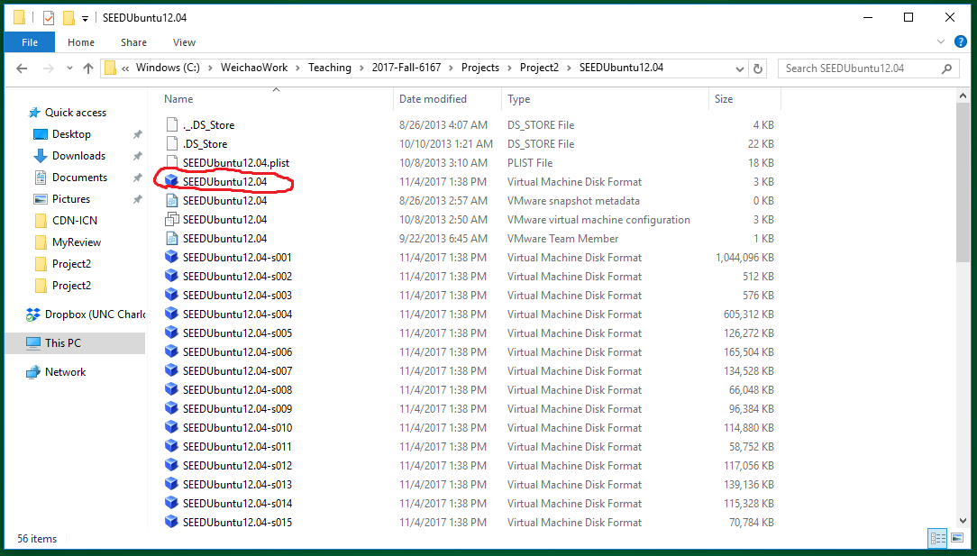

Fig 2. This figure shows the unzipped folder of the virtual machine. There are many “.VMDF” files when you launch the VM in VirtualBox. Please use the circled one.

**Task 2**:

Now you have prepared your environment. Go to:

<http://www.cis.syr.edu/~wedu/seed/Labs_12.04/Web/Web_Tracking_Elgg/>

and read about the Web Tracking Lab Description. Please read the Project Description at least twice even if you do not understand it in the first time since you need to follow the instructions step-by-step. You also need to get a full view of the project before you start doing it.

**Task 3**:

Follow the Project Description to do the project. Below we attach several screenshots so that you know you are on the right track.

**Tip 1**: on page 2 of the Project Description, the authors provide you the URL of the webpages that they have created in the VM. Remember that you need to launch the Apache service in your VM so that the website access can run smoothly.

**Tip 2**: The authors have also created corresponding user accounts in the webpage Elgg (also provided on page 2 of the Project Description.). You can use the accounts to log in.

**Tip 3**: In Section 3.2 of the Project Description (page 4), the lab needs you to collect information about the webpages with LiveHTTPHeader. The following figure shows you how to get access to the information.

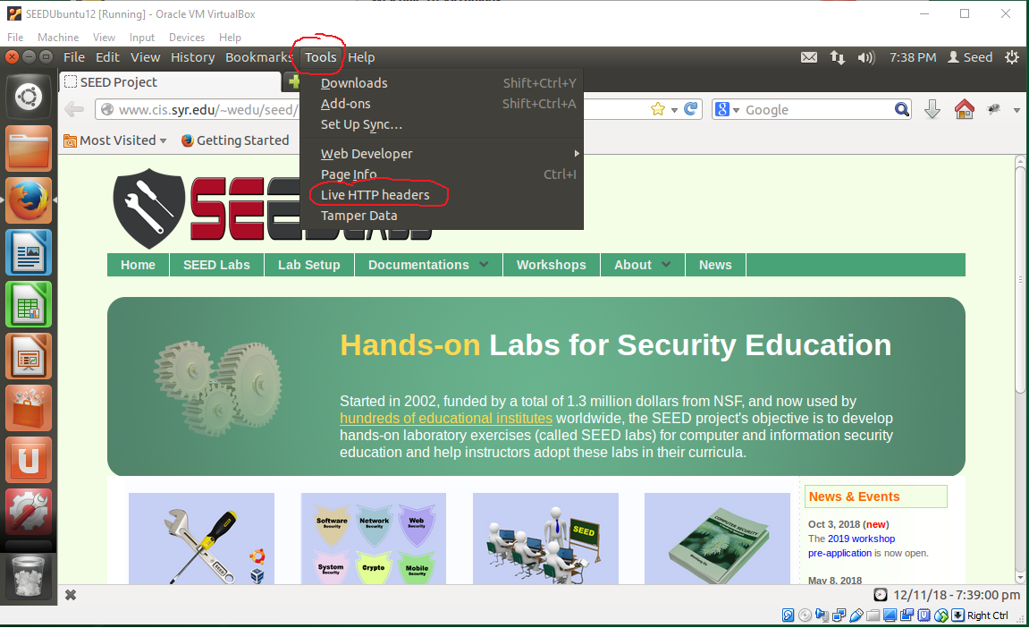

Fig 3. The figure shows you how to launch the LiveHTTPHeader tool in Firefox.

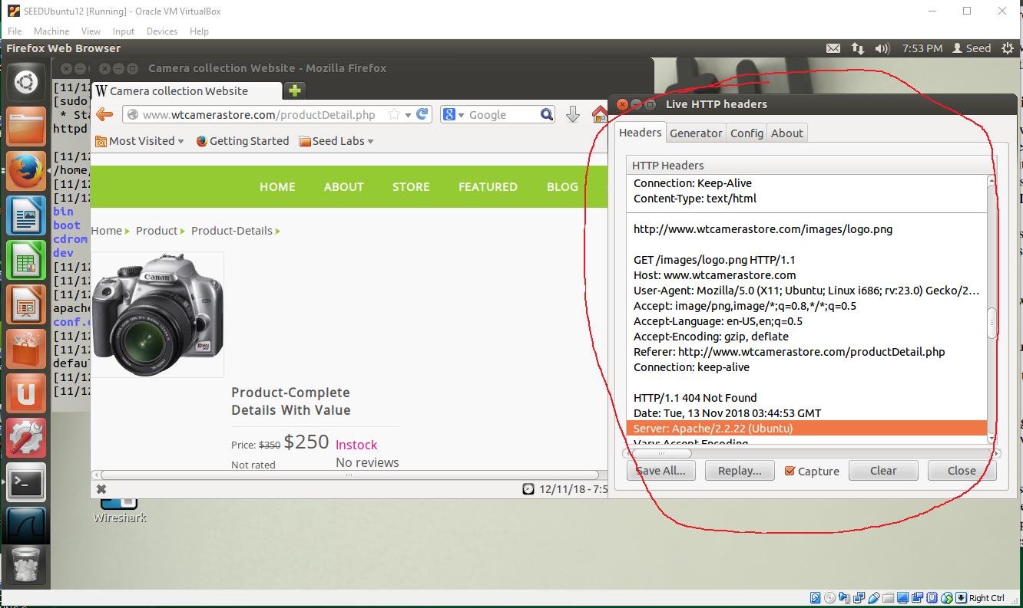

Fig 4. This figure shows an example of the captured header information by LiveHTTPHeader. Please note that you can click on the “clear” button to restart your capture so it becomes easier for you to locate the information you need.

**Tip 4**: In the same section, the lab needs you to use Firebug add-on. The following figures show you how to launch the Firebug and what the information look like.

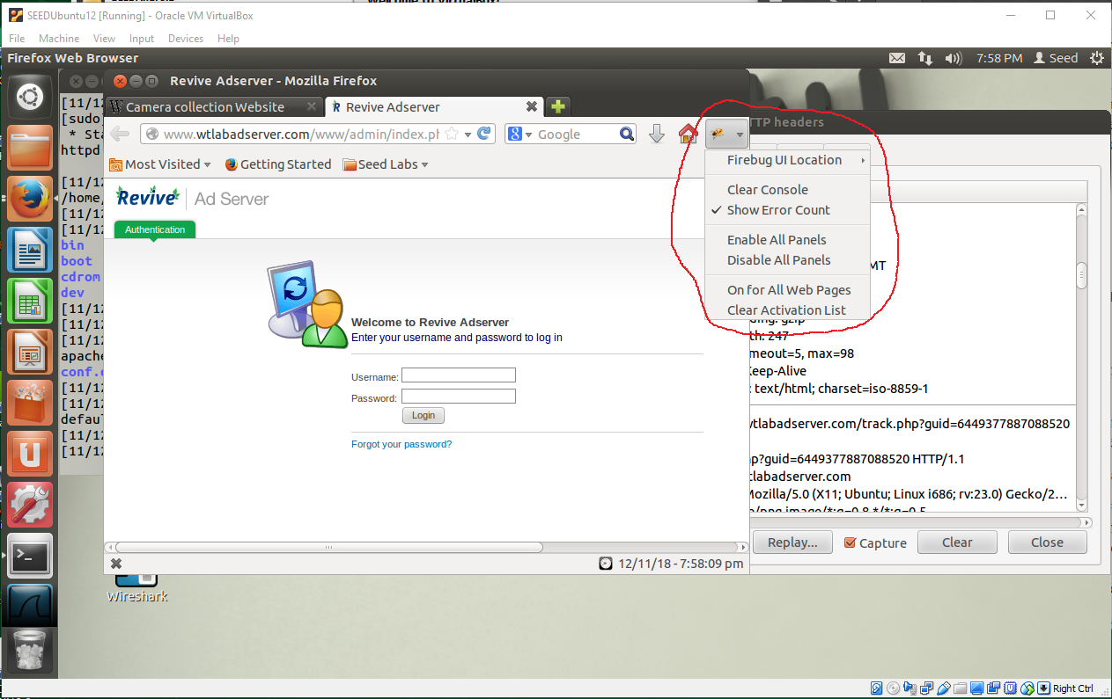

Fig 5. The figure shows the location of Firebug in Firefox.

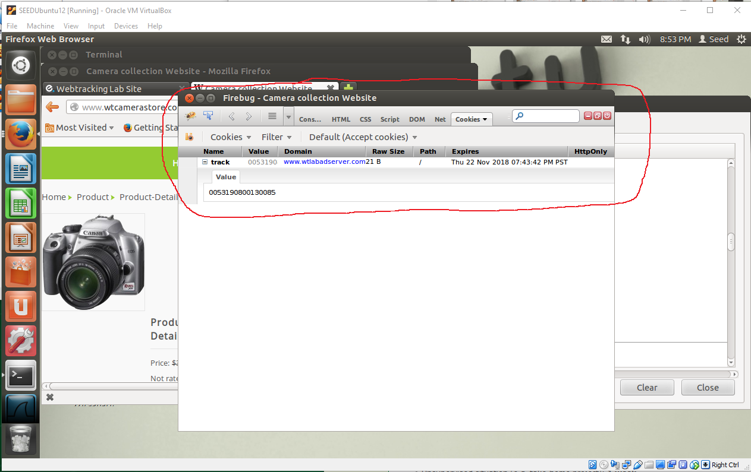

Fig 6. This figure shows the information that Firebug captures. Note that it is related to the current active page in Firefox. When you switch between pages, the Firebug data will also change.

**Tip 5**: In Section 3.3 of the Project Description (page 5), you need to access:

[www.wtlabadserver.com/preferences.php](http://www.wtlabadserver.com/preferences.php)

and you can actually see for how many times each item in the webpage you have accessed. Now access two different items in the Mobile store or Camera store with different number of times. Does the item shown in the Elgg webpage also change? Which item is shown? What will happen when two items are accessed with the same number of times?

**Tip 6**: In Section 3.6 of the Project Description (page 6), you need to access some real world webpage and see how the Cookies are embedded. I try Amazon.com but there is just too much information. As an alternative, I access the “www.usnews.com”, which also contains tons of information in the LiveHTTPHeader. But it is better than Amazon. Below is a screenshot. Note that I cover the advertisement website.

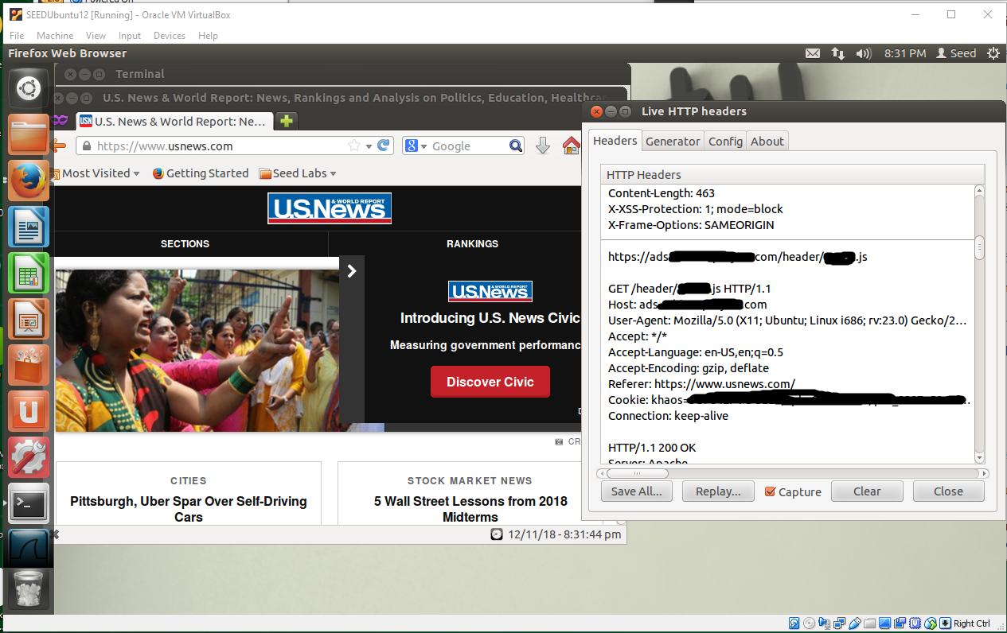

Fig 7. The cookies from www.usnews.com

**Report**:

You need to turn in your project report as the Project Description requires (Section 5). Specifically, your report need to cover:

1. Describe and draw a figure to show your network environment including the browser, the advertisement site, the social media site, and the Mobile or Camera store webpage that you access;
2. Screen captures and explanations for the tasks 3.1 – 3.7 in the Project Description page 3 to page 7.
3. Any surprising results that you see or you learn from the project.