**Server Publication Using Windows**

# Activity One: How to Connect to the CSCI Server through WinSCP

1. If you haven’t already done so, install WinSCP on your local pc. You can obtain WinSCP from the following site:

<http://winscp.net/eng/download.php>

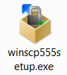

(Choose the installation package.)

2. Launch WinSCP (usually by double-clicking on the installed WinSCP icon:

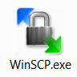

3. When WinSCP launches, a login popup menu will be displayed:

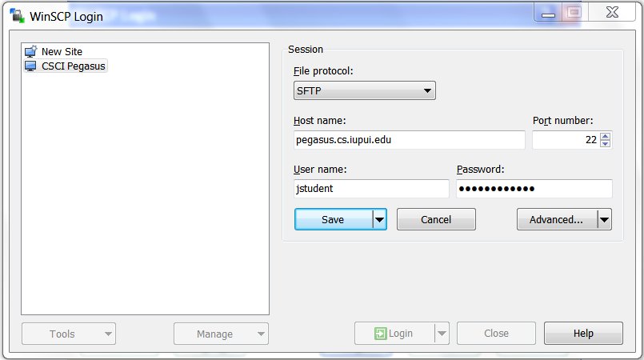

You need only fill in three fields:

A. Host name: pegasus.cs.iupui.edu

B. Your user name (your Oncourse login)

C. Your Password (your Oncourse passphrase)

Once you have filled in these three fields, press the “Login” box at the bottom middle of the pop up screen. At this point, a status screen should display for a moment. It will show activity statements that are occurring as the connection between your local pc and Pegasus is established. When all the steps have been performed, the activity screen will be automatically replaced by a split screen as illustrated below.

4. The split screen should now appear, ALTHOUGH IT SHOULD HARDLY HAVE ANYTHING ON THE RIGHT HAND SIDE.

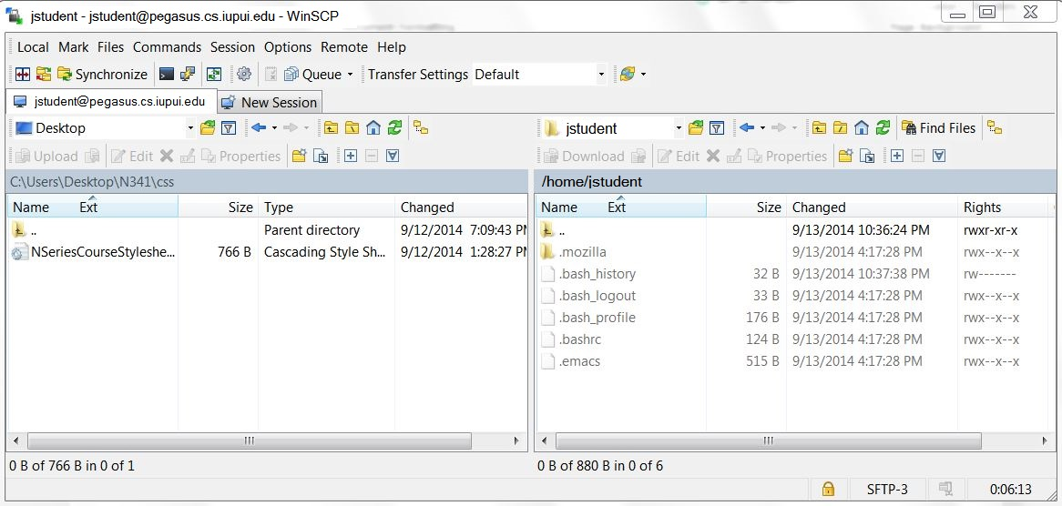

This split screen is typical of File Transfer Programs (or “FTP” programs). The left hand side screen corresponds to the pc you are typing on (called the “local” or “client” pc). The right hand side corresponds to the pc you are connected to (called the “remote”, or “host”, or “server” pc).

**Activity Two: Create Course Directory Structure with Correct Permissions**

Notice on the menu of the remote WinSCP screen is a picture of a file folder with a star. We’ll be using this button next to create subdirectories within your Pegasus account.

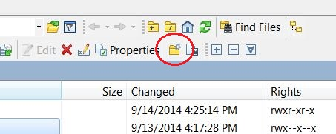

Pegasus is a university machine, which serves many different kinds of customers. Some of the work placed on Pegasus is very sensitive, such as research being conducted by a senior faculty member, etc. Other content might be student files – very important, but not of a critical nature. To make certain that a student doesn’t somehow “step on” critical file content on Pegasus, it is customary to segregate student work inside of a “software fence” of sorts. By convention, this software fence is often called “public_html”. So… we will create a sub-directory at your home account called public_html, and all your work will be placed inside that directory. IMPORTANT: public_html is case sensitive, and there are no spaces.

Important: Make sure the magic fairies know you are working on the Pegasus side and not your local pc side to create subdirectories. You let them know this by single clicking anywhere on the right hand side of the screen. This is like saying “Yo dawg, I want to work up on Pegasus for a minute.” Now, to create the subdirectory called public_html, click on the Create Subdirectory icon at the top right hand side of your screen. In effect, you are saying to the magic fairies: please create a subdirectory for me.



When you click on the create subdirectory icon, a text box will appear, as shown below.

The filename textbox:

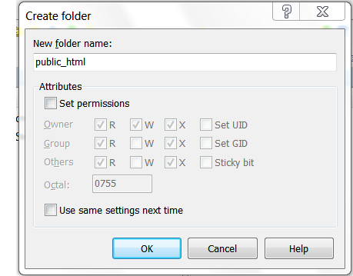

Type in the word “public_html” and press the OK button. The magic fairies will create a subdirectory called public_html in your Pegasus account, just as you requested.

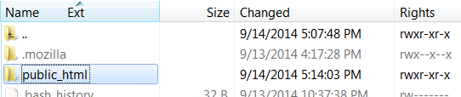

At this point, you could interpret the little “rwx-“ symbols to the right of the file creation date. However, this approach is a little beyond us now, so… we will manually check to make sure permissions have been set appropriately on our public_html subdirectory. Here is what you need to understand: Pegasus doesn’t run Windows as an operating system. It runs an operating system called Unix (or Linux). Unix recognizes three kinds of people: Owner, Group and World. As you go from one FTP program to another, these categories might be given a slightly different name, but the concept is the same. There is you as the owner of the subdirectory, a group of people if you are working together on a group project, and world is the, well, rest of the world, such as anyone who gets on the Internet, even your Aunt Matilda in East Cupcake or your Mom wherever she might be. Furthermore, these three different groups of people can have access to do up to three kinds of activities: Read, Write and Execute. As owner, you want to be able to do everything (Read, Write and Execute), but while you want everyone else (Group and World) to be able to read and run your works, you don’t want them to be able to dork it up! So, you will give yourself rights to do everything, but you will restrict everybody else to reading and executing. To do this, you will need to check the permissions on your subdirectory, and make certain that they are “set” to 755.

So, right click on public_html and a drop down menu will appear. Choose Properties, and when the Properties menu is displayed, verify that they are set to 755. If they are, click cancel. If they aren’t, fix them so that they are set to 755!

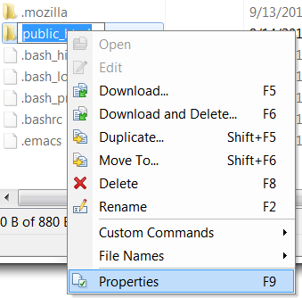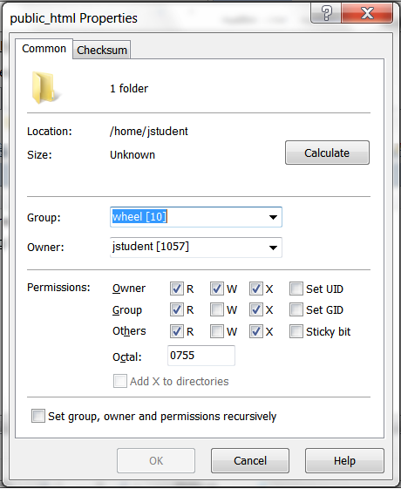

Now, we had SOOOO much fun creating the public_html directory that we are going to mostly do it all over again. Specifically, we are going to now create yet another subdirectory, this time INSIDE of public_html. For example, you might want to have a subdirectory for each class you are taking. You at least want to have a subdirectory for our class, and we will call it n341. (Note the lower case n, and no spaces!). Go inside of the public_html directory by double clicking on it. Next, click on the create subdirectory icon at the bottom of your screen to cause the directory text field to appear. This time, type in “n341” and press OK.

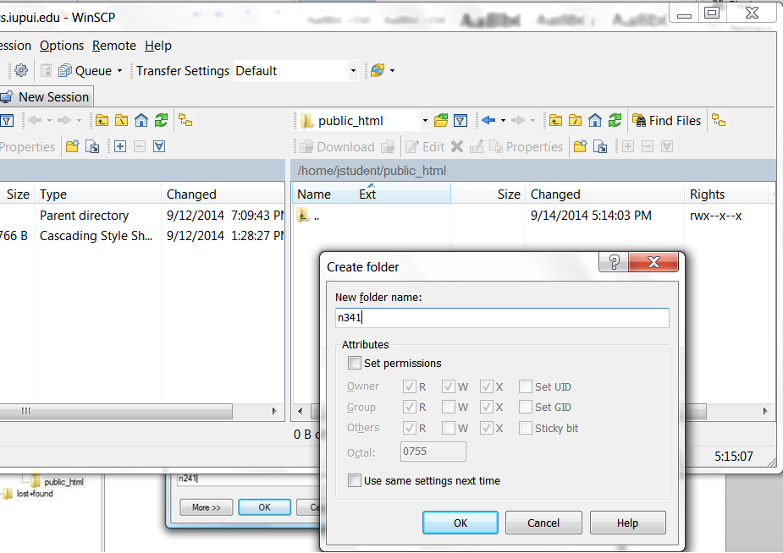

Verify that its permissions are set to 755.

Open a browser (such as Mozilla or IE or Safari), and go directly to the [N341 Class Web Page](http://www.cs.iupui.edu/~mroberts/new/n341/). Look towards the top of the page, and click on the link for the DE Class Gallery. **(Be sure you select DE Class Gallery).**

Click on your name in the Class Gallery list. You should see a screen that looks similar to:

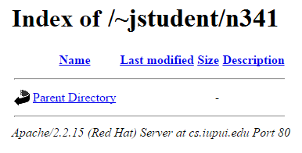

(Of course, it should reflect your username.) Leave the browser open.

[If for some reason you don’t see something similar, contact your instructor and we’ll work it out!]

Transfer your index.html file from your local pc up to your Pegasus n341 subdirectory. To do this, locate the file you want on the left hand side of the WinSCP split screen. Simply drag it over to the right hand side of the screen and let go.

Note: if the file you want to transfer isn’t currently visible on the left hand side of your pc, you might have to “move around” in your directory structure to locate them. Notice that on BOTH the left and right hand sides of the screen, there are navigation keys and a “location” text area that allow you to see where you are and navigate to somewhere else:

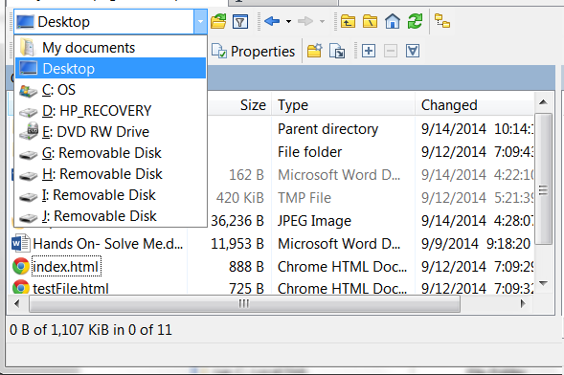

Move around as required until you locate your n341 work. Click on the file and drag it to the right hand side. The “Upload” screen will appear:

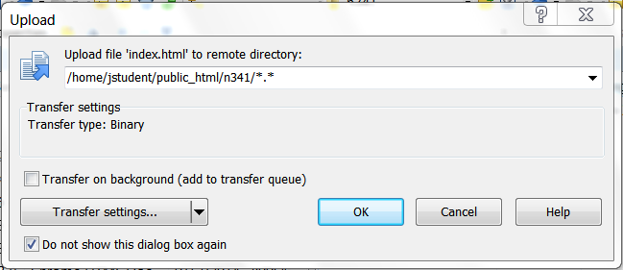

At this point, you might get a confirmation screen, or a Write Over prompt, or whatever. Answer appropriately to cause the file to be copied over to Pegasus. Once the file is over on Pegasus, right click on the file, choose properties, and make certain the properties are set to 644. (So – directories get set to 755, files 644!)

As a final step in this activity, verify that your file is really on Pegasus, in the correct location, and visible:

Refresh the browser window that is open to your directory on the CSCI server. (The “chasing” arrow button on the browser menu bar will accomplish this). Your class web page should now look similar to the one at the following link: [Sample Student File with html Page](http://cs.iupui.edu/~mroberts/new/n341/sampleStudentFile.html)

Ok, we’re almost done… Return to the Lab html file and begin Activity Three.

# Activity Three: Create Class Index Page

Download the template index page from the link provided in the Activity Three instructions. Perform a “View Source” on the file, and save the displayed source code to your local pc. Open your web page editor (Notepad, Notepad++, TextEdit, etc.) and look at the source code. Scroll down in the code until you get to the part that says: N341 Course Page for Josephina Student. Edit this line to reflect your name instead of Josephina’s. Scroll back up to the comment lines. In HTML, these are lines of code like this:

<!--

TITLE:

AUTHOR:

PURPOSE:

ORIGINALLY CREATED ON:

LAST MODIFIED ON:

LAST MODIFIED BY:

MODIFICATION HISTORY:

-->

These lines are ignored by the browser magic fairies, but are like little sticky notes to a web developer. Fill them out so that they reflect your name and current dates. When you are finished, save your file as index.html Note the lower case letters. The index.html file is a special name that tells the browser to default to this file when the user comes to your directory on the web.

Alright, drag the index.html file, the testFile.html file, and the externalAlert.js file into your n341 directory (using WinSCP).

Refresh your browser and view your class web page. The index page should automatically display, with active links to the testFile page and JS Hello World.

Return to the html Lab Page and begin Activity Four, and then go straight to Activity Five.



Oh, grasshopper, you did so well.

OH MY GOODNESS, YOU JUST EARNED SO MUCH CHOCOLATE: