Machine learning-Assignment2

Student id:700674089

Student Name: Jahnavi Danda

CRN: CS571013466

**GitHub Repository**

<https://github.com/jxd40890/Machine-learning-Assignment2.git>

**Assignment1 video URL**

https://drive.google.com/drive/folders/1Tdv86KzjhSEo7rIwvCyGR8-9W4y14fjO?usp=sharing

Question1

1. Numpy

* Using NumPy create random vector of size 15 having only Integers in the range 1-20.
* Reshape the array to 3 by 5 2.
* Print array shape.
* Replace the max in each row by 0

**Solution:-**

**Code screenshot:**

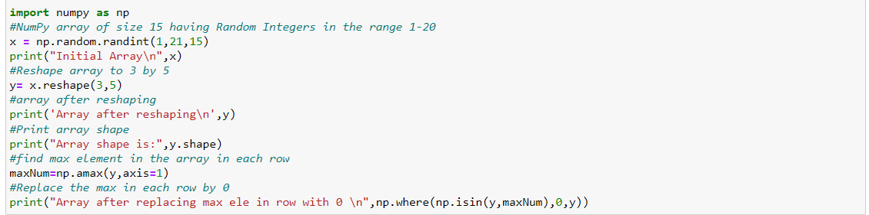

**Output Screenshot**

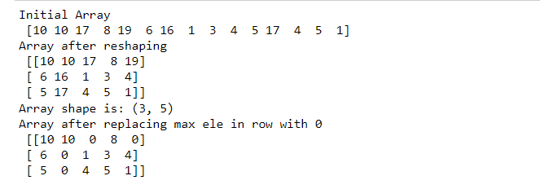

Question2:

2. Pandas

* Read the provided CSV file ‘data.csv
* Show the basic statistical description about the data.
* Check if the data has null values. a. Replace the null values with the mean
* Select at least two columns and aggregate the data using: min, max, count, mean.
* Filter the dataframe to select the rows with calories values between 500 and 1000.
* Filter the dataframe to select the rows with calories values > 500 and pulse < 100.
* Create a new “df_modified” dataframe that contains all the columns from df except for “Maxpulse”.
* Delete the “Maxpulse” column from the main df dataframe
* Convert the datatype of Calories column to int datatype.
* Using pandas create a scatter plot for the two columns (Duration and Calories)

**Solution:-**

**Code screenshot:**

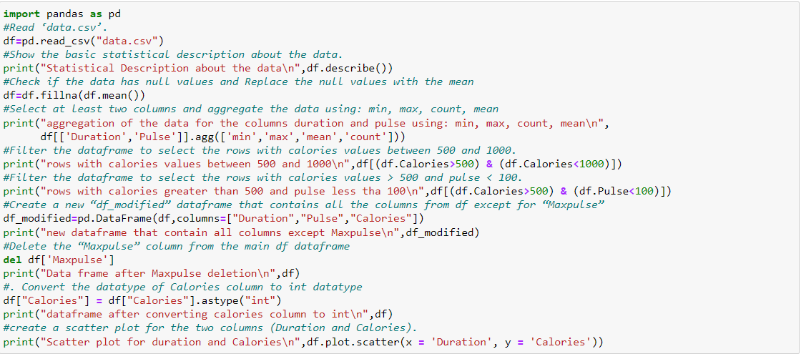

**Output screenshot**

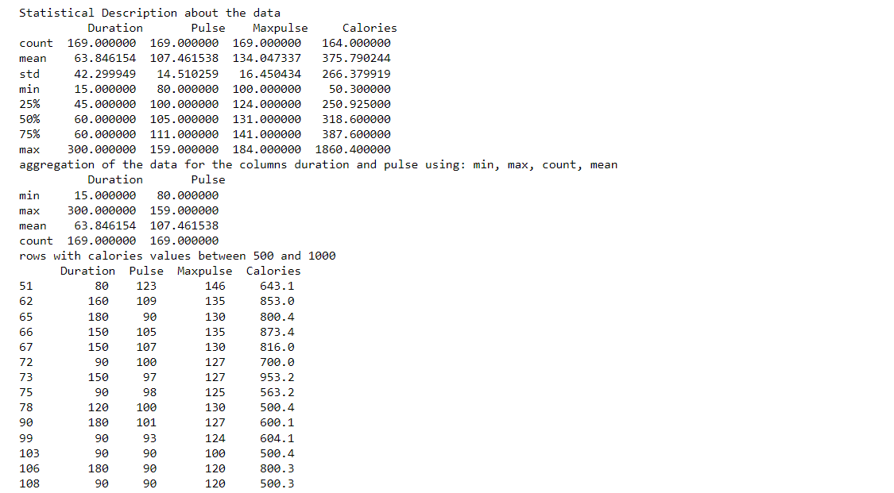

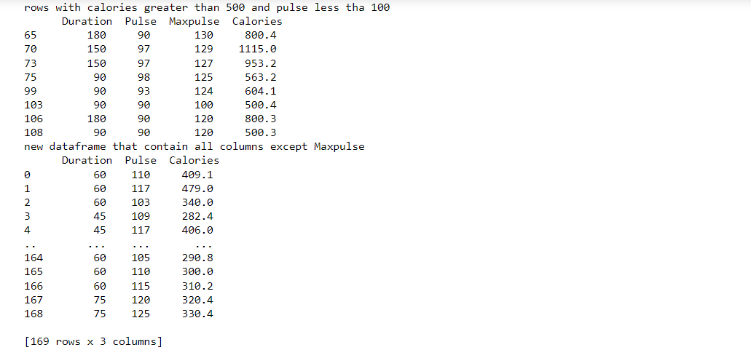

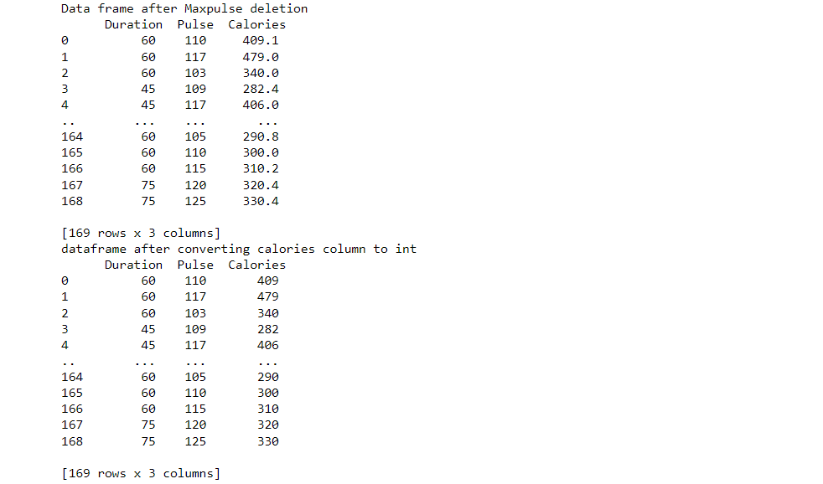

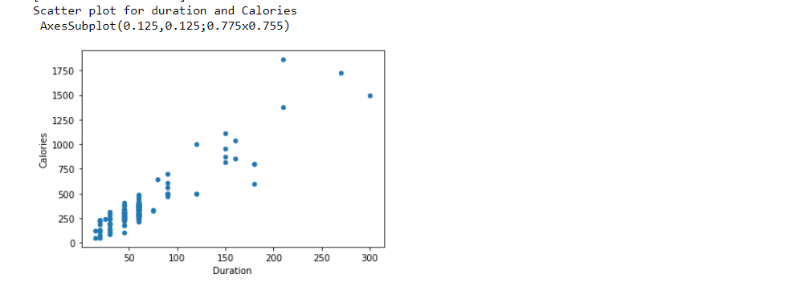

Question3:

3. Matplotlib

* 1. Write a Python programming to create a below chart of the popularity of programming Languages.
* 2. Sample data: Programming languages: Java, Python, PHP, JavaScript, C#, C++ Popularity: 22.2, 17.6, 8.8, 8, 7.7, 6.7

**Solution:**

**Code Screenshot**

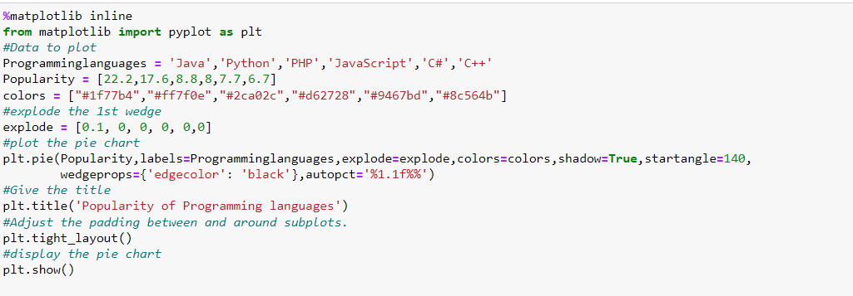

**Output screenshot**

