关于客户分析表重复数据。

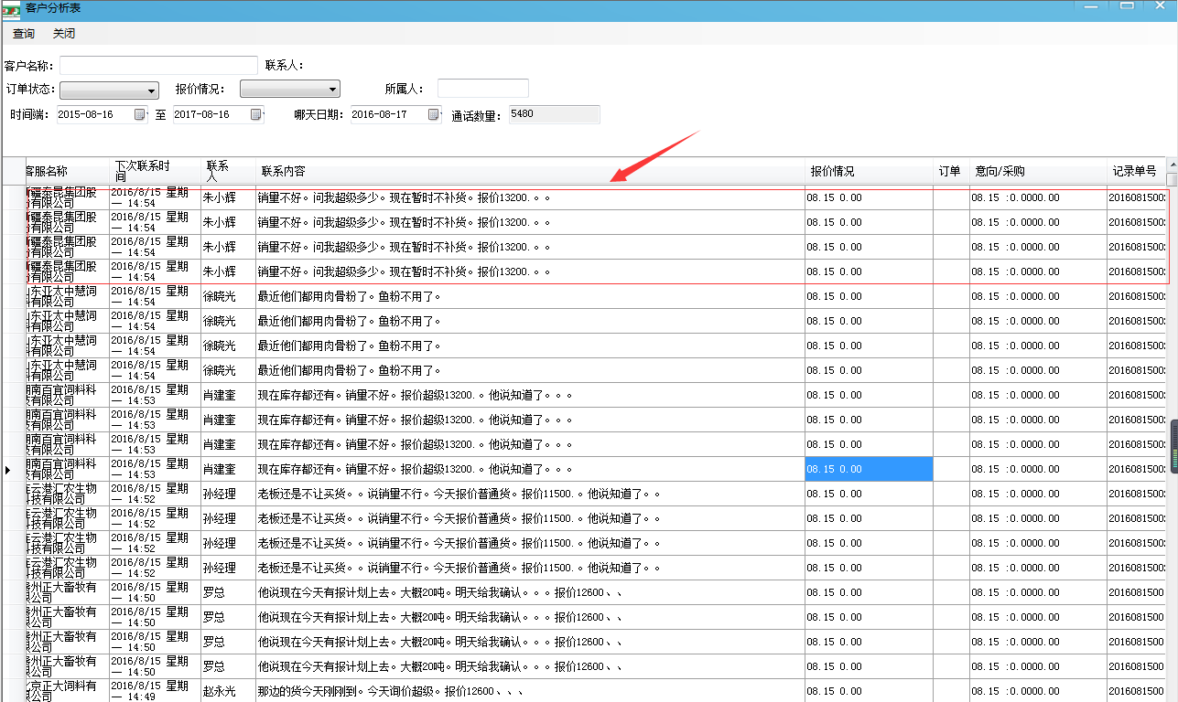是根据添加通话记录来的

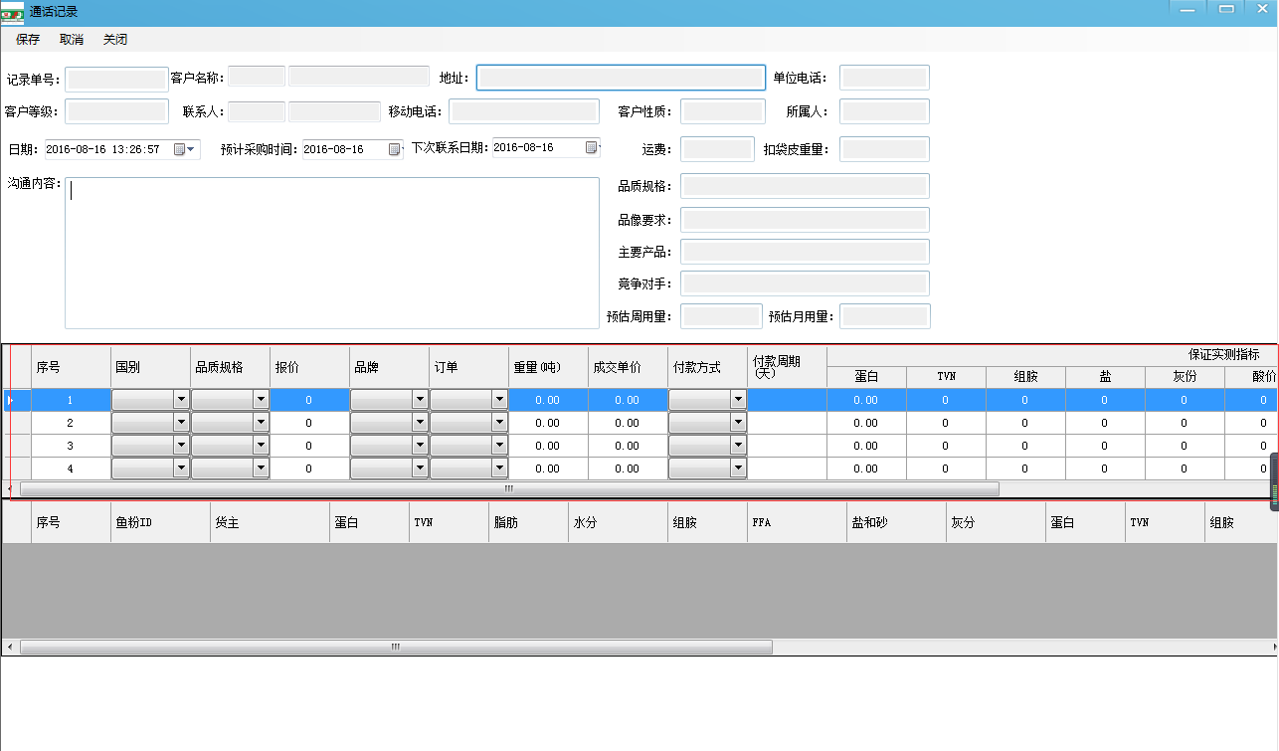  
MYSQL v_callrecorddetail视图多表关联

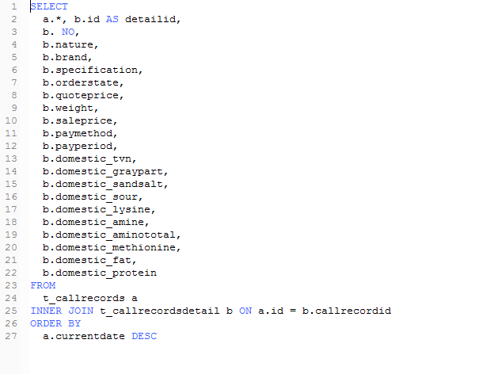  
 SELECT

a.*, b.id AS detailid,

b. NO,

b.nature,

b.brand,

b.specification,

b.orderstate,

b.quoteprice,

b.weight,

b.saleprice,

b.paymethod,

b.payperiod,

b.domestic_tvn,

b.domestic_graypart,

b.domestic_sandsalt,

b.domestic_sour,

b.domestic_lysine,

b.domestic_amine,

b.domestic_aminototal,

b.domestic_methionine,

b.domestic_fat,

b.domestic_protein

FROM

t_callrecords a

INNER JOIN t_callrecordsdetail b ON a.id = b.callrecordid

ORDER BY

1. currentdate DESC

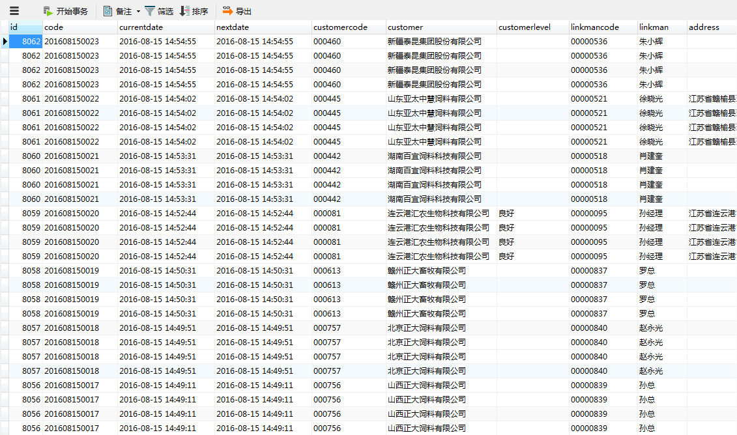

能不能重新写一条视图查询，根据v_callrecorddetail虚拟表的id相同的，更改成一条其他4条字段不同的合并，根据id ，不同的4行数据合并成一个单元格，相同的只要一个。

不懂的可以打电话给我！