客服分析表

旧

SELECT

a.*, b.id AS detailid,

b. NO,

b.nature,

b.brand,

b.specification,

b.orderstate,

b.quoteprice,

b.weight,

b.saleprice,

b.paymethod,

b.payperiod,

b.domestic_tvn,

b.domestic_graypart,

b.domestic_sandsalt,

b.domestic_sour,

b.domestic_lysine,

b.domestic_amine,

b.domestic_aminototal,

b.domestic_methionine,

b.domestic_fat,

b.domestic_protein

FROM

t_callrecords a

INNER JOIN t_callrecordsdetail b ON a.id = b.callrecordid

ORDER BY

1. currentdate DESC

新

SELECT

id,

customercode,

customer,

currentdate,

createman,

nextdate,

modifyman,

linkmancode,

linkman,

communicatecontent,

CODE,

GROUP_CONCAT(

DISTINCT CONCAT(

DATE_FORMAT(currentdate, '%m.%d'),

' ',

quoteprice,

'',

specification,

'',

brand

) SEPARATOR ' | '

)AS'bjqk',

GROUP_CONCAT(

CONCAT(

DATE_FORMAT(currentdate, '%m.%d'),

' ',

orderstate,

weight,

specification,

saleprice

) SEPARATOR ' | '

)AS'cgyx',

GROUP_CONCAT(DISTINCT orderstate)AS 'orderstate'

FROM

v_callrecorddetail

GROUP BY

currentdate DESC,

id,

customercode,

customer,

nextdate,

linkmancode,

linkman,

communicatecontent,

CODE

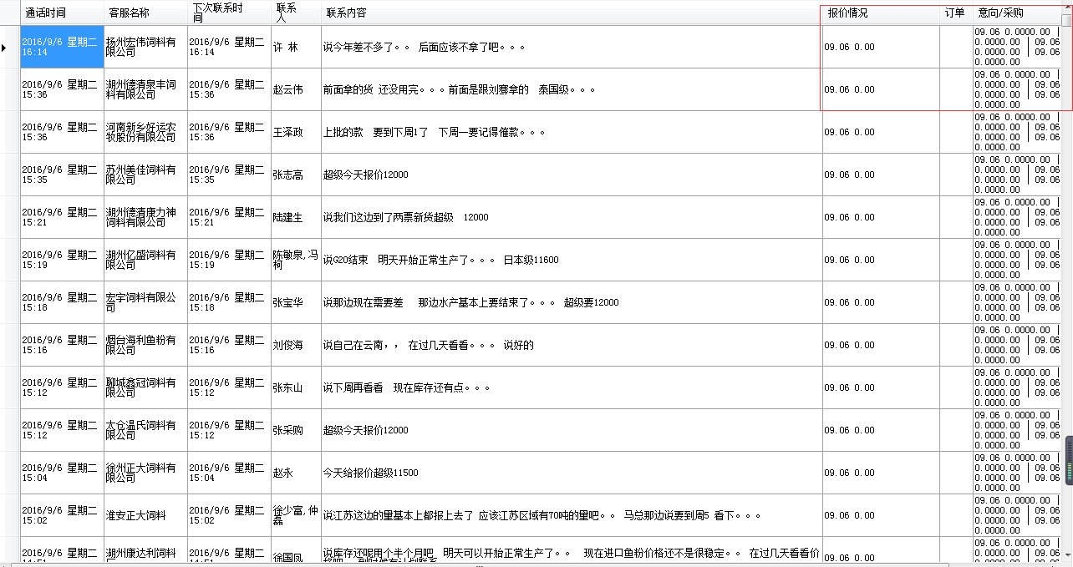

重新更改成一条其他4条字段不同的合并，根据id ，改成一行（报价情况）和（意向采购）

|  |  |  |  |  |
| --- | --- | --- | --- | --- |
|  | 报价情况  订单  意向采购 | 报价情况  订单  意向采购 | 报价情况  订单  意向采购 | 报价情况  订单  意向采购 |

上次发你的视图，应该满足要求？

如何最大化窗口

Form.WindowState = FormWindowState.Maximized;

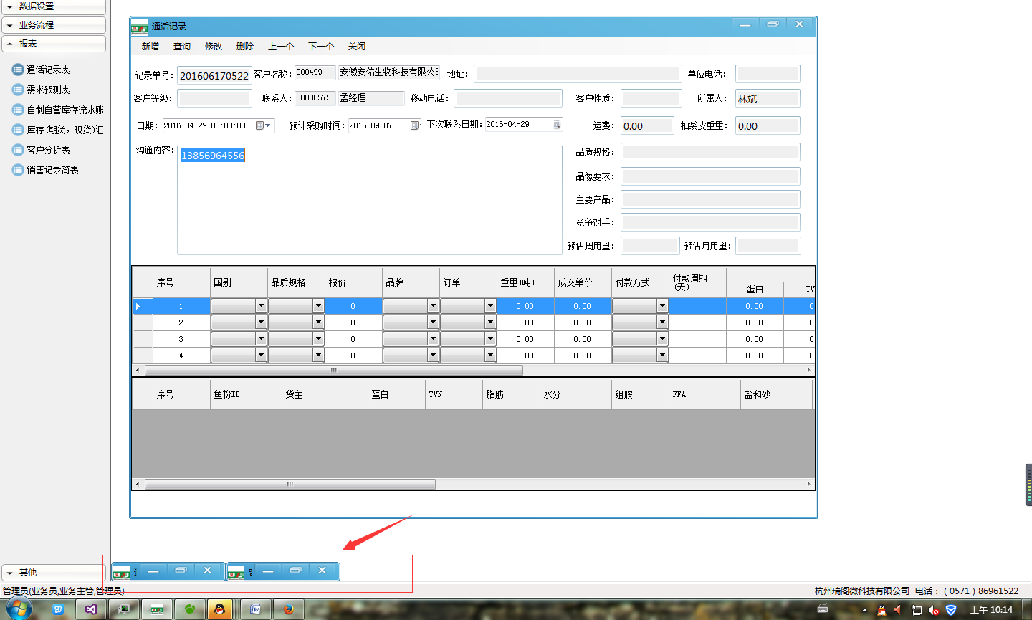

下面的的窗口浮现在上面

