Base & Facility Support

(Change O&M and Facility Support to Base & Facility Support)
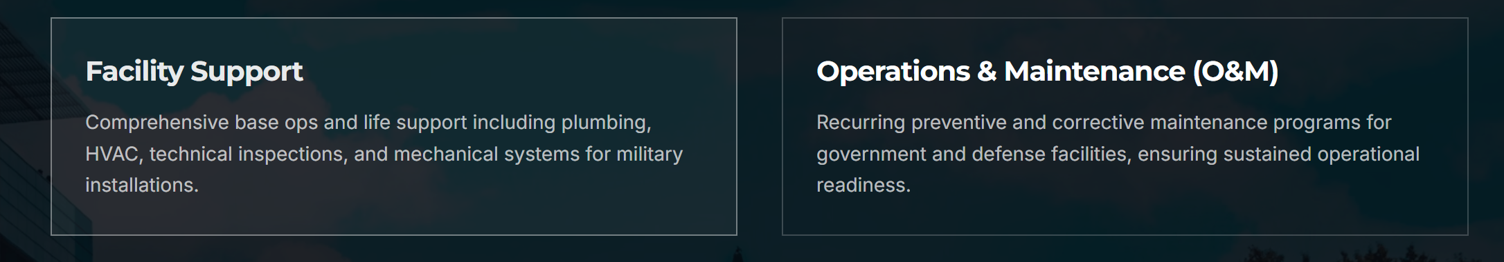
Base & Facility Support
G&E delivers mission-critical installation and operations support that directly enables global DoD readiness objectives. Through successful execution of numerous complex task orders under large prime contractors, G&E has demonstrated a consistent record of excellence, reliability, and superior performance ratings.
Our team brings together in-house engineers, certified Construction Managers (CM), and experienced Program Managers (PM) who ensure disciplined execution, technical oversight, and seamless coordination across all operational functions.
We provide integrated facility and installation support solutions designed to:
Increase operational reliability
Reduce lifecycle cost of ownership
Improve installation quality of life
Sustain and enhance mission readiness
Our Reliability-Centered and Condition-Based Maintenance methodology ensures optimized asset performance while maintaining cost efficiency and compliance with DoD standards.
By managing critical infrastructure and operational functions, G&E enables military personnel and command leadership to focus fully on core mission objectives.
- Core Capabilities
- Facilities Engineering & Management
- Operations & Maintenance (O&M) Services
- Bulk & Retail Fuel / Water Distribution Support
- Airfield Operations & Ground Support
- Food Service Operations & Logistics
- Power Generation & Utilities Management
- Emergency & Critical Response Services
- Transportation & Fleet Management
- Physical Security & Installation Support Services

