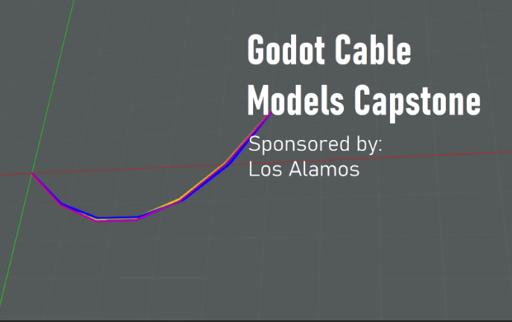Project Title: **Godot Cable Models**

[Image](https://tamucs.sharepoint.com/:i:/r/teams/Team-Fall24-CSCE482-Capstone822-Godot/Shared%20Documents/931-Godot/Project%20Presentation/Demo%20Video/Godot_Image.png?csf=1&web=1&e=cHKu7Y) Alt Text Description: “Godot Cable Models Capstone. Sponsored by Los Alamos. Overlayed 2D models of hanging cables.”

Sponsor Name: Los Alamos National Laboratory

A synopsis of the project (45 words or less)

* An exploratory program implementing a Finite Element Method and a Mass-Spring approach to simulate the deformation and displacement of a weighted cable. Cable parameters and external conditions are defined by the user.

Research area(s) the project belongs in, choosing from this list.

* Software, Software Engineering

Name of team members, each member's major and class.

* Thomas Holt, Computer Science, Class of 2025
* Mustafa Tekin, Computer Science, Class of 2025
* John Mo, Computer Science, Class of 2025
* Jordan Daryanani, Computer Science, Class of 2025
* Jonathan Zhao, Computer Science, Class of 2025

[Our GitHub](https://github.com/jxhnmo/csce482spring2025godotcable)