Jiang Xie

Q1

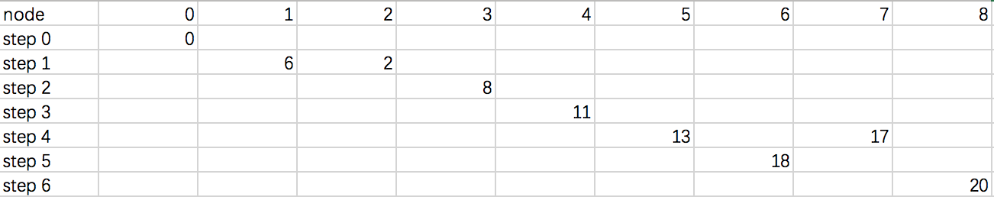

0-1-3-4-7-8

Q2,3

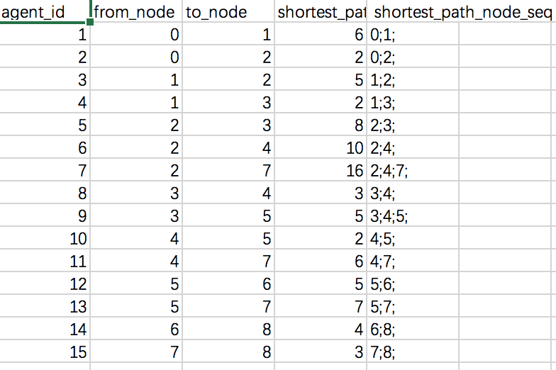

Q4

Route for vehicle 0:

0 Load(0) -> 8 Load(20) -> 9 Load(27) -> 10 Load(84) -> 0 Load(84)

Distance of the route: 64.95358041299247m

Load of the route: 84

Route for vehicle 1:

0 Load(0) -> 5 Load(30) -> 6 Load(75) -> 7 Load(98) -> 0 Load(98)

Distance of the route: 45.5597481411299m

Load of the route: 98

Route for vehicle 2:

0 Load(0) -> 4 Load(23) -> 2 Load(42) -> 3 Load(76) -> 1 Load(100) -> 0 Load(100)

Distance of the route: 55.76491222541475m

Load of the route: 100

Route for vehicle 3:

0 Load(0) -> 15 Load(9) -> 14 Load(27) -> 13 Load(42) -> 11 Load(85) -> 12 Load(100) -> 0 Load(100)

Distance of the route: 65.13802008629716m

Load of the route: 100

Total Distance of all routes: 231.41626086583426m