Jiang XIe

1. Please download the vissim network at the following link:

<https://www.dropbox.com/s/h0kzkcs2s6uq6z8/HW5_Problem_1.inpx?dl=0>

1. Please show the network information using snapshot for the required operations, such as, link information, connector information, vehicle input information, etc., so that you can be familiar with this network.

Link

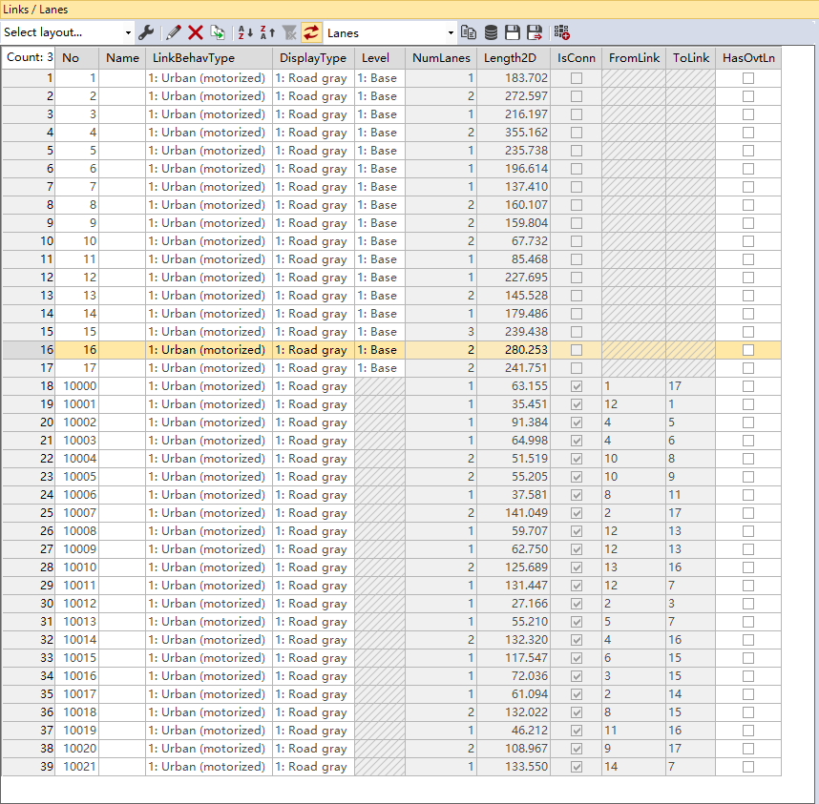

Vehicle input

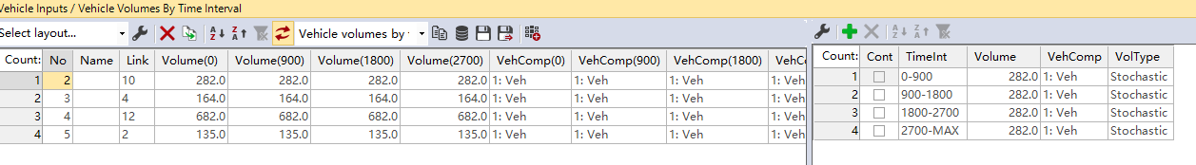

Conflict area

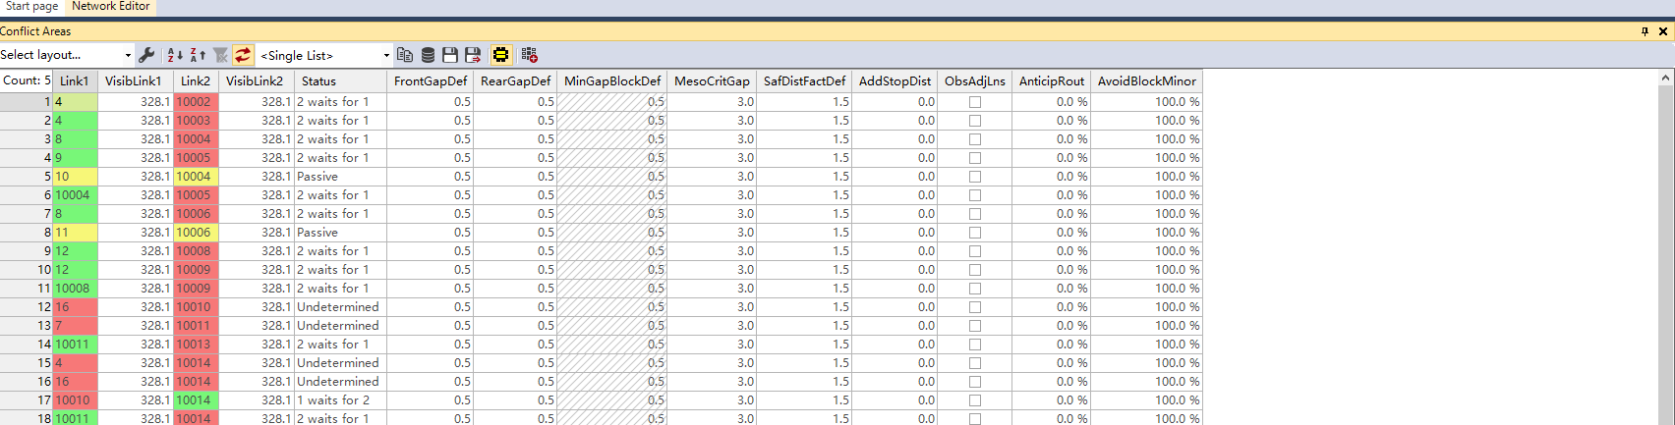

(2) Please choose three paths defined by yourself randomly, and check their travel time measures following the instructions:

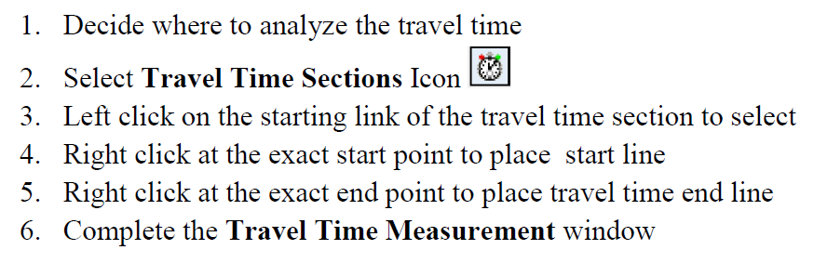

Then run the simulation and make sure the simulation is finished.

After that, go to “Evaluation” in the menu to “Result Lists” 🡪 “Vehicle Travel Time Result”, to show your result.

I selected link 15, 12 and 16 for the simulation.

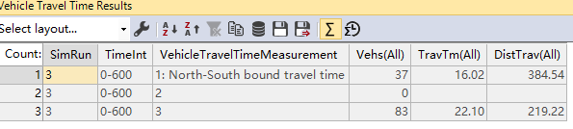

2. Please provide the derivation process of how the GM-1 car-following model is equal to Greenberg’s macroscopic speed-density model?

V=Vf-(Vf/Kj)\*K is Greenberg’s speed-density model, ${\ddot{x}}_{n+1}\left(t+∆t\right)=\frac{α_{0}}{x_{n}\left(t\right)-x_{n+1}\left(t\right)}\left[{\dot{x}}_{n}\left(t\right)-{\dot{x}}_{n+1}\left(t\right)\right]$

$$a_{n+1}\left(t+∆t\right)=\frac{α_{0}}{x_{n}\left(t\right)-x_{n+1}\left(t\right)}*\left[v_{n}\left(t\right)-v_{n+1}\left(t\right)\right]$$

$$\int{a_{n+1}}dt=\int{\frac{α_{0}}{x_{n}\left(t\right)-x_{n+1}\left(t\right)}*\left[v_{n}\left(t\right)-v_{n+1}\left(t\right)\right]}dt$$

Let S= $x_{n}\left(t\right)-x_{n+1}\left(t\right)$

$$\frac{dS}{dt}=v_{n}\left(t\right)-v_{n+1}\left(t\right)$$

Thus

$$\int{a_{n+1}}dt=α_{0}\int{\frac{dS}{S}}$$

$$v_{n+1}\left(t\right)=α_{0}logS+C$$

In this case, S is the space between each vehicle, thus S=1/k

With boundary condition when S is very small which is jam condition, v=0

$$0=α_{0}log\frac{1}{k_{j}}+C$$

We can solve C from above

$$v_{n+1}\left(t\right)=α_{0}log\frac{k_{j}}{k}$$

Since q=kv

q= $α_{0}*k*log\frac{k_{j}}{k}$

differentiating with k

$$\frac{dq}{dk}=α_{0}log\frac{k_{j}}{k}-α_{0}=0$$

Thus

Thus

3. Based on Little’s law, please derive why Q=KV.

L=λW

It is the average number in the lane is equal to the product of arrive rate(veh/hour) and time spend(hour/lane) in the line. Q=kv indicates the traffic flow equals to product of density and speed. Q is veh/hour; V is km/hour and K is veh/km. That is, veh/hour=km/hour\*veh/km. If we consider the length of lane is constant, it makes km=1. Veh/hour=1/hour\*veh/1 which is same as little’s law equation.

$$L=A-D$$

$$W=\int_{0}^{t}{Ldt}$$

Average number of vehicles in the system is $\overline{L}=\frac{W}{t}$

Same $\overline{W}=\frac{W}{A}$

And λ=A/t

In this case, we can use $\overline{L}$ as vehicle per hour which is Q, K is veh/km and V is km/hour. Since

$\overline{L}=\overline{W}*$ λ\*, thus Q=KV.