The Strak Machine

Short Instruction

Matthias Boese 2020

This short instruction will explain some basic functions of the Strak Machine, that are mandatory for using it.

Please take a look at „Strak_Machine_Reference“ for the full reference of functions that are included in the Strak Machine.

1. Main purpose / function of the Strak Machine

For aerodynamic reasons, the wing of an aircraft very often does not have a rectangular-shape with a constant chord-length all along the wingspan.

When the chord-length changes along the wingspan (even at a fixed airspeed), there will be a change in Reynolds-numbers that is proportional to the change in chord-length.

If the same airfoil is used all along a wing with changing chord-length, this will lead to a loss in performance of the wing, as the airfoil will only have the optimum performance at a certain position-range along the wing-span.

The Strak Machine can help to improve the overall wing-performance by creating a set of airfoils, that are optimized according to the different Reynolds-numbers that occur along the wing-span.

The user specifies a set of Reynolds-numbers for the root-airfoil and for the strak-airfoils, that will be passed to the Strak Machine by a parameter-file („strakdata.txt“).

Each specified Reynolds-number (except for the Reynolds-number of the root-airfoil, which is the first), will lead to a new airfoil to be created, that is optimized for this Reynolds-number.

In order to get the parameters to control the optimizer (which is Xoptfoil-JX) for creating the new airfoil, the root-airfoil will first be analyzed at the given Reynolds-numbers, using Xfoil to carry out polar-calculations.

The polars of the root-airfoil will be imported by the Strak Machine and a set of proposed target-polars for the new airfoils will be calculated.

The user can apply trim-values to each single target-polar to adapt the shape of the polar to his needs.

The target-polars will be used to generate input-files for Xoptfoil-JX, that will carry out the desired optimizations and will create the new airfoils.

2. Two different Versions: „Strak Machine pure“ / „Strak Machine instant“

As the current implementation of the Strak Machine is based on Python 3.x , usually a Python-Distribution and additional packages have to be installed in order to use it.

Also several paths (e.g. for the python-interpreter) have to be set and in some cases the windows-registry has to be patched, so that the command-line-arguments will be properly passed towards the python-interpreter.

Additional packages, like matplotlib, numpy, a Fortran-namelist-parser etc. have to be installed.

To improve „ease-of-use“ for those users, who do not have much experience with python, there will be a precompiled version of the strak-machine, that will run without having to install python.

This first version is called „Strak Machine instant“.
The Download-size of this version will be larger, as all necessary Python-scripts will be included in the „compiled“ .exe-version.
This version also is portable could even be started from an USB-stick.
But it should be mentioned here, that the starting time of this version is a little bit longer, because the exe-files will be automatically unzipped after starting them.

The second version „Strak Machine pupe“ is for advanced users, who already have a python-installation, know how to install additional packages and so can take advantage of the smaller download size.

Both versions in the end feature the same functions.

3. Getting Started

Before getting started, in case of „Strak Machine pure“ you may have to install Python.
You can follow the next 4 steps to complete the installation.
In case of „Strak Machine instant“ you can directly jump to step 3.5.

3.1 Strak-Machine pure: installing a Python-Distribution
Strak machine pure requires a Python 3.x-Installation.

The installation can either be downloaded from https://www.python.org/downloads/
or you can use „Python-Anaconda“, which is a bigger distribution that already includes the package „matplotlib“.

3.2 Strak-Machine pure: Installing additional packages

After you have installed Python 3.x, you have to install the following additional packages using the „pip install“ command in the windows commandline:

pip install f90nml
pip install colorama
pip install termcolor

If you did not choose Anaconda, but a smaller Python-Distribution, you will also have to execute:
pip install matplotlib

Note: In some python-versions a specific version of matplotlib is required, as there are dpendencies between the packages.

There is a specific pip-command to install a certain version of a package (hint: type „pip –help“ to get all features of pip).

3.3 Strak-Machine pure: patching the windows registry

You may have to patch the windows registry in order to get the commandline-arguments correctly passed to the python-interpreter.

To do this, open „RegEdit“ and navigate to HKEY_CLASSES_ROOT\Applications\python.exe\shell\open\command.
Right click on name (Default) and Modify. Enter (for Example):
"C:\ProgramData\Anaconda3\python.exe" "%1" %*

3.4 Strak-Machine pure: setting the path environment-variable

The path to the Python-Interpreter that you have installed has to be included in the „path“-environment-variable.

3.5 Both versions of Strak Machine: unzip the archive

Unzip the zip-archive „strakmachine_instant.zip“ or strakmachine_pure.zip“ to your desired location.

Inside the unzipped folder you will find a complete runnable version that is setup with an example „SD-strak“.

3.6 Starting the Strak Machine

Now you are ready to take a first look.

Start the batchfile „start_strakmachine.bat“

If every previous step was carried out correctly, the next thing you should see is a window showing the analysis of the „SD-airfoil“:

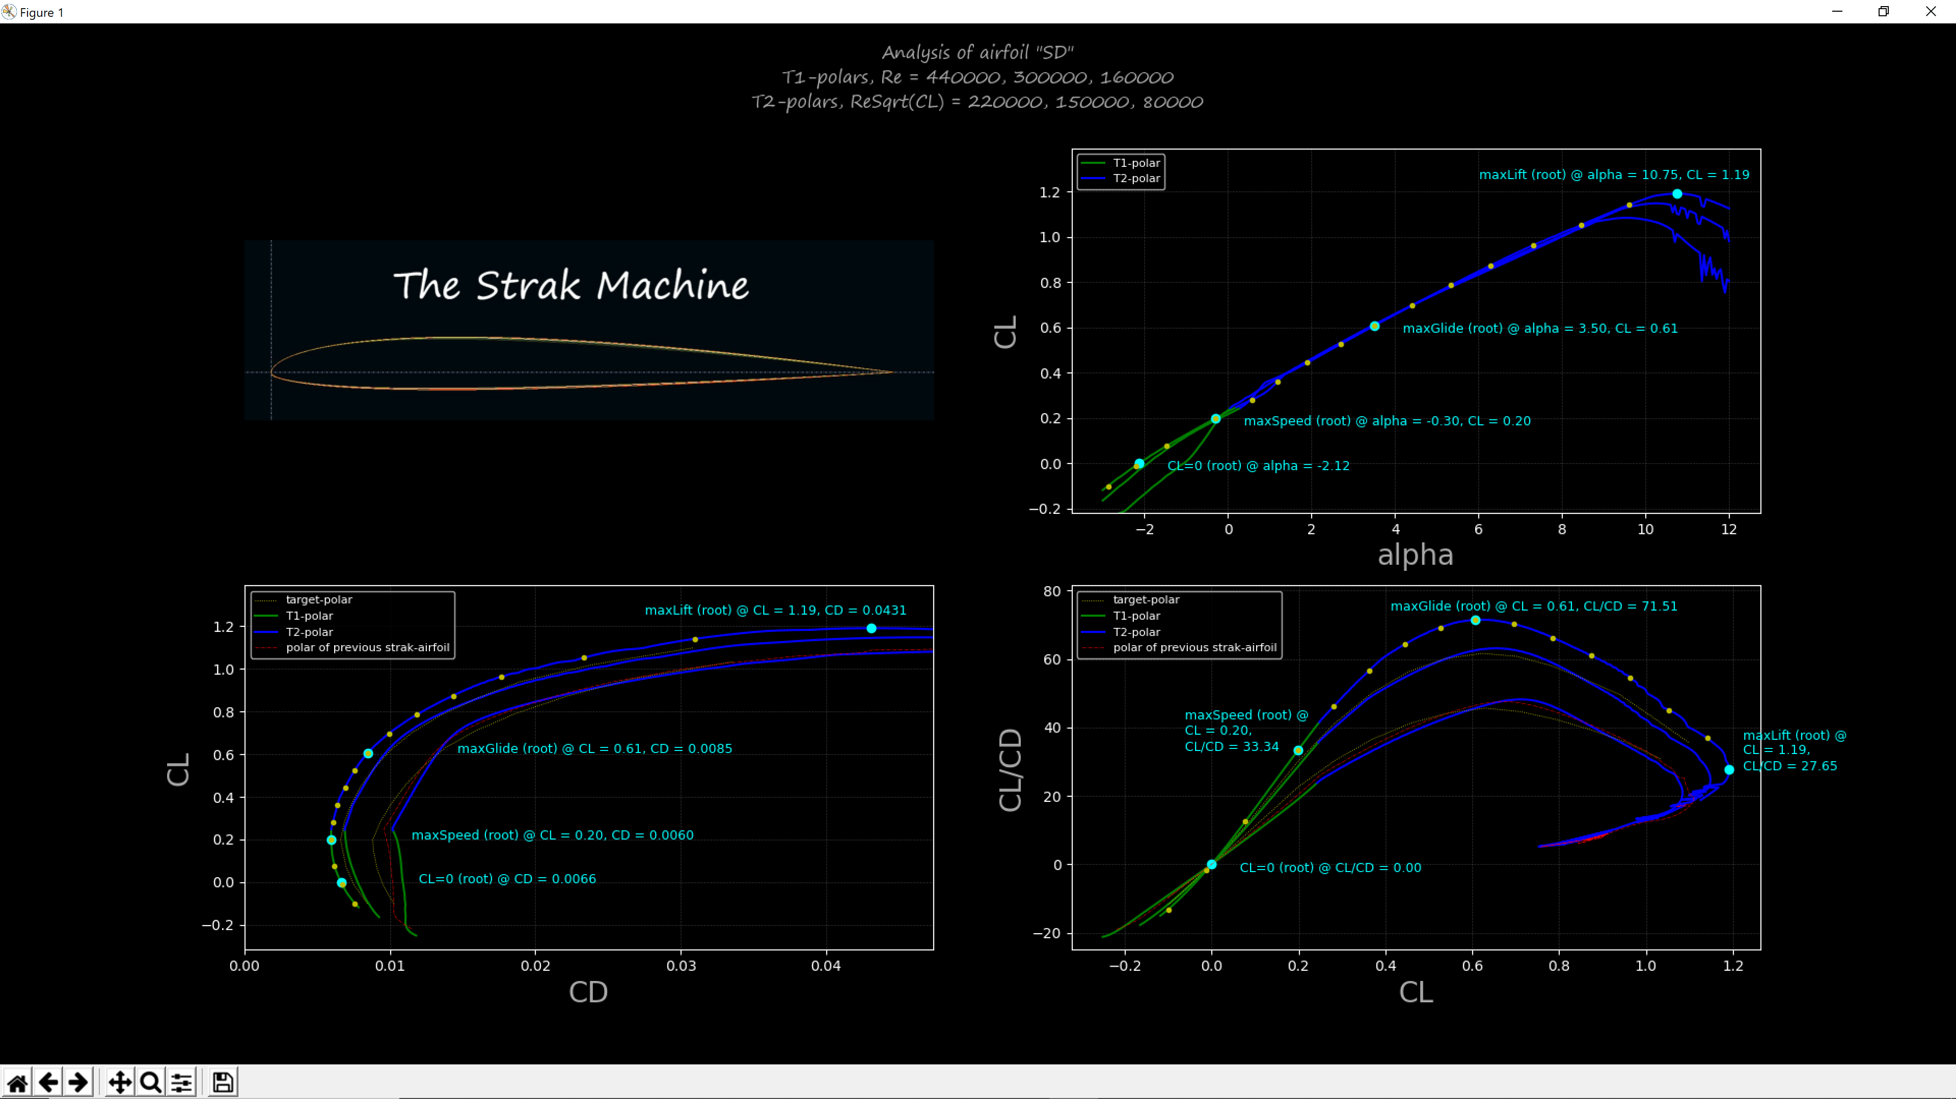
The window will be divided into for sub-windwos, showing the strak-machine-logo in the upper left sub-window and showing three graphs in the other three sub-windows.

containing the polars and further results of the analysation.
The upper left

4. The configuration-file „strakdata.txt“

