Planform-Creator
(Part of the Strak Machine)

Short Instruction

Matthias Boese V1.0, 29.11.2020

This short manual describes how to use the Python-Script / the program "Planform-Creator" in combination with the Strak-Machine to create the wing plan of a wing with only a few parameters.

The airfoils created with the Strak-Machine are automatically placed at the positions of the wing resulting from the respective Re-number.

The generated wing plan is displayed graphically and can thus be used, for example, as a template for creating a CAD model of the wing.

Furthermore, an XML file of the wing is generated, which can be imported into XFRL5.
With XFLR5, it is then possible to simulate and calculate the performance of the wing, including the airfoils created with the Strak-Machine.

1. Parameters of the Planform-Creator

"templateFileName": "plane_template.xml",
"outFileName": "MainWing.xml",
"planformName": "main wing",
"isFin": "false",
"wingspan": 3.98,
"fuselageWidth": 0.135,
"planformShape": "elliptical",
"leadingEdgeOrientation": "up",
"rootchord": 0.310,
"tipchord": 0.032,
"rootTipSweep": 4.0,
"hingeDepthPercent": 23.5,
"dihedral": 2.5,
"showQuarterChordLine": "true",
"showTipLine": "true",
"showHingeLine": "true"}

2. Types of planforms

The planform creator supports two types of planforms:
a) Elliptical planforms
b) simple trapezoidal planforms

3. Start of the planform-creator, generating an example-planform
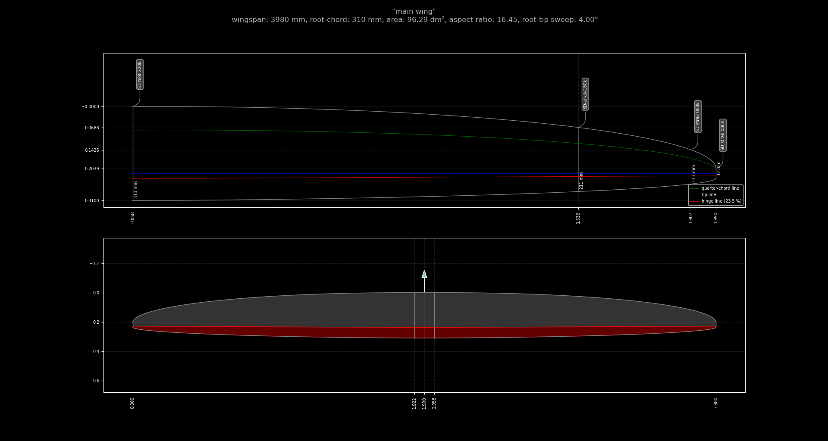

The graphics can be saved by clikcing the “disk”-Symbol in the toolbar:
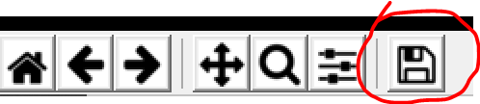

4. How to import the XML-file of the wing into XFLR5

