The Strak Machine

Reference

Matthias Boese V1.0, 25.09.2020

This reference gives a brief and concise overview of all functions included in the Strak Machine and should therefore be used in addition to the short instruction, which describes the basic operation, installation and use.

1. Console-output of the Strak Machine

After the Strak Machine has been started using the batch file "start_strakmachine.bat", a console window will open, showing some print output (actions, that have been performed by the Strak Machine, results of the analysis etc.)

In order to enable a "corporate design" and to emphasize the connection between Strak Machine and Xoptfoil-JX, the following specifications were made for certain print outputs, using different colors:

Error: (red) An error was found, due to which a further execution is no longer possible

Note: (cyan) A note for the user, no user intervention required

Warning: (yellow) There is something wrong, but further operation is still possible, the user should pay attention to this point

2. Parameters of the Strak Machine

The Strak Machine uses a configuration file called "strakdata.txt" in the „ressources“ folder, which contains all necessary configuration data.

The file has to be provided in json-format.

The parameters contained there are used to formulate the basic "job" of the Strak Machine (which one is the root airfoil, how many strak airfoils are to be created, which are the relevant Reynolds- numbers), and will be also used to adapt the operation of the Strak Machine to the specific requirements of the user.

The parameters of the Strak Machine can be roughly divided into mandatory parameters, which have to be adjusted by the user according to his project, and optional parameters, which can be understood as "expert settings" and are preset internally with default values.

2.1 Mandatory Parameters

The following is a list of the mandatory parameters that already have been described in the document "Strak Machine Short instruction".

If any of the mandatory parameters is missing in the file „strakdata.txt“, this will be detected after start and the user will get an Error:-message.

As these parameters are mandatory, there will be no default value automatically used if one of the parameters is missing.

In the case below the parameter seedFoilName has not been specified:

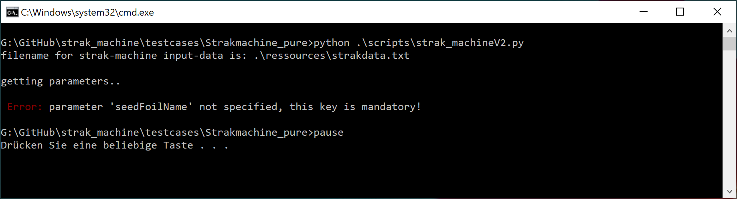

"xoptfoilTemplate"
The name of the template-file, that will be used in order to generate the input-files for Xoptfoil that are necessary for the airfoil-generation.
The advanced user also can provide his own template file here.
The name must be written without the ending „.txt“.
The file can be found in the „ressources“ folder.
The example-files “iOpt.txt” and “iOpt_HH.txt” will be included in the Strak Machine and can be used as a reference.

“iOpt.txt” will use “camb-thick-plus” airfoil-shaping functions, “iOpt_HH.txt” will use “Hicks-Henne” airfoil shaping functions.

Using “camb-thick-plus” is faster than using “Hicks-Henne” (about 4 times faster, less iterations are needed), but has more limitations concerning the possible solution space / the ability of changing the geometry of the airfoil and thus in some cases will not accurately achieve the desired target-polars.

If “Hicks-Henne” is used, the user also has to take care of setting the “constraints” correctly in the xoptfoil-template-file to ensure that curvature-checking (thresholds, number of reversals etc.) will match to the chosen root-airfoil.

The example-file “iOpt_HH.txt” will only provide a default constraint-setting, which will work correctly with the “SD.dat” root-airfoil.

Please have a look at the document “Xoptfoil-JX Reference” to get further information how to setup the constraints for curvature-checking.

"seedFoilName"
The name of the airfoil-file that will be used as the root-airfoil
The name must be written without the ending „.dat“.
The airfoil-data has to be provided as an ASCII-textfile in selig-format and must be located at the „ressources“ folder.

"minCLGain"
This trim-value will move the most lower point of the target polar to the left or right (if you look at the „C_{L} over C_{D}“ - graph).

Please Note: This parameter always has to be provided as a list (using [..,..] notation)

"maxSpeedGain"
This trim-value will move the point of lowest drag of the target-polar to the left or right (if you look at the „C_{L} over C_{D}“ – graph).

Please Note: This parameter always has to be provided as a list (using [..,..] notation)

"maxGlideGain"
This trim-value will move the point of best lift/ drag of the target-polar to the left or right (if you look at the „C_{L} over C_{D}“ – graph) or up and down, if you look at the „C_{L}/ C_{D} over C_{L}“-graph.

Please Note: This parameter always has to be provided as a list (using [..,..] notation)

"maxLiftGain"
This trim-value will have an influence on the operating point with the highest lift of the target polar.
The point can be moved to the left or right (if you look at the „C_{L} over C_{D}“ – graph) or up and down, if you look at the „C_{L}/ C_{D} over C_{L}“-graph.

Please Note: This parameter always has to be provided as a list (using [..,..] notation)

"maxGlideShift"
The value of „maxGlideShift“ specifies a C_{L}-difference for shifting the maxGlide-point (change C_{L} of the maxGlide point).

Please Note: This parameter always has to be provided as a list (using [..,..] notation)

„reynolds“
A list of numbers that represent ReSqrt(C_{L})-values for a type 2 polar calculation, the number of list-elements equals the overall number of airfoils.

The first number belongs to the root-airfoil, the following numbers belong to the following airfoils that shall be created.

Please Note: For a correct function of the Strak Machine the numbers must be sorted in descending order.
This parameter always has to be provided as a list (using [..,..] notation)

"maxReynoldsFactor"
This factor will be used to limit the maximum Reynolds-number that is used for the analysis of the airfoil.

The Strak-machine will always carry out two polar-calculations for each number that is specified in the „reynolds“-list.

1. Type 2-polar-calculation with ReSqrt(C_{L}) = number specified in the „reynolds“-list
2. Type 1-polar-calculation with Re = maxReynoldsFactor * number specified in the „reynolds“-list

2.2 Optional Parameters

Next you can find here a list of optional parameters, which include additional "expert settings".

These parameters can be inserted at any position or in any order in the file "strakdata.txt" on demand.

If these parameters are not specified by the user in "strakdata.txt", internal default values will be automatically used.

The respective default value is therefore specified for each parameter in this description.

After starting the Strak Machine in a commandline window you will also see a „Note“-Message displayed for each optional parameter, that has not been mentioned within „stradata.txt“.

The „Note“-Message will also show the default-value.

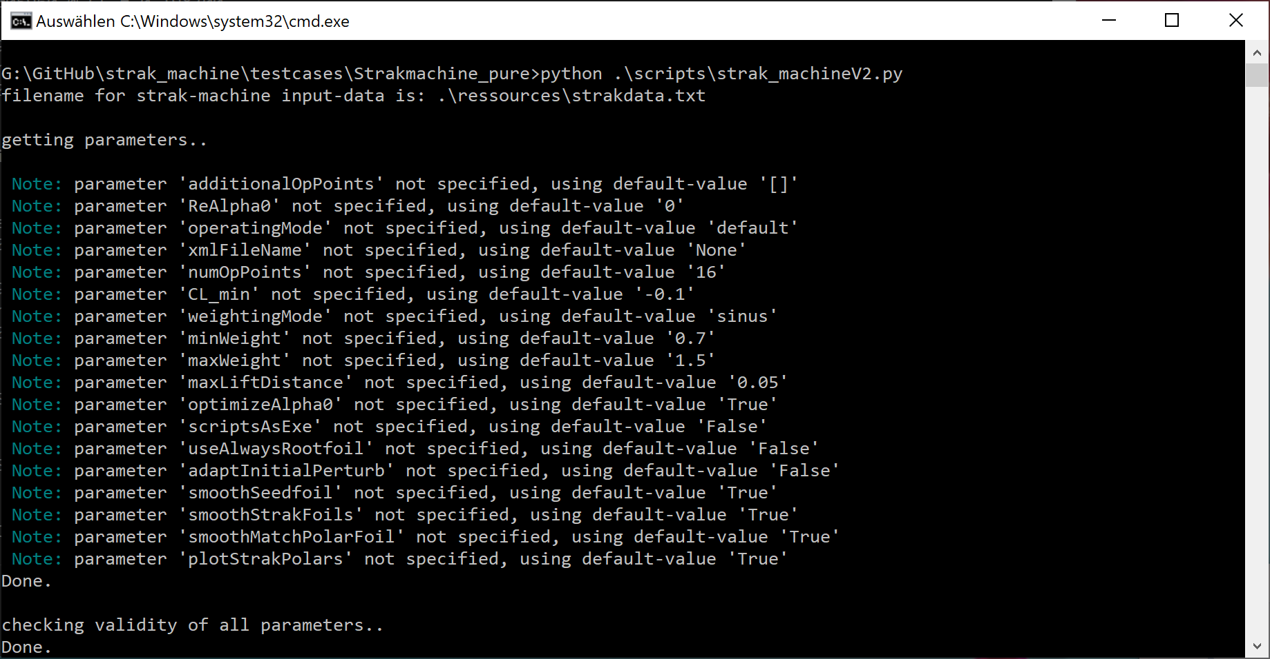

"optimizeAlpha0"
This parameter tells the Strak Machine, whether to carry out an optimization for the zero lift angle for the airfoil, that will be created (try to keep the same zero lift angle for the airfoil as the root airfoil has).
The zero lift angle between the root airfoil and the following airfoils will be compared at a different (usually higher) Re-number than has been specified for the lift/drag-targets.

The reason for this is, that at low Re-numbers the alpha/C_{L}-calculation of the model provided by Xfoil seems to correspond less well with the real world and thus will deliver unwanted results.

In the visualizer, you will very often notice that one of the operating points seems not to match with the other operating points.

This is the operating point used for optimizing the zero lift angle, calculated at a different Re-number.

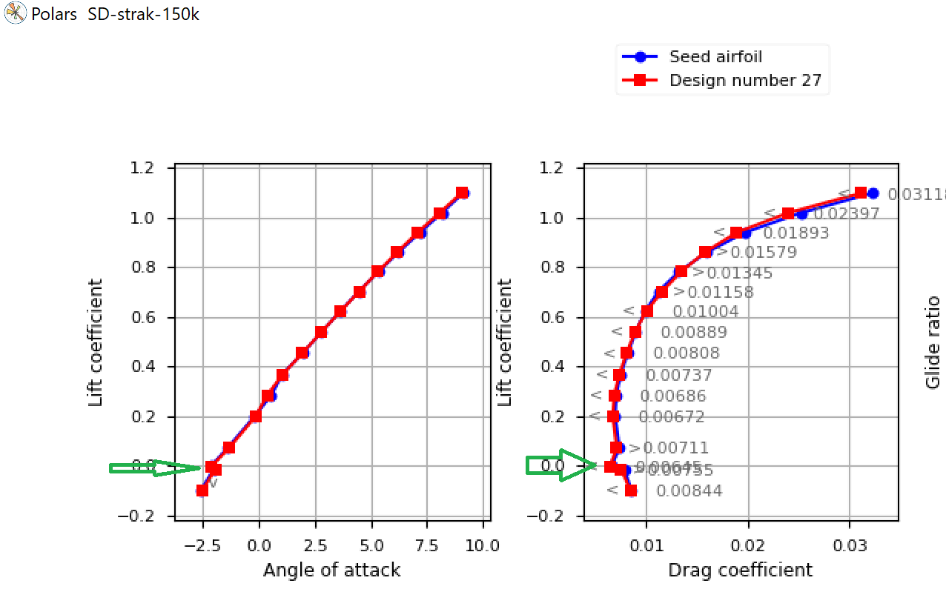
Default-value: „True“ (carry out this kind of optimization)
possible values: „True“, "False"

Please Note: This parameter always has to be provided as a list (using [..,..] notation)

„operatingMode“
As an option, it is possible to choose between different modes for operating the Strak Machine (two modes have been implemented so far).

The normal mode is the "default" mode and is used to create a set of airfoils which is derived from a root airfoil (the „normal“ operation of the Strak Machine).
Everything described so far here and also in the short instruction refers to this default mode.

For development and verification purposes there is another mode, this is the so called "matchpolarfoils" mode.

Analogous to the "matchfoils" mode in Xoptfoil, this mode is used to convert a given profile into another using the optimizer.

Only in this case not in a direct way directly using the airfol coordinates, but via the detour of the airfoil polars.
This is a very interesting experimental mode.
In this way it can be determined, for example, how exactly the geometric data of an airfoil can be reconstructed from the airfoil polars with the help of the optimizer.
Another, future mode could be that first the root airfoil is created, e.g. based on target values from an Excel spreadsheet, and then the other airfoils are created on this basis.

Default-value: „default“
possible values: „default“, "matchpolarfoils"

„xmlFileName“
This parameter is currently of experimental character and serves the purpose of importing a given wing geometry, which is available as an XML file in XFLR5 format, and then automatically deriving the required Reynolds numbers from it.

Currently the XFLR5 file must contain the complete "plane" as data, so that the xml-parser can correctly find the data of the main wing.
In a future version it is planned that only the data of one wing must be included.

Default-value: None (Do not use a XML-File)

„numOpPoints“
The polar of the root airfoil is mapped using discrete points, which are distributed as evenly as possible on the polar by a special algorithm.
The number of points used for this can be set with this parameter.
The minimum number of points has to be >= 5 and this will be checked by the Strak Machine.
It should be noted that the number of points always includes one point for the definition of the zero lift angle, which is always counted (regardless, if the optimization for this angle is switched off, or not).
However, this point is not displayed in the graphic windows of the Strak Machine.
The number of points has a linear effect on the time Xoptfoil needs for the calculation (the more points, the higher the calculation time), but also has an effect on the accuracy with which the polars of the root profile can be mapped (the more points, the more accurate).
A compromise should be sought here between the required calculation time and the desired quality of the result.
It is suggested to use at least 13 points.

Default-value: 16

„CL_min“
This parameter determines the minimum value of C_{L} from which on an analysis of the root airfoil is performed.
This value is also the starting point of all target-polars.
Depending on the requirements of the range of lift which shall be included in the analysis, this parameter can be adjusted.

Default-value: -0.1

„weightingMode“
A „weighting“ must be assigned to each operating point in the xoptfoil-inputfile (for more information please refer to the Xoptfoil-reference).
This is done automatically by the Strak Machine.
Since a variable number of operating points can be specified with the help of an automatism, it is also necessary to specify the weighting of the operating points automatically.
For this purpose two different algorithms can be selected.
In the mode "sinus" a sinusoidal distribution of the weighting with a maximum in the “maxGlide”-point is given.
Especially when using the airfoil-shaping via "camb-thick-plus" this weighting mode has proved to be very useful.
If this weighting mode has been selected, the maximum and minimum weighting can also be specified separately (see the following parameters "maxWeight", "minWeight").
Theoretically it also would be possible to do the weighting "inverse" (with a minimum in the point maxGlide)
In the "constant" mode, a constant weighting is specified for all operating points.
The parameters "maxWeight", "minWeight") are irrelevant in this case.

Default-value: „sinus“
possible values: “sinus”, “constant”

„minWeight“
The minimum value used for weighting.
Only relevant if "weightingMode": "sinus" is selected.

Default-value: 0.7

„maxWeight“
The maximum value used for weighting.
Only relevant if "weightingMode": "sinus" is selected.

Default-value: 1.5

„maxLiftDistance“
In the context of polar calculation using XFOIL, convergence problems can occur, especially in the range of high C_{L} values.
This means that the calculation of the polar curve at this operating point could not be performed successfully and the calculated values show a high deviation / inaccuracy and can not be used for an exact analysis of the airfoil.
The parameter "maxLiftDistance" defines a safety distance for the point of the target polar curve with the highest lift coefficient from the point with the highest lift coefficient of the root-airfoil.
This means for example, if the root airfoil has the point with the highest lift at C_{L} = 1.19, the point of highest lift of the target-polar will be at C_{L} = 1.14.

Default-value: 0.05

“additionalOpPoints”
This parameter allows the user to define own points on the polar of the root airfoil, which should be included in the analysis.
Each value provided in this list stands for the C_{L} of an operating point.
With the help of the additional operating points, for example, a predominantly manual allocation of the operating points is possible by setting the value of "numOpPoints" to 5.

Default-value: no additional op-points

Please Note: This parameter always has to be provided as a list (using [..,..] notation)

“ReAlpha0”
This parameter can be used to specify a demanded Reynolds-number that will be used for matching the zero lift angle of all airfoils (see also the description of the parameter "optimizeAlpha0").
If no value is specified or the parameter is set to zero (which is the same), then the Reynolds-number of the root-airfoil will be used for all zero lift angle-calculations.

Example (showing two lines of “strakdata.txt”:
"reynolds": [220000, 150000, 80000],
"maxReynoldsFactor": 2.0

→ Reynolds-number for the zero lift angle will be 220000 * 2.0 = 440000

Default-value: 0

“scriptsAsExe”
This parameter must be set “True” in case of “Strak Machine instant”.
The Strak Machine will generate batchfiles automatically, that shall be used for creation of the whole strak, for starting the visualizer etc.
In case of “Strak Machine instant” the call of the required tools, like Strak Machine and visualizer will be “.exe” calls instead of calling the python-interpreter.

Default-value 'False' (set-up for “Strak Machine Pure”)

“useAlwaysRootfoil”
This parameter determines whether a subsequent airfoil should be created based on the predecessor airfoil or always based on the root airfoil.
If this parameter is set to "True", this means that each strak airfoil should be created based on the root airfoil.
The advantage of creating based on the root airfoil is that the order in which the subsequent airfoils are created is not important (you could even start with creating the tip-airfoil).
The big advantage of creating a new airfoil based on the previous airfoil is that the difference that the optimizer has to correct for the creation of the new airfoil is optimally small and therefore better results can be achieved by using only one single run of the optimizer.

Default-value 'False' (always use the respective predecessor airfoil)
possible values: „True“, "False"

“adaptInitialPerturb”
One parameter within the xoptfoil-template-file is the parameter "inital_perturb":

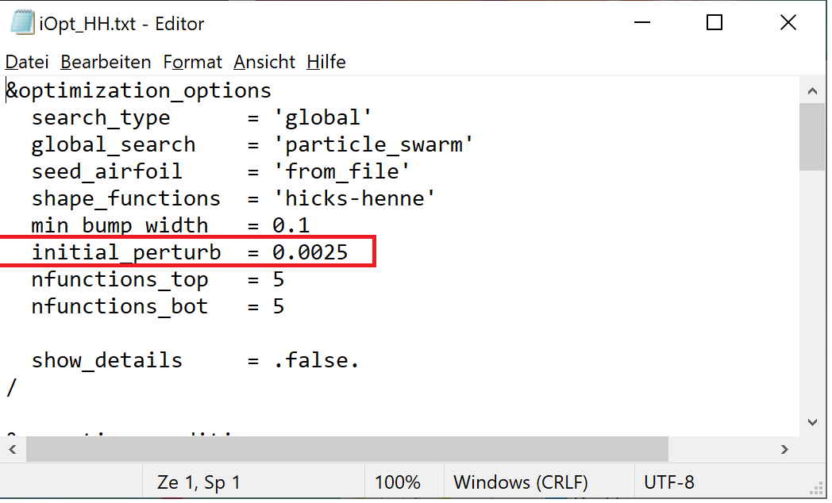
The parameter "inital_perturb" influences the initial search radius of the particle swarm optimization of Xoptfoil.
You can think of it roughly like the first shot in billiards, where the strength of the shot determines how far apart the balls are.
Depending on how large the change to the initial airfoil to be made by the optimizer is, a more or less "powerful" impact is needed to actually achieve the required changes.

If "adaptInitialPerturb" is set to the value "True", the Strak Machine tries to determine the optimum value of "inital_perturb" automatically based on the difference of the Reynolds numbers between the current airfoil to be created and the previous airfoil (the parameter "useAlwaysRootfoil" is also considered).

This function is currently still experimental.

Default-value 'False' (use always the value “initial_perturb”, as it has been defined in the xoptfoil-template file
possible values: „True“, "False"

“smoothSeedfoil”
This parameter determines whether an automatic "smoothing" of the root airfoil using "Xfoil-worker.exe" should be performed or not.
Especially older airfoils whose data has been downloaded from the Internet sometimes have a low number of points and a coarse discretization of the points (few decimal places).
This can affect the calculated polars.
The smoothing function changes the number of interpolation points and smoothes the airfoil before it is used as a root airfuil to build up further strak airfoils.
If this function is active, all polar calculations are also based on the smoothed airfoil.
The smoothed root-airfoil can be found in the “build\airfoils”-folder

Default-value 'True' (automatic smoothing will be carried out)

“smoothStrakFoils”
This parameter determines whether an automatic "smoothing" of the created strak-airfoils using "Xfoil-worker.exe" should be performed or not.
If this function is active, all polar calculations are also based on the smoothed airfoils.
The smoothed strak-airfoils can be found in the “build\airfoils”-folder

Default-value 'True' (automatic smoothing will be carried out)

“smoothMatchPolarFoil”
This parameter determines whether an automatic "smoothing" of the so called “match-polar-foil” using "Xfoil-worker.exe" should be performed or not.

Default-value 'True' (automatic smoothing will be carried out)

“plotStrakPolars”
This parameter determines whether the polars of the respective predecessor airfoil should be displayed within the three graphs of the Strak Machine, if they have already been created.
These polars can be useful as a guide for manually setting the trim values of the target-polars.

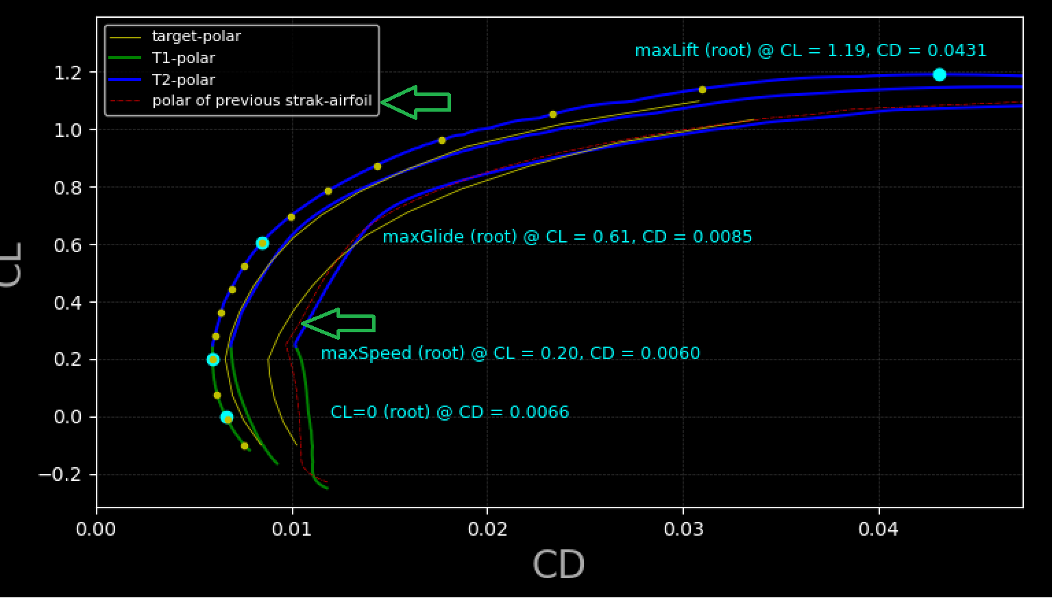
Default-value 'True' (the polars of the respective predecessor airfoils will be shown)

3. Unwanted results and what can be done about them

This chapter is still under construction and will be continuously expanded in the future.
During the use and parametrization of the Strak Machine by the user, it can happen that the desired results regarding the geometry of the profiles or polar shape are not achieved.
This chapter is intended to show causes and possible remedial measures to correct this.

3.1 Correcting misbehavior regarding the geometry of the created airfoils

3.1.1 The airfoil was created too thick, compared to the predecessor airfoil
Correct the value of "maxSpeedGain", increment the value, so that lower drag at the point of lowest drag is requested.
Start the Strak Machine to make the new value effective, then create the respective airfoil again.

3.1 Correcting misbehavior regarding the polars of the created airfoils

