vaelora Deployment Guide

Step 1: Source Code

1. Register a GitHub account

2. Fork the repository
Fork the repository (https://github.com/jxl970225/vaelora) to your own account.

Step 2: Deployment

1. Register a Cloudflare account

2. Deploy R2
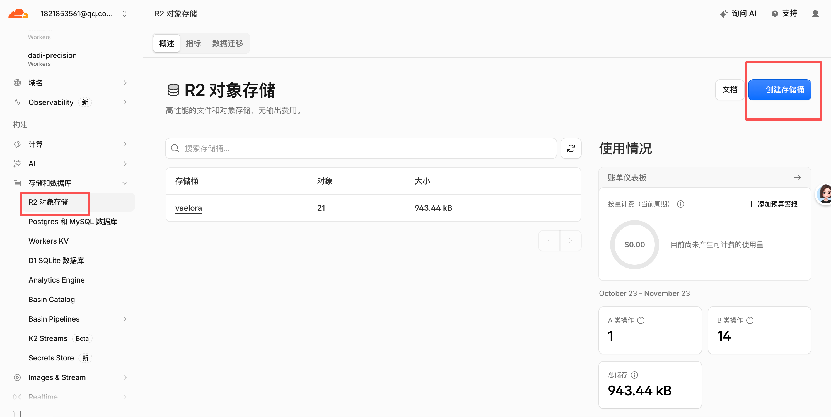
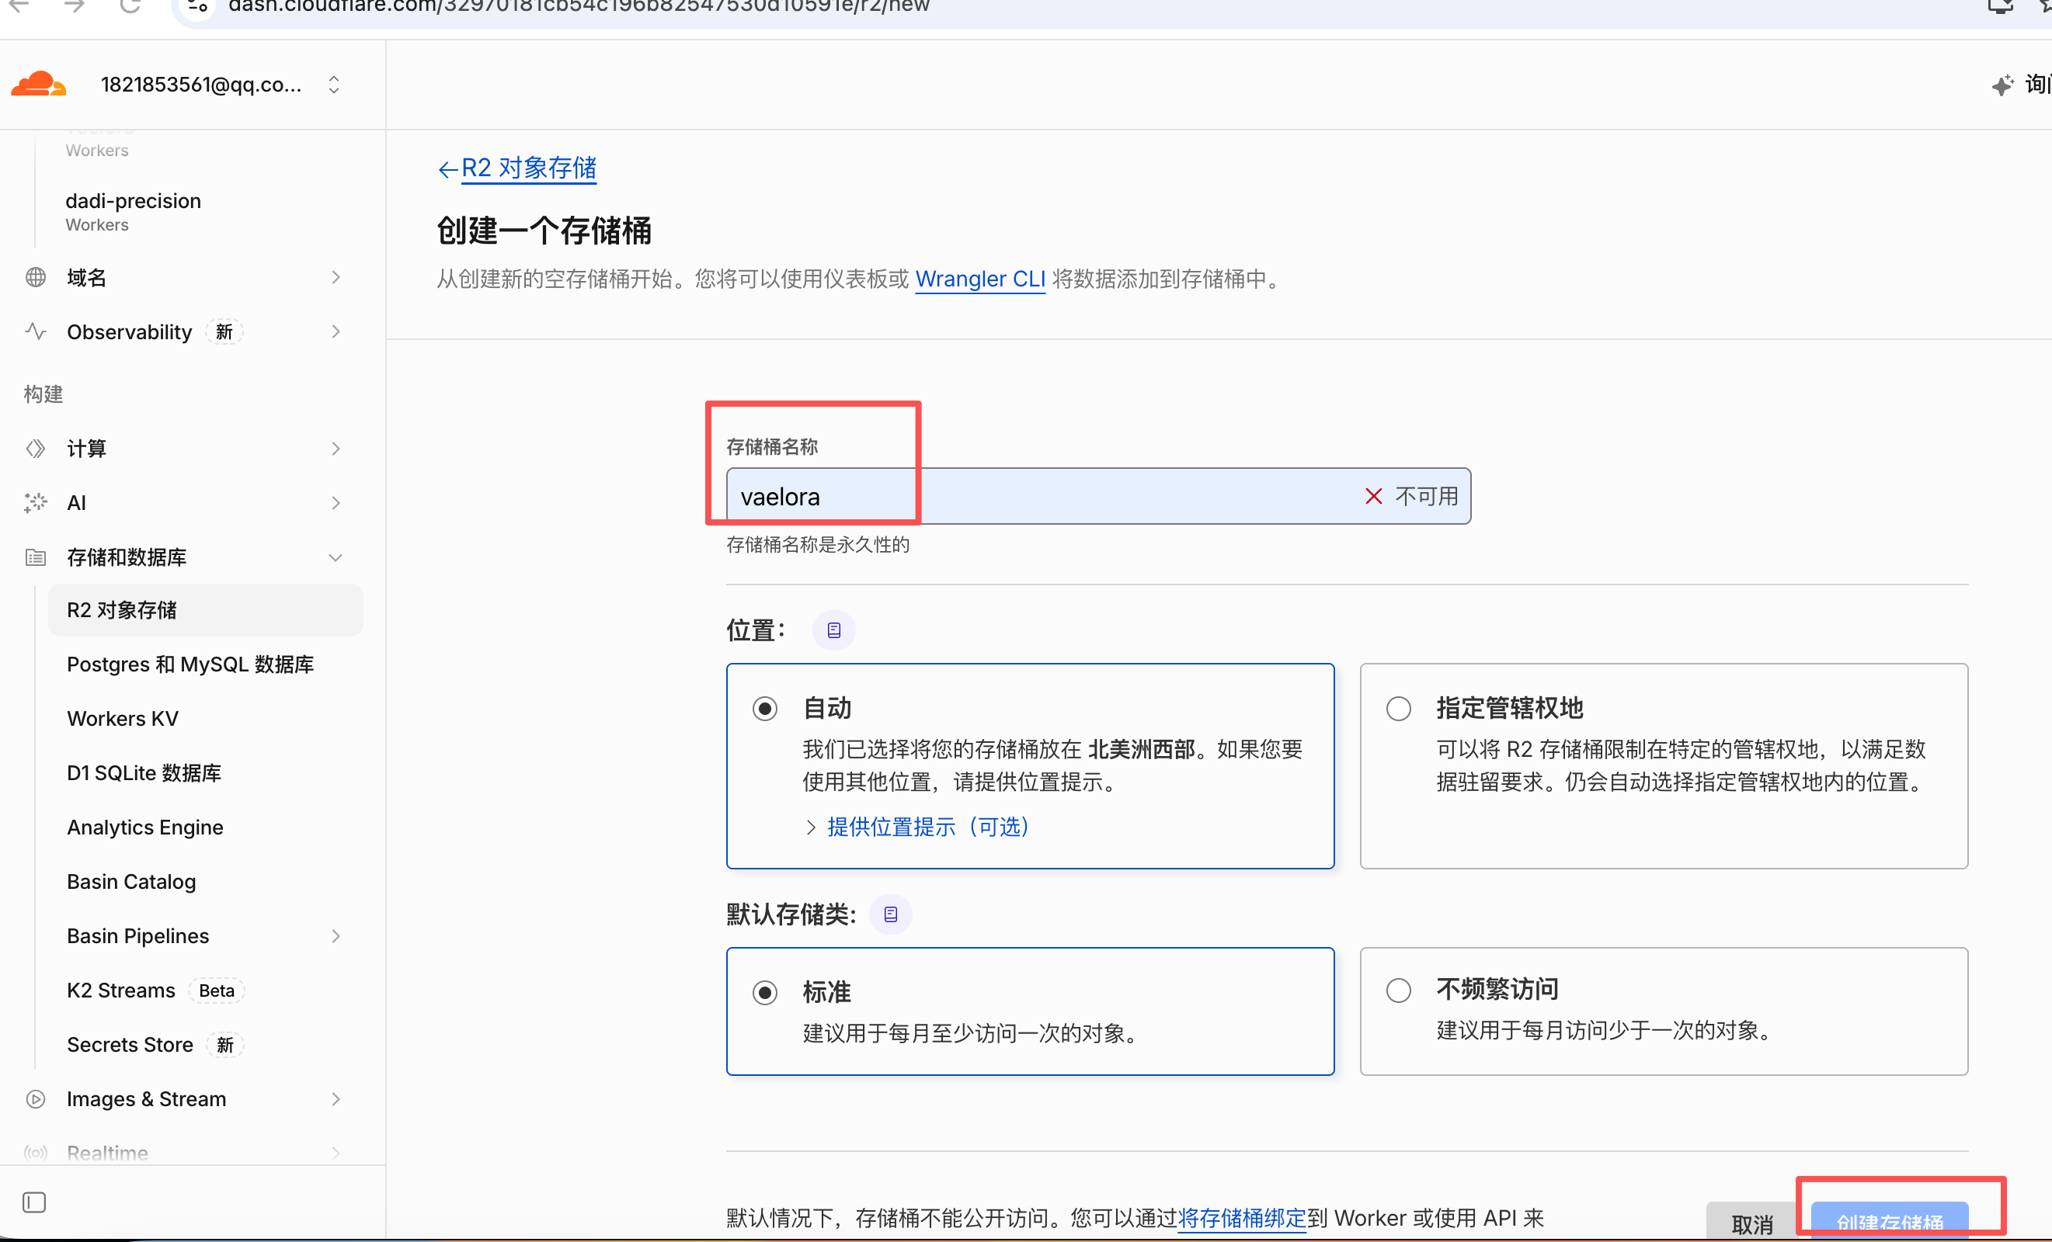

3. Deploy Worker (Works)
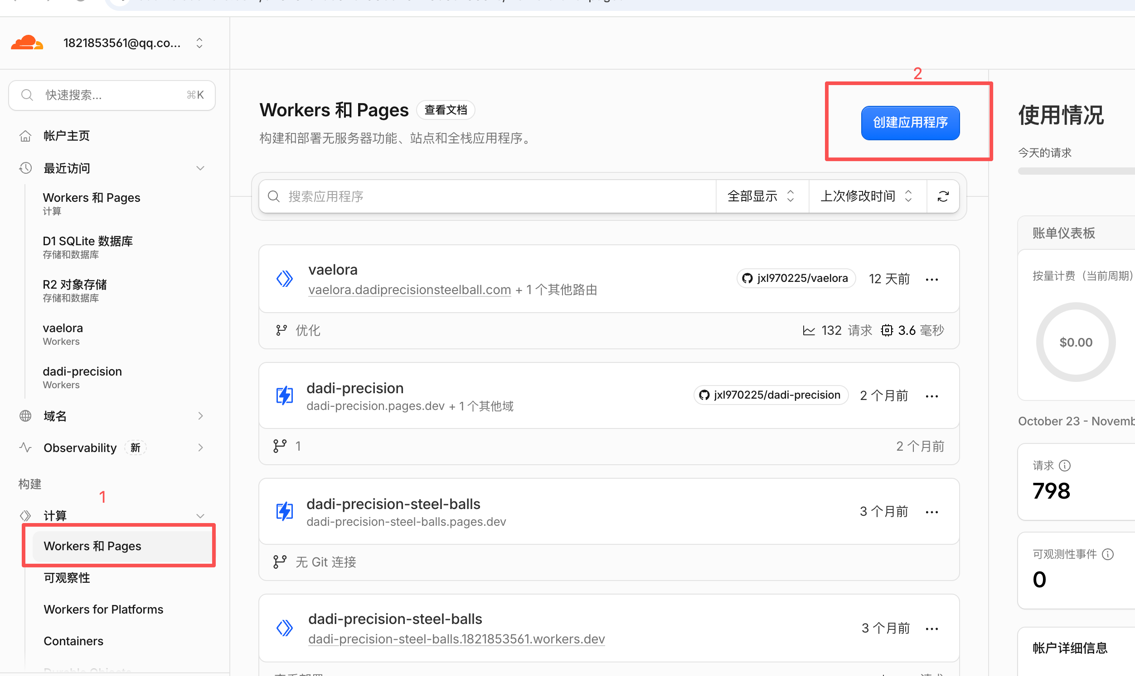
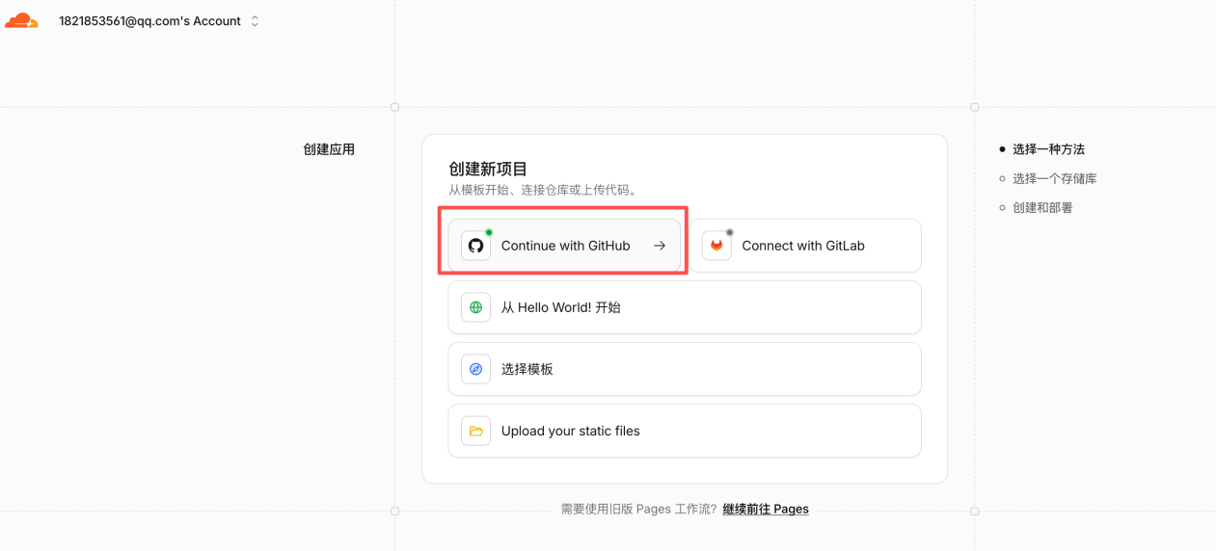
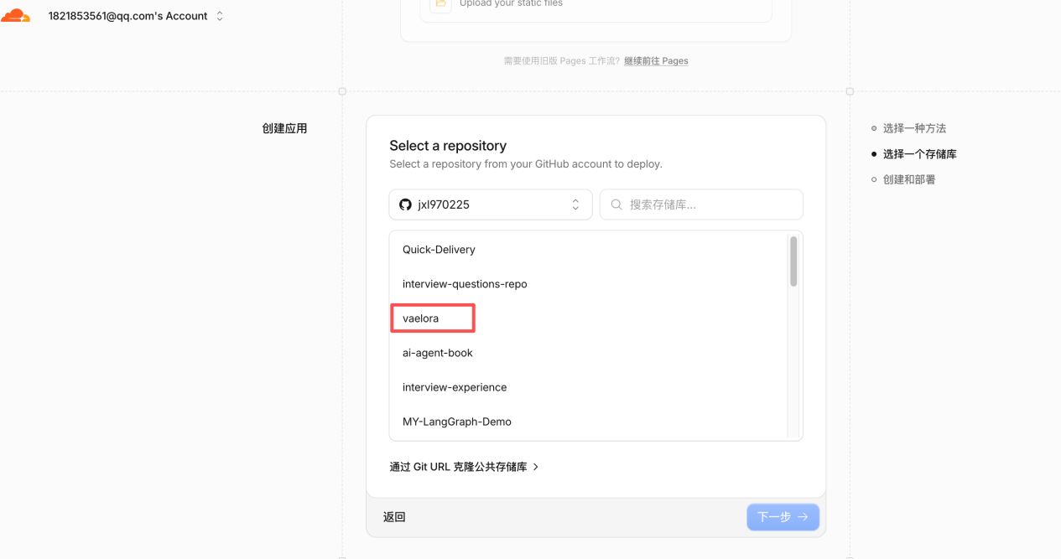

4. Configure variables
ADMIN_PASSWORD_HASH: 240be518fabd2724ddb6f04eeb1da5967448d7e831c08c8fa822809f74c720a9
ADMIN_USER: admin
MAX_UPLOAD_BYTES: 8388608
SESSION_SECRET: admin
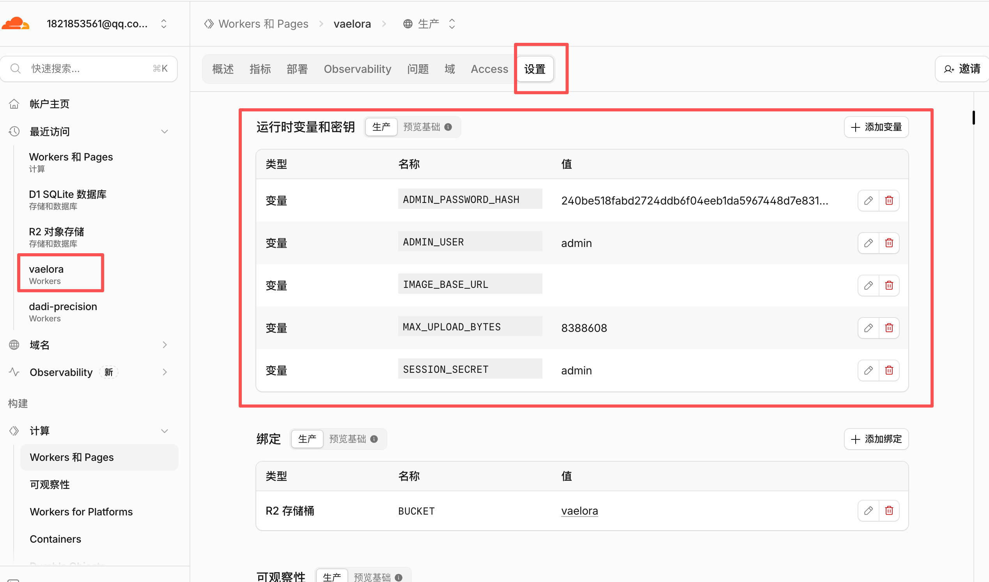

Bind a Domain
You need to register a domain first.


