 | TDE Form E1

Faculty of Technology, Design and Environment - Ethics Review Form E1

- This form should be completed jointly by the Supervisor and Student who is undertaking a research/major project which involves human participants.

- It is the Supervisor who is responsible for exercising appropriate professional judgement in this review.

- Before completing this form, please refer to the University Code of Practice for the Ethical Standards for Research involving Human Participants, available at https://www.brookes.ac.uk/sites/research-support/research-ethics-and-integrity/policies-procedures-and-useful-documents/obu-urec-code-of-practise-policies and to any guidelines provided by relevant academic or professional associations.

- Note that the ethics review process needs to fully completed and signed before fieldwork commences.

- Project Title:
ProsePal:An Intelligent Writing Assistant for Web Novel Authors
- Name of Supervisor and School in which located:
Clivia，Chengdu University of technology
- Name of Student and Student Number:
Hanna 202218020401
- Brief description of project outlining where human participants will be involved (30-50 words):
This project develops an "Intelligent Writing Assistant" for web novel authors. Human participants (authors and editors) will be involved in initial interviews to define software requirements and later in User Acceptance Testing (UAT) to evaluate the software prototype and provide feedback.

 |  | Yes | No
1. | Does the study involve participants who are unable to give informed consent (e.g. children, people with learning disabilities)?
2. | If the study will involve participants who are unable to give informed consent (e.g. children under the age of 18, people with learning disabilities), will you be unable to obtain permission from their parents or guardians (as appropriate)?
3. | Will the study require the cooperation of a gatekeeper for initial access to groups or individuals to be recruited (e.g. students, members of a self-help group, employees of a company)?
4. | Are there any problems with the participants’ right to remain anonymous, or to have the information they give not identifiable as theirs?
5. | Will it be necessary for the participants to take part in the study without their knowledge/consent at the time? (e.g. covert observation of people in non-public places?)
6. | Will the study involve discussion of or responses to questions the participants might find sensitive? (e.g. own traumatic experiences)
7. | Are drugs, placebos or other substances (e.g. food substances, vitamins) to be administered to the study participants?
8. | Will blood or tissue samples be obtained from participants?
9. | Is pain or more than mild discomfort likely to result from the study?
10. | Could the study induce psychological stress or anxiety?
11. | Will the study involve prolonged or repetitive testing of participants?
12. | Will financial inducements (other than reasonable expenses and compensation for time) be offered to participants?
13. | Will deception of participants be necessary during the study?
14. | Will the study involve NHS patients, staff, carers or premises?

Signed: |  | Supervisor
Signed: | 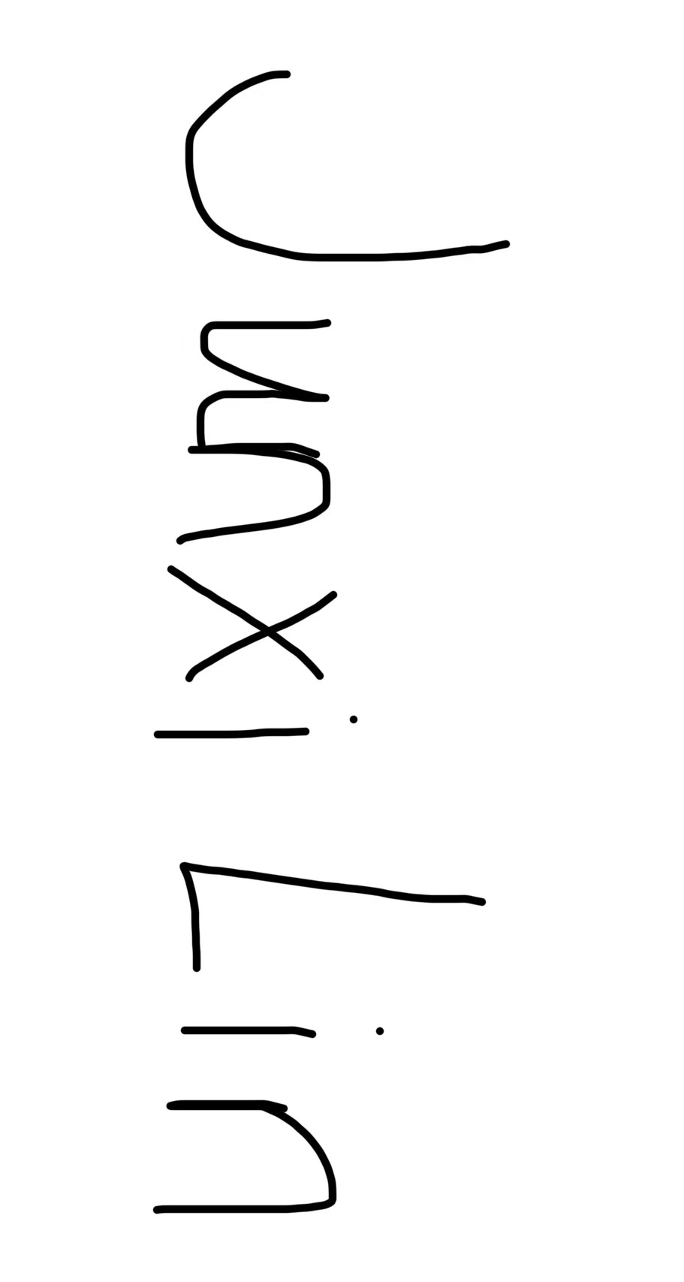 | Student
Date: |  | 30/10/2025

What to do now:

- If you have answered ‘no’ to all the above questions:

- The student must send the completed and fully signed E1 form to their Dissertation Module Leader.
- The student must keep a copy of the E1 form which must be bound into their dissertation as an appendix.
- The supervisor must keep a copy of the E1 form as they are responsible for monitoring compliance during the fieldwork.

- If you have answered ‘yes’ to any of the above questions:

- The supervisor and student must complete the TDE E2 form available at https://www.brookes.ac.uk/sites/research-support/research-ethics-and-integrity/research-ethics/ethics-application-process-forms/forms-and-templates-for-masters-and-undergraduate
- Note that the information in the E2 must be in sufficient detail for the ethical implications to be clearly identified.
- The signed E2 and signed E1 Form must be emailed to Tim Jones (tjones@brookes.ac.uk) who is the Faculty Research Ethics Officer (FREO) for review. Please allow at least two weeks for this review process.
- If/when approved the FREO will issue an E3 Ethics Approval Notice.
- The student must send the E1, E2 and E3 Notice to the Dissertation Module Leader.
- The student must also keep copies which must be bound into their dissertation as an appendix.
- The supervisor must keep a copy of documentation to monitor compliance during field work.

- If you answered ‘yes’ to any of questions 1-13 and ‘yes’ to question 14, an application must be submitted to the appropriate NHS research ethics committee. This is an onerous and time consuming process so the supervisor should liaise early with the FREO if the student is considering this.

