UNDERGRADUATE PROJECT PROPOSAL

Project Title | ProsePal:An Intelligent Writing Assistant for Web
 | Novel Authors
Student ID | 202218020401
Supervisor Name | Clivia
Student Name | Hanna
Student Major | Software Engineering

 |  | Date Submitted | 30/10/2025

Table of Contents

Table of Contents I
Chapter 1. Introduction 1
1.1 Background of Study 1
1.2 Project Aim 1
1.3 Project Objectives 1
1.4 Project Overview 2
1.4.1 Scope 2
1.4.2 Audience 3
1.5 Proposed Structure of the Report 3
Chapter 2. Background Review 5
2.1 Fundamental Description of Software 5
2.2 Background Review 5
2.3 Limitations of Existing Works 6
2.4 Summary 6
Chapter 3. Methodology 7
3.1 Problem Statement 7
3.2 Approach 7
3.3 Technology 8
3.4 Project Version Management Plan 9
3.5 Summary 9
Chapter 4. Project Management 10
4.1 Activities 10
4.2 Schedule 10
4.3 Data Management Plan 11
4.4 Project Deliverables 11
References 12

Chapter 1. Introduction

Background of Study
With the rise of digital media, web literature has become a lifeful and significant component of the global cultural industry, attracting hundreds of millions of readers and creators [1]. However, despite this creative boom, many authors still rely on universal office software such as Microsoft Word, Google Docs for their work. While powerful, these tools were designed for general document processing and fall short of meeting the complex demands of long-form narrative works, especially web novels, which require functionalities like non-linear chapter management, visualization of character relationships, and check the coherence of the plot [2].
Creators often face too many challenges,such as including frequently switching between multiple applications to consult research data, manage ideas, and organize outlines, which significantly fragments their creative focus and reduces efficiency. Furthermore, the manuscripts revision process often relies on subjective communication between authors and editors,lacking of tools for data analysis to assist in revision.The advancement of modern computational linguistics and human-computer interaction offers a potential solution to these pain points [3]. Therefore, develop a writing assistant system specifically designed for web novel author—integrating intelligent analysis and efficient collaboration—is of significant practical importance and applicational value.

Project Aim
The primary aim of this project is to design and implement an integrated software called "ProsePal." This system aims to significantly enhance the creative output, quality of works, and collaborative experience of online novel authors by providing a platform that integrates creative conception, writing, analysis, and collaboration.

Project Objectives
To achieve the project aim, the following types of work will be performed:
- Research and Analysis Work: To conduct a comparative analysis of existing writing tools to define functional baselines and identify key market gaps.
- System Design Work: To perform system and software architecture design, including the creation of database schemas, API specifications, and high-fidelity UI mockups.
- Implementation and Development Work: To program the front-end and back-end modules of the application, including the core text editor, document management system, and intelligent analysis etc.
- Integration Work: To integrate the core application with third-party services and libraries, specifically for NLP functionalities and real-time collaboration features.
- Testing and Quality Assurance Work: To execute a comprehensive testing strategy, including the development of unit tests, the execution of integration tests, and the coordination of user acceptance testing to ensure software stability and reliability.

Project Overview
This project aims to develop an intelligent writing assistant software specifically designed for web novel creators. It combines traditional text editing function with advanced data analysis, project management, and online collaboration tools to solve the efficiency bottlenecks and the difficulties of creat that authors currently face in their workflow.

1.4.1 Scope
The software will provide a focused, integrated environment through the following detailed functionalities:
Intelligent Document Management:
- Real-time Cloud Synchronization: All work will be auto-saved and synced across devices.
- Version History: The system will automatically save snapshots of the document, allowing users to review, compare , and restore previous versions.
- Visual Chapter/Outline Management: A dedicated panel will allow authors to view their manuscript as a collection of "cards", which can be reordered via drag-and-drop to restructure the plot.
Integrated Research Environment:
- Split-Screen View: An embedded browser will allow writers to conduct research within the same window as their manuscript, eliminating context-switching.
- Research/Note Manager: A "corkboard" or notes section will allow users to clip text, images, and links from the web, and link them to specific chapters or characters.
NLP-Powered Intelligent Analysis:
- Character Relationship Mapping: The system will automatically parse the text to identify character interactions and generate a visual graph of their relationships.
- Sentiment Analysis: A "Story Emotion Curve" will be generated, plotting the emotional valence of the narrative chapter by chapter to help authors manage pacing.
- Consistency Checker: Authors can create "character sheets" with key traits.The tool will flag potential contradictions found later in the text.
Seamless Collaboration:
- Role-Based Access Control: Project owners can invite collaborators as "Editors" (full edit/comment rights) or "Viewers" (read-only).
- Suggestion Mode: Similar to "Track Changes" in Microsoft Word, editors can make suggestions that the author can then accept or reject individually.
- Real-time Comments: A comment thread will be available for discussions, supporting mentions to notify specific collaborators.

1.4.2 Audience
The findings and deliverables of this project will primarily benefit the following groups:
- Web Novel Authors: As the core users, they will directly benefit from a more professional and intelligent creative environment, allowing them to focus more on the art of storytelling.
- Content Editors and Planners: They can leverage the system's collaborative and analytical features to guide authors more effectively, assess manuscript quality, and gain a high-level understanding of a work's structure and potential.

Proposed Structure of the Report
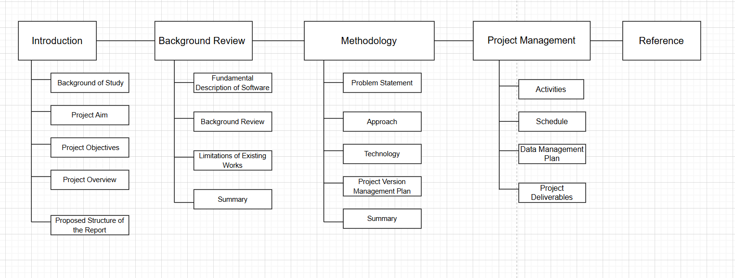

Figure 1-1. Project structure flowchart

Chapter 2. Background Review

Fundamental Description of Software
The ProsePal is a writing assistant software. It is a category of applications designed to help users improve their writing efficiency and quality. Core functionalities typically include text editing, formatting, and spell/grammar checking. With technological advancements, modern writing tools have evolved beyond basic word processing to integrate advanced features such as project management, research organization, distraction-free writing modes, and online collaboration to meet the specific needs of various domains [4]

Background Review

Comparative Analysis of Software Features
This section provides a comparative analysis of existing writing software relevant to this project. These tools can be categorized into three types: general document tools, professional writing software, and existing web novel writing tools. The analysis will focus on their features regarding document management, collaboration capabilities, and intelligent analysis.
Table 2-1. Format of Table
Authoring Tools | Document Management (Version Control, Outline) | Collaboration Features | Intelligent Analysis (Character Mapping, Plot Curve) | Proofreading check
Microsoft Word[6] | Yes | Yes | No | Yes
Google docs[7] | Yes | Yes | No | Yes
Scrivener[8] | Yes | Yes | No | No
Ulysses[9] | Yes | Yes | No | No
Writer's assistant | Yes | Yes | No | Yes
Orange melon writing | Yes | No | No | Yes
Our Proposed System | Yes | Yes | Yes | Yes

Limitations of Existing Works
The analysis above reveals a clear market gap in existing tools:
- General Document Tools lack professional features designed for long-form writing, such as complex chapter management and character tracking, leading to a fragmented creative process.
- Professional Writing Software, while excellent for structural management, generally has weak or non-existent collaboration features, failing to meet the close communication needs between authors and editors.
- Existing Web Novel Tools often have basic functionalities and weak analytical capabilities, failing to fully leverage data analysis techniques to assist creative decision-making.
In summary, the current market lacks an integrated solution that seamlessly combines a fluid writing experience, deep narrative intelligence, and efficient online collaboration.

Summary
This chapter introduced the fundamental concept of writing assistant software and, through comparative analysis, identified the shortcomings of existing tools in serving web novel authors. These limitations highlight the necessity of developing a more comprehensive and intelligent integrated writing platform, which is the core goal of this project.

Chapter 3. Methodology

This chapter details the methodology adopted to solve the aforementioned problems, including a clear problem statement, software development approach, technology selection, and version management plan.

Problem Statement
Web novel authors face three core problems in their creative process:
- Inefficiency due to Tool Fragmentation: Authors must frequently switch between software for writing, research, and outlining, which disrupts their creative flow and increases cognitive load [5].
- Lack of Macro-level Management for Complex Narratives: Long-form novels involve numerous characters and plotlines that are difficult to manage and track with traditional tools, leading to potential logical inconsistencies.
- Subjective and Inefficient Manuscript Revision Process: Collaboration between authors and editors relies on offline, unstructured communication that lacks data support, resulting in long and inefficient revision cycles.

Approach

Software Development Method
This project will adopt Agile Development principles, closely following a Scrum framework. Each sprint will begin with a planning meeting to select tasks from a product backlog and will conclude with a sprint review to demonstrate a working, incremental version of the software. This iterative approach is ideal for this project as it allows for flexibility and rapid prototyping.
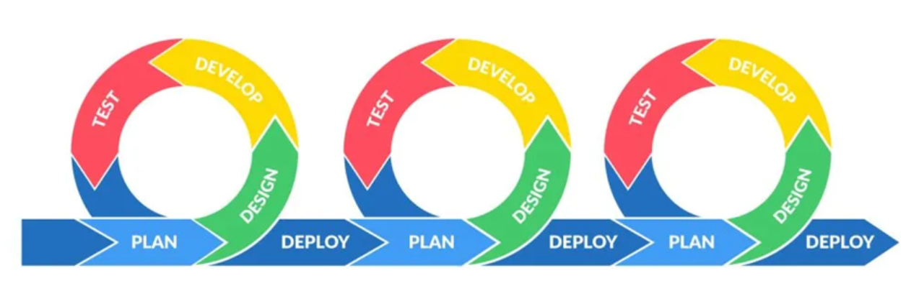
Figure 3-1. Image of Agile

Requirements Gathering
A multi-faceted approach will be used for requirements elicitation:
- Indirect Interviews: Analyzing interview records with web novel editors to extract core pain points and feature needs.
- Competitive Analysis: Systematically analyzing existing writing software to establish functional baselines and identify opportunities for innovation.
- User Personas: Creating typical user personas of web novel authors to ensure design decisions remain user-centric.

Testing and Evaluation Techniques
- Unit Testing: Using frameworks like Jest to test individual components in isolation.
- Integration Testing: Verifying that different modules interact correctly.
- User Acceptance Testing: Inviting authors and editors to test the software in later stages to gather qualitative feedback for final optimization.

Technology
Table 3-1. Table of software and hardware
Category | Tools | Purpose
Frontend[10] | Vue.js+TypeScript | Building a responsive and interactive user interface.
Backend | Node.js[11],Python[12] | Handling business logic, API requests, and user authentication.
Database | MongoDB[13],MySQL | Storing document content, user data, and analysis results.
Search Engines | Elasticsearch | Fast full-text search and keyword positioning
AI&NPL service | DeepSeek，spaCy[14]，ECharts，SnowNLP | DeepSeek/spaCy+ECharts timeline visualization, emotion curve using SnowNLP+ECharts,
Proofreading | Grammarly API[15] | Grammar and spelling error checks
Real-time | WebSocket[16], Socket.IO [17] | Real-time data push and communication
Hardware | Developer PC,Cloud Sever | Develop and test locally; Deploy to backend and production environments
Testing Tools | Jest[18],Postman[19] | Unit test, API test

Project Version Management Plan
The development process will use Git for version control, with GitHub as the remote code repository. The development will be divided into four main versions.
Table 3-2. Table of version management plan
Versions | Details
Version 1 | Implementation of the core writing MVP
Version 2 | Integration of basic intelligent analysis features.
Version 3 | Introduction of collaboration and search features.
Version 4 | Implementation of advanced analysis features and product optimization.

The full project source code will be available at: https://github.com/jxlin0524/Web-application-project

Summary
This chapter has defined the core problems the project aims to solve. By combining established requirements engineering practices, a comprehensive testing strategy, and a modern technology stack, a solid foundation has been laid for the project's successful implementation.

Chapter 4. Project Management

Activities
Table 4-1. Table of activities
Activities | Details
Preliminary Research | Determine the research topic, collect and analyze relevant academic literature and market competitors.
Prepare Project Proposal | Complete the Project Proposal document.
Requirement Analysis | Research requirement, find suitable methods to solve the problem
System Design | Design the detailed functional specifications, database schema, and system architecture.
Development & Implementation | Code the frontend, backend, and NLP services according to the version plan.
Testing & Evaluation | Perform unit, integration, and user acceptance testing for all software modules.
Thesis Writing | Write the final thesis
Thesis Modify | Make thesis reversions
Presentation Preparation | Prepare the final project presentation slides and defend the project.

Schedule
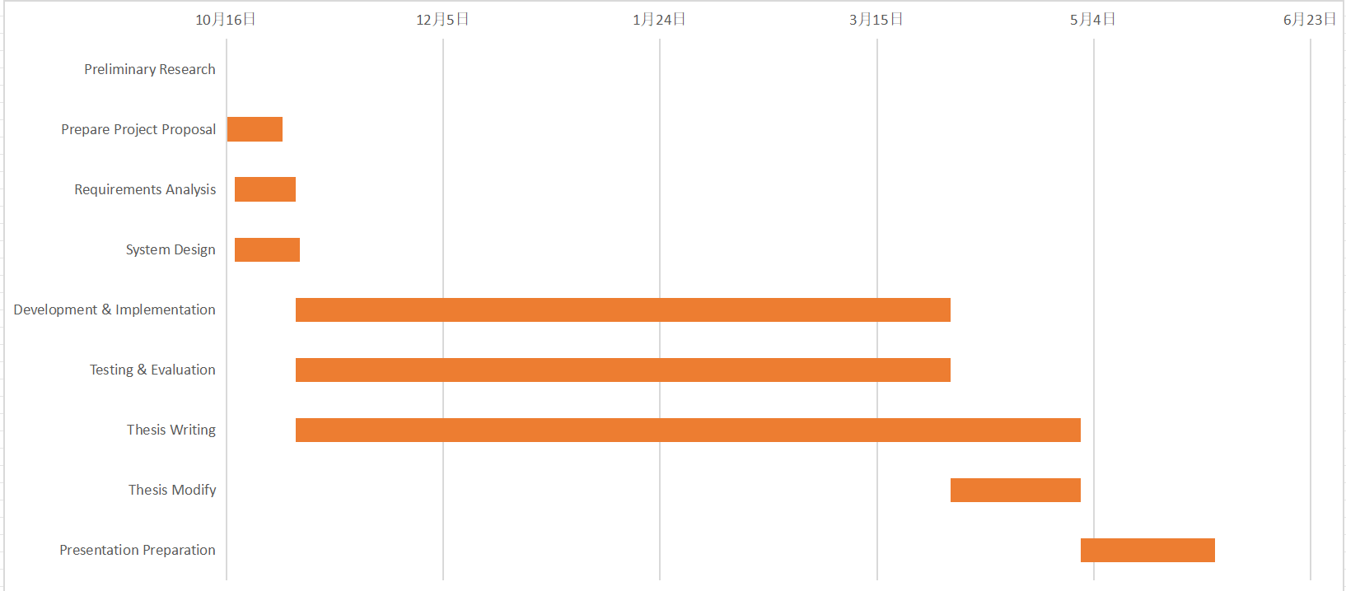
Figure 4-2. Project Schedule

Data Management Plan
Zotero is used to manage the preliminary literature of the project, GitHub is used to manage the code and Baidu drive is used to manage the report.
Table 4-2. Caption should be here
Management Category | Tool
Literature Management | Zotero
Code Management | GitHub
Project Reports & Logs | Baidu drive

Project Deliverables
This section lists what needs to be delivered throughout the project.
- The project proposal
- Weekly report
- Progress Report
- Final Project Report
- Project codes
- Project presentation slides
- Project presentation

References
[1] C. T. Hsiao, “Understanding online literature: A book-like new medium,” in 2018 IEEE International Conference on Consumer Electronics-Taiwan (ICCE-TW), May 2018, pp. 1–2. doi: 10.1109/ICCE-China.2018.8448834.
[2] A. Morrison, “Doing it in style: a review of word processing and presentation software for creative and academic writing,” Computers and Composition, vol. 22, no. 3, pp. 347–365, 2005, doi: 10.1016/j.compcom.2005.05.005.
[3] N. Sharples, “The Writer’s Workbench: A Computational Tool for Narrative Generation,” in Proceedings of the 10th International Conference on Computational Creativity, Charlotte, NC, USA, Jun. 2019.
[4] S. K. K. Chow and K. H. H. Tsoi, “A Review of Computer-Assisted Writing Tools,” International Journal of Computer-Assisted Language Learning and Teaching, vol. 6, no. 3, pp. 71-87, 2016.
[5] P. J. Kellogg, “Cognitive strategies in writing,” American Journal of Psychology, vol. 104, no. 2, pp. 217-240, 1991.
[6] Microsoft, “Microsoft Word - Word Processing Software.” Accessed: Oct. 27, 2025. [Online]. Available: https://www.microsoft.com/en-us/microsoft-365/word
[7] Google, “Google Docs: Online Document Editor.” Accessed: Oct. 27, 2025. [Online]. Available: https://www.google.com/docs/about/
[8] Literature & Latte, “Scrivener | The biggest leap forward in writing software.” Accessed:Oct.27,2025.[Online].Available:https://www.literatureandlatte.com/scrivener/overview
[9] Ulysses,“Ulysses | The Ultimate Writing App for Mac, iPad and iPhone.” Accessed: Oct. 27, 2025. [Online]. Available: https://ulysses.app/
[10] Meta, “React – A JavaScript library for building user interfaces.” Accessed: Oct. 15, 2025. [Online]. Available: https://react.dev/
[11] OpenJS Foundation,“Node.js — Event-driven I/O server-side JavaScript environment.”Accessed: Oct. 27, 2025. [Online]. Available: https://nodejs.org/
[12]“Python Language Reference.”Python Software Foundation. Accessed: Oct. 27, 2025. [Online]. Available: https://www.python.org
[13] MongoDB, Inc.,“MongoDB: The Developer Data Platform.” Accessed: Oct. 27, 2025. [Online]. Available: https://www.mongodb.com/
[14] M. Honnibal and I. Montani, “spaCy: Industrial-strength Natural Language Processing in Python.”Accessed:Oct.27,2025.[Online]. Available: https://spacy.io
[15] Grammarly, "Grammarly for Developers," developer.grammarly.com. [Online]. Available: https://developer.grammarly.com/
[16] I. Fette and A. Melnikov,” The WebSocket Protocol,”RFC 6455, Dec. 2011. [Online]. Available: https://datatracker.ietf.org/doc/html/rfc6455
[17] Socket.IO, "Socket.IO: Bidirectional and low-latency communication for every platform," socket.io. Accessed:Oct. 27, 2025.[Online]. Available: https://socket.io/
[18] OpenJS Foundation, "Jest: Delightful JavaScript Testing," jestjs.io.Accessed:Oct. 27, 2025. [Online]. Available: https://jestjs.io/
[19] Postman, Inc., "Postman API Platform," postman.com. Accessed:Oct. 27, 2025.[Online]. Available: https://www.postman.com/

