UNDERGRADUATE PROJECT PROGRESS REPORT

Project Title | ProsePal:An Intelligent Writing Assistant for Web
 | Novel Authors
Student ID | 202218020401
Supervisor Name | Clivia
Student Name | Hanna
Student Major | Software Engineering

 |  | Date Submitted | 7/1/2026

Table of Contents

Table of Contents I
Chapter 1. Introduction 1
1.1 Background of Study 1
1.2 Project Aim 1
1.3 Project Objectives 1
1.4 Project Overview 2
1.4.1 Scope 2
1.4.2 Audience 3
1.5 Proposed Structure of the Report 3
Chapter 2. Background Review 4
2.1 Fundamental Description of Software 4
2.2 Background Review 4
2.3 Limitations of Existing Works 5
2.4 Summary 5
Chapter 3. Technical Progress 6
3.1 Problem Statement 6
3.2 Approach 6
3.3 Technology 7
3.4 Testing and Evaluation Plan 8
3.5 Design and Implementation 9
3.5.1 Web design 9
3.5.2 Database design 12
3.6 Summary 13
Chapter 4. Project Management 14
4.1 Activities 14
4.2 Schedule 14
4.3 Project Version Management Plan 15
4.4 Data Management Plan 15
4.5 Project Deliverables 15
Chapter 5. Professional Issues and Risk 17
5.1 Risk Analysis 17
5.2 Professional Issues 18
5.2.1 Legal Issues 18
5.2.2 Ethical Issues 19
5.2.3 Social Issues 19
5.2.4 Environmental Issues 20
References 21

Chapter 1. Introduction

Background of Study
With the rise of digital media, web literature has become a lifeful and significant component of the global cultural industry, attracting hundreds of millions of readers and creators [1]. However, despite this creative boom, many authors still rely on universal office software such as Microsoft Word, Google Docs for their work. While powerful, these tools were designed for general document processing and fall short of meeting the complex demands of long-form narrative works, especially web novels, which require functionalities like non-linear chapter management, visualization of character relationships, and check the coherence of the plot [2].
Creators often face too many challenges,such as including frequently switching between multiple applications to consult research data, manage ideas, and organize outlines, which significantly fragments their creative focus and reduces efficiency. Furthermore, the manuscripts revision process often relies on subjective communication between authors and editors,lacking of tools for data analysis to assist in revision.The advancement of modern computational linguistics and human-computer interaction offers a potential solution to these pain points [3]. Therefore, develop a writing assistant system specifically designed for web novel author—integrating intelligent analysis and efficient collaboration—is of significant practical importance and applicational value.

Project Aim
The primary aim of this project is to design and implement an integrated software called "ProsePal." This system aims to significantly enhance the creative output, quality of works, and collaborative experience of online novel authors by providing a platform that integrates creative conception, writing, analysis, and collaboration.

Project Objectives
To achieve the project aim, the following types of work will be performed:
- Research and Analysis Work: To conduct a comparative analysis of existing writing tools to define functional baselines and identify key market gaps.
- System Design Work: To perform system and software architecture design, including the creation of database schemas, API specifications, and high-fidelity UI mockups.
- Implementation and Development Work: To program the front-end and back-end modules of the application, including the core text editor, document management system, and intelligent analysis etc.
- Integration Work: To integrate the core application with third-party services and libraries, specifically for NLP functionalities and real-time collaboration features.
- Testing and Quality Assurance Work: To execute a comprehensive testing strategy, including the development of unit tests, the execution of integration tests, and the coordination of user acceptance testing to ensure software stability and reliability.

Project Overview
This project aims to develop an intelligent writing assistant software specifically designed for web novel creators. It combines traditional text editing function with advanced data analysis, project management, and online collaboration tools to solve the efficiency bottlenecks and the difficulties of creat that authors currently face in their workflow.

1.4.1 Scope
The software will provide a focused, integrated environment through the following detailed functionalities:
Intelligent Document Management:
- Real-time Cloud Synchronization: All work will be auto-saved and synced across devices.
- Version History: The system will automatically save snapshots of the document, allowing users to review, compare , and restore previous versions.
- Visual Chapter/Outline Management: A dedicated panel will allow authors to view their manuscript as a collection of "cards", which can be reordered via drag-and-drop to restructure the plot.
Integrated Research Environment:
- Split-Screen View: An embedded browser will allow writers to conduct research within the same window as their manuscript, eliminating context-switching.
- Research/Note Manager: A "corkboard" or notes section will allow users to clip text, images, and links from the web, and link them to specific chapters or characters.
NLP-Powered Intelligent Analysis:
- Character Relationship Mapping: The system will automatically parse the text to identify character interactions and generate a visual graph of their relationships.
- Sentiment Analysis: A "Story Emotion Curve" will be generated, plotting the emotional valence of the narrative chapter by chapter to help authors manage pacing.
- Consistency Checker: Authors can create "character sheets" with key traits.The tool will flag potential contradictions found later in the text.
Seamless Collaboration:
- Role-Based Access Control: Project owners can invite collaborators as "Editors" (full edit/comment rights) or "Viewers" (read-only).
- Suggestion Mode: Similar to "Track Changes" in Microsoft Word, editors can make suggestions that the author can then accept or reject individually.
- Real-time Comments: A comment thread will be available for discussions, supporting mentions to notify specific collaborators.

1.4.2 Audience
The findings and deliverables of this project will primarily benefit the following groups:
- Web Novel Authors: As the core users, they will directly benefit from a more professional and intelligent creative environment, allowing them to focus more on the art of storytelling.
- Content Editors and Planners: They can leverage the system's collaborative and analytical features to guide authors more effectively, assess manuscript quality, and gain a high-level understanding of a work's structure and potential.

Proposed Structure of the Report

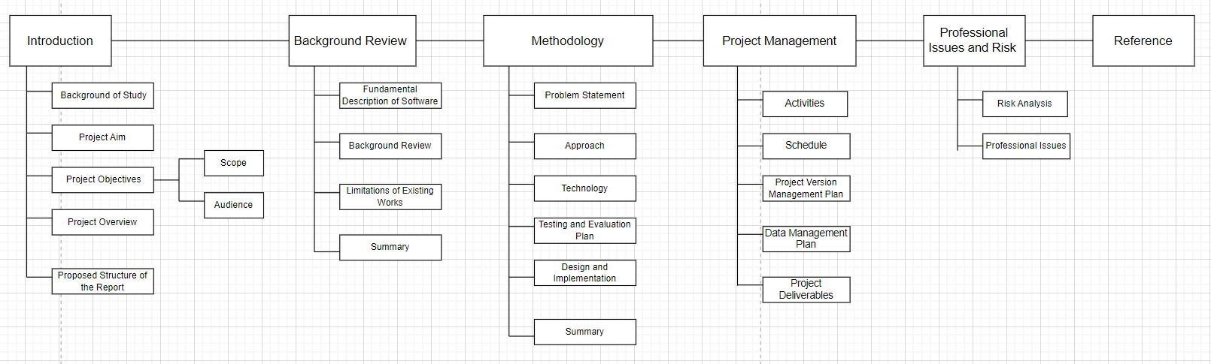

Figure 1-1. Project structure flowchart

Chapter 2. Background Review

Fundamental Description of Software
The ProsePal is a writing assistant software. It is a category of applications designed to help users improve their writing efficiency and quality. Core functionalities typically include text editing, formatting, and spell/grammar checking. With technological advancements, modern writing tools have evolved beyond basic word processing to integrate advanced features such as project management, research organization, distraction-free writing modes, and online collaboration to meet the specific needs of various domains [4]

Background Review

Comparative Analysis of Software Features
This section provides a comparative analysis of existing writing software relevant to this project. These tools can be categorized into three types: general document tools, professional writing software, and existing web novel writing tools. The analysis will focus on their features regarding document management, collaboration capabilities, and intelligent analysis.
Table 2-1. Format of Table
Authoring Tools | Document Management (Version Control, Outline) | Collaboration Features | Intelligent Analysis (Character Mapping, Plot Curve) | Proofreading check
Microsoft Word[6] | Yes | Yes | No | Yes
Google docs[7] | Yes | Yes | No | Yes
Scrivener[8] | Yes | Yes | No | No
Ulysses[9] | Yes | Yes | No | No
Writer's assistant | Yes | Yes | No | Yes
Orange melon writing | Yes | No | No | Yes
Our Proposed System | Yes | Yes | Yes | Yes

Limitations of Existing Works
The analysis above reveals a clear market gap in existing tools:
- General Document Tools lack professional features designed for long-form writing, such as complex chapter management and character tracking, leading to a fragmented creative process.
- Professional Writing Software, while excellent for structural management, generally has weak or non-existent collaboration features, failing to meet the close communication needs between authors and editors.
- Existing Web Novel Tools often have basic functionalities and weak analytical capabilities, failing to fully leverage data analysis techniques to assist creative decision-making.
In summary, the current market lacks an integrated solution that seamlessly combines a fluid writing experience, deep narrative intelligence, and efficient online collaboration.

Summary
This chapter introduced the fundamental concept of writing assistant software and, through comparative analysis, identified the shortcomings of existing tools in serving web novel authors. These limitations highlight the necessity of developing a more comprehensive and intelligent integrated writing platform, which is the core goal of this project.

Chapter 3. Technical Progress
This chapter details the methodology adopted to solve the aforementioned problems, including a clear problem statement, software development approach, technology selection, and version management plan.

Problem Statement
Web novel authors face three core problems in their creative process:
- Inefficiency due to Tool Fragmentation: Authors must frequently switch between software for writing, research, and outlining, which disrupts their creative flow and increases cognitive load [5].
- Lack of Macro-level Management for Complex Narratives: Long-form novels involve numerous characters and plotlines that are difficult to manage and track with traditional tools, leading to potential logical inconsistencies.
- Subjective and Inefficient Manuscript Revision Process: Collaboration between authors and editors relies on offline, unstructured communication that lacks data support, resulting in long and inefficient revision cycles.

Approach

Software Development Method
This project will adopt Agile Development principles, closely following a Scrum framework. Each sprint will begin with a planning meeting to select tasks from a product backlog and will conclude with a sprint review to demonstrate a working, incremental version of the software. This iterative approach is ideal for this project as it allows for flexibility and rapid prototyping.
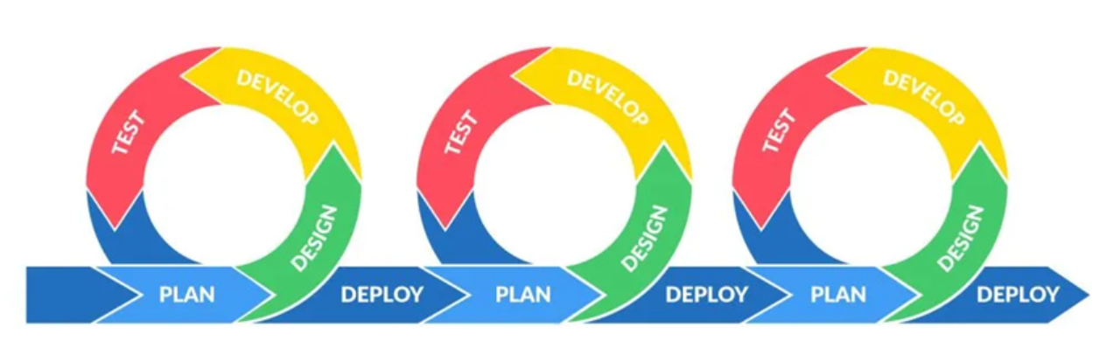
Figure 3-1. Image of Agile

Requirements Gathering
A multi-faceted approach will be used for requirements elicitation:
- Indirect Interviews: Analyzing interview records with web novel editors to extract core pain points and feature needs.
- Competitive Analysis: Systematically analyzing existing writing software to establish functional baselines and identify opportunities for innovation.
- User Personas: Creating typical user personas of web novel authors to ensure design decisions remain user-centric.

Testing and Evaluation Techniques
- Unit Testing: Using frameworks like Jest to test individual components in isolation.
- Integration Testing: Verifying that different modules interact correctly.
- User Acceptance Testing: Inviting authors and editors to test the software in later stages to gather qualitative feedback for final optimization.

Technology
Table 3-1. Table of software and hardware
Category | Tools | Purpose
Frontend[10] | Vue.js+TypeScript | Building a responsive, interactive user interface and managing component states (e.g., Dashboard, Editor).
Backend | Node.js[11]+ Express | Handling business logic, API requests, and user authentication.Handling RESTful API requests, business logic, and dual-layer caching orchestration.
Database | MySQL | Storing document content, user data, and analysis results.Storing structured data including projects, documents, editorial comments, and AI summary caches.
AI Services | LLM API (e.g., Llama-3 / OpenAI SDK) | Deploying Qwen on a rented server locally to generate timelines for AI components and refine articlesExecuting Map-Reduce timeline generation, RAG-based world building consultation, and contextual text polishing.
Hardware | Developer PC,Cloud Sever | Develop and test locally; Deploy to backend and production environments
Testing Tools | Jest[15] | Unit test, API test
Data Caching. | Node.js fs + Crypto (MD5) | Generating content fingerprints and storing compiled JSON timelines for zero-latency retrieval.

Testing and Evaluation Plan
In alignment with the Test-Driven Development (TDD) methodology, the testing strategy for the project is designed to ensure code quality and user satisfaction from the initial development phase through to deployment. By writing test cases before the actual implementation, we ensure that every feature is purposeful and bug-free. The evaluation plan comprises three distinct layers: Unit Testing, Integration Testing, and User Acceptance Testing (UAT).
- Unit Testing
Plan: Unit testing serves as the primary verification layer in our TDD workflow. We will utilize Jest as the testing framework to test individual components and utility functions in isolation. Given the project's architecture (Vue.js frontend and Node.js backend), Jest is ideal for snapshot testing of Vue components and validating JavaScript logic without needing to run the entire application. The process follows the "Red-Green-Refactor" cycle: writing a failing Jest test for a specific component behavior, implementing the logic to pass the test, and then refactoring the code.
Case : A key case for unit testing is the Registration Form Component.
- Scenario: The system must validate that the "Confirm Password" field matches the "Password" field.
- TDD Process: We will write a Jest test case that simulates a user entering two different passwords and asserts that the component emits a specific validation error message. Initially, this test will fail. We will then implement the matching logic within the Vue component script. Once the test passes, we guarantee that this specific unit of logic functions correctly in isolation, regardless of the backend status.

b) Integration Testing
Plan: While unit testing validates isolated parts, integration testing verifies that different modules interact correctly as a cohesive system. In this project, the critical interaction lies between the Vue.js frontend client and the Node.js/Express backend API. The goal is to ensure that data flows correctly across the network boundary, verifying that requests sent from the client are correctly received, processed, and responded to by the server.
Case (Login Data Flow): The primary integration test case is the End-to-End Login Request.
- Scenario: Testing the complete path from the user clicking the "Login" button to receiving an authentication token.
- Process: The test will simulate a valid HTTP POST request triggered by the frontend to the /api/login endpoint. It checks if the Express backend successfully queries the database and if the frontend correctly receives and stores the returned JWT token in the local storage. This confirms that the frontend module and backend module are "speaking" the same language and handling data formats (JSON) correctly.

c) User Acceptance Testing (UAT)
Plan: User Acceptance Testing (UAT) is the final phase of the evaluation plan, shifting the focus from code correctness to usability and user satisfaction. Unlike the automated nature of unit and integration tests, UAT involves inviting potential users (e.g., authors, editors, or students) to test the software in the later stages of development. The objective is to gather qualitative feedback regarding the user interface (UI), user experience (UX), and overall workflow smoothness to ensure the system meets real-world needs.
Case (UI/UX Feedback): A specific UAT session will focus on the "Login/Register" Switch Experience.
- Scenario: Users will be asked to navigate the dual-function page, switching between "Sign In" and "Sign Up" modes, and completing a registration.
- Process: Testers will perform these tasks without guidance. We will observe if they find the transition animation smooth or distracting, and if the error messages (e.g., "User already exists") are clear and helpful.
- Goal: This qualitative feedback will be used for final optimization, such as adjusting the animation speed, refining color contrast for better readability, or rephrasing system notifications to be more user-friendly before the final release.

Design and Implementation

3.5.1 Web design
The initial design of the front-end interface was constructed using the Vue.js and Typescript, including user registration and login, the main page, etc. At the same time the clear structure and accessible navigation bar helps users to use the system to do their work better.
The demo design of the frontend pages are shown below:

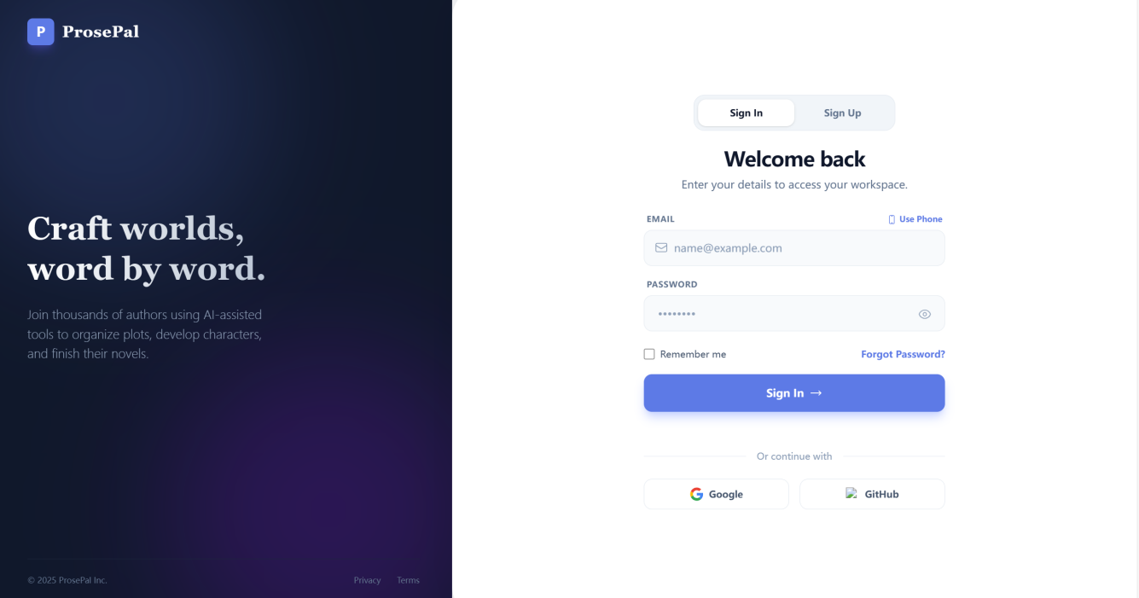

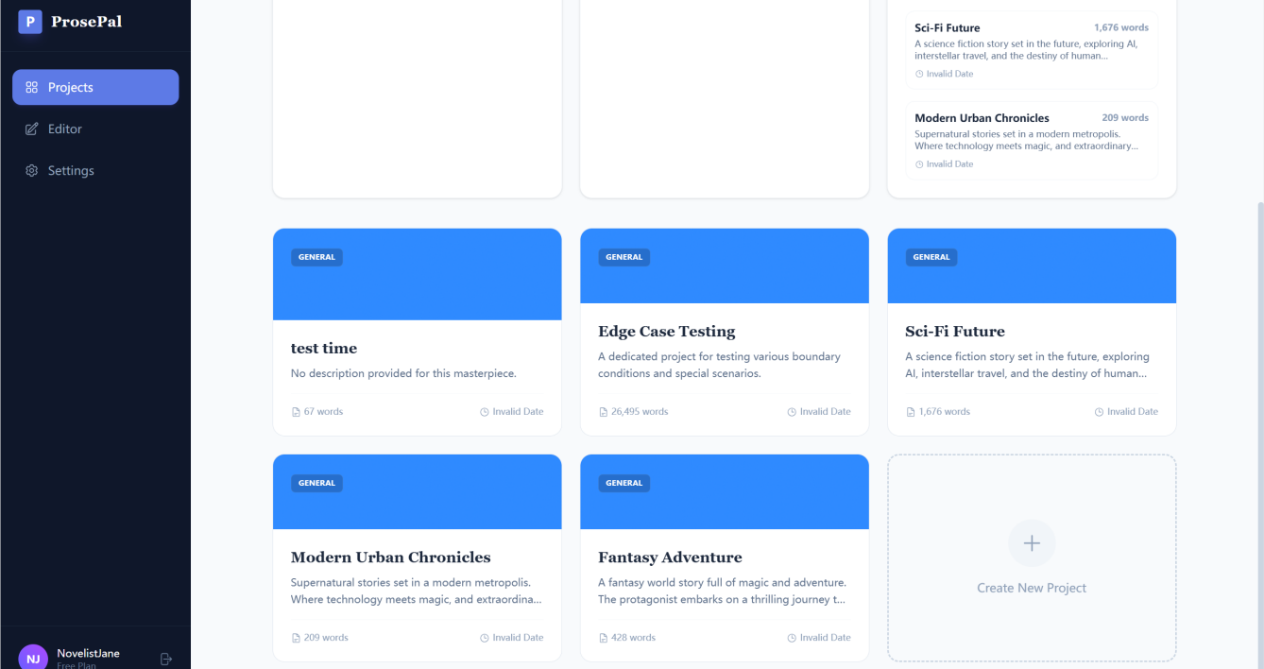

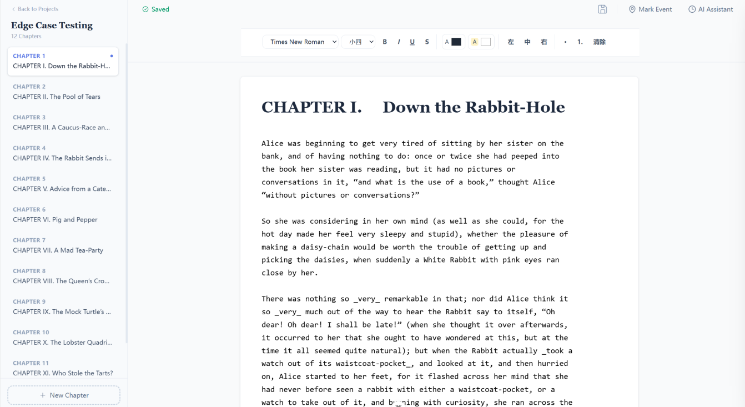

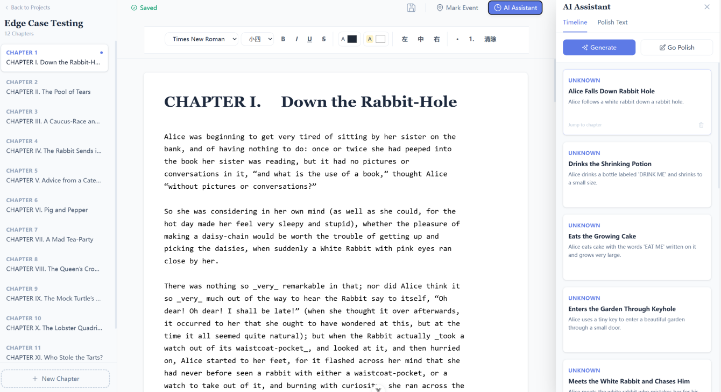

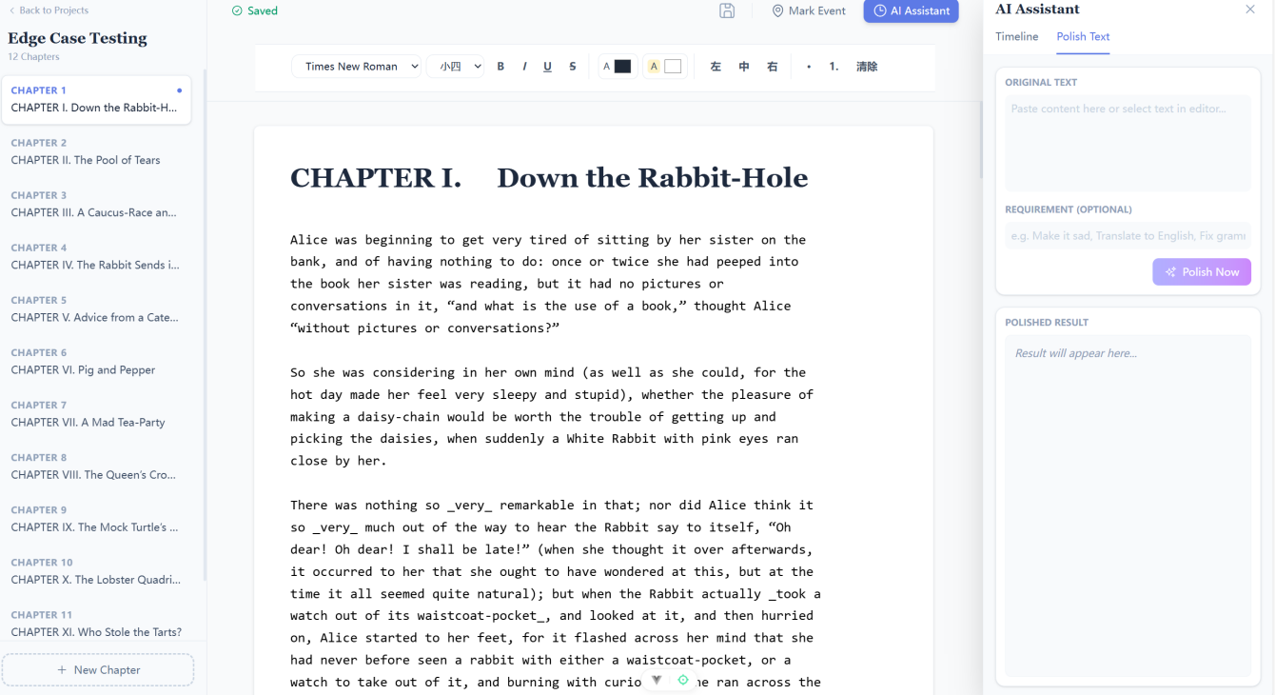
Figure 3-3: The frontend pages demo

3.5.2 Database design
Based on the ER diagram of the ProsePal basic system, the database code was written to add primary and foreign key restrictions to reflect various relationships such as one-to-many. The database ProsePal basic was created using MySQL software and contains a total of six tables .
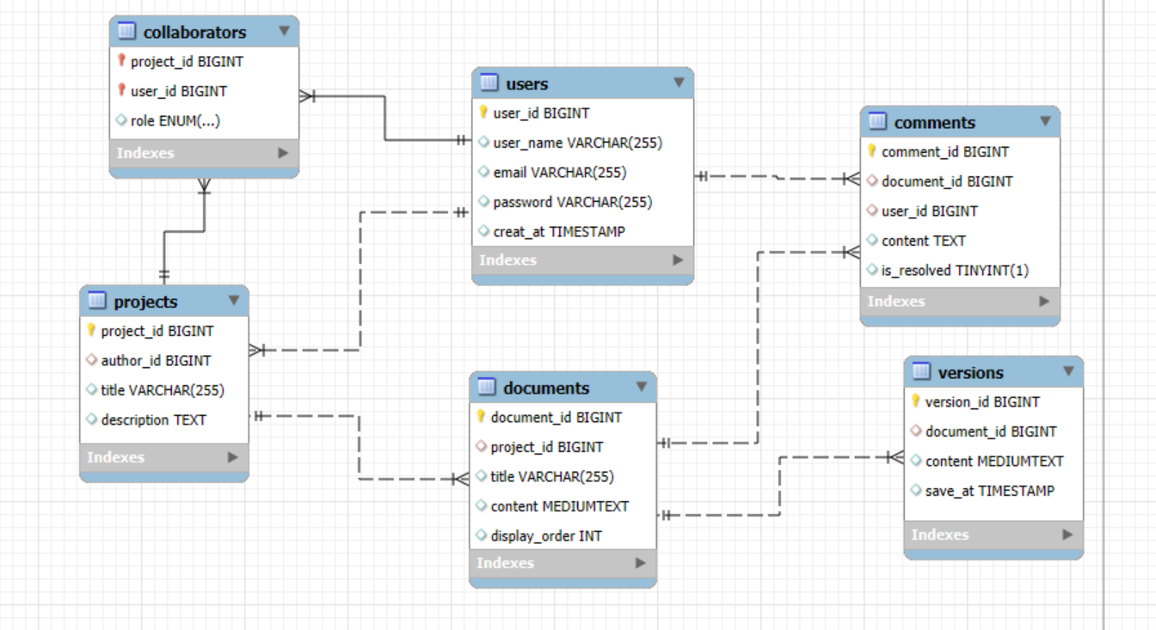
Figure 3-4: The ER diagram of the basic system

Summary
This chapter has defined the core problems the project aims to solve. By combining established requirements engineering practices, a comprehensive testing strategy, and a modern technology stack, a solid foundation has been laid for the project's successful implementation.

Chapter 4. Project Management

Activities
Table 4-1. Table of activities
Activities | Details
Preliminary Research | Determine the research topic, collect and analyze relevant academic literature and market competitors.
Prepare Project Proposal | Complete the Project Proposal document.
Requirement Analysis | Research requirement, find suitable methods to solve the problem
System Design | Design the detailed functional specifications, database schema, and system architecture.
Development & Implementation | Code the frontend and backend according to the version plan.
Testing & Evaluation | Perform unit, integration, and user acceptance testing for all software modules.
Thesis Writing | Write the final thesis
Thesis Modify | Make thesis reversions
Presentation Preparation | Prepare the final project presentation slides and defend the project.

Schedule
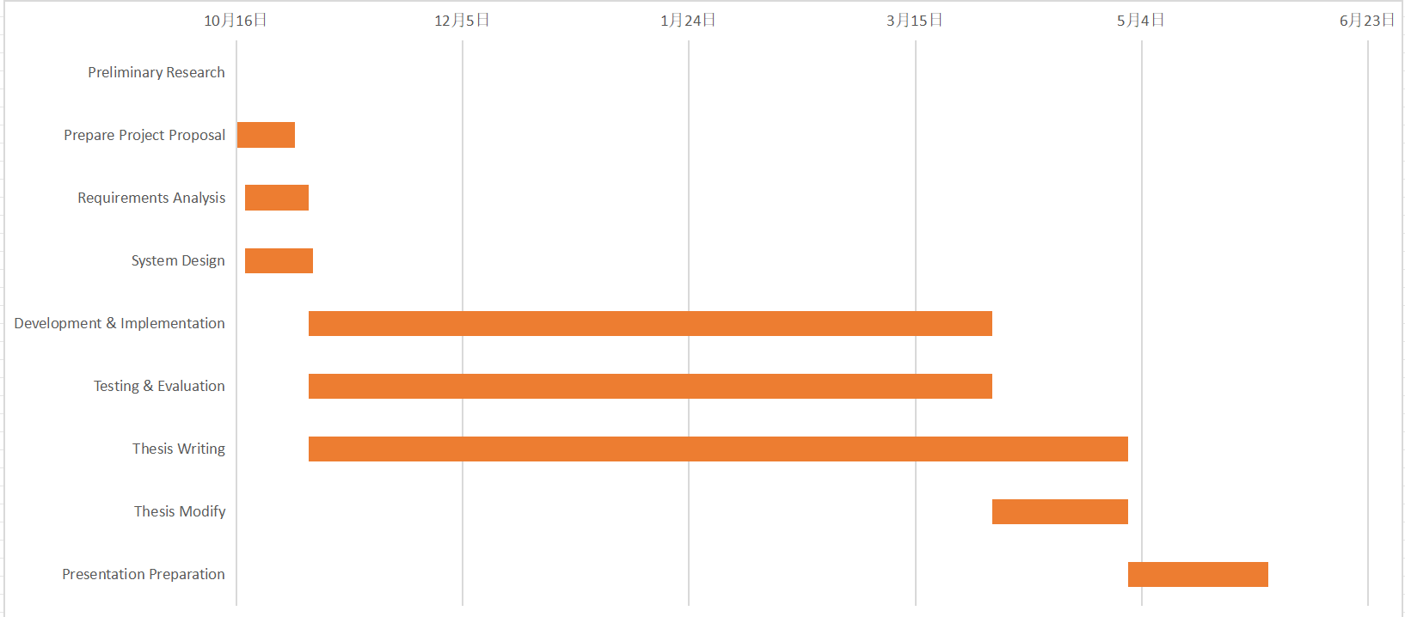
Figure 4-2. Project Schedule

Project Version Management Plan
The development process will use Git for version control, with GitHub as the remote code repository. The development will be divided into four main versions.
Table 4-2. Table of version management plan
Versions | Details
Version 1 | Implementation of the core writing MVP
Version 2 | Integration of basic intelligent analysis features.
Version 3 | Introduction of collaboration and search features.
Version 4 | Implementation of advanced analysis features and product optimization.

The full project source code will be available at: https://github.com/jxlin0524/Web-application-project

Data Management Plan

Zotero is used to manage the preliminary literature of the project, GitHub is used to manage the code and Baidu drive is used to manage the report.
Table 4-3. Caption should be here
Management Category | Tool
Literature Management | Zotero
Code Management | GitHub
Project Reports & Logs | Baidu drive

Project Deliverables
This section lists what needs to be delivered throughout the project.
- The project proposal
- Weekly report
- Progress Report
- Final Project Report
- Project codes
- Project presentation slides
- Project presentation

Chapter 5. Professional Issues and Risk

5.1 Risk Analysis
Table 5-1. Table of version management plan
Risk ID | Potential Risk | Cause ID | Potential Causes | Severity | Likelihood | Risk | Mitigation ID | Mitigation
R1.1 | Missed deadline | C1.1.1 | Illness | 1 | 2 | 2 | M1.1.1 | Register exceptional circumstances if ill.
 |  | C1.1.2 | Scope Creep | 3 | 2 | 6 | M1.1.2 | Develop a scope specification, iterate once and check once
 |  | C1.1.3 | Poor time management | 4 | 2 | 8 | M1.1.3 | Make a Gantt plan early
R1.2 | Feature creep | C.1.2.1 | Over-ambitious project spec. | 2 | 2 | 4 | M1.2.1 | Discuss plan with supervisor early. Create basic (must-have) goals and enhancements (nice-to-have).
R1.3 | Software bugs | C1.3.1 | Non-modular design | 2 | 2 | 4 | M1.3.1 | Create highly modular desigh before implementation
 |  | C1.3.2 | Poor test plan | 4 | 3 | 12 | M1.3.2 | Create test plan at start
R1.4 | Loss of data | C1.4.1 | Poor version control | 4 | 4 | 16 | M1.4.1 | Implement version control strategy at start.

5.2 Professional Issues
As a software developer, adhering to professional standards is as crucial as technical implementation. This project is developed in accordance with the BCS Code of Conduct and the ACM Code of Ethics and Professional Conduct. The following sections identify and discuss the relevant issues in the context of developing the secure login and registration system.

5.2.1 Legal Issues
The primary legal concern for a login/registration system is Data Protection and Privacy.
GDPR / Data Protection Act 2018: The system collects personal data (email addresses and passwords). According to BCS Code of Conduct Clause 3.a, members must "comply with all applicable laws and regulations" [16]. Failure to protect user data from breaches would violate this clause and legal statutes.
- Application: To comply with this, I implemented bcrypt to hash passwords before storing them. Storing passwords in plain text would violate the principle of "Respecting Privacy" [17], which mandates protecting personal information from unauthorized access [17]
Intellectual Property (IP): The project utilizes open-source frameworks (Vue.js and Node.js).
- Application in Project: I must adhere to their respective licenses (mostly MIT License). This involves acknowledging the use of these libraries and ensuring that any proprietary code developed does not violate third-party IP rights.
Computer Misuse Act 1990: As the developer of a security system, I must ensure the system does not facilitate unauthorized access.
- Application in Project: I have implemented input validation to prevent SQL Injection and XSS attacks, ensuring the system cannot be easily exploited to access unauthorized data.

5.2.2 Ethical Issues
Ethical considerations focus on the developer's responsibility to the user and the profession.
ACM Code 1.6 (Respect Privacy)[17]: Developers have a duty to treat personal information with care.
- Discussion: Treating the "test data" as if it were real user data establishes good professional habits. It is unethical to design a system that gives a false sense of security (e.g., displaying a "Secure" lock icon but transmitting data over HTTP without encryption).
BCS Code of Conduct (Professional Competence and Integrity): Developers should only undertake work they are competent to perform and should accept responsibility for their work.
- Discussion: Adopting Test-Driven Development (TDD) is an ethical choice in this context. By writing tests first, I am actively verifying that the code functions as intended and minimizing the risk of delivering a flawed product. Ignoring known bugs or "patching" them superficially would be a breach of professional integrity.

5.2.3 Social Issues
Social issues in software development often relate to Accessibility and Inclusivity.
Accessibility (BCS - Public Interest): Software should be usable by everyone, including people with disabilities. A login page is a gateway; if it is inaccessible, users are completely locked out of the service.
- Discussion: The "Dual-Function" design (switching between Login and Register) relies on visual animations. To address social exclusion, I must ensure that:
- The color contrast between the text and the background meets WCAG (Web Content Accessibility Guidelines) standards for visually impaired users.
- The form is navigable via keyboard (Tab key) for users who cannot use a mouse.
User Experience (UX): Poorly designed security (e.g., overly complex password requirements without clear instructions) causes user frustration and anxiety.
- Discussion: I have aimed to provide clear, real-time feedback (via Vue.js reactivity) when a user enters a password, ensuring the system is helpful rather than punitive.

5.2.4 Environmental Issues
While software is intangible, its development and operation have an environmental footprint (Energy Consumption).
Code Efficiency: Bloated, inefficient code requires more processing power (CPU/RAM) to run, leading to higher electricity consumption on servers.
- Discussion: By using Node.js (which is event-driven and non-blocking), the backend is designed to handle requests efficiently. Furthermore, the TDD approach encourages refactoring and removing redundant code, leading to a leaner application that consumes fewer resources.
Electronic Waste: Developing heavy applications that require users to upgrade their hardware contributes to e-waste.
- Discussion: The frontend is built with Vue 3, which is a lightweight framework. This ensures the login page loads quickly and runs smoothly even on older devices, extending the lifespan of user hardware.

References
[1] C. T. Hsiao, “Understanding online literature: A book-like new medium,” in 2018 IEEE International Conference on Consumer Electronics-Taiwan (ICCE-TW), May 2018, pp. 1–2. doi: 10.1109/ICCE-China.2018.8448834.
[2] A. Morrison, “Doing it in style: a review of word processing and presentation software for creative and academic writing,” Computers and Composition, vol. 22, no. 3, pp. 347–365, 2005, doi: 10.1016/j.compcom.2005.05.005.
[3] N. Sharples, “The Writer’s Workbench: A Computational Tool for Narrative Generation,” in Proceedings of the 10th International Conference on Computational Creativity, Charlotte, NC, USA, Jun. 2019.
[4] S. K. K. Chow and K. H. H. Tsoi, “A Review of Computer-Assisted Writing Tools,” International Journal of Computer-Assisted Language Learning and Teaching, vol. 6, no. 3, pp. 71-87, 2016.
[5] P. J. Kellogg, “Cognitive strategies in writing,” American Journal of Psychology, vol. 104, no. 2, pp. 217-240, 1991.
[6] Microsoft, “Microsoft Word - Word Processing Software.” Accessed: Oct. 27, 2025. [Online]. Available: https://www.microsoft.com/en-us/microsoft-365/word
[7] Google, “Google Docs: Online Document Editor.” Accessed: Oct. 27, 2025. [Online]. Available: https://www.google.com/docs/about/
[8] Literature & Latte, “Scrivener | The biggest leap forward in writing software.” Accessed:Oct.27,2025.[Online].Available:https://www.literatureandlatte.com/scrivener/overview
[9] Ulysses,“Ulysses | The Ultimate Writing App for Mac, iPad and iPhone.” Accessed: Oct. 27, 2025. [Online]. Available: https://ulysses.app/
[10] Meta, “React – A JavaScript library for building user interfaces.” Accessed: Oct. 15, 2025. [Online]. Available: https://react.dev/
[11] OpenJS Foundation,“Node.js — Event-driven I/O server-side JavaScript environment.”Accessed: Oct. 27, 2025. [Online]. Available: https://nodejs.org/
[12] Grammarly, "Grammarly for Developers," developer.grammarly.com. [Online]. Available: https://developer.grammarly.com/
[13] I. Fette and A. Melnikov,” The WebSocket Protocol,”RFC 6455, Dec. 2011. [Online]. Available: https://datatracker.ietf.org/doc/html/rfc6455
[14] Socket.IO, "Socket.IO: Bidirectional and low-latency communication for every platform," socket.io. Accessed:Oct. 27, 2025.[Online]. Available: https://socket.io/
[15] OpenJS Foundation, "Jest: Delightful JavaScript Testing," jestjs.io.Accessed:Oct. 27, 2025. [Online]. Available: https://jestjs.io/
[16] ACM (2018). ACM Code of Ethics and Professional Conduct. Association for Computing Machinery. Available at: https://www.acm.org/code-of-ethics Accessed: 6 Janary, 2026
[17]BCS (2021). BCS Code of Conduct. British Computer Society. Available at: https://www.bcs.org/membership-and-registrations/become-a-member/bcs-code-of-conduct/ Accessed: 6 Janary, 2026

