Homework #2 – Convert C to Assembly

CS 3844 Section 0B1, Fall 2020, Dr. O'Hara

Given this C program:

#include <stdio.h>

int main(int argc, char *argv[]) {

int i;

printf("Hex Dec Oct Ch\n");

for (i=32; i<256; i++) {

printf(" %2x %3d %3o %c\n", i, i, i, i);

}

}

Output should look like this (from both the C program above and your Assembly version):

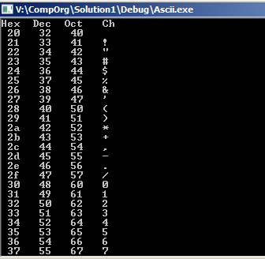

Convert it to Assembly (inside C). You must use Visual Studio in the VDI. If you run it on Linux, characters 128 to 255 won't show up.

#include <stdio.h>

#include <stdlib.h>

int main(int argc, char *argv[]) {

char *hdr = "Hex Dec Oct Ch\n";

char *msg = "%3x %3d %3o %c\n";

__asm {

TBD

}

system("pause");

}

Replace the TBD with two parts: a loop on EAX from 32 to 255, and a function. You must do a CALL to your function and RET to return. And you must pass in the loop variable to the function using the EAX register.

Hint: Use the command "call printf" to do the two prints. It expects all the parameters on the Stack. What order do the parameters need to be to printf?