Predictive Spatiotemporal Demand Modeling for Optimal Electric Vehicle Charging Station Placement Using Classical Machine Learning
Prathamesh Patil | Srijan Bera | Snehal Tyagi
Roll No.: 9 | Roll No.: 17 | Roll No.: 24
Registration No.: 240962052 | Registration No.: 240962300 | Registration No.: 240962368

Abstract—Public EV chargers are usually placed where land is available, not where drivers need them. Using 259,415 charging sessions logged by the City of Palo Alto, we built a pipeline that forecasts hourly demand at each charging site, maps where demand outruns port supply, clusters the shortfall with DBSCAN, and tests a recommended expansion in a queueing simulation. After cleaning, 138,336 sessions at 8 sites (2017–2019) form a site-hour panel with the number of active ports as exposure. Count models fitted on 2017–2018 were scored on all of 2019. Hourly arrivals turned out to be Poisson once calendar, site and lag effects were included (NB2 dispersion estimate at zero), while daily totals were overdispersed (α = 0.0168); at that level the negative binomial model raised interval coverage from 84.3% to 87.9%. The Poisson GLM reached a test deviance of 0.778 (D² = 0.475) against 0.807 for gradient boosting, and its rate ratios show, for instance, that paid charging cut arrivals per port by up to 59% at some sites. The gap analysis points to one under-supplied zone, downtown. In simulation, four overflow ports there reduce turned-away weekday sessions from 1,708 to 202 per year.
Index Terms—Electric vehicle charging demand, Poisson regression, negative binomial regression, spatial clustering, DBSCAN, queueing simulation, infrastructure planning, demand forecasting
I. Introduction
The rapid adoption of electric vehicles (EVs) is straining existing charging infrastructure, which has largely grown in an unplanned, reactive manner rather than in response to actual usage demand [2]. Charging stations are frequently sited based on land availability or investor convenience rather than data-driven demand estimates, resulting in some areas being oversaturated with chargers while others remain underserved. This mismatch causes long wait times, underutilized assets, and slower EV adoption in high-need areas.
This project addresses the problem by building a demand prediction and placement recommendation system using real-world charging session data. Historical session logs are aggregated into time-based demand features and modeled using count-based regression techniques suited to discrete event data, since charging sessions are fundamentally count occurrences rather than continuous quantities. Spatial clustering is then applied to the predicted demand surface to identify underserved high-demand zones, which are proposed as candidate locations for new stations.
Unlike existing black-box forecasting approaches, this project emphasizes interpretable, classical statistical and machine learning methods, making the results directly explainable to urban planners and utility operators making real infrastructure decisions.
The work makes four contributions: a documented cleaning and exposure model for an open session log; a comparison of continuous, count and black-box models on a strict temporal hold-out, including where overdispersion actually appears; a demand-supply gap analysis that turns forecasts into candidate sites; and a simulation, checked against observed occupancy, of what the recommended capacity would change.
II. Literature Review
Research on EV charging demand prediction has grown substantially since 2020, driven by rising global EV adoption. A large share of recent work applies deep learning architectures—LSTM, GRU, Transformer, and graph convolutional networks—to forecast charging load at the station or city level [7], [8], [11], [12], using machine learning methods including RNN, LSTM, Bi-LSTM, GRU, CNN, and transformers on charging events from public stations. Similarly, transformer-based models have been proposed specifically for multi-horizon EV demand forecasting across short- and long-term windows, predicting charging demand at 7-day, 30-day, and 90-day horizons [1]. While these deep models often report strong accuracy, they require large training datasets and offer limited interpretability for infrastructure planners.
A parallel body of work has moved toward data-driven infrastructure planning, not just forecasting. One study analyzing spatiotemporal charging patterns across Chinese megacities found that supply-demand imbalances vary sharply by both location and time, motivating precisely localized rather than uniform infrastructure strategies. Another framework develops a demand estimation model using spatiotemporal charging data and points-of-interest features as part of a broader grid-aware optimization pipeline [10], though it notes that many existing approaches focus solely on spatial or demand-side factors, often assuming grid upgrades are trivially achievable.
For station siting specifically, GIS- and clustering-based methods dominate the literature. One approach applied DBSCAN clustering to assess charging access disparities between urban and suburban areas, while multi-criteria decision-making methods such as AHP, TOPSIS, and PROMETHEE have been widely used to rank candidate sites against criteria like traffic volume, population density, and land cost, with clustering techniques specifically used to group areas of high EV demand to guide placement decisions.
Household- and session-level forecasting studies provide complementary insight into demand granularity. Ensemble and classical regression approaches have been shown to perform competitively for session- and energy-level forecasting without resorting to deep architectures, with custom weighted ensemble machine learning applied to session and energy forecasting at charging stations [3]–[5]. Broader systematic reviews of the field confirm that EV energy demand prediction techniques remain an active and rapidly evolving research area, but critical gaps persist around model interpretability and integration with real infrastructure decisions [2].
Activity-based and origin-destination models [13], [16], [17] and large fleet-data studies [14], [15] estimate spatiotemporal demand from travel records. We work instead from operator session logs, which are the data most cities actually hold.
III. Research Gaps
1) Interpretability–accuracy tradeoff: Most high-performing models (CNN, Transformer, GCN-based) are black-box in nature, making them difficult for utility planners and municipal bodies to trust or justify decisions from.
2) Disconnect between forecasting and placement: Demand forecasting and station siting are largely studied as separate problems—forecasting papers rarely propose actionable placement recommendations, and siting papers (GIS/MCDM-based) often rely on static criteria rather than dynamically predicted demand.
3) Undercounting via continuous-variable models: Many studies treat charging session counts as continuous variables and apply standard linear/deep regression, ignoring that session counts are inherently discrete count data, for which Poisson/Negative Binomial regression is statistically more appropriate.
4) Limited use of density-based spatial clustering for hotspot identification: While k-means is common, density-based methods (DBSCAN) that naturally handle irregular-shaped demand hotspots and noise are comparatively underused in this specific pipeline (forecast → cluster → recommend).
This project addresses these gaps by combining statistically appropriate count-based demand forecasting with density-based spatial clustering in a single interpretable, end-to-end pipeline that outputs actionable station-placement recommendations.
IV. Objectives
1) To collect and preprocess real-world EV charging session data and engineer temporal demand features (hour-of-day, day-of-week, holiday indicators, rolling averages).
2) To develop a count-based regression model (Poisson / Negative Binomial regression) to predict station-level and zone-level charging demand.
3) To apply density-based spatial clustering (DBSCAN) on predicted demand to identify underserved high-demand zones (“charging deserts”) relative to existing station density.
4) To generate and visualize optimal candidate locations for new charging stations based on demand-coverage gap analysis.
V. Dataset and Study Area
The data are the City of Palo Alto charging session records [23], 259,415 rows and 33 fields from 2011-07-29 to 2020-12-31. Each row is one plug-in event with station, port, start and end time, plug-in and charging duration, energy, fee and coordinates. The chargers sit in four downtown garages (Bryant, High, Hamilton, Webster), two garages near California Avenue (Cambridge, Ted Thompson) and two libraries (Rinconada and Mitchell Park, MPL). Table I describes the sites and Table II the cleaning steps.
TABLE I
Charging sites, 2017–2019
Site | Ports | Sessions | Plug-in (h) | kWh
Bryant | 9 | 21,549 | 2.38 | 9.2
Cambridge | 10 | 21,982 | 2.08 | 7.1
Hamilton | 3 | 15,308 | 2.23 | 8.0
High | 8 | 23,093 | 2.25 | 9.0
MPL | 5 | 14,085 | 2.40 | 8.6
Rinconada Lib | 3 | 8,625 | 2.76 | 10.2
Ted Thompson | 8 | 11,608 | 2.65 | 9.9
Webster | 6 | 22,086 | 2.57 | 9.5
Total / mean | 52 | 138,336 | 2.37 | 8.8
Ports: active Level-2 ports in mid-2019. Plug-in and kWh are means per session.
TABLE II
Data cleaning log
Cleaning step | Removed | Remaining
Raw records | — | 259,415
Exact duplicate rows | 4 | 259,411
Excluded stations (SHERMAN, 'BRYANT # 1') | 52 | 259,359
Unparseable start time / UTC-stamped records | 31 | 259,328
Zero / negative plug-in duration | 0 | 259,328
Plug-in duration > 24 h | 22 | 259,306
Energy < 0.1 kWh | 1,830 | 257,476
Level-1 (120 V outlet) sessions | 4,534 | 252,942
Outside study window | 114,606 | 138,336
UTC-stamped rows have end times before start times. Level-1 rows use 120 V outlets that are not counted as capacity. 'Plug In Event Id' resets and is never used as a key.
The 'Address 1' field is unreliable (the High Street garage appears as '528 High St', '528 high st' and '528 High St.'), so stations are keyed on 'Station Name', and a site is that name without the city prefix and the trailing station number. SHERMAN (39 sessions, all in December 2020) and a stray 'BRYANT # 1' station are dropped.
Capacity changed during the study: 23 ports opened in 2017–2018 (High in January 2017, Bryant in July 2017, Cambridge and Ted Thompson in March 2018). Each port counts as active from the day of its first session to the day of its last one, and a gap of more than 30 days is treated as an outage (41 cases). The resulting count of active ports $c_{st}$ for site $s$ and hour $t$ is the exposure of the models. The number of cars plugged in at once never exceeds $c_{st}$, which supports the definition.
Charging was free until 2017-08-01; the share of paid sessions rose to 56% in 2017-Q3 and 100% in 2017-Q4. Because 2020 is distorted by COVID-19 (19,923 sessions against 47,380 in 2019), the study window is 2017–2019.
VI. Methodology
Fig. 1 summarises the pipeline. Every tuning decision uses the last quarter of the training period (2018-Q4); the 2019 test year is used once, for the final evaluation.

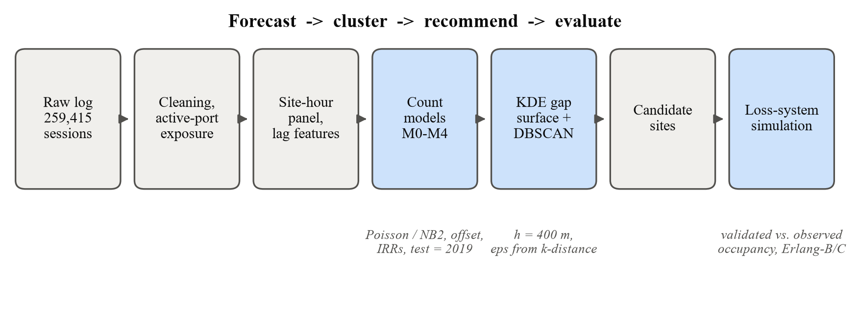
Fig. 1. Pipeline from the raw log to the evaluated recommendation.

A. Panel and Features
Sessions are counted by start hour, giving $y_{st}$ arrivals at site $s$ in hour $t$, on the complete site-hour grid (210,240 rows; 140,160 train, 70,080 test). Features are hour of day, day of week, weekend × hour, month, a US federal holiday flag, the fee regime, a linear trend, site effects and three lag terms that look back at least 24 h:
 | $$ℓ_{st}^{\left(24\right)}=log(1+y_{s,t−24})$$ | (1)
 | $$ℓ_{st}^{\left(168\right)}=log(1+y_{s,t−168})$$ | (2)
 | $$r_{st}=log(1+\frac{1}{7}\sum_{k=1}^{7}{y_{s,t−24k}})$$ | (3)
Because no feature uses the hour being predicted or anything after it, the 2019 forecasts are one day ahead and free of leakage. Two refinements were chosen on the validation quarter: site × hour terms for 06:00–23:00 (night hours share one profile, since some site-hour cells had no training arrivals) with site × fee terms, and a trend that is held at its last training value when forecasting. The exposure enters as an offset,
 | $$logμ_{st}=logc_{st}+x_{st}^{⊤}β$$ | (4)
so each coefficient acts on arrivals per active port (210 parameters in total).
B. Dispersion Checks
Before choosing between Poisson and negative binomial models we compare variance and mean across homogeneous cells and apply the Cameron–Trivedi test [20], which regresses a transformed residual of the fitted Poisson model on the fitted mean:
 | $$\frac{\left(y_{st} − {\hat{μ}}_{st})^{2} − y_{st}\right.}{{\hat{μ}}_{st}}=α{\hat{μ}}_{st}+ε_{st}$$ | (5)
A positive α points to NB2-type overdispersion, a negative one to underdispersion.
C. Forecasting Models
All models share the features and the split. M0 is the seasonal naive forecast ${\hat{y}}_{st}=y_{s,t−168}$. M1 is ordinary least squares on the counts (the continuous approach of Gap 3), with the port count as a regressor. M2 is a Poisson GLM with offset (4) and log-likelihood
 | $$ℓ_{P}(β)=\sum_{s,t}{[}y_{st}logμ_{st}−μ_{st}−log(y_{st}!)]$$ | (6)
M3 is the NB2 model, a Poisson–gamma mixture:
 | $$Pr(Y=y)=\frac{Γ(y+α^{−1})}{Γ(α^{−1})y!}{\left(\frac{1}{1+αμ}\right)}^{α^{−1}}{\left(\frac{αμ}{1+αμ}\right)}^{y}$$ | (7)
 | $$Var(Y)=μ+αμ^{2}$$ | (8)
The dispersion α is estimated by maximising the profile likelihood over log α with a bounded search. When the maximum is at α = 0 we report a one-sided 95% upper bound and the boundary likelihood-ratio test. The fits use a sparse IRLS solver written for this work; it matches statsmodels [22] to about ${10}^{−9}$. Standard errors are clustered by site-day, because hours of the same day share shocks. M4 is scikit-learn's histogram gradient boosting [21], [28] with Poisson loss; it is fitted to the rate per port with the port count as sample weight, which reproduces the exposure. M3c (NB2 without lags) shows what the lags add.
1) Evaluation: On 2019 we report MAE, RMSE, mean Poisson deviance and the deviance explained,
 | $$\overline{d}=\frac{2}{n}\sum_{i}{[}y_{i}log\frac{y_{i}}{{\hat{μ}}_{i}}−(y_{i}−{\hat{μ}}_{i})]$$ | (9)
 | $$D^{2}=1−\overline{d}(\hat{μ})/\overline{d}(\overline{y})$$ | (10)
plus the log-likelihood per observation, the coverage of central 90% prediction intervals, the predicted share of zero hours, calibration by decile, the randomised PIT for counts [26], and daily MAE and MAPE per site. A daily Poisson/NB2 pair (site-day counts with 1- and 7-day lags) tests dispersion at the planning scale.
D. Spatial Gap Analysis
Site coordinates are projected to metres with a local equirectangular projection. From the 2019 forecasts each site gets its predicted sessions $w_{s}$, its weekday peak-hour arrival rate $λ_{s}$ and, with the mean weekday plug-in time $𝔼[S_{s}]$ and ports $c_{s}$, a peak utilisation
 | $$ρ_{s}=λ_{s}𝔼[S_{s}]/c_{s}$$ | (11)
On a 40 m grid around the sites (1 km buffer), demand and supply are Gaussian kernel densities weighted by predicted sessions and by ports, the second scaled to the same total:
 | $$D(u)=\sum_{s}{w_{s}}K_{h}(u−u_{s})$$ | (12)
 | $$S(u)=\frac{\sum_{s}{w_{s}}}{\sum_{s}{c_{s}}}\sum_{s}{c_{s}}K_{h}(u−u_{s})$$ | (13)
 | $$G(u)=D(u)−S(u)$$ | (14)
The bandwidth h = 400 m is roughly a five-minute walk; 250 m and 600 m are tested as well. Cells with G above its 95th percentile are clustered with DBSCAN [18], using G divided by that threshold τ as sample weight, so a cell is a core point when
 | $$\sum_{‖u_{j}−u_{i}‖≤ε}{G(}u_{j})/τ≥minPts$$ | (15)
We set minPts = 4 (twice the dimension [18], [27]) and read ε from the k-distance plot; its knee falls on the grid spacing, so ε is set to the grid diagonal (57.1 m). Each cluster's candidate site is its gap-weighted centroid, moved to the nearest cluster cell at least 150 m from existing chargers if necessary.
E. Queueing Simulation
Each site is simulated on a typical 2019 weekday as a loss system: arrivals follow a non-homogeneous Poisson process with the forecast hourly rate (generated by thinning [24]), plug-in times are resampled from that site's 2019 weekday sessions starting in the same hour, and a driver who finds all ports busy leaves. Two days are simulated per run and the first is discarded; 500 runs are made with a fixed seed. The simulator is checked against occupancy rebuilt from the real 2019 sessions, once with forecast rates and once with the observed rates. At the peak hour, with offered load a = λE[S], the Erlang loss and delay formulas [25] give a reference:
 | $$B(c,a)=\frac{a^{c}/c!}{\sum_{k=0}^{c}{a^{k}}/k!}$$ | (16)
 | $$C(c,a)=\frac{cB(c,a)}{c−a[1−B(c,a)]},a<c$$ | (17)
For the candidate we test 2 or 4 new ports used as overflow (a driver tries the own garage first, then the new site) and full pooling of the cluster, in which drivers are sent to any free port. Results are scaled to the 251 working weekdays of 2019. Since turned-away drivers never appear in the log, all demand figures are lower bounds.
VII. Experimental Setup
Training uses 2017–2018 (140,160 site-hours) and testing all of 2019 (70,080), without shuffling. Tuning fits stop at 2018-09 and are scored on 2018-Q4; the chosen settings (Table III) are then refitted on the full training period. Software: Python 3.12.5, statsmodels 0.15.0, scikit-learn 1.9.1, pandas 3.0.6; all seeds are fixed at 42.
TABLE III
Settings chosen on 2018-Q4
Setting | Options | Chosen
HGB learning rate | 0.05, 0.1 | 0.10
HGB leaves | 15, 31, 63 | 15
HGB iterations | 200, 500 | 200
GLM trend | extrap., frozen, none | frozen
GLM site terms | none, ×fee, ×hour, both | both
KDE bandwidth | 250, 400, 600 m | 400 m
DBSCAN minPts, ε | k-distance plot | 4, 57 m
Simulation runs | — | 500

VIII. Results and Discussion
A. Exploratory Analysis
Use grew from 6,139 sessions in 2012 to 48,437 in 2017, fell by 12.2% in 2018 after fees were introduced, and recovered to 47,380 in 2019 (Fig. 2(a)). 77% of sessions start on a weekday. Weekdays have a morning peak from commuters and an evening peak near 18:00; the busiest slot overall is Thursday at 18:00 with 11.5 arrivals per hour (Fig. 2(b)). The 2018 drop was concentrated at Rinconada, MPL, High and Webster, while the sites that gained ports grew (Fig. 2(c)).

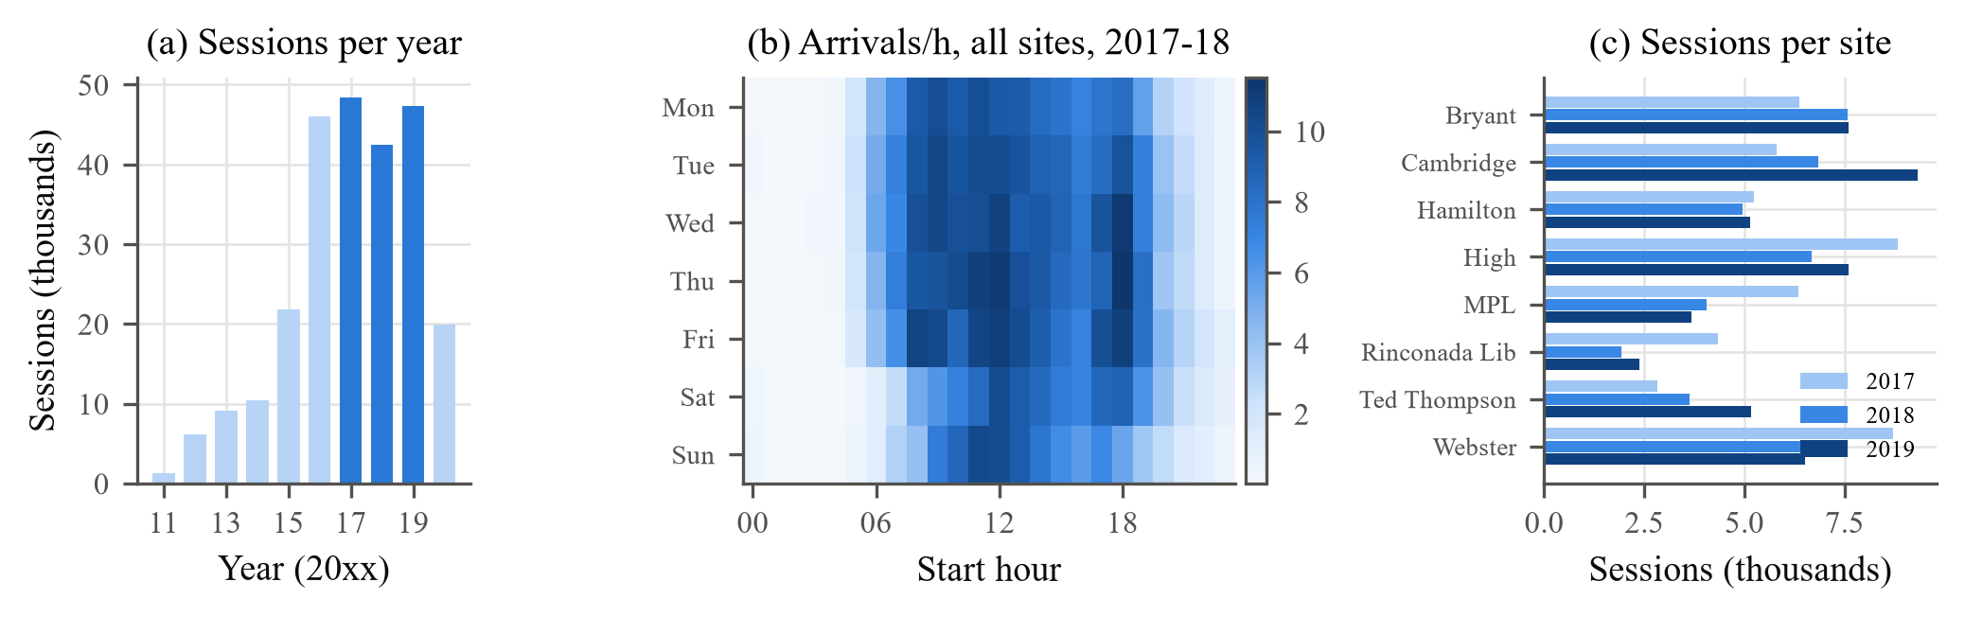
Fig. 2. (a) Clean sessions per year (dark: study window). (b) Mean arrivals per hour, all sites, 2017–2018. (c) Sessions per site and year.

B. Dispersion
60.7% of site-hours have no arrival. Against common practice, the hourly counts are not overdispersed (Table IV, Fig. 3). The median variance-to-mean ratio over 384 hourly cells is 0.99, and the Cameron–Trivedi coefficient is negative (−0.057, t = −7.6). In the busiest decile the ratio drops to 0.89: a full site cannot accept more cars, which squeezes the variance. The NB2 likelihood is therefore maximised at α = 0 and M3 reduces to M2. Daily totals behave differently. Weather and local events affect every hour of a day together, and these shared shocks show up once the hours are summed: the daily NB2 estimate is α = 0.0168 with a likelihood-ratio statistic of 142.3, and its intervals cover more of 2019.
TABLE IV
Dispersion tests and daily models
Statistic | Hourly | Daily
Pearson χ²/df | 1.10 | 1.36
C–T α (t) | −0.057 (−7.6) | 0.012 (7.7)
NB2 α (SE) | 0 (≤ 0.0004) | 0.0168 (0.0017)
LR test vs. Poisson | 0.0 | 142.3
2019 90% cov., Poisson | 97.4% | 84.3%
2019 90% cov., NB2 | 97.4% | 87.9%
2019 log-lik./obs, NB2 | −0.850 | −3.010
Hourly NB2 bound: one-sided 95% profile-likelihood bound. Hourly coverage is conservative because interval limits are integers.

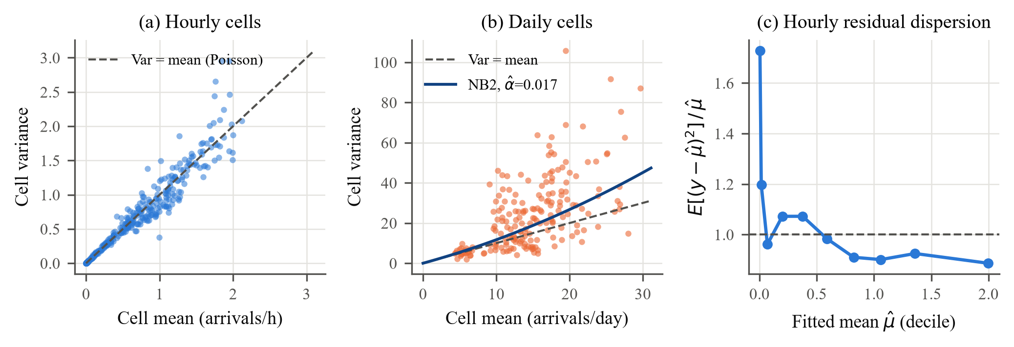
Fig. 3. Variance against mean for (a) hourly and (b) daily cells of the training data, and (c) residual variance/mean by decile of the hourly Poisson fit.

C. Forecast Accuracy
Table V lists the 2019 results. The count GLM (M2, equal to M3 here) has the lowest deviance (0.778), RMSE and log-likelihood loss. Gradient boosting has the lowest MAE, partly because MAE rewards predicting zero in quiet hours, yet it predicts too many zeros (68.1% against 61.1%) and misses the 2019 total by 27.8%. Trees cannot go beyond the levels seen in training, and 2019 demand rebounded. Boosting did win on the validation quarter (0.722 against 0.773), which shows how a short hold-out can flatter a flexible model. OLS gives negative forecasts in 15.1% of hours and intervals 1.41 times wider than the count model. Dropping the lags (M3c) costs 0.026 in deviance. At the daily level the GLM is off by 3.64 sessions per site-day on a mean of 16.2.

TABLE V
Accuracy on the 2019 test year (70,080 site-hours)
Model | MAE | RMSE | Dev. | D² | LL/obs | 90% cov. | 2019 bias | Daily MAE | Daily MAPE
M0 Seasonal naive | 0.609 | 1.076 | — | — | — | — | −0.1% | 4.03 | 34.2%
M1 OLS | 0.546 | 0.837 | 0.794 | 0.464 | — | 89.3% | −3.6% | 3.59 | 30.9%
M2 Poisson GLM | 0.525 | 0.831 | 0.778 | 0.475 | −0.850 | 97.4% | −9.4% | 3.64 | 28.3%
M3 NB2 GLM | 0.525 | 0.831 | 0.778 | 0.475 | −0.850 | 97.4% | −9.4% | 3.64 | 28.3%
M3c NB2, no lags | 0.535 | 0.850 | 0.804 | 0.458 | −0.863 | 97.2% | −10.8% | — | —
M4 HGB-Poisson | 0.514 | 0.858 | 0.807 | 0.456 | −0.864 | 96.1% | −27.8% | 5.34 | 32.3%
Dev.: mean Poisson deviance (OLS clipped at 0.01). 2019 bias: predicted/observed total − 1. Daily columns pool all sites; MAPE excludes days with no arrivals.

Table VI shows the two choices made on the validation quarter. Site-specific terms cut the worst single-site bias on 2019 from 24% to 18%. The frozen trend was preferred on validation, but on 2019 a model without any trend would have done slightly better (0.7723 against 0.7781). We kept the validation choice so that the test year was never used for selection.
TABLE VI
Specification choices (Poisson GLM)
Specification | p | Val. dev. | Test dev. | Test bias
Site effects only | 77 | 0.7988 | 0.7958 | −8.8%
+ site × fee | 84 | 0.7863 | 0.7868 | −8.2%
+ site × hour | 203 | 0.7831 | 0.7849 | −9.9%
+ both (chosen) | 210 | 0.7728 | 0.7781 | −9.4%
Trend extrapolated | — | 0.7740 | 0.7882 | −14.2%
Trend frozen | — | 0.7728 | 0.7781 | −9.4%
Trend none | — | 0.7740 | 0.7723 | −2.3%
Selection uses the validation column only. Trend rows use the chosen site terms.
D. Interpretation
The rate ratios (Table VII, Fig. 4) read directly. At Bryant a weekday port receives about 228 times as many arrivals between 09:00 and 10:00 as between midnight and 01:00 (95% CI 152–341). At 09:00 a Saturday has 25% and a Sunday 31% fewer arrivals than a Monday, and a federal holiday lowers the rate to 0.62 of a normal day. A doubling of recent same-hour demand raises the expected rate by a factor of 1.22. The fee effect varies widely: arrivals per port fell by 59% at Ted Thompson and 52% at Rinconada Lib, but did not change measurably at Hamilton (IRR 1.02, CI 0.98–1.07). Hamilton has only 3 ports and was often full, so a drop in demand there hardly changes the recorded arrivals. The Ted Thompson and Cambridge estimates also reflect their March 2018 expansion.
TABLE VII
Selected rate ratios (M3)
Term | IRR | 95% CI | p
Weekday 09:00 vs 00:00, Bryant | 227.6 | 152.1–340.7 | <0.001
Saturday vs Monday, 09:00 | 0.750 | 0.702–0.802 | <0.001
Sunday vs Monday, 09:00 | 0.690 | 0.643–0.740 | <0.001
Federal holiday | 0.618 | 0.566–0.675 | <0.001
Trend (per year) | 0.895 | 0.872–0.918 | <0.001
log(1+y), 24 h lag | 1.054 | 1.039–1.071 | <0.001
log(1+y), 168 h lag | 1.166 | 1.147–1.185 | <0.001
log(1+7-day mean) | 1.338 | 1.285–1.393 | <0.001
Fee regime, Bryant | 0.522 | 0.494–0.552 | <0.001
Fee regime, Cambridge | 0.583 | 0.555–0.612 | <0.001
Fee regime, Hamilton | 1.023 | 0.982–1.065 | 0.284
Fee regime, High | 0.696 | 0.669–0.725 | <0.001
Fee regime, MPL | 0.730 | 0.699–0.763 | <0.001
Fee regime, Rinconada Lib | 0.478 | 0.454–0.504 | <0.001
Fee regime, Ted Thompson | 0.409 | 0.385–0.435 | <0.001
Fee regime, Webster | 0.849 | 0.817–0.882 | <0.001
Confidence intervals are cluster-robust by site-day.
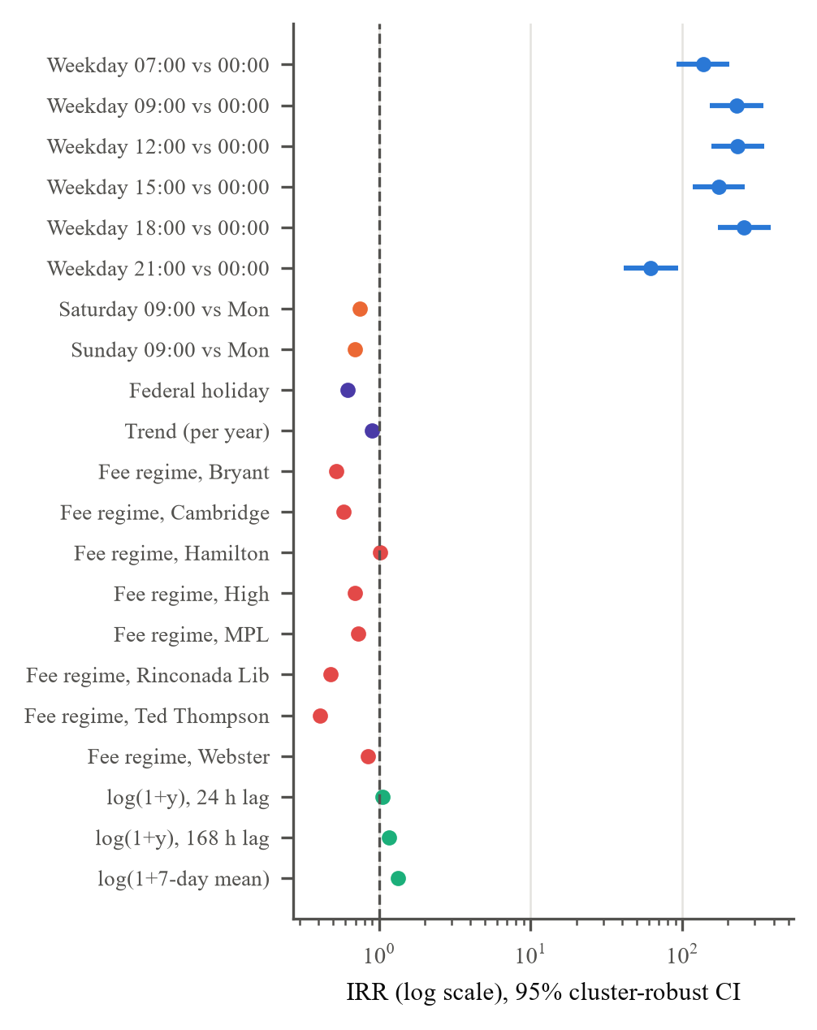
Fig. 4. Rate ratios with 95% cluster-robust confidence intervals (log scale).
E. Calibration and Residuals
The forecasts follow the test week closely (Fig. 5(a)). By decile the GLM is well calibrated except in the busiest hours, where it predicts 1.86 arrivals per hour against 2.14 observed; boosting predicts 1.46 (Fig. 5(b)). For the hourly GLM, 10.4% of PIT values lie outside [0.05, 0.95] against a nominal 10%, so the Poisson spread is right. For daily totals the tail share is 18.6% for Poisson and 14.4% for NB2 (Fig. 5(c)). Residual autocorrelation is negligible (Fig. 5(d); lag 1: 0.014, lag 24: 0.047).

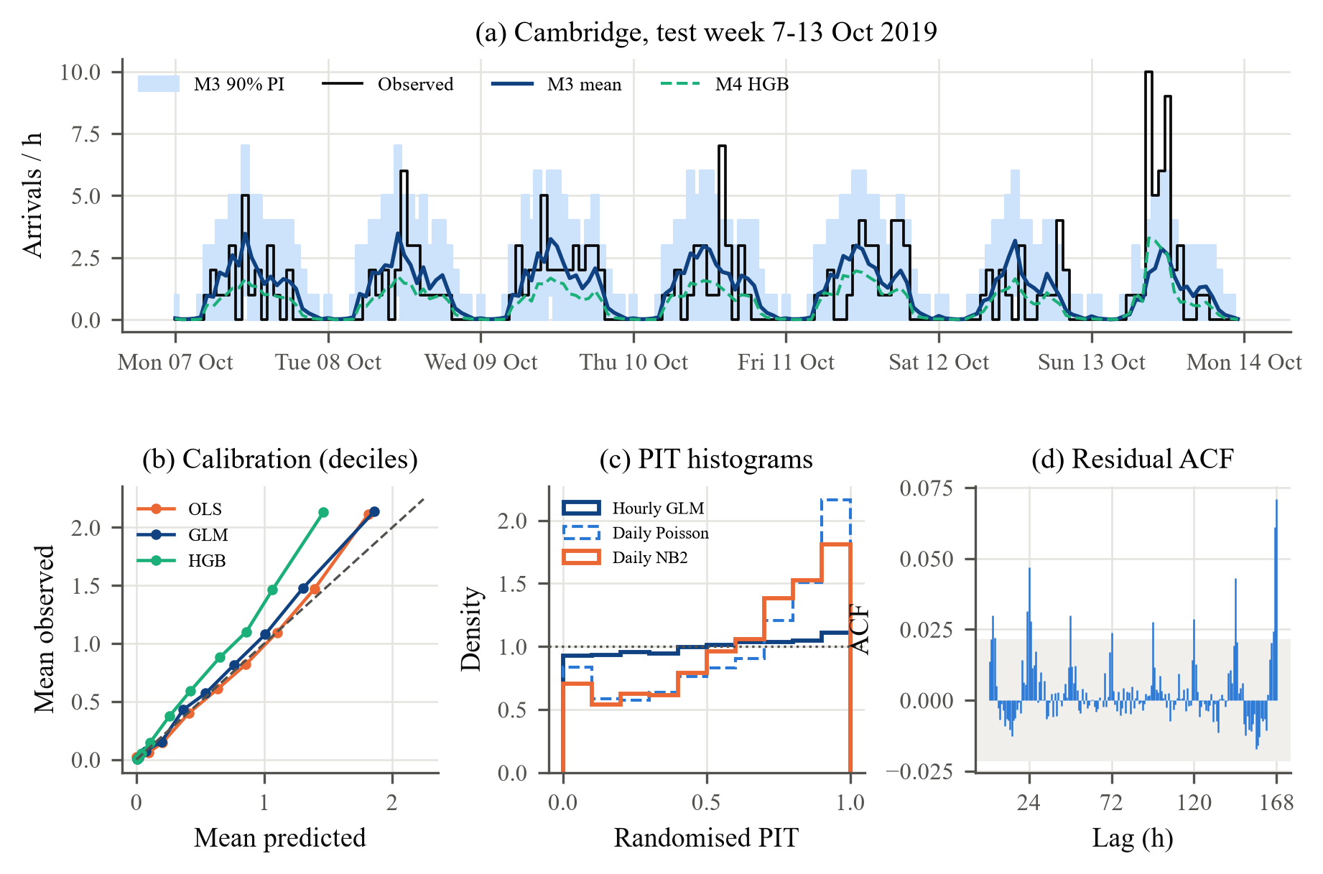
Fig. 5. (a) Observed and predicted arrivals with the M3 90% interval, one test week. (b) Calibration by decile. (c) Randomised PIT. (d) Residual autocorrelation (band: approx. 95%).

F. Demand Gap and Candidate Site
Table VIII turns the forecasts into planning figures. Hamilton (1,519 predicted sessions per port, peak ρ = 0.85) and Webster (1,042) carry far more per port than the other sites (618–894). The gap surface therefore has one positive area over downtown, while Cambridge, Ted Thompson, Rinconada and MPL are relatively over-supplied (Fig. 6). DBSCAN finds 1 cluster of 1.60 km² holding a gap of 1,903 sessions per year (Fig. 7). Its centroid, (37.4461, −122.1586), lies 239 m from Hamilton, between the Hamilton, Webster and Bryant garages, and is the recommended site. It moves by at most 10 m for bandwidths of 250–600 m and by 78 m when observed instead of predicted sessions are used. A second small zone near Cambridge appears only with the 250 m kernel and is not recommended.
TABLE VIII
Predicted 2019 demand and utilisation
Site | c | Pred. | Obs. | Pred./port | Peak ρ
Bryant | 9 | 6,896 | 7,597 | 766 | 0.54
Cambridge | 10 | 8,941 | 9,332 | 894 | 0.57
Hamilton | 3 | 4,558 | 5,136 | 1,519 | 0.85
High | 8 | 6,200 | 7,590 | 775 | 0.49
MPL | 5 | 3,212 | 3,684 | 642 | 0.34
Rinconada Lib | 3 | 1,941 | 2,371 | 647 | 0.44
Ted Thompson | 8 | 4,946 | 5,158 | 618 | 0.52
Webster | 6 | 6,252 | 6,512 | 1,042 | 0.71
Pred./Obs.: 2019 sessions. ρ: offered load per port in the busiest weekday hour.

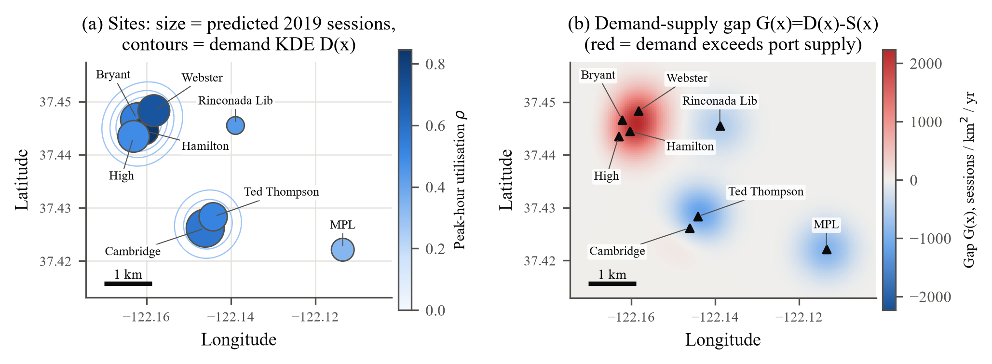
Fig. 6. (a) Sites sized by predicted 2019 sessions and coloured by peak utilisation. (b) Gap G(x) for h = 400 m; red marks demand above port supply.

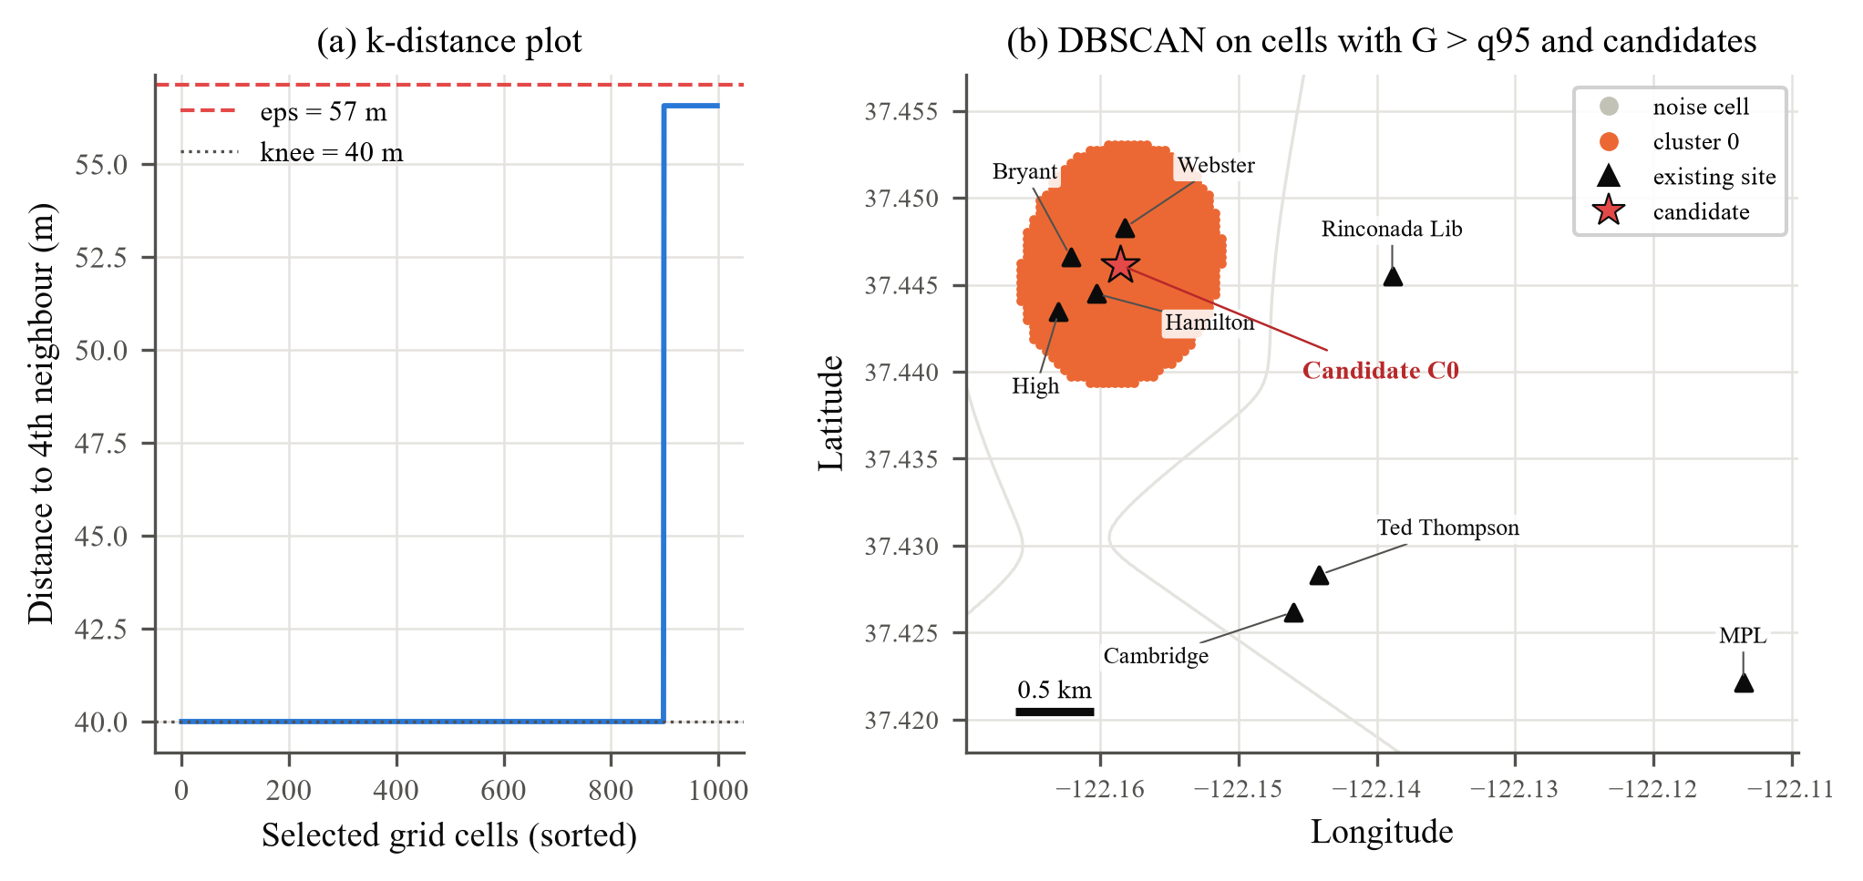
Fig. 7. (a) k-distance plot (k = 4). (b) DBSCAN cluster of high-gap cells, existing sites (triangles) and the candidate (star).

G. Simulation
With observed arrival rates the simulator reproduces hourly occupancy at every site (r = 0.988–0.999; Fig. 8(a), Table IX). With forecast rates the shapes still agree (r ≥ 0.95) but the level inherits the forecast shortfall. Erlang-B at the peak arrival hour exceeds the simulated blocking at 8 of 8 sites, because cars that arrive at the peak stay about two hours and blocking builds up later in the morning (Fig. 8(b)). Hamilton is the exception to a good fit: random arrivals at its observed rate would lose 20% of drivers, yet every recorded session was served, which suggests that drivers there time their visits to free ports.

TABLE IX
Simulator check and peak-hour blocking
Site | c | Occ. r | Occ. MAE | a (Erl.) | Erlang-B | Sim. block | Lost/day | Lost/day (M3)
Bryant | 9 | 0.999 | 0.09 | 6.26 | 8.7% | 6.3% | 0.89 | 0.34
Cambridge | 10 | 0.998 | 0.10 | 6.44 | 5.8% | 2.8% | 0.35 | 0.22
Hamilton | 3 | 0.992 | 0.29 | 3.51 | 40.3% | 24.8% | 3.01 | 2.47
High | 8 | 0.998 | 0.12 | 6.02 | 12.3% | 6.0% | 0.81 | 0.17
MPL | 5 | 0.996 | 0.04 | 1.92 | 3.2% | 0.4% | 0.08 | 0.09
Rinconada Lib | 3 | 0.988 | 0.07 | 1.75 | 17.2% | 8.3% | 0.38 | 0.21
Ted Thompson | 8 | 0.998 | 0.08 | 5.00 | 7.0% | 4.0% | 0.39 | 0.15
Webster | 6 | 0.998 | 0.21 | 5.85 | 25.4% | 5.0% | 2.10 | 1.16
Occupancy r and MAE compare the 24 hourly means of simulation and data. a, Erlang-B and simulated blocking refer to the peak arrival hour; all columns except the last use observed 2019 rates.

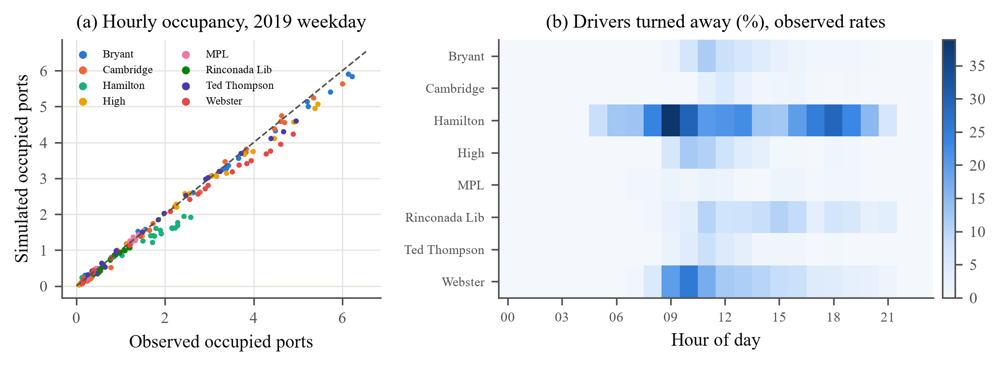
Fig. 8. (a) Simulated against observed mean occupancy per hour (all sites, observed arrival rates). (b) Share of drivers turned away by site and hour.

Table X gives the effect of the recommendation in the downtown cluster. At observed 2019 demand the four garages turn away 1,708 weekday sessions per year. Two overflow ports at the candidate reduce this to 604 and four ports to 202, a fall of 88%. With forecast rates the same four ports take the figure from 1,036 to 41. Sending drivers to any free port in the cluster, with no new hardware, already brings losses down to 94, so real-time availability information is about as useful as new ports here; together they leave 7.
TABLE X
Downtown scenarios (weekdays)
Scenario | Ports | Lost/yr (M3) | Lost/yr (obs.) | Peak block
Baseline | 26 | 1,036 | 1,708 | 14.4%
Overflow, +2 | 28 | 260 | 604 | 8.5%
Overflow, +4 | 30 | 41 | 202 | 3.1%
Pooled, +0 | 26 | 5 | 94 | 2.1%
Pooled, +2 | 28 | 1 | 45 | 1.2%
Pooled, +4 | 30 | 0 | 7 | 0.3%
Bryant, Hamilton, High and Webster. Per year = 251 weekdays. Peak block uses observed rates.
H. The Research Gaps Revisited
For Gap 1, the interpretable GLM was more accurate than gradient boosting on the unseen year in deviance, RMSE and likelihood, and its coefficients answer planning questions directly. For Gap 2, the same forecasts drive the gap map, the clustering and the simulation. For Gap 3, count models give valid probabilities, but the usual case for NB2 holds only for daily totals. For Gap 4, DBSCAN isolated the high-gap zone without fixing the number of clusters and set isolated cells aside as noise.
IX. Limitations
1) One city: Eight sites in one city give a gap map of imbalance between existing sites; areas without chargers cannot be assessed, and the results may not transfer to other cities.
2) Censored demand: Drivers who found a full site are not recorded, so demand, the fee effect at busy sites and the simulated losses are all underestimated.
3) Level shift: 2019 demand was under-predicted by 9.4% overall (High −18%), and the trend choice rests on one short validation quarter.
4) Missing data: Weather, traffic and points of interest were not available. Port outages were inferred from gaps in use, and the simulation assumes random arrivals and no waiting.
X. Conclusion and Future Work
The forecast-cluster-recommend pipeline of the synopsis was built and tested on real Palo Alto data. A count GLM with an exposure offset, site-specific terms and past-only lags explains 48% of the hourly deviance in an unseen year and holds up better than gradient boosting. Hourly arrivals are Poisson; daily totals need NB2. The gap analysis identifies downtown Palo Alto as under-supplied, and four overflow ports at the candidate site would recover about 1,507 weekday sessions per year. Future work should model censoring directly, add weather and land-use data, include grid limits in placement [6], [9], [10] and repeat the study in other cities.
References
[1] S. Koohfar, W. Woldemariam, and A. Kumar, “Prediction of Electric Vehicles Charging Demand: A Transformer-Based Deep Learning Approach,” Sustainability, vol. 15, no. 3, p. 2105, 2023.
[2] F. Marzbani, A. H. Osman, and M. S. Hassan, “Electric Vehicle Energy Demand Prediction Techniques: An In-Depth and Critical Systematic Review,” IEEE Access, vol. 11, pp. 96242–96259, 2023.
[3] K. Akshay, G. H. Grace, K. Gunasekaran, and R. Samikannu, “Power Consumption Prediction for Electric Vehicle Charging Stations and Forecasting Income,” Scientific Reports, vol. 14, no. 1, p. 6497, 2024.
[4] R. N. Akshayaa, S. Sajidha, and R. Radha, “Session and Energy Forecasting for Electric Vehicle Charging Station Using Custom Weighted Ensemble Machine Learning,” Results in Engineering, vol. 26, p. 105104, 2025.
[5] F. Bellizio, B. Dijkstra, A. Fertig, J. Van Dijk, and P. Heer, “Machine Learning Approaches for the Prediction of Public EV Charge Point Flexibility,” Sustainable Energy, Grids and Networks, vol. 42, p. 101657, 2025.
[6] B. Al-Hanahi, I. Ahmad, D. Habibi, P. Pradhan, and M. A. Masoum, “A Charging Strategy for Large Commercial Electric Vehicle Fleets,” IEEE Access, vol. 12, pp. 46042–46058, 2024.
[7] L. Douaidi, S. M. Senouci, I. El Korbi, F. Harrou, and A. Yazici, “Federated Deep Learning for Enhanced Prediction of Electric Vehicle Charging Station Availability,” Cluster Computing, vol. 28, no. 6, p. 364, 2025.
[8] K. Hallak and O. Kem, “Adaptive Federated Learning Framework for Predicting EV Charging Stations Occupancy,” International Journal of Transportation Science and Technology, 2025.
[9] R. Lyu, H. Guo, K. Zheng, M. Sun, and Q. Chen, “Co-Optimizing Bidding and Power Allocation of an EV Aggregator Providing Real-Time Frequency Regulation Service,” IEEE Transactions on Smart Grid, vol. 14, no. 6, pp. 4594–4606, 2023.
[10] C. Li, Z. Dong, G. Chen, B. Zhou, J. Zhang, and X. Yu, “Data-Driven Planning of Electric Vehicle Charging Infrastructure: A Case Study of Sydney, Australia,” IEEE Transactions on Smart Grid, vol. 12, no. 4, pp. 3289–3304, 2021.
[11] F. Cheng and H. Liu, “Multi-Step Electric Vehicles Charging Loads Forecasting: An Autoformer Variant with Feature Extraction, Frequency Enhancement, and Error Correction Blocks,” Applied Energy, vol. 376, p. 124308, 2024.
[12] J. Shi, W. Zhang, Y. Bao, D. W. Gao, and Z. Wang, “Load Forecasting of Electric Vehicle Charging Stations: Attention Based Spatiotemporal Multi-Graph Convolutional Networks,” IEEE Transactions on Smart Grid, vol. 15, no. 3, pp. 3016–3027, 2024.
[13] H. Li, D. Liang, Y. Zhou, Y. Shi, D. Feng, and S. Shi, “Spatiotemporal Charging Demand Models for Electric Vehicles Considering User Strategies,” Frontiers in Energy Research, vol. 10, p. 1013154, 2022.
[14] Y. Zhao, Z. Wang, Z. J. M. Shen, and F. Sun, “Data-Driven Framework for Large-Scale Prediction of Charging Energy in Electric Vehicles,” Applied Energy, vol. 282, p. 116175, 2021.
[15] J. Zhang et al., “Charging Demand Prediction in Beijing Based on Real-World Electric Vehicle Data,” Journal of Energy Storage, vol. 57, p. 106294, 2023.
[16] Y. S. Liu, M. Tayarani, and H. O. Gao, “An Activity-Based Travel and Charging Behavior Model for Simulating Battery Electric Vehicle Charging Demand,” Energy, vol. 258, p. 124938, 2022.
[17] L. Zhang et al., “OD Matrix Based Spatiotemporal Distribution of EV Charging Load Prediction,” Power System Protection and Control, vol. 49, pp. 82–91, 2021.
[18] M. Ester, H.-P. Kriegel, J. Sander, and X. Xu, “A Density-Based Algorithm for Discovering Clusters in Large Spatial Databases with Noise,” in Proc. 2nd Int. Conf. Knowledge Discovery and Data Mining (KDD), 1996, pp. 226–231.
[19] A. C. Cameron and P. K. Trivedi, Regression Analysis of Count Data, 2nd ed. Cambridge, U.K.: Cambridge University Press, 2013.
[20] A. C. Cameron and P. K. Trivedi, “Regression-Based Tests for Overdispersion in the Poisson Model,” Journal of Econometrics, vol. 46, no. 3, pp. 347–364, 1990.
[21] F. Pedregosa et al., “Scikit-learn: Machine Learning in Python,” Journal of Machine Learning Research, vol. 12, pp. 2825–2830, 2011.
[22] S. Seabold and J. Perktold, “Statsmodels: Econometric and Statistical Modeling with Python,” in Proc. 9th Python in Science Conf. (SciPy), 2010, pp. 92–96.
[23] City of Palo Alto, “Electric Vehicle Charging Station Usage, July 2011 – December 2020,” City of Palo Alto Open Data. Mirrored on Kaggle as “EV Charging Station Usage of California City” (kaggle.com/datasets/venkatsairo4899/ev-charging-station-usage-of-california-city) and on GitHub (github.com/andriysavcyn/palo-alto-ev-charging), accessed Oct. 2026.
[24] P. A. W. Lewis and G. S. Shedler, “Simulation of Nonhomogeneous Poisson Processes by Thinning,” Naval Research Logistics Quarterly, vol. 26, no. 3, pp. 403–413, 1979.
[25] D. Gross, J. F. Shortle, J. M. Thompson, and C. M. Harris, Fundamentals of Queueing Theory, 4th ed. Hoboken, NJ, USA: Wiley, 2008.
[26] C. Czado, T. Gneiting, and L. Held, “Predictive Model Assessment for Count Data,” Biometrics, vol. 65, no. 4, pp. 1254–1261, 2009.
[27] J. Sander, M. Ester, H.-P. Kriegel, and X. Xu, “Density-Based Clustering in Spatial Databases: The Algorithm GDBSCAN and Its Applications,” Data Mining and Knowledge Discovery, vol. 2, no. 2, pp. 169–194, 1998.
[28] G. Ke et al., “LightGBM: A Highly Efficient Gradient Boosting Decision Tree,” in Advances in Neural Information Processing Systems 30 (NeurIPS), 2017, pp. 3146–3154.

