LOCAL GENERATION READOUT

Yenia Apartment Dance
  - Wan2.2-Animate pose-controlled motion transfer
Field | Value | Field | Value
Run | 20260825T053824Z-yenia-wan | Delivery | 15.000 s / 360 frames / 24 fps
Mode | Pose-only + native continuation | Format | 1080 x 1920 H.264 + AAC
Status | Complete with limitation recorded | Scope | Local only; not published

Results
Wan2.2-Animate delivered a 15-second vertical dance transfer with one continuous Yenia character, the approved apartment, and the cleared source soundtrack. The pose-only control path removed the gray-matte and source-scene leakage seen in the earlier RGB-guided H3 experiments.
OUTCOME The primary export passed all automated format checks and full-frame visual review. The 0:10 identity jump is absent and all four continuation boundaries read as continuous motion.

Delivered files
Role | Relative file | SHA-256
Primary | final/yenia_dance_wan22_1080x1920.mp4  9.8 MB | cfb6da44fb10574c8416e3484f337412  ab23f9542a07ab7e599985bc26ff427d
Hair-prompt comparison | final/yenia_dance_wan22_hairfix_1080x1920.mp4  9.7 MB | cc8fa99724f46f008b1c78d48bdd6b76  bb054a91f2d1c601bb47b57615ffb107
Model master | final/yenia_dance_wan22_480x832_master.mkv  35.6 MB | a55b1159cc3f2bed5a256b7dbfeceaa5  b13473289ead893f85fd31ce3d5fefbb
Alternate master | final/yenia_dance_wan22_hairfix_480x832_master.mkv  35.5 MB | 67fdf86c556598710eec17fe76bdf43b  7e0b4c5df2bd7588db3fe3c581989d6b

Primary technical verification
Metric | Observed | Metric | Observed
Frames | 360 | Duration | 15.000 s
Resolution | 1080 x 1920 | Frame rate | 24 fps
Video | H.264 / yuv420p | Audio | AAC / stereo / 48 kHz
Audio bitrate | 194 kbps | Fast-start | Yes (moov before mdat)
Source-audio PCM | Exact decoded match | Automated checks | 14 / 14 passed

Automated delivery gate
Check | State | Check | State
Audio bitrate | PASS | Audio channels | PASS
Audio codec | PASS | Audio duration | PASS
Audio present | PASS | Audio sample rate | PASS
Audio start | PASS | Video duration | PASS
Fast-start | PASS | Frame rate | PASS
Frame count | PASS | Height | PASS
Pixel format | PASS | Video codec / width | PASS

GATE RESULT All 14 automated format and timing checks passed before visual review.

Visual QA
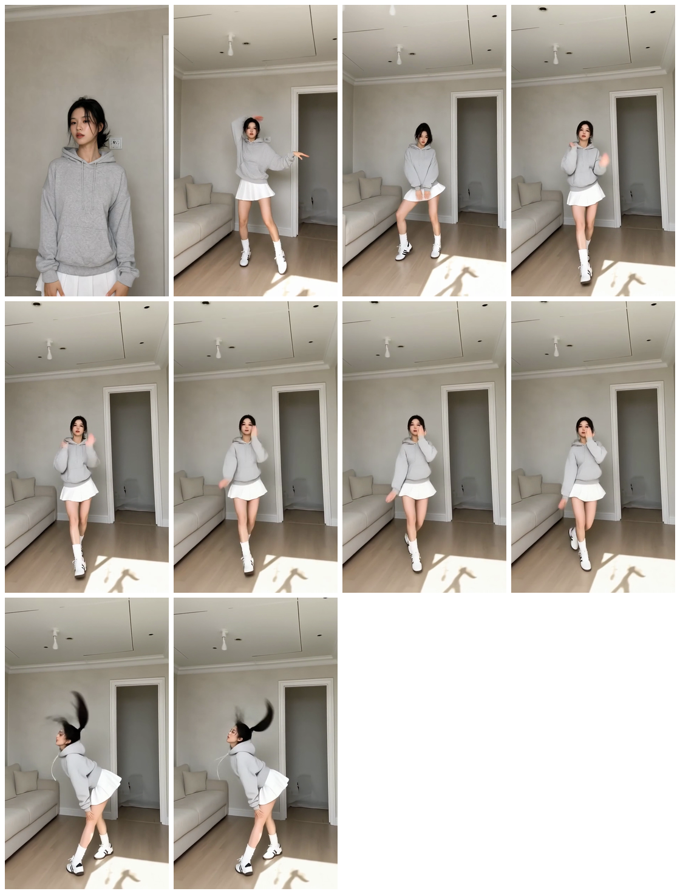
Primary output contact sheet: start, choreography samples, continuation neighborhood, and final spin/bend.
- Exactly one adult Yenia appears in every delivered frame.
- Face, gray hoodie, white pleated skirt, socks, sneakers, and apartment remain accepted across the full scan.
- No source crowd, exterior scene, gray matte, face, clothing, text, logo, or watermark appears.
- All 360 frames were reviewed through eight contiguous full-frame contact sheets.

0:10 continuity check
The prior face change occurred around 0:10. In this run, delivered frames 236-244 (9.83-10.17 seconds) retain the same Yenia identity while the hands and torso move through the choreography.
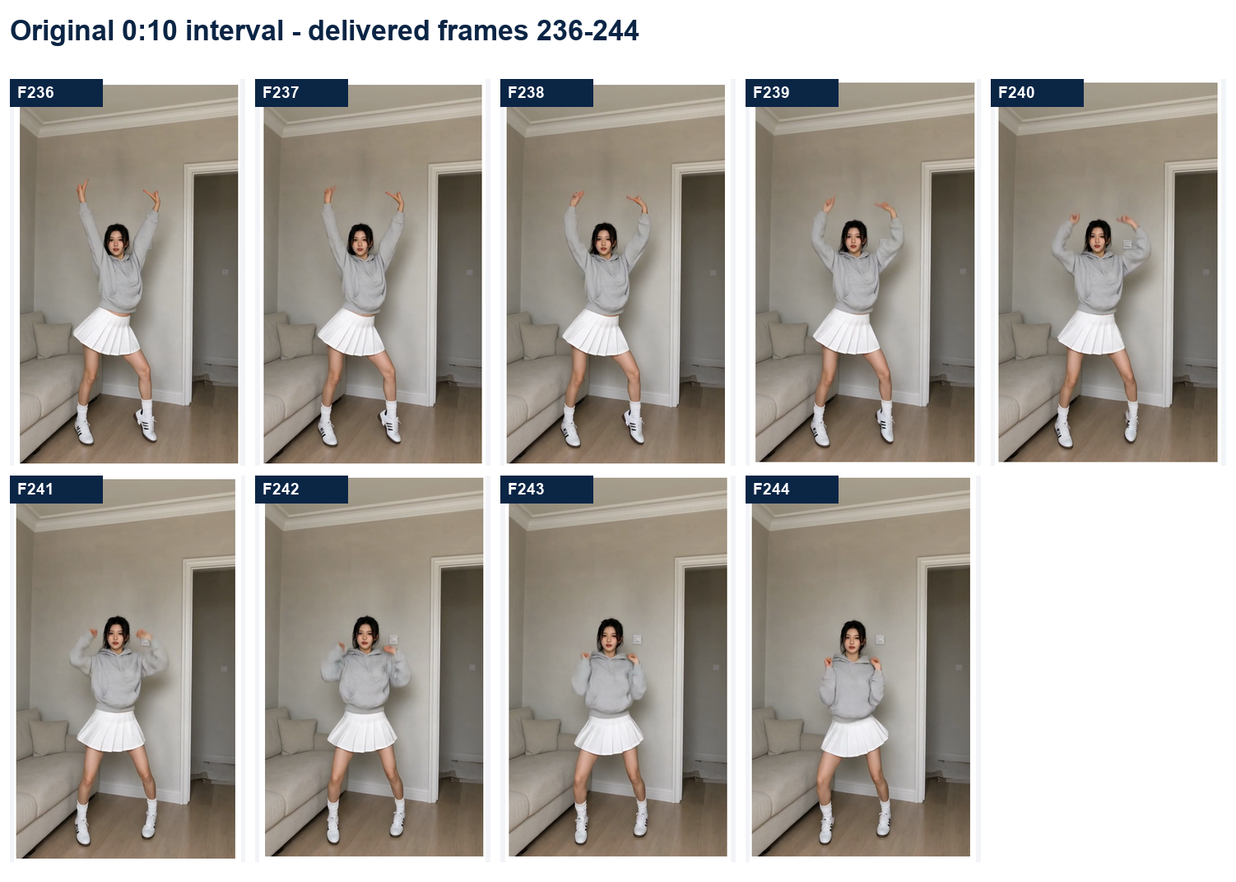
Frames 236-244 around 0:10. No identity reset or second face appears.

Continuation boundaries
Delivered frame | Time | Review | Finding
77 | 3.208 s | Visual pass | No reset, duplicate, or camera jump
149 | 6.208 s | Visual pass | No reset, duplicate, or camera jump
221 | 9.208 s | Visual pass | No reset, duplicate, or camera jump
293 | 12.208 s | Visual pass | No reset, duplicate, or camera jump

Continuity method: each request generated 77 frames; after the first chunk, five generated continuation frames conditioned the next request and only the subsequent 72 new frames were kept. The final five padding frames were discarded.

Known limitation and bounded retry
RECORDED LIMITATION During approximately frames 329-359 (13.71-14.96 seconds), the compact tied updo stretches into a ponytail-like silhouette during the fast spin and bend. Face, outfit, body, and apartment remain continuous.
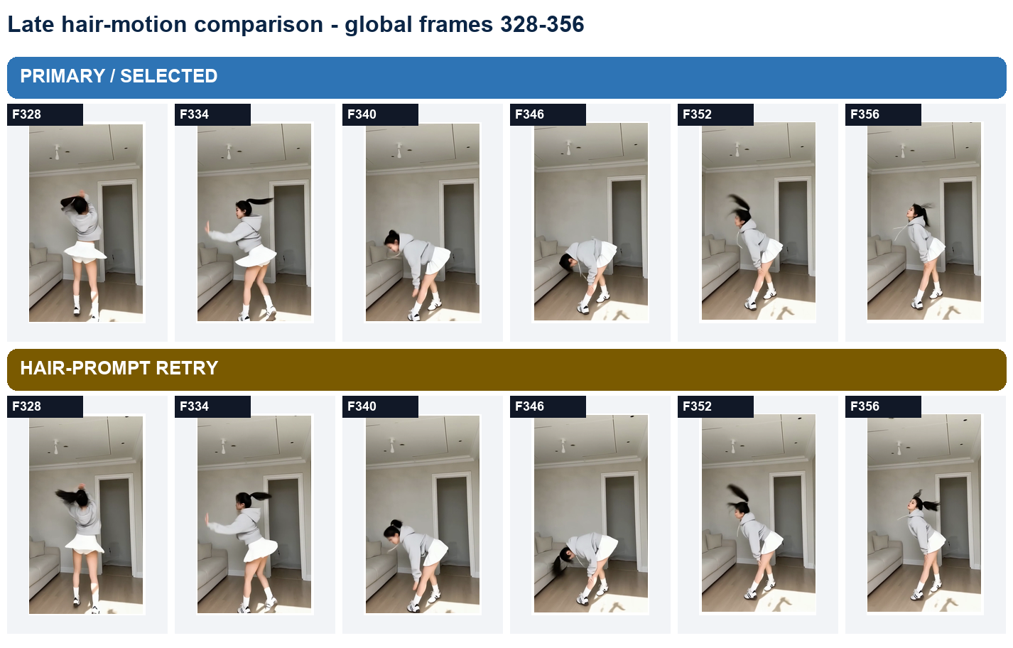
Primary versus seed 24082215 hair-prompt retry. The targeted retry did not materially reduce the elongated hair motion.
Selection decision: keep the base primary (chunk 4 seed 24082205). Preserve the retry as an alternate comparison, but do not call it a fix.

Inputs
The generation deliberately separates appearance from motion. Yenia and her apartment enter through a single RGB appearance anchor; the source choreography enters through an official Wan-format whole-body skeleton video. No source RGB face crop is supplied to the generator.
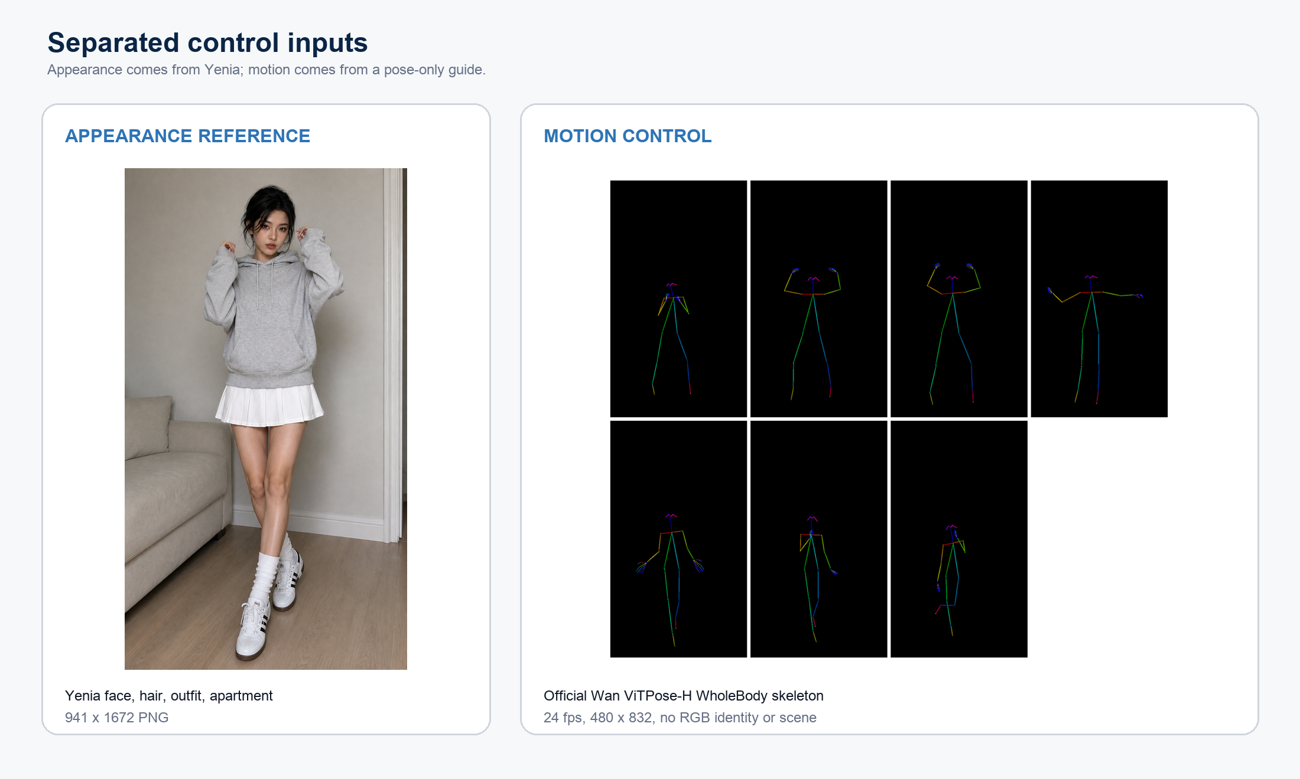
Appearance and motion are independent inputs. This separation is the main control against source-person and background leakage.

Reference roles
Input | Relative file | Role | Technical facts
Appearance anchor | inputs/yenia_appearance_anchor.png | Identity, face, hair, outfit, apartment | 941 x 1672 PNG
Cleared source | inputs/source_dance.mp4 | Choreography, timing, camera, audio | 576 x 1024; 526 frames; 24 fps
Isolated guide | inputs/motion_guide_360.mkv | Preprocessing source for the first 15 seconds | 360 frames
Selected pose | controls/full_vitpose_360.mkv | Official Wan whole-body motion control | 480 x 832; 360 frames; 0 misses
Padded pose | controls/full_vitpose_365_padded.mkv | Five tail clones for native continuation | 365 frames; clones not delivered

FACE CONDITIONING None. Wan expects 512 x 512 RGB face crops; the source dancer's crop was excluded to prevent identity leakage. DWPose face landmarks remain diagnostic only and are not generation inputs.

Rights and transfer boundary
Boundary | Recorded scope
Allowed from source | Choreography; timing; scale and position; camera motion; cleared audio
Excluded from source | Identity; face; clothing; background; text; watermark
Character / scene | Yenia, gray hoodie, white skirt, socks, sneakers, and Yenia's apartment
Publication | Not requested; files remain local

Input provenance
Asset | Relative path | SHA-256
Yenia appearance anchor | inputs/yenia_appearance_anchor.png | 9728c986d07d3e6399caf4f6961fb496  ff9f432e27d059fcf469a1ca0b10cef6
Source dance | inputs/source_dance.mp4 | 8f5011accef0b5be61618d8bd845c63a  dd3b007c4fb640f246a6b4ad682d2913
Isolated motion guide | inputs/motion_guide_360.mkv | 9668bddb5f70c58a3c98415b1d89fbc2  7e72b1ec3199d7b273e822a53a5cba27
ViTPose control | controls/full_vitpose_360.mkv | d3b44b48b4b682be113edfb88603e25c  f36ddf49e82437ae2e898bb236e716fc
Padded pose control | controls/full_vitpose_365_padded.mkv | f7216a6a91b7f8974e338573f2af0a3f  28c7b7535e899764104df7a732c874f6

Original character assets (unchanged)
Character file | SHA-256
face.png | 17bfef209000a6966063d5d319896b26  d8585bd51b5026d7b76c023b8b2e6e90
face_profile.png | ddd68d16a3aa7e707bc10f39994f58ca  2e4f2c8f063c9569b0b022aad7763422
face_expressions.png | cec3dd8460581eca6bb7db191e14219b  60de60568a22c39cecdc4e7725212250
outfits.png | 4c57f4bc30d0eae45814bd62c6aec2b4  d459aad314214c05b2dd625e6a4333bc

Document paths are relative to the run directory. No SSH password, private host address, token, or absolute user path is recorded here.

Benchmarks
The local run used the RTX 2080 Ti for motion preprocessing and the RTX 3090 for Wan generation. The 32 GB host configuration was sufficient with ComfyUI cache disabled and 1 GB of VRAM reserved.

Hardware allocation
Compute | Memory | Role | Observed outcome
RTX 2080 Ti | 11 GB VRAM | ViTPose / DWPose preprocessing | Selected pose extraction completed with zero missing detections
RTX 3090 | 24 GB VRAM | Wan2.2-Animate generation | Observed smoke peak about 20.7 GB VRAM; 100% utilization
Ryzen 7 5800X | 30 GiB usable RAM + 8 GiB swap | Orchestration, I/O, offload | Nominal 32 GB system; no 48 GB upgrade required for this run

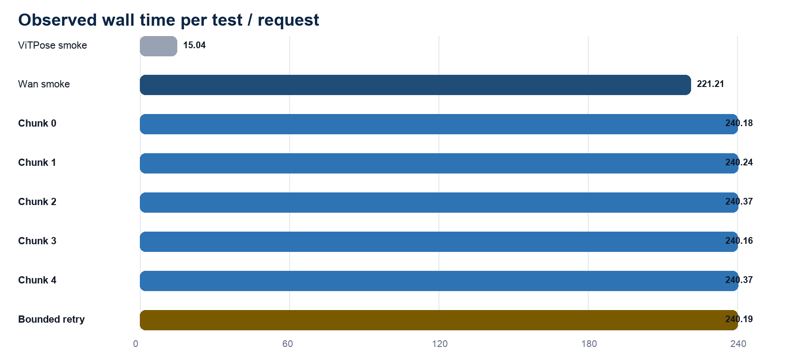
Wall-clock observations. Production chunk timings include runner polling; the 221.21-second smoke value is direct ComfyUI execution time.

Timing summary
Phase | Frames | Runtime | Rate | Notes
ViTPose smoke extraction | 77 | 15.036 s | 5.12 fps | Includes setup and model-tree hashing
Wan smoke / Comfy execution | 77 | 221.21 s | 0.348 fps | Accepted 0:10 stress interval
Wan smoke / runner wall | 77 | 240.35 s | 0.320 fps | Includes API polling overhead
Selected production chunks | 365 generated | 1201.31 s | 20.02 min | Equivalent to 80.1x delivered realtime
Bounded hair retry | 77 | 240.20 s | 4.00 min | Not selected

Production chunk sequence
Chunk | Pose offset | Seed | Requested | Kept | Runner wall
0 | 0 | 24082201 | 77 | 77 | 240.179 s
1 | 72 | 24082202 | 77 | 72 | 240.242 s
2 | 144 | 24082203 | 77 | 72 | 240.366 s
3 | 216 | 24082204 | 77 | 72 | 240.157 s
4 | 288 | 24082205 | 77 | 72 | 240.366 s
Retry 4 | 288 | 24082215 | 77 | 72 (alternate) | 240.195 s

FRAME ACCOUNTING 77 + 72 + 72 + 72 + 72 = 365 generated frames. Five padded tail frames were removed, yielding exactly 360 delivered frames (15.000 seconds at 24 fps).

Generation settings
Setting | Value | Setting | Value
Model canvas | 480 x 832 | Frame rate | 24 fps
Request length | 77 frames | Continuation | 5 frames
Steps | 6 | CFG | 1.0
Sampler | Euler | Scheduler | Simple
Sampling shift | 8.0 | Denoise | 1.0
LightX2V strength | 1.0 | Face video | None
Mode | Native move / pose-only | Output crop | 468 x 832 before upscale

Installed model provenance
Component | Installed filename | SHA-256
Diffusion | Wan2_2-Animate-14B_fp8_scaled_e4m3fn_KJ_v2.safetensors | b1cd5a67e968e5bb38fcf84dab58f2fb  551e0889fd463acb2a657259a70bbbf6
Speed LoRA | lightx2v_I2V_14B_480p_cfg_step_distill_rank64_bf16.safetensors | 85c4a61c30e0497aa44b91d93a893b62  4708461a56fe5485183b28fa07e2dfb3
Text encoder | umt5_xxl_fp8_e4m3fn_scaled.safetensors | c3355d30191f1f066b26d93fba017ae9  809dce6c627dda5f6a66eaa651204f68
CLIP Vision | clip_vision_h.safetensors | 64a7ef761bfccbadbaa3da77366aac41  85a6c58fa5de5f589b42a65bcc21f161
VAE | wan_2.1_vae.safetensors | 2fc39d31359a4b0a64f55876d8ff7fa8  d780956ae2cb13463b0223e15148976b

Software and service restoration
Item | Revision / result | State
ComfyUI | 0.33.0 / a7365071e47175fb06572d0a56d1bf4116c2f581 | Recorded
Official Wan code | 42bf4cfaa384bc21833865abc2f9e6c0e67233dc | Recorded
Wan process model | cb93a225fbaf1ca100f54e79da8f994995b689b3 | Recorded
llama-chat | Healthy after restoration | Pass
llama-embed | Healthy after restoration | Pass
Publishing / Git | No commit, push, or publication | Out of scope

Observed pipeline contrast
This is an operational comparison from this project, not a controlled model benchmark; the conditioning methods and run settings differ.
Dimension | Earlier H3 observation | Wan2.2-Animate result
Motion control | Raw RGB reference video | ViTPose whole-body skeleton
Source scene / matte | Gray/background leakage observed | No source or gray leakage observed
Identity near 0:10 | Face change observed | No identity jump observed
Long-run continuity | Independent-segment seam risk | Native five-frame continuation passed
Remaining issue | Late hair drift | Late hair elongation still present

BENCHMARK CONCLUSION The 2080 Ti was useful for pose preprocessing, the 3090 completed local Wan generation within about four minutes per 77-frame request, and the existing 32 GB host RAM was adequate for this tested configuration.
Evidence basis: provenance/manifest.json, provenance/final_primary_verification.json, provenance/assembly_primary.json, metadata/*_run.json, and the QA contact sheets stored with this run.

