**Name of Project:** SignEase – AI Sign Language Translator

**Sub-Theme:** Equality and Social Inclusion

**Opportunities Identified:**

According to the World Health Organisation, 430 million people (over 5% of the global population) experience moderate or higher levels of hearing loss. [1](https://www.who.int/news-room/fact-sheets/detail/deafness-and-hearing-loss)

While businesses make effort to be inclusive, only 39.5% of deaf or HOH (hard of hearing) adults were employed full time, compared to 57.5% of their hearing counterparts. Also, only 18% of deaf or HOH adults held a bachelor's degree or higher, compared to 33% of their hearing counterparts. [2](https://www.verywellhealth.com/what-challenges-still-exist-for-the-deaf-community-4153447)

The figures show that there is a concern that the deaf or HOH would not perform as well. One reason is that the organisations they are in are not set up to help them thrive.

Since the Covid pandemic, hybrid work arrangement has become the new normal. In a survey by the Centre for Creative Leadership, less than 10% of Singapore leaders expect employees to be on-site 100% of the time. [3](https://www.hcamag.com/asia/news/general/singapore-seen-as-apacs-champion-of-hybrid-work/428165)

Hybrid work arrangement provides the opportunity for technological solutions to break down communication barriers between the hearing and hearing-impaired, and foster social inclusion.

**Proposed Idea and Platform:**

SignEase is an innovative AI-powered sign language translation application that utilizes advanced Computer Vision and Natural Language Processing (NLP) to support communication between hearing and hearing-impaired team members in an online meeting setting.

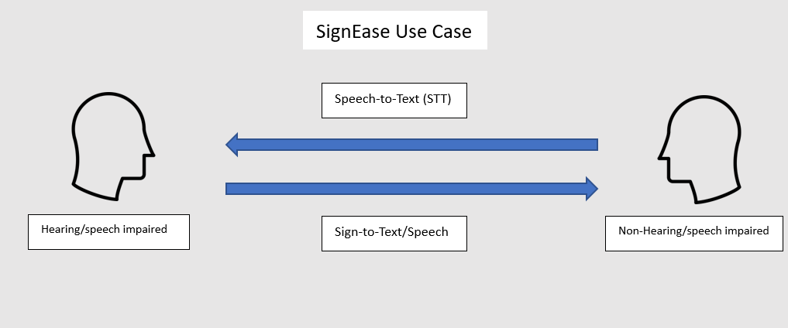

* A hearing participant speaking in an online meeting will have his speech transcribed and displayed as subtitle over the video to the hearing-impaired.
* The hearing-impaired can participate in the meeting through hand signs which will be translated into text and speech in the pre-specified language such as English or Mandarin. The text for the hand sign is displayed as subtitle over the video. At the same time other participants will be able to hear audibly the words corresponding to its hand signs.
* After the meeting ends, users can archive the text of the conversation history.

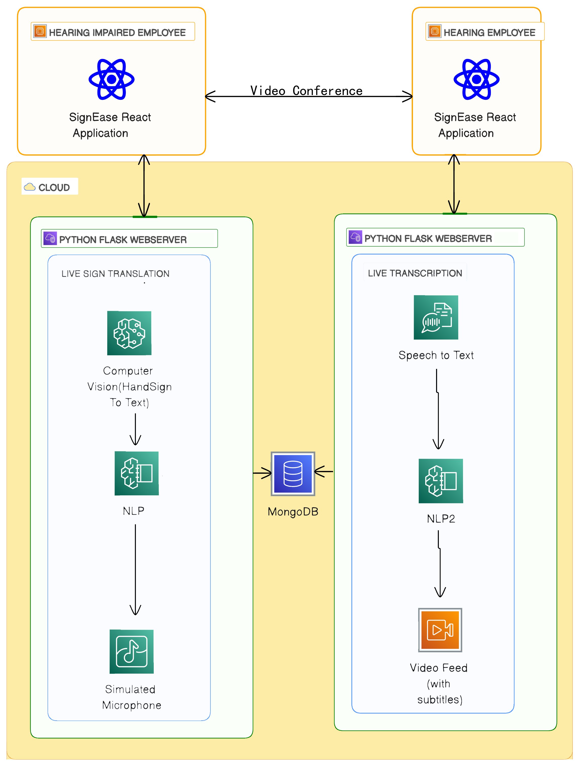

**Target Audience:** Our target audience are companies and education institutions aiming to foster social inclusivity by providing the means for their hearing-impaired employees or students to work effectively with their hearing team members; as well as individuals who wants to communicate effectively with the hearing-impaired.

**Originality and Value:**

SignEase unique features are it:

* Performs real-time translation from hand signs to text and speech, and vice versa from speech to text.
* Supports different languages like English and Mandarin during the translation
* Displays as subtitles over the video the words spoken or hand signs used in a meeting
* Archives conversation history, both spoken and hand-sign, as text
* Integrates with any online meeting tools like MS Teams or Zoom through SignEase API package.
* Continuously improves the range of phrases and accuracy of the machine learning models, with explicit user consent of datasets provided by users when using the app.

Benefits of SignEase include:

* Eliminating prejudice and stereotypes towards hearing-impaired individuals.
* Enhancing social inclusion for hearing-impaired individuals, promoting equality and equal opportunities.

**Type of Data:** Images and videos of various sign languages such as American Sign Language (ASL).