Xampp is required to be able to run a web server that can host the database.

Download and install here: <https://www.apachefriends.org/index.html>

Once installed, start apache and mysql servers:

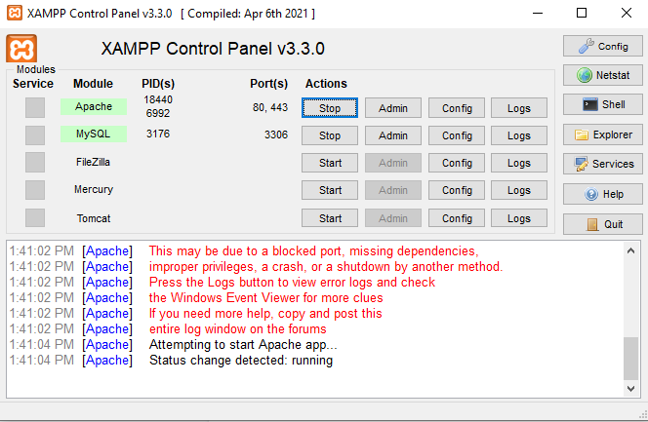

Navigate to: <http://localhost/phpmyadmin/>

Click on import and choose the included file: order-hub.sql; this should load all tables into the database.

#

Where the xampp folder was installed, navigate to the htdocs folder, and copy the OrderHub folder into htdocs.

You should then be able to navigate to: <http://localhost/OrderHub/> to view the website with all database functions.