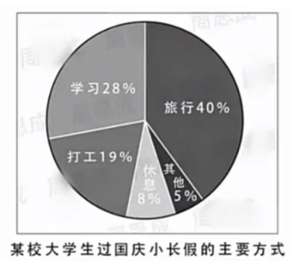

As is revealed clearly in the pie chart above, the major ways vary greatly in terms of the students in university spend their National Days holiday. Based upon the data provided, one can see that those traveling accounts for the largest percentage(40%), while the proportion of studying is 28%, In contrast, however, only 8% of them intend to have a rest.

Theoretically, several reasons may trigger the trend mentioned above, but as far as I am concerned, the following two are of utmost importance. On the one hand, this situation stems largely from the students’ outlook upon traveling. According to a recent Internet questionnaire, the overwhelming majority of the respondents treat traveling as an opportunity to enjoy the landscape and widen their eyes, which contributes to their future job. On the other hand, I’d like to highlight here is the students’ quick-temposed life and the pressure of societal competition.

Considering the arguments above, we may reasonably conclude that it is no surprise to see this phenomenon. But I am quite certain that this established situation will persist for quite a while in the forthcoming years.