Dashboard Documentation

[http://dashboard.blizzard.pixelforest.io](http://dashboard.blizzard.pixelforest.io/)

Table des matières

Menu : Detail of the views 2

Dashboard (Fraud Detector & Multi Attribution) 3

Choice of section Fraud Detector or Multi Attribution 3

Structure of the dashboard page 4

Request parameters section 4

Filters section 6

Dataviz section 6

Datatable section 9

Reporting 10

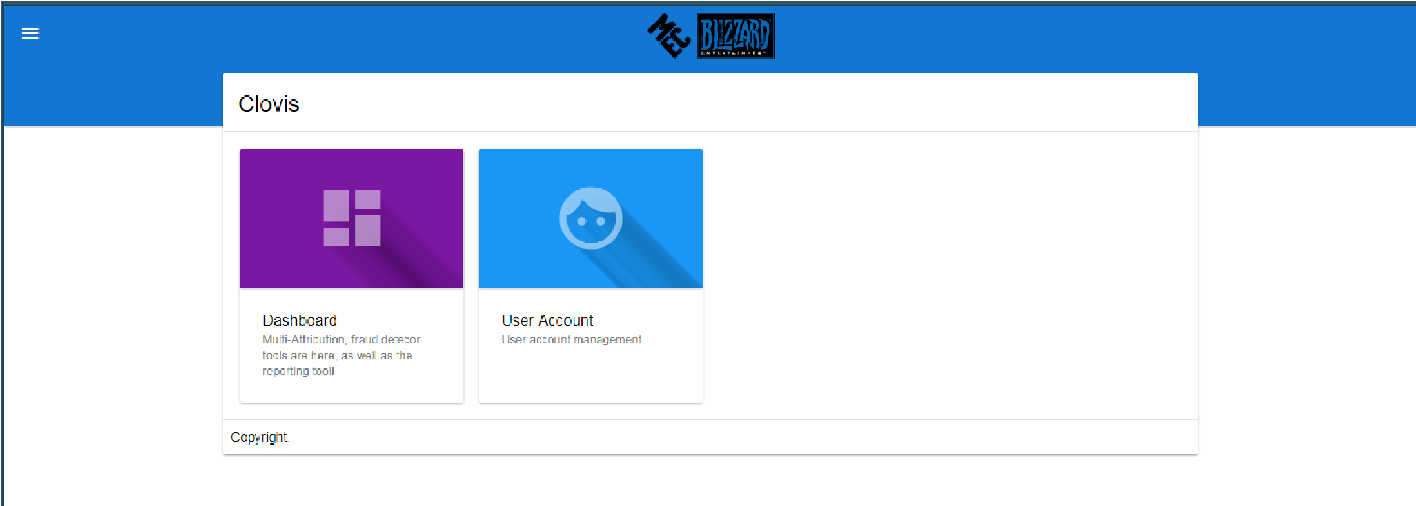

# Menu : Detail of the views

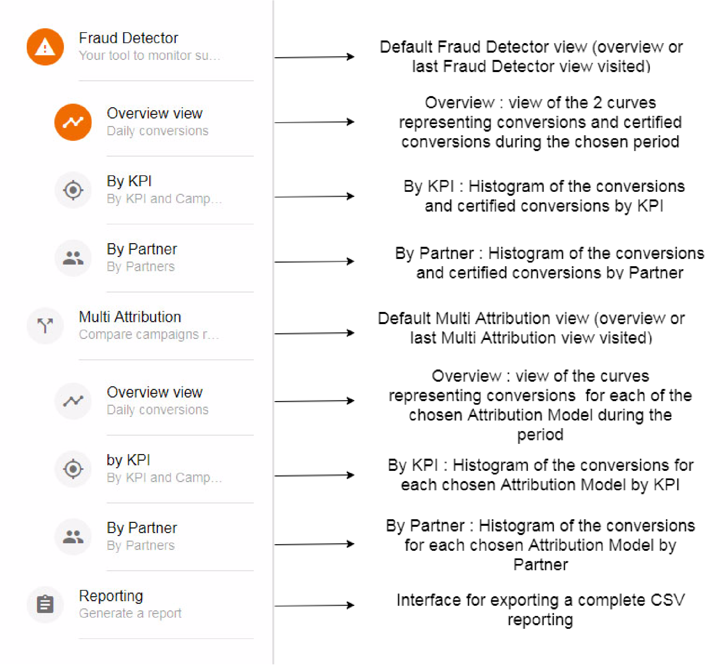

# Dashboard (Fraud Detector & Multi Attribution)

## Choice of section Fraud Detector or Multi Attribution

Fraud Detector : Display data for comparison between conversions and certified conversions

Multi Attribution : Compare multiple attribution models and performances depending on the model.

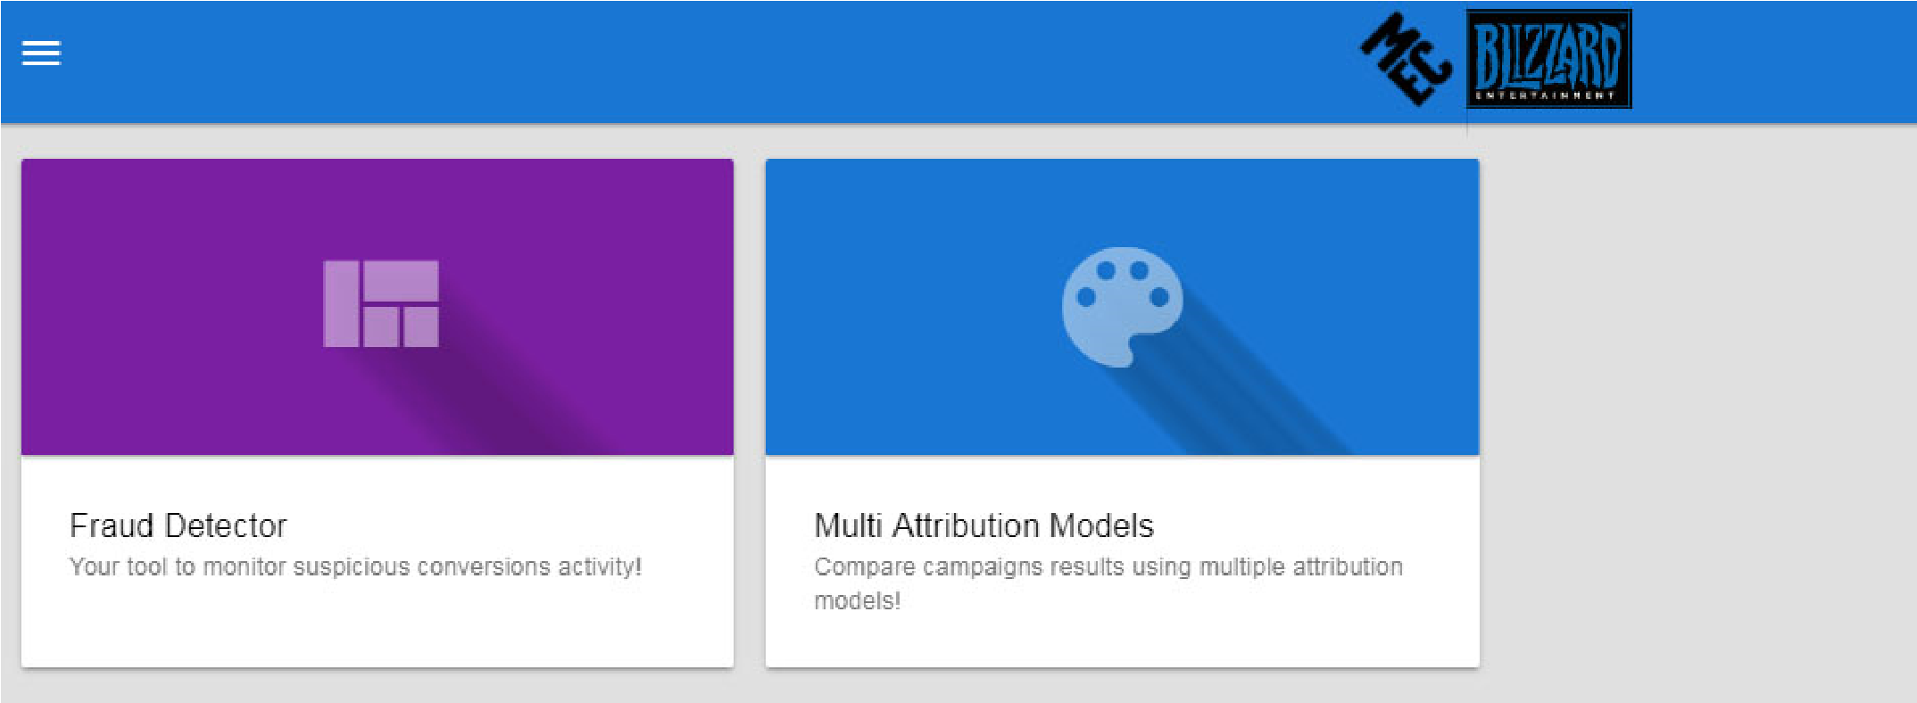

## Structure of the dashboard page

Menu : Choose here the page and view requested

Request : Indicate date range and attribution model(s) , and fetch data for these parameters on the server (Details)

Filters : Dynamically filter data on a list of KPIs, Metacampaigns, Advertisers and/or Partners (Details)

Dataviz : Visual representation of the requested and filtered data. The format of the representation (line chart / histogram) depends on the chosen view (Details)

Datatable : Dynamic display of the requested and filtered data. Data can be grouped, searched from and exported (Details)

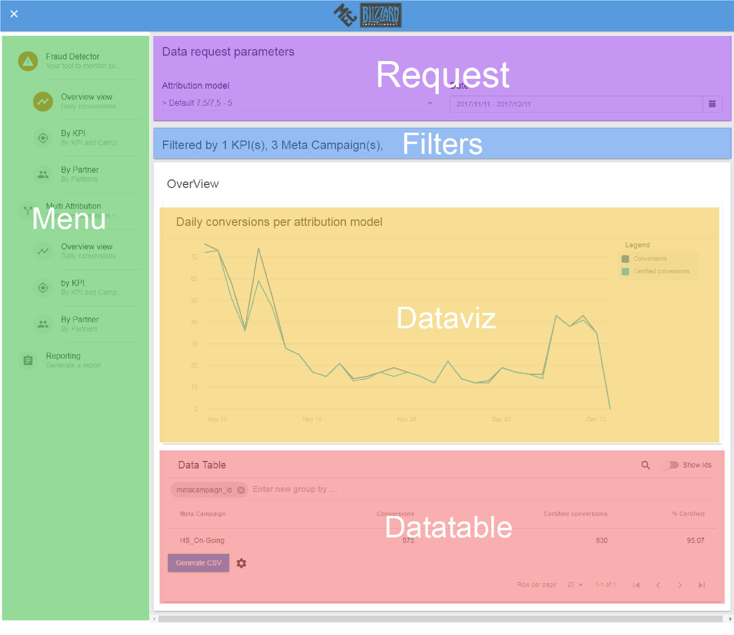

### Request parameters section

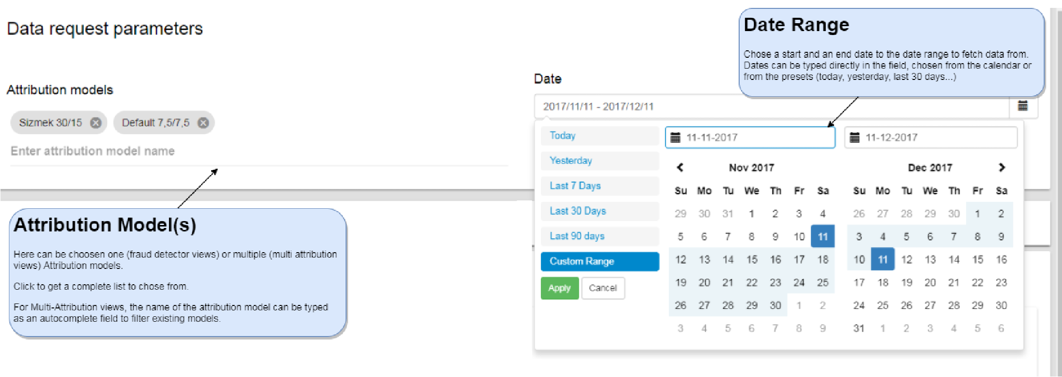

### Filters section

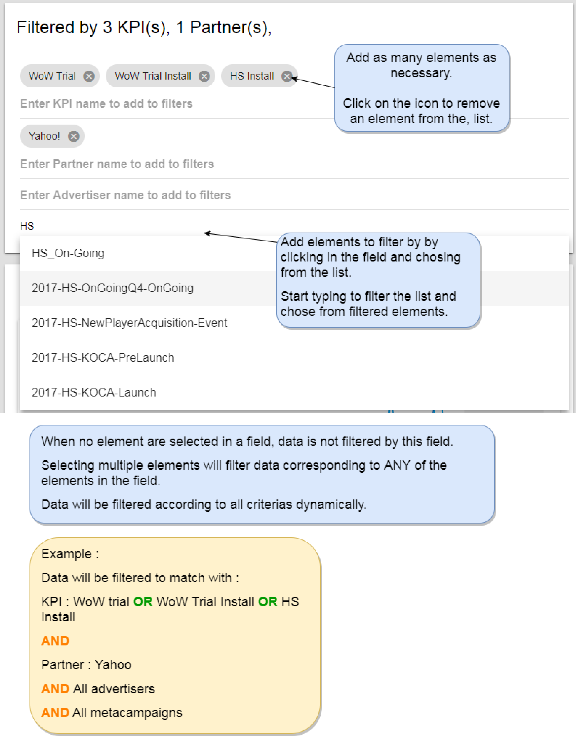

### Dataviz section

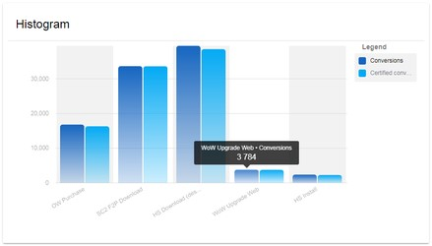

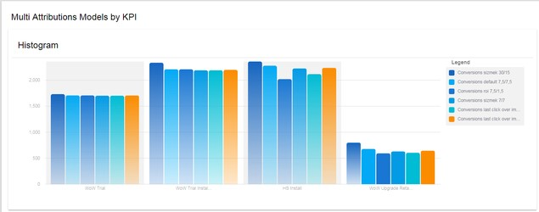

Histogram : data is grouped by the specific field of the view (KPI / Partner) and represented as an histogram.

Multiple bars represent either conversions versus certified conversions (in the Fraud Detector section) or each Attribution Model chosen to be compared (in Attribution Model section).

Detailed data for the day can be obtained by hovering a bar :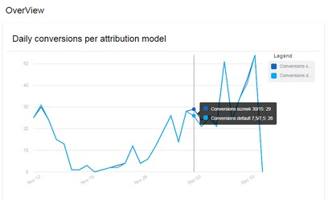

Overview : data is represented per day in the requested perdiod, the curves representing either conversions versus certified conversions (in the Fraud Detector section) or each Attribution Model chosen to be compared (in Attribution Model section).

Detailed data for the day can be obtained by hovering the curve on the desired date.

### Datatable section

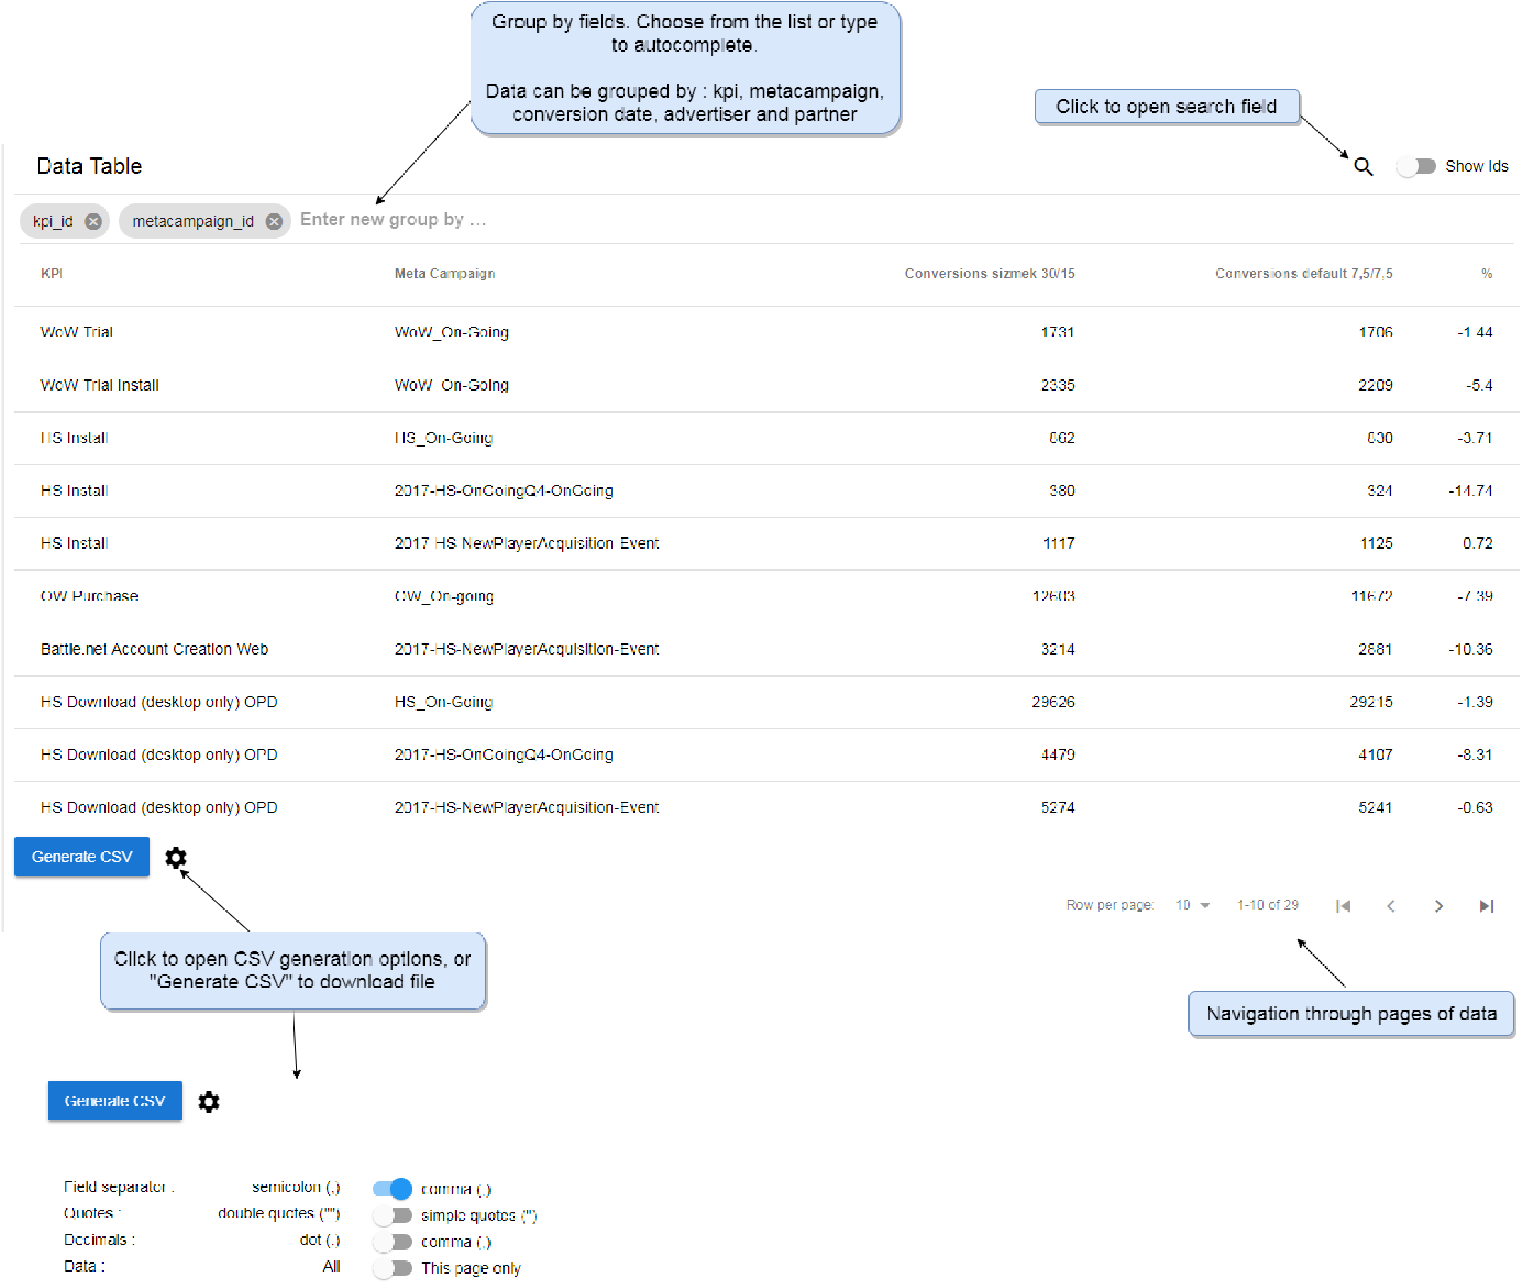

# Reporting

