Our country

India

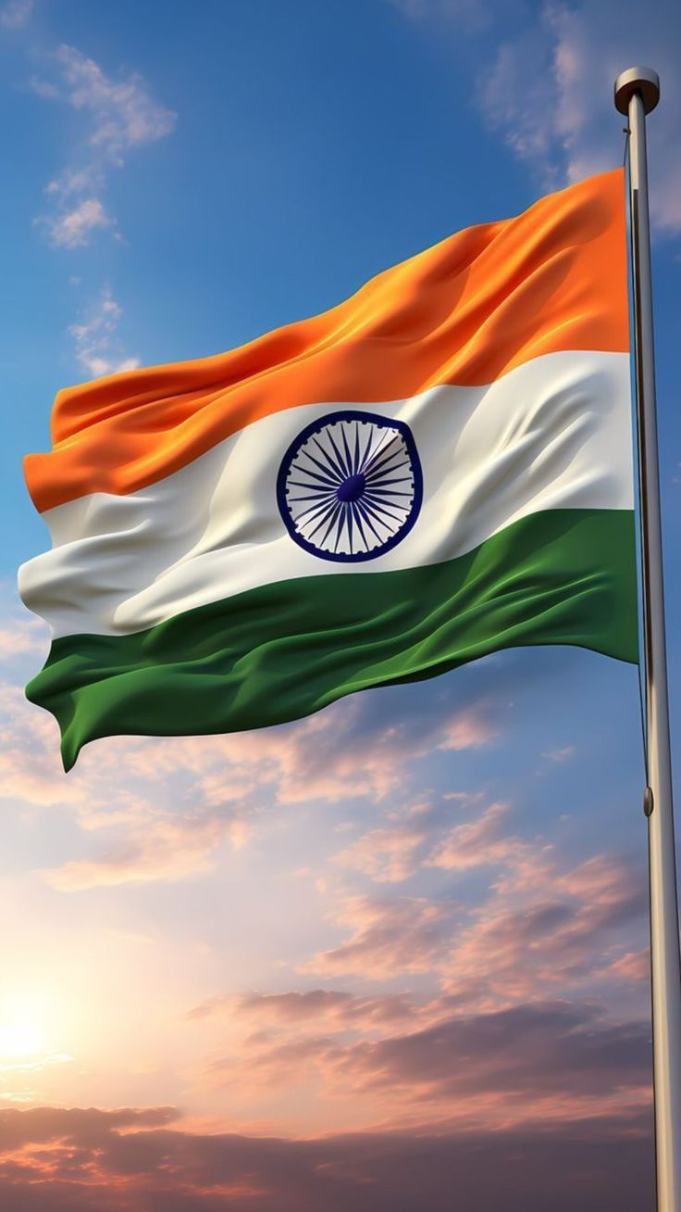

**India**

**India**. India's history is a vast and complex story that goes back tens of thousands of years. It is marked by deep cultural, spiritual, and political changes. One of the world’s first urban civilizations, (as well as leading history’s first civilization to build cities on a grid system) likely rose in what is now Pakistan around 2500 BC and in its height was renowned for having very advanced urban planning ad trade. Then came the Vedic age which laid the foundations of Hindu philosophy and social order. Powerful empires like the Maurya’s and Guptas — ravishing epochs of art, science, literature. The medieval era witnessed the rise of regional kingdoms and the spread of Islam, culminating in the impressive Mughal Empire, famous for its stunning architecture and cultural blending. The British took over in the 18th century and almost two centuries of foreign control followed. India’s struggle for independence, in the form of nonviolent resistance led by people such as Mahatma Gandhi, eventually resulted in freedom in 1947. In the decades since, that country has flourished into a vibrant democracy and a major world power that wears its past and present in equal measure with tradition and high-tech wizardry

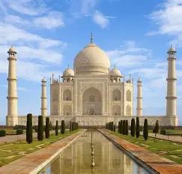

* **Culture And Religion**

**- India Is A Dense Amalgam Of Religions Like Hinduism, Islam, Christianity, Sikhism, Buddhism, And Jainism.**

**- It Observes A Vast Number Of Festivals Like Diwali, Holi, Eid, Christmas, And Navratri, Each With Unique Practices.**

**- This Nation Possesses 22 Official Languages, And The Two Main Ones Are Hindi And English.**

* **History As Well As Politics**

**- The Country Has A Civilization That Goes Back Over 5000 Years, Having Ancient Cities Such As Mohenjo-Daro And Harappa.**

**- It Was Dominated By Strong Empires Such As The Mauryas, Guptas, And Mughals Before They Became Colonized By The British.**

**- India Got Independence In 1947, And It Became A Nation With A Republic In 1950 With A Democratic Constitution.**

**- Today It Applies The Federal Parliamentary Republic With A President And Prime Minister At The Helm.**

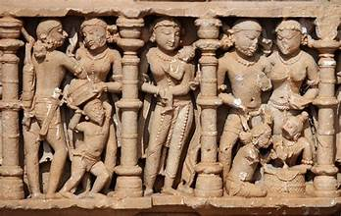

* **ECONOMY AND INNOVATION**

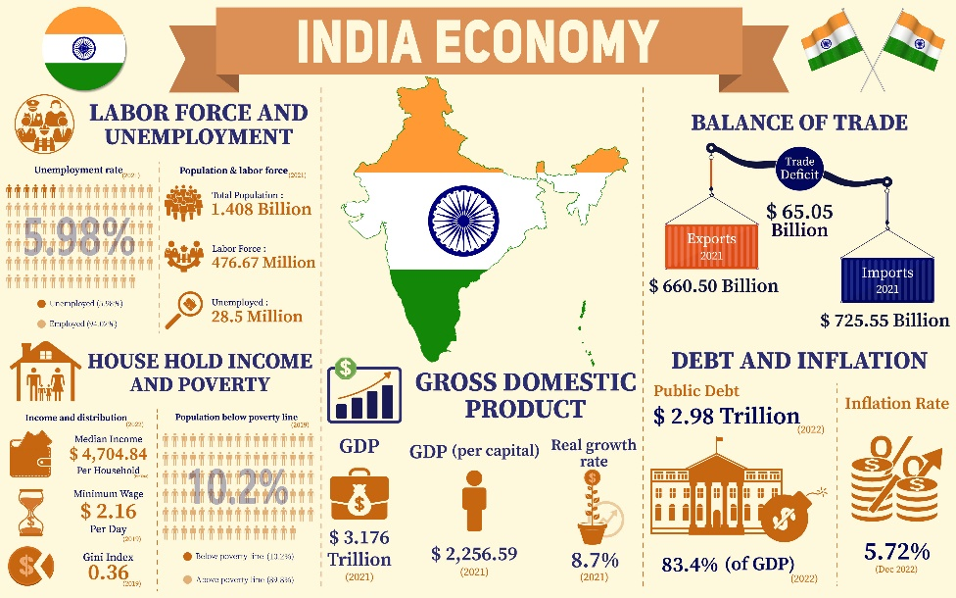

**- INDIA IS ONE OF THE "FASTEST-GROWING ECONOMIES": NOMINALLY IT RANKS 4TH AMONG COUNTRIES WITH GDP VALUES, WHILE IT COMPARES TO HAVING THE THIRD-LARGEST ECONOMY IN PURCHASING POWER PARITY (PPP).**

**- IT LEADS IN SERVICES IN TERMS OF IT, PHARMACEUTICALS, SPACE EXPLORATION, AND RENEWABLE ENERGY.- THE NATION POSTS VERY VIBRANT STARTUP SCENE AND ISCOME THE HUB FOR INNOVATION AND ENTREPRENEURSHIP.**

**Man, India isn’t just a place you find on a map -- it’s got its own heartbeat. Maybe it’s the chime of temple bells ringing in the middle of the night, or maybe it’s the warm, spicy aroma of cardamom from chai bubbling away on some guy’s rickety cart. Sure, it’s wet feet and soggy clothes, but suddenly everyone’s feeling inspired, right? The country is wild -- from Ladakh’s remote, almost sacred silence, where the air feels almost holy, to Old Delhi’s Chandni Chowk, bursting with colors, noise, and all kinds of chaos happening at once. India’s full of contradictions. You’ve got weddings that last for days, cricket matches that turn into almost spiritual gatherings, old philosophies hiding in dusty books, and tech freaks building the future in shiny glass skyscrapers. India doesn’t just show off its beauty. It’s the kind that hangs out with you -- shares fresh stories, scoops a little extra rice onto your plate, and leaves you spinning with all the wild, wonderful EXPIRENCES.**

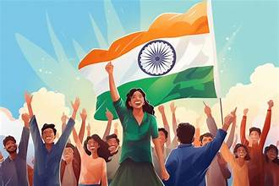

**At last all I want to say is India is the best country and I LOVE MY COUNTRY.**

**JAI Hind..THANKYOU..**