# PYTHON

# Python is a high-level, interpreted, general-purpose programming language. It was created by Guido van Rossum and first released in 1991. Python is known for its clear and readable syntax, which emphasizes code readability and reduces the cost of program maintenance.

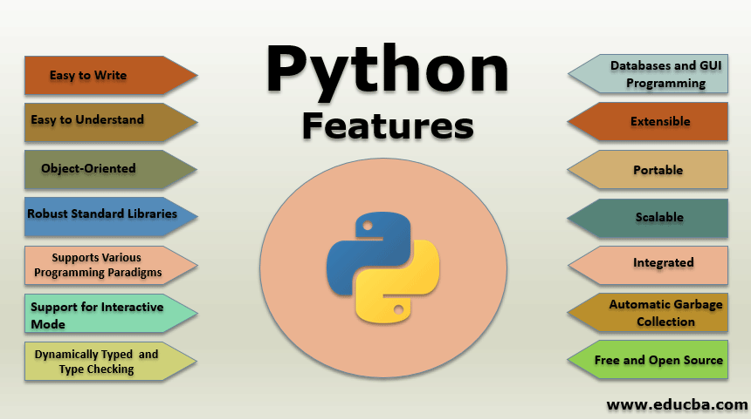

Key characteristics of Python:

* **Interpreted:**

Python code is executed line by line by an interpreter, rather than being compiled into machine code before execution. This makes the edit-test-debug cycle faster.

* **High-level:**

Python abstracts away many low-level details of computer hardware, allowing programmers to focus on solving problems rather than managing memory or other system resources.

* **Object-oriented:**

Python supports object-oriented programming (OOP), allowing for the creation of modular and reusable code through classes and objects.

* **Dynamic typing:**

Variables in Python do not need to be explicitly declared with a data type; their type is determined at runtime based on the value assigned.

* **Extensive standard library:**

Python comes with a large collection of pre-written modules and packages that provide functionality for various tasks, from web development to data analysis.

* **Versatile:**

, and more. Python is used in a wide range of applications, including web development (e.g., Django, Flask), data science and machine learning (e.g., NumPy, Pandas, TensorFlow), automation, scientific computing

ADVANTAGES OF PYTHON

* **Simplicity and Readability:**

Python's clear, concise syntax, resembling natural language, makes it easy to learn, write, and understand, fostering rapid development and maintainability.

* **Versatility and Flexibility:**

It is a general-purpose language used across various domains, including web development (Django, Flask), data science (NumPy, Pandas), machine learning (TensorFlow, PyTorch), automation, and scripting.

* **Extensive Libraries and Frameworks:**

Python boasts a vast ecosystem of pre-built libraries and frameworks that streamline development for specific tasks, reducing the need to write code from scratch.

* **Improved Productivity:**

Its straightforward syntax and rich libraries enable developers to achieve more with less code, leading to faster development cycles and increased efficiency.

DISADVANTAGES OF PYTHON

* **Performance and Speed:**

Python is an interpreted language, leading to slower execution speeds compared to compiled languages like C++ or Java. This can be a significant drawback for computationally intensive tasks or applications requiring high performance.

* **Memory Consumption:**

consumption. This can be a concern in memory-constrained environments or when dealing with large datasets Python's design, prioritizing developer convenience, can result in higher memory.

* **Weak in Mobile and Browser Environments:**

Python is not a primary choice for mobile app development or client-side web development due to its performance characteristics and the availability of more specialized frameworks in those domains.

* **Runtime Errors:**

Being dynamically typed, Python's type checking occurs at runtime rather than compile-time. This can lead to runtime errors that might have been caught earlier in statically typed languages.

PYTHON LIBRARIES

* PILLOW
* PANDAS
* NUMPY
* MATPLOTLIB
* ARROW
* SCIPY
* REQUESTS

