**"SLIDING CIRCLES"**

---------------------------------

This question is based on the Inclusion of Other in the Self (IOS) Scale (Aron, Aron, & Smollan, 1992).

Note that the value measured is proportional to the distance travelled by the "Self" circle.  
It is **NOT** proportional to the area of overlap, so if you want the area, you will have to do some calculations later on.

If you feel the instructions are unclear, incomprehensible, or incomplete, please get in touch with me via the contact methods listed on my [GitHub](https://github.com/jxtay) profile (<https://github.com/jxtay>).

Reference:  
Aron, A., Aron, E. N., & Smollan, D. (1992). Inclusion of other in the self scale and the structure of interpersonal closeness. Journal of personality and social psychology, 63(4), 596.

---------------------------------

**PROCEDURE**

1. Create a Slider type question in Qualtrics.

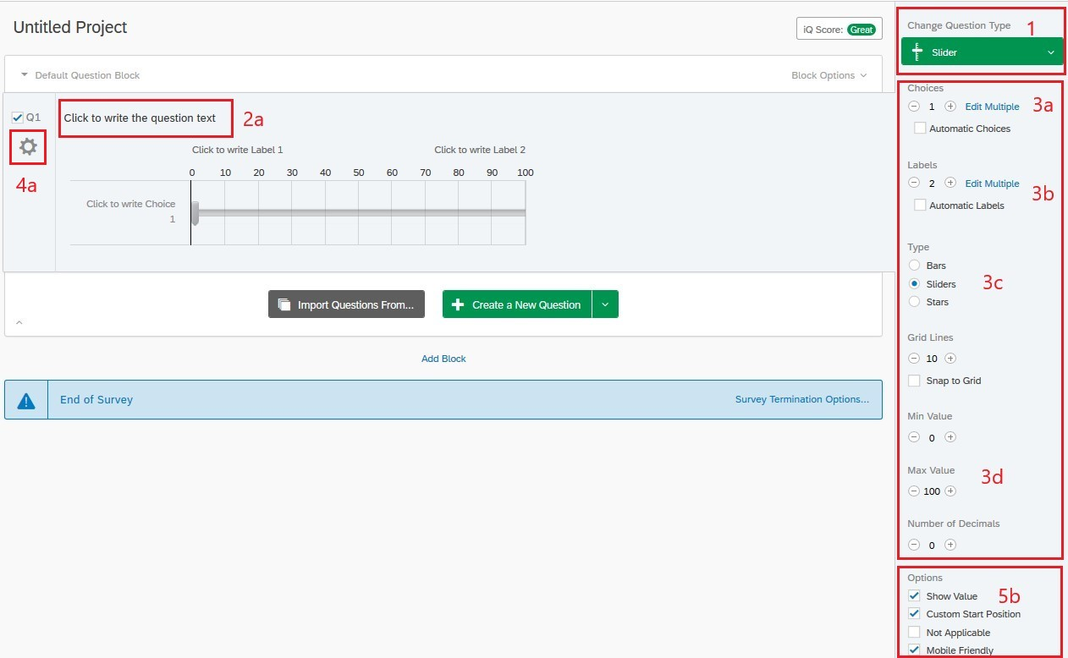

1. Add the question content:
   1. Click on the question text to edit it.
   2. Using the HTML View, copy and paste the contents of "question-html.txt".
   3. Once done, click outside the editing area. You should now see two labelled circles appearing as the content of the question.

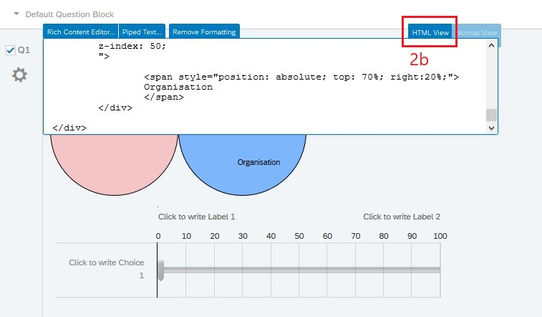

1. Adjust the options of the question:
   1. Set Choices = 1, so that there is only one slider.
   2. Set Labels as necessary. I set it to 2 to label the anchors on either end of the slider ("not at all" and "completely").
   3. Set Type = Sliders.
   4. Set the min and max value of the slider. I recommend min = 0, max = 100, decimals = 0.

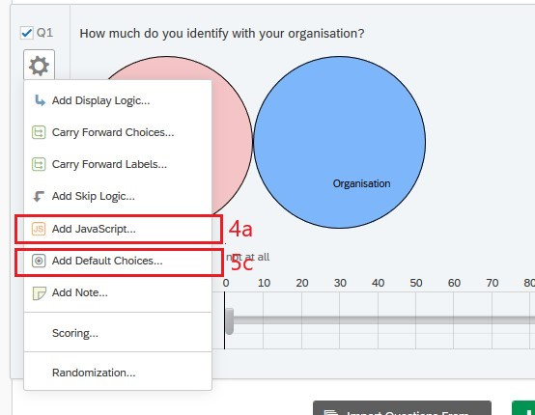

1. Add JavaScript to the question:
   1. Right-click on the question (or click on the gear icon to the left of the question) and select "**Add JavaScript...**".
   2. Copy and paste the contents of "question-javascript.txt".
   3. Make changes to the "CONFIGURATION" section of the JavaScript as required. See the comments in the code for details.

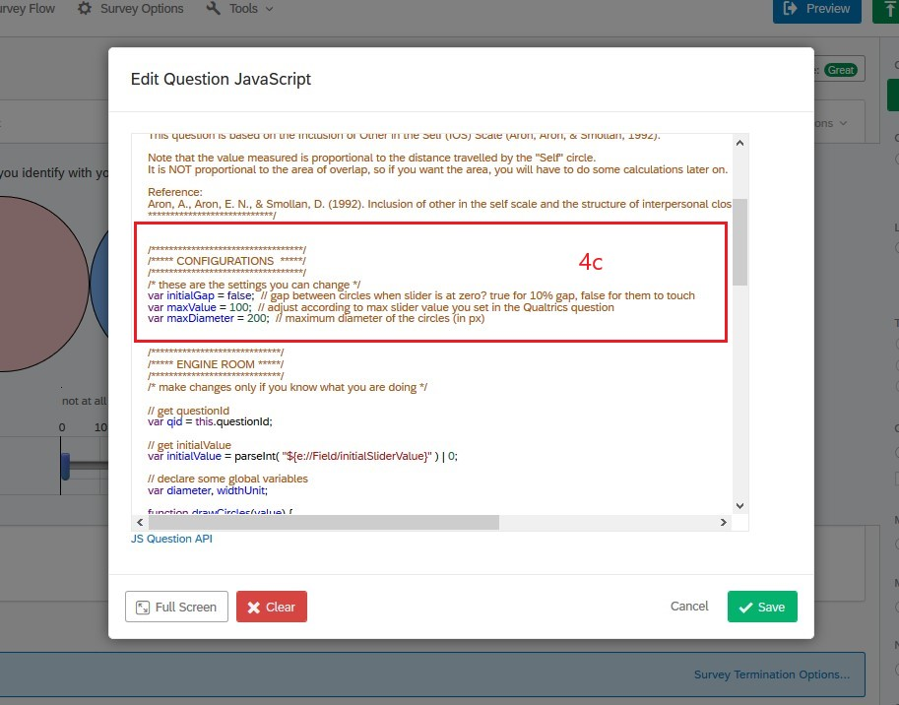

Hope this works for you!

p.s. An additional feature:

1. If you want to set the initial state of the slider according to a value from a previous question/survey:
   1. Use an embedded data named "*initialSliderValue*".
   2. Check "**Custom Start Position**" and "**Show Value**" in the question's options.]
   3. Right-click on the question (or click on the gear icon to the left of the question), and select "**Add Default Choices...**"
   4. In the pop-up titled "**Edit Default Choices**", click on the textbox to the right of the slider and fill it with ${e://Field/initialSliderValue. Remember to click "**Save**".
   5. After completing step d, you may uncheck the "Show Value" option if you want.

