Instructions

- Download and Install Ganache (https://sourceforge.net/projects/ganache.mirror/files/v2.5.4/Ganache-2.5.4-win-setup.exe/download)
- Download and install anaconda3 from given link(ignore step 1,3 if you already done )
- link :https://www.filehorse.com/download-anaconda-64/download/

Make sure that like given in the image below, check first three checkboxes
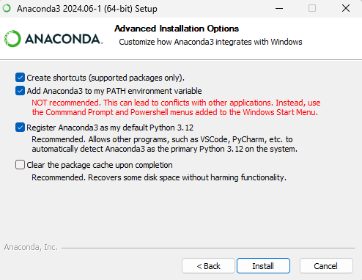
- Extract “AIcyberchain_fullcode.rar” file in a folder
- Extract “cvenv.rar” file to location C->users->user(it may be vary based on your system)->anaconda3->envs
- Download Visual Studio Code from https://code.visualstudio.com/
- Open AIcyberchain_fullcode folder in Vs code.
- Download and install wireshark from its official website.
- After installation open wireshark
- Open anaconda prompt and navigate to the code folder using cd command
- Run command: activate myenv
- Run command:python manage.py runserver

