User Attention Proxy as a Knowledge Router: A Novel Deep Learning Framework for Adaptive Knowledge Exploration and Exploitation in LLMs
Online Appendix
Appendix A. Additional Descriptive Statistics
This appendix reports the descriptive statistics of the Q&A dataset used in the experiments. The data construction, annotation, and partition procedures are described in Section 5.1 of the main manuscript.
Table A1. Descriptive Statistics of the Q&A Dataset.
Statistics | Mean | StdDev | Min | Max
Text length per review (words) | 52.61 | 58.64 | 1 | 2,437
Number of images per review | 2.89 | 2.00 | 1 | 15
Text length per question (words) | 19.30 | 4.64 | 8 | 48
Text length per answer (words) | 61.25 | 31.36 | 3 | 197

Appendix B. Statistical Significance Test Results
This appendix reports the Tukey-Kramer post hoc pairwise comparison results between UAP-DL and each benchmark for Experiments 1-3. The tests were conducted separately for the LLM-labeled and human-annotated datasets and for the corresponding experimental conditions.
Table B1. Tukey-Kramer Test Result: UAP-DL vs. Benchmarks (Experiment 1).
Method | LLM-Labeled Dataset |  |  | Human-Annotated Dataset
Method | Satisfactory Conversations | Unsatisfactory Conversations | All Conversations | Satisfactory Conversations | Unsatisfactory Conversations | All Conversations
EchoSight | 7.81*** | 0.63 | 4.24*** | 3.74+ | 2.40 | 3.03***
MORE | 7.17*** | 1.31 | 4.25*** | 6.17*** | 0.89 | 3.76***
G-Retriever | 5.83*** | 1.07 | 3.48*** | 5.67*** | 1.43 | 3.65***
GNP | 5.84*** | 1.11 | 3.50*** | 5.42*** | 1.12 | 3.47***
CoA | 7.91*** | 0.80 | 4.40*** | 5.27*** | 2.14 | 3.92***
ToG | 7.74*** | 0.82 | 4.31*** | 3.28 | 2.39 | 2.95***
MiRAG | 8.10*** | 1.05 | 4.58*** | 4.79** | 2.78 | 3.83***
VDocRAG | 4.86*** | 0.19 | 2.54*** | 0.39 | 1.42 | 0.77
Adaptive-RAG | 6.43*** | 0.53 | 3.51*** | 2.03 | 2.92 | 2.36**
Notes. *** Significant at the 0.001 level; ** Significant at the 0.01 level; * Significant at the 0.05 level; ⁺ Significant at the 0.1 level.

Table B2. Tukey-Kramer Test Result: UAP-DL vs. Benchmarks (Experiment 2).
Method | LLM-Labeled Dataset |  |  |  | Human-Annotated Dataset
Method | LSTM | GCN | Transformer | MLP | LSTM | GCN | Transformer | MLP
EchoSight | 3.79*** | 3.90*** | 3.04*** | 3.07*** | 2.59 | 2.76*** | 3.47* | 2.59
MORE | 4.16*** | 3.96*** | 2.75*** | 2.38* | 2.90* | 2.96*** | 4.20** | 2.90*
G-Retriever | 3.07*** | 5.05*** | 2.50*** | 3.28*** | 2.47 | 2.83*** | 4.88*** | 2.47
GNP | 3.11*** | 4.26*** | 2.08** | 2.66** | 2.24 | 2.73*** | 2.95 | 2.24
CoA | 2.77** | 4.84*** | 2.32*** | 3.27*** | 4.27*** | 4.04*** | 4.49*** | 4.27***
ToG | 2.95*** | 6.12*** | 3.34*** | 2.80*** | 1.95 | 2.67** | 3.41* | 1.95
MiRAG | 2.78** | 3.49*** | 2.38*** | 2.80*** | 3.55** | 4.02*** | 3.82** | 3.55**
VDocRAG | 2.77** | 2.67** | 1.36 | 1.50 | 1.13 | 1.33 | 1.50 | 1.13
Adaptive-RAG | 2.87** | 3.11*** | 1.82* | 2.52** | 2.18 | 2.25* | 2.99+ | 2.18
Notes. *** Significant at the 0.001 level; ** Significant at the 0.01 level; * Significant at the 0.05 level; ⁺ Significant at the 0.1 level.

Table B3. Tukey-Kramer Test Result: UAP-DL vs. Benchmarks (Experiment 3).
Method | LLM-Labeled Dataset |  |  |  | Human-Annotated Dataset
Method | LSTM | GCN | Transformer | MLP | LSTM | GCN | Transformer | MLP
EchoSight | 3.82*** | 3.01*** | 2.51*** | 2.88*** | 4.25*** | 2.16 | 2.74* | 2.56
MORE | 2.69*** | 9.27*** | 2.18*** | 3.77*** | 4.33*** | 2.81⁺ | 3.97*** | 3.72**
G-Retriever | 5.25*** | 9.23*** | 4.24*** | 4.77*** | 5.66*** | 3.47** | 5.77*** | 5.33***
GNP | 4.69*** | 2.53*** | 4.26*** | 4.69*** | 5.20*** | 2.36 | 4.68*** | 4.33***
CoA | 2.09*** | 2.93*** | 0.83*** | 2.05*** | 3.97** | 2.15 | 2.97* | 2.83⁺
ToG | 1.46*** | 3.87*** | 1.35*** | 1.77*** | 2.17 | 0.58 | 2.09 | 1.28
MiRAG | 1.74*** | 3.43*** | 0.98*** | 1.97*** | 3.99** | 1.86 | 2.91* | 2.71
VDocRAG | 1.39*** | 2.46*** | 0.59** | 1.43*** | 1.05 | 2.09 | 1.30 | 1.41
Adaptive-RAG | 1.53*** | 2.72*** | 0.78*** | 1.65*** | 1.92 | 1.99 | 1.84 | 1.38
Notes. *** Significant at the 0.001 level; ** Significant at the 0.01 level; * Significant at the 0.05 level; ⁺ Significant at the 0.1 level.

Appendix C. Explanatory Analyses
The explanatory analyses provide supportive evidence that UAP-DL organizes knowledge across multiple aspects and granularities and adjusts its contributions according to the user query, thereby helping explain how MAKR, MGKI, and ECRG support user-oriented response generation.
Appendix C.1 Multi-Granularity Coverage and Diversity Analysis of Generated Responses
We evaluated UAP-DL’s capability in satisfying users’ information needs along the dimensions of informational diversity and granularity. First, to assess multi-granularity need fulfillment, we designed a multi-granularity semantic alignment (MGSA) metric. Specifically, an LLM was first prompted to decompose each user query into three hierarchical levels of information needs: coarse-grained overall needs, aspect-level needs, and fine-grained attribute-level needs. Each level was represented by a semantic description and a set of relevant keywords. Another LLM then assigned a continuous coverage score between 0 and 1 for each level to measure how well the generated response covered the corresponding information needs, and the MGSA score for response $i$ was obtained by averaging the three coverage scores:
$$\begin{aligned}{MGSA}_{i}=\frac{1}{L_{i}}\sum_{l=1}^{L_{i}}{c_{il}},\#\left(C1\right)\end{aligned}$$
where $L_{i}$ denotes the number of information-need levels identified for query $i$, and $c_{il}$ denotes the coverage score of the generated response at level $l$.
Second, to evaluate informational diversity, we introduced two diversity metrics—content diversity (CD) and semantic diversity (SD)—which capture the richness of expression and the semantic breadth of the generated responses, respectively. Specifically, CD is measured using the Distinct-$n$ metric [1], which quantifies lexical diversity at the n-gram level:
$$\begin{aligned}CD=\frac{Number of unique n-grams in the generated response}{Total number of n-grams in the generated response},\#\left(C2\right)\end{aligned}$$
where $n∈\left\{1,2\right\}$ corresponds to word-level and phrase-level diversity. Higher CD values indicate lower lexical repetition and greater content diversity.
Semantic diversity (SD) captures the internal semantic variation of the response. Specifically, we first segmented the generated response into sentences, each of which was encoded into a vector representation using a pretrained model. SD was then computed as the average pairwise semantic distance among these sentence representations:
$$\begin{aligned}SD=\frac{2}{S\left(S-1\right)}\sum_{i=1}^{S}{\sum_{j=i+1}^{S}{\left(1-\cos\left(s_{i},s_{j}\right)\right)}},\#\left(C3\right)\end{aligned}$$
where $S$ is the number of sentences. $s_{i}$ and $s_{j}$ denote the semantic representations of sentence $i$ and $j$. Higher SD values indicate greater semantic variability across sentences. Table C1 summarizes the results. UAP-DL consistently outperformed all benchmarks on all metrics (i.e., MGSA, CD, and SD), indicating a strong capability in fulfilling users’ diverse and multi-granularity information needs.
Table C1. Multi-Granularity Coverage and Diversity of Responses Generated by UAP-DL vs. Benchmarks.
Method | MGSA | CD (Distinct_1) | CD (Distinct_2) | SD
EchoSight | 78.46 (14.40) | 65.43 (12.66) | 80.26 (15.95) | 48.56 (13.43)
MORE | 84.35 (9.06) | 54.46 (17.72) | 67.37 (23.17) | 41.08 (16.36)
G-Retriever | 83.44 (8.55) | 68.73 (15.11) | 84.70 (17.82) | 42.57 (16.45)
GNP | 83.86 (8.38) | 69.84 (15.30) | 83.76 (19.22) | 48.17 (13.20)
CoA | 77.25 (12.37) | 81.17 (10.08) | 96.54 (4.55) | 46.29 (14.57)
ToG | 76.56 (7.39) | 80.25 (9.37) | 93.25 (6.88) | 47.15 (12.38)
MiRAG | 79.76 (12.50) | 59.23 (14.44) | 72.28 (18.86) | 46.27 (18.18)
UAP-DL | 85.13 (8.33) | 85.54 (3.26) | 98.88 (1.52) | 52.33 (1.15)
Notes. Standard deviation is enclosed in parentheses. The best performance is in bold font.

Appendix C.2 Multi-Aspect Knowledge Retrieval Analysis
We randomly selected an instance from the dataset to illustrate how MAKR enhances informational diversity from a user perspective. Specifically, we examined multiple clusters at the review level and computed intra-cluster diversity for three types of representations: original (i.e., $g_{k}^{ml}$), low-pass (i.e., $L_{k}^{mli}$), and high-pass (i.e., $H_{k}^{mli}$). Intra-cluster diversity was quantified by the average pairwise similarity among elements within each cluster. As illustrated in Figure C1, the original representations exhibited high similarity across most clusters, indicating that the originally retrieved information is highly concentrated and contains substantial content redundancy. The low-pass representations showed slightly higher similarity than the original in most clusters, reflecting their emphasis on shared knowledge within each cluster. In contrast, the high-pass representations exhibited markedly lower similarity, demonstrating their effectiveness in capturing differentiated knowledge.
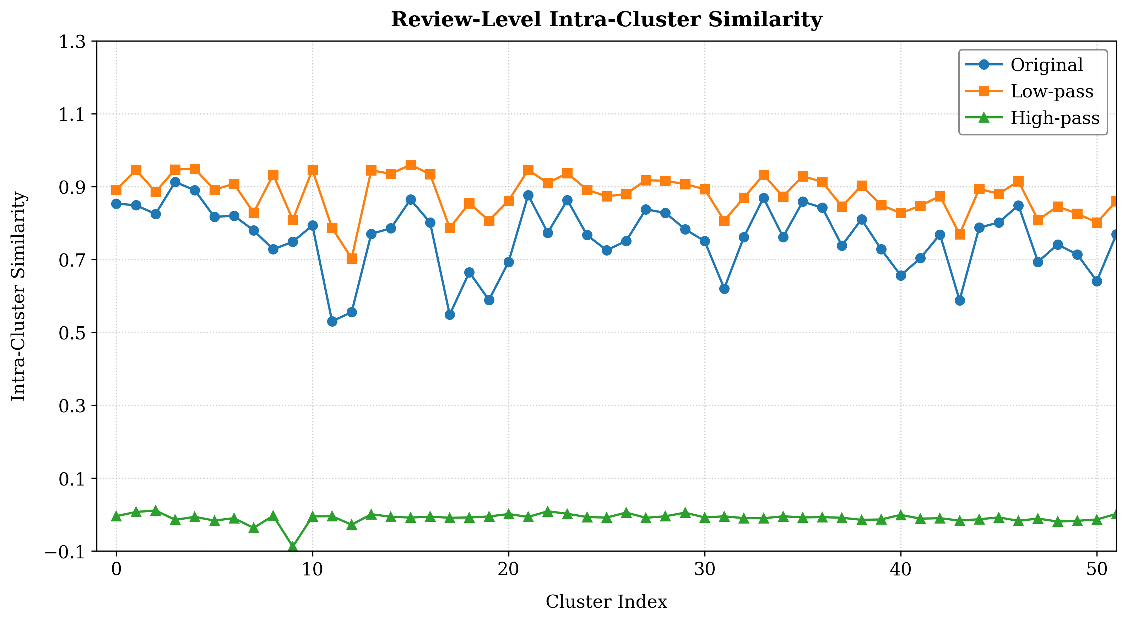
Figure C1. Variations in Intra-Cluster Knowledge Diversity.
Appendix C.3 Multi-Granularity Knowledge Retrieval Analysis
We randomly selected 200 instances from the dataset to examine users’ varying attention toward diverse and multi-granularity knowledge. Specifically, we first clustered these instances into six user groups. For each group, we then computed the mean granularity-wise cross-modal attention weights (i.e., $α_{L}^{mli}$ and $α_{H}^{mli}$) across textual (i.e., topic, review, and sentence) and visual (i.e., concept, review image, image patch) granularities.
As shown in Figure C2, users exhibited distinct attention allocations across knowledge granularities, with substantial heterogeneity observed across user groups even at the same granularity. Moreover, attention patterns systematically differed between high-pass (Figure C2(a)) and low-pass information (Figure C2(b)). Collectively, these findings highlight the importance of accounting for users’ differentiated attention patterns when retrieving diverse and multi-granularity knowledge.
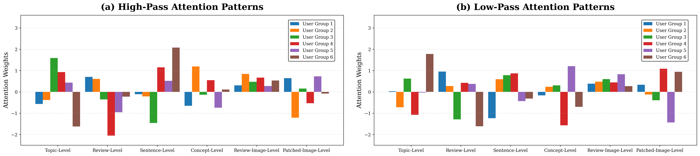
Figure C2. Users’ Attention Divergence Toward Diverse Multi-Granularity Knowledge.
Appendix C.4 Qualitative Tracing of Low-Pass and High-Pass Knowledge Selection
To qualitatively illustrate how UAP-DL retrieves diversified information through low-pass and high-pass filtering, we conducted a qualitative tracing analysis. We first identified the textual granularity receiving the highest cross-attention weight. Within the selected granularity, we then used the query-aware aspect attention weights to identify the most important clusters in the shared-information and differentiated-information channels. Finally, within each selected cluster, we traced the original knowledge nodes that contributed most strongly to the corresponding low-pass or high-pass representation through the graph-filtering matrix.
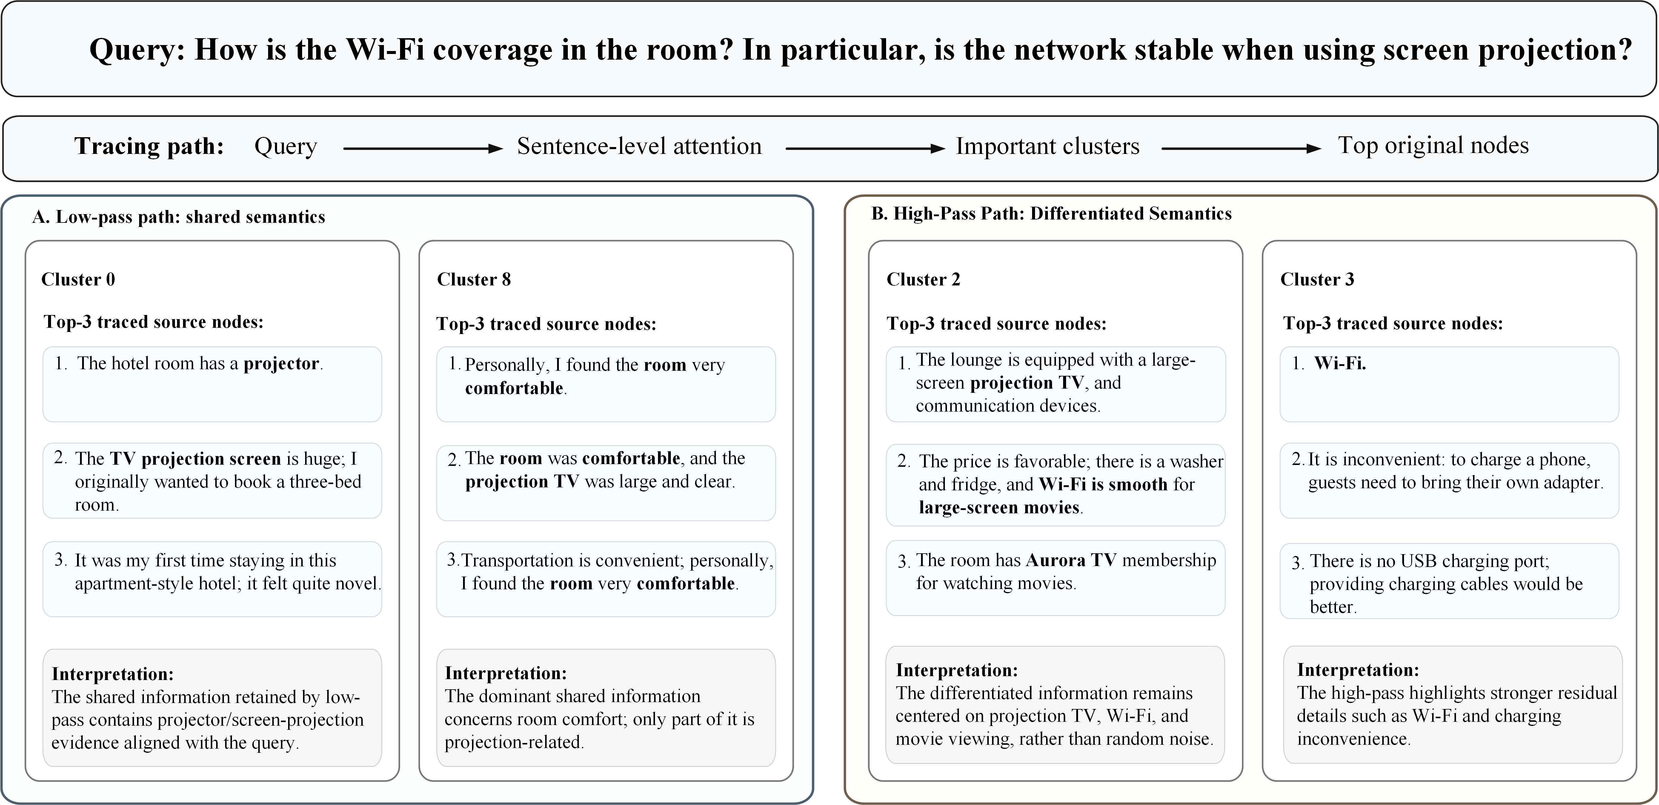
Figure C3. Qualitative Tracing of Low-Pass and High-Pass Knowledge Selection.
As shown in Figure C3, for the query “How is the Wi-Fi coverage in the room? In particular, is the network stable when using screen projection?”, the cross-attention weights showed that sentence-level knowledge contributes most to the final representation. Therefore, the subsequent tracing analysis was conducted at the sentence level.
In the low-pass path, Cluster 0 contributed most strongly to the low-pass representation. Although Cluster 8 exhibited higher intra-cluster similarity and therefore contains more internally consistent shared semantics, its main content concerned general room comfort and was only weakly related to Wi-Fi stability or screen projection. By contrast, the highly contributing nodes in Cluster 0, such as “the hotel room has a projector” and “the TV projection screen is huge,” collectively captured shared information about in-room projection facilities that is more relevant to the current query. Therefore, despite its lower intra-cluster similarity than Cluster 8, Cluster 0 received a higher contribution weight in the query-conditioned low-pass representation. These results indicate that the low-pass filtering mechanism of UAP-DL enables the model to retrieve valuable shared information that is relevant to the current query.
In the high-pass path, Cluster 2 contributed most to the high-pass representation. Its highly contributing nodes included differentiated information such as “large-screen projection TV” and “Wi-Fi is smooth for watching large-screen movies,” which are directly related to the current query and thus receive a higher weight. Cluster 3 also contained differentiated information, but only part of its content was directly relevant to the query. Therefore, its weight was lower than that of Cluster 2. These results indicate that the high-pass filtering mechanism enables UAP-DL to retrieve valuable query-relevant differentiated information, rather than merely selecting knowledge with low semantic similarity.
Overall, the tracing results provide qualitative evidence that the low-pass path aggregates query-relevant shared evidence across diversified nodes, whereas the high-pass path preserves complementary and differentiated evidence that is particularly informative for the current query.
Appendix D. Inference Efficiency Analysis
We measured the average single-sample inference time of UAP-DL and all benchmark methods. The total inference time denotes the end-to-end inference time, and the online non-generation time refers to the online computation remaining after excluding LLM response generation from the end-to-end inference time. For UAP-DL, this includes query relevance estimation, graph construction, and multi-aspect and multi-granularity knowledge retrieval. The hotel knowledge base was constructed offline in advance, including review partitioning, representation encoding, and aspect clustering; these preprocessing costs are therefore excluded from online inference time.
As shown in Table D1, UAP-DL required an average end-to-end inference time of 4,085.55 ms, of which only 13.83 ms was attributable to online non-generation computation. These results indicate that query-conditioned graph construction and multi-aspect and multi-granularity knowledge retrieval introduce limited additional online overhead, and that most end-to-end latency is attributable to LLM response generation rather than the proposed knowledge-routing architecture.

Table D1. Single-Sample Inference Time (ms) of UAP-DL and the Benchmark Methods.
Method | Total Inference Time | Online Non-generation Time
EchoSight | 4,578.36 | 81.63
MORE | 3,046.58 | 4.25
G-Retriever | 2,957.04 | 32.99
GNP | 3,766.43 | 4.10
CoA | 10,533.54 | 5,249.90
ToG | 9,931.55 | 5,326.55
MiRAG | 4,428.92 | 7.36
VDocRAG | 4,348.25 | 310.94
Adaptive-RAG | 5,328.13 | 7.13
UAP-DL | 4,085.55 | 13.83
Notes. All inference times are reported in milliseconds per sample.

Appendix E. Spectral Justification of the Diversity-Based Graph Filtering
This appendix provides the theoretical justification for applying low- and high-pass graph filtering to the diversity-based graph introduced in Section 4.3.1. Specifically, we clarify the source of the numerical asymmetry in the adjacency matrix constructed in Eq. (1), show that the resulting adjacency and degree-normalized propagation operators are similar to real symmetric matrices and therefore possess real eigenvalues, and further establish the low- and high-pass spectral characteristics of the propagation operators used in Eqs. (4)-(5).
For notational simplicity, we omit the modality, granularity, and user indices used in the main text. We use $A$, $D$, and $\tilde{A}$ to denote, respectively, the adjacency matrix, its degree matrix, and the degree-normalized propagation operator corresponding to those defined in the paper. Note that $D$ is distinct from $D_{ϵ}$, introduced below, which is used only to characterize the row-wise normalization of the underlying diversity relation. Let $s_{j}$ denote the query-relevance score of knowledge node $j$, and define the underlying diversity relation between nodes $j$ and $h$ as
$$\begin{aligned}W_{jh}=\left|s_{j}-s_{h}\right|.\#\left(E1\right)\end{aligned}$$
Because $W_{jh}=W_{hj}$, the matrix $W$ is symmetric, i.e., $W=W^{T}$.We further define
$$\begin{aligned}D_{ϵ}=diag\left(\sum_{h}{W_{jh}}+ϵ\right),\#\left(E2\right)\end{aligned}$$
where $ϵ>0$ is the numerical-stability term used in the actual implementation. This term avoids a zero denominator when all query-relevance differences associated with a node are zero and guarantees that $D_{ϵ}$ is invertible. The row-normalized diversity component can then be written as $\begin{aligned}{D_{ϵ}}^{-1}W,\end{aligned}$ whose $\left(j, h\right)$-th element is
$$\begin{aligned}{\left({D_{ϵ}}^{-1}W\right)}_{jh}=\frac{\left|s_{j}-s_{h}\right|}{\sum_{k=1}^{K}{\left|s_{j}-s_{k}\right|}+ϵ}.\#\left(E3\right)\end{aligned}$$
This corresponds to the normalized off-diagonal diversity weight defined in Eq. (1) of the main text. Meanwhile, let $e_{j}$ denote the query-relevance weight of node $j$ (see Eq. (2)), we further define
$$\begin{aligned}S=diag\left(e_{1},...,e_{K}\right).\#\left(E4\right)\end{aligned}$$
Because $W_{jj}=0$, the complete adjacency matrix can equivalently be expressed as
$$\begin{aligned}A=S+{D_{ϵ}}^{-1}W.\#\left(E5\right)\end{aligned}$$
Although the underlying diversity relation $W$ is symmetric, the complete adjacency matrix $A$ is generally asymmetric because row-wise normalization introduces node-specific scaling factors, such that $A_{jh}≠A_{hj}$ in general. Thus, the numerical asymmetry of $A$ does not arise from an intrinsically directed relation between knowledge nodes. Rather, it results from applying node-specific row normalization to an underlying symmetric diversity relation.
We next show that although $A$ is numerically asymmetric, it is similar to a real symmetric matrix and therefore possesses a real-valued eigenspectrum. Since $S$ and $D_{ϵ}$ are both diagonal matrices, they commute. Together with $W=W^{T}$, we obtain
$$\begin{aligned}D_{ϵ}A=D_{ϵ}S+W=SD_{ϵ}+W^{T}=\left(S+W{D_{ϵ}}^{-1}\right)D_{ϵ}=A^{T}D_{ϵ}.\#\left(E6\right)\end{aligned}$$
Equivalently,
$$\begin{aligned}A^{T}=D_{ϵ}A{D_{ϵ}}^{-1}.\#\left(E7\right)\end{aligned}$$
We then define
$$\begin{aligned}B={D_{ϵ}}^{1/2}A{D_{ϵ}}^{-1/2}.\#\left(E8\right)\end{aligned}$$
Using Eq. (E7),
$$\begin{aligned}B^{T}={D_{ϵ}}^{-1/2}A^{T}{D_{ϵ}}^{1/2}={D_{ϵ}}^{-1/2}(D_{ϵ}A{D_{ϵ}}^{-1}){D_{ϵ}}^{1/2}={D_{ϵ}}^{1/2}A{D_{ϵ}}^{-1/2}=B.\#\left(E9\right)\end{aligned}$$
Hence, $B$ is a real symmetric matrix. Moreover,
$$\begin{aligned}A={D_{ϵ}}^{-1/2}B{D_{ϵ}}^{1/2},\#\left(E10\right)\end{aligned}$$
which shows that $A$ is similar to the real symmetric matrix $B$.
Since similar matrices have the same eigenvalues and a real symmetric matrix has real eigenvalues, $A$ therefore has real eigenvalues and is diagonalizable. Thus, although row-wise normalization makes $A$ numerically asymmetric, its spectral structure remains well defined. This property is consistent with the standard spectral correspondence between row-normalized and symmetrically normalized graph operators derived from symmetric weighted relations [2].
Spectral Property of the Degree-Normalized Propagation Operator
We next show that the above spectral property is preserved after the degree normalization actually used for graph filtering in the main text. Let $D$ denote the degree matrix of $A$. The degree-normalized propagation operator is defined as
$$\begin{aligned}\tilde{A}={(D+I)}^{-1/2}(A+I){(D+I)}^{-1/2}.\#\left(E11\right)\end{aligned}$$
From Eq. (E6), $D_{ϵ}A=A^{T}D_{ϵ}$, therefore
$$\begin{aligned}D_{ϵ}(I+A)={(I+A)}^{T}D_{ϵ}.\#\left(E12\right)\end{aligned}$$
Because $D_{ϵ}$ and ${(D+I)}^{-1/2}$ are both diagonal matrices, they commute. Hence,
$$\begin{aligned}\begin{aligned}D_{ϵ}\tilde{A}&=D_{ϵ}{\left(D+I\right)}^{-\frac{1}{2}}\left(I+A\right){\left(D+I\right)}^{-\frac{1}{2}} \\ &={\left(D+I\right)}^{-\frac{1}{2}}D_{ϵ}\left(I+A\right){\left(D+I\right)}^{-\frac{1}{2}} \\ &={\left(D+I\right)}^{-\frac{1}{2}}{\left(I+A\right)}^{T}D_{ϵ}{\left(D+I\right)}^{-\frac{1}{2}} \\ &={\left(D+I\right)}^{-\frac{1}{2}}{\left(I+A\right)}^{T}{\left(D+I\right)}^{-\frac{1}{2}}D_{ϵ} \\ &={\tilde{A}}^{T}D_{ϵ}.\end{aligned}\#\left(E13\right)\end{aligned}$$
Therefore,
$$\begin{aligned}{\tilde{A}}^{T}=D_{ϵ}\tilde{A}{D_{ϵ}}^{-1}.\#\left(E14\right)\end{aligned}$$
We further define
$$\begin{aligned}\tilde{B}={D_{ϵ}}^{1/2}\tilde{A}{D_{ϵ}}^{-1/2}.\#\left(E15\right)\end{aligned}$$
Then,
$$\begin{aligned}{\tilde{B}}^{T}={D_{ϵ}}^{-1/2}{\tilde{A}}^{T}{D_{ϵ}}^{1/2}={D_{ϵ}}^{-1/2}{(D}_{ϵ}\tilde{A}{D_{ϵ}}^{-1}{{)D}_{ϵ}}^{1/2}={D_{ϵ}}^{1/2}\tilde{A}{D_{ϵ}}^{-1/2}=\tilde{B}.\#\left(E16\right)\end{aligned}$$
Thus, $\tilde{B}$ is a real symmetric matrix. Moreover,
$$\begin{aligned}\tilde{A}={D_{ϵ}}^{-1/2}\tilde{B}{D_{ϵ}}^{1/2}.\#\left(E17\right)\end{aligned}$$
Therefore, although $\tilde{A}$ is generally asymmetric in numerical form, it is likewise similar to a real symmetric matrix and consequently possesses a real-valued eigenspectrum. This establishes that the numerical asymmetry introduced by row-wise normalization does not invalidate the spectral basis of the degree-normalized propagation operator actually used in the subsequent graph filtering.
Low-pass and high-pass spectral responses
We further show why the two propagation operators employed in Eqs. (4)-(5), namely $\tilde{A}$ and $I-\tilde{A}$, exhibit low-pass and high-pass spectral characteristics, respectively. Define the corresponding row-normalized propagation operator as
$$\begin{aligned}P={(D+I)}^{-1}(A+I).\#\left(E18\right)\end{aligned}$$
Since $D+I$ contains the row sums of $A+I$,
$$\begin{aligned}P1=1.\#\left(E19\right)\end{aligned}$$
Thus, $P$ is a nonnegative row-stochastic matrix. Moreover,
$$\begin{aligned}\tilde{A}={(D+I)}^{-1/2}(A+I){(D+I)}^{-1/2}={(D+I)}^{1/2}P{(D+I)}^{-1/2},\#\left(E20\right)\end{aligned}$$
which shows that $P$ and $\tilde{A}$ are similar and therefore possess identical eigenvalues. Because $e_{j}$ is obtained through the softmax operation, $e_{j}>0$. Meanwhile, because $ϵ>0$, the sum of the off-diagonal diversity weights in row $j$ satisfies
$$\begin{aligned}\sum_{h≠j}{A_{jh}}=\frac{\sum_{h}{W_{jh}}}{\sum_{h}{W_{jh}}+ϵ}<1.\#\left(E21\right)\end{aligned}$$
The diagonal element of $P$ is therefore
$$\begin{aligned}P_{jj}=\frac{1+e_{j}}{1+e_{j}+\sum_{h≠j}{A_{jh}}}>\frac{1}{2}.\#\left(E22\right)\end{aligned}$$
Because each row of $P$ sums to one, the radius of the $j$-th Gershgorin disc is ${1-P}_{jj}<\frac{1}{2}$. Therefore, all eigenvalues of $P$ lie in the open right half-plane. In addition, because $P$ is row-stochastic, 1 is an eigenvalue of $P$, and its spectral radius is therefore equal to one.
As shown above, $P$ is similar to $\tilde{A}$, while $\tilde{A}$ possesses a real-valued eigenspectrum. Hence, every eigenvalue $μ_{k}$ of $P$ and $\tilde{A}$ is real. Combining these properties gives
$$\begin{aligned}0<μ_{k}≤1.\#\left(E23\right)\end{aligned}$$
Let $v_{k}$ denote an eigenvector of $\tilde{A}$ associated with eigenvalue $μ_{k}$:
$$\begin{aligned}\tilde{A}v_{k}={μ_{k}v}_{k}.\#\left(E24\right)\end{aligned}$$
Following the graph-shift-based frequency interpretation in graph signal processing, a spectral component corresponds to a lower graph frequency when it changes less after application of the graph shift, whereas a larger change corresponds to a higher graph frequency [3]. For $v_{k}$,
$$\begin{aligned}v_{k}-\tilde{A}v_{k}=(1-μ_{k})v_{k}.\#\left(E25\right)\end{aligned}$$
Under a common normalization of the eigenvectors, the corresponding graph-frequency ordering can therefore be represented as
$$\begin{aligned}ω_{k}=1-μ_{k}.\#\left(E26\right)\end{aligned}$$
From Eq. (E23),
$$\begin{aligned}0≤ω_{k}<1.\#\left(E27\right)\end{aligned}$$
Thus, a larger $μ_{k}$ corresponds to smaller graph variation and hence a lower graph frequency, whereas a smaller $μ_{k}$ corresponds to larger graph variation and a higher graph frequency. For the low-pass branch, applying $\tilde{A}$ to $v_{k}$ gives
$$\begin{aligned}\tilde{A}v_{k}={μ_{k}v}_{k}=(1-ω_{k})v_{k}.\#\left(E28\right)\end{aligned}$$
Therefore, its spectral response is
$$\begin{aligned}h_{low}(ω_{k})=1-ω_{k}.\#\left(E29\right)\end{aligned}$$
This response decreases monotonically with graph frequency. Accordingly, lower-frequency components receive larger responses, whereas higher-frequency components are increasingly attenuated. Hence, $\tilde{A}$ exhibits a low-pass spectral response. Correspondingly, the high-pass branch employs the complementary propagation operator $I-\tilde{A}$. For the same eigenvector $v_{k}$,
$$\begin{aligned}(I-\tilde{A})v_{k}=(1-μ_{k})v_{k}=ω_{k}v_{k}.\#\left(E30\right)\end{aligned}$$
Its spectral response is therefore
$$\begin{aligned}h_{high}(ω_{k})=ω_{k}.\#\left(E31\right)\end{aligned}$$
This response increases monotonically with graph frequency. Consequently, low-frequency components are suppressed, whereas components exhibiting larger variation across diversity-connected nodes receive stronger responses. Hence, $I-\tilde{A}$ exhibits a high-pass spectral response.
Taken together, these results show that the propagation operators used in Eqs. (4)-(5) have complementary low- and high-pass spectral characteristics. In the context of the proposed diversity-based graph, the low-pass branch preserves information that varies consistently across different query-conditioned knowledge perspectives, whereas the high-pass branch emphasizes differentiated information that varies more substantially across these perspectives. Thus, although row-wise normalization makes the adjacency matrix numerically asymmetric, the resulting graph-filtering operations retain a well-defined spectral interpretation.
Appendix F. Cross-Fold Near-Duplicate Question Analysis
To examine whether near-duplicate questions appeared across the training and test sets, we conducted a semantic similarity analysis under the original five independent 10-fold cross-validation splits used in Experiment 1. For each test question $Q^{i}$, we compared it with all questions in the corresponding training set. We first calculated character $n$-gram Jaccard similarity at multiple granularities $\left(n=3,4,5,6\right)$:
$$\begin{aligned}J_{n}\left(Q^{i}, Q^{j}\right)\text{=}\frac{\left|G_{n}\left(Q^{i}\right)∩G_{n}\left(Q^{j}\right)\right|}{\left|G_{n}\left(Q^{i}\right)∪G_{n}\left(Q^{j}\right)\right|},\#\left(F1\right)\end{aligned}$$
where $G_{n}\left(Q^{i}\right)$ denotes the set of character $n$-gram in question $Q^{i}$. For each test question, its maximum cross-fold Jaccard similarity was calculated as
$$\begin{aligned}J_{i,n}^{max}\text{=}\max_{Q^{j}∈Q_{train}}J_{n}\left(Q^{i}, Q^{j}\right)\text{.}\#\left(F2\right)\end{aligned}$$
We additionally calculated normalized Levenshtein similarity:
$$\begin{aligned}E\left(Q^{i}, Q^{j}\right)\text{=1}-\frac{d_{lev}\left(Q^{i}, Q^{j}\right)}{max\left(len\left(Q^{i}\right),len\left(Q^{j}\right)\right)},\#\left(F3\right)\end{aligned}$$
where $d_{lev}\left(∙\right)$ denotes the Levenshtein edit distance and $len\left(∙\right)$ denotes the number of characters in a question. For each test question, its maximum normalized edit similarity with all questions in the corresponding training set was calculated as
$$\begin{aligned}E_{i}^{max}\text{=}\max_{Q^{j}∈Q_{train}}\text{E}\left(Q^{i}, Q^{j}\right)\text{.}\#\left(F4\right)\end{aligned}$$
For each similarity measure and threshold, we calculated the percentage of test questions whose maximum similarity to any question in the corresponding training set exceeded that threshold. Table F1 reports the mean and standard deviation across the five independent runs. Overall, the proportion of highly similar questions decreased substantially as the similarity threshold increased. Across the four character $n$-gram specifications, only 2.97%-3.13% of test questions exceeded the 0.90 similarity threshold, while the corresponding proportion for normalized edit similarity was 6.92%.

Table F1. Percentage of Test Questions Exceeding Cross-Fold Similarity Thresholds.
Measure | $≥$0.70 | $≥$0.80 | $≥$0.90
Character 3-gram Jaccard | 7.85 (0.16) | 4.98 (0.13) | 3.13 (0.11)
Character 4-gram Jaccard | 6.10 (0.11) | 4.15 (0.14) | 3.09 (0.11)
Character 5-gram Jaccard | 5.28 (0.08) | 3.95 (0.13) | 2.97 (0.10)
Character 6-gram Jaccard | 5.04 (0.10) | 3.95 (0.13) | 2.97 (0.10)
Normalized edit similarity | 24.96 (0.10) | 15.16 (0.19) | 6.92 (0.16)
Notes. Values are mean percentages of test questions with maximum similarity $≥$ each threshold. Standard deviations across five runs are in parentheses.

References
[1] J. Li, M. Galley, C. Brockett, J. Gao, B. Dolan, A Diversity-Promoting Objective Function for Neural Conversation Models, Association for Computational Linguistics: Human Language Technologies, (2016) 110-119.
[2] U. von Luxburg, A Tutorial on Spectral Clustering, Stat. Comput., 17(4) (2007) 395–416.
[3] A. Sandryhaila, J.M.F. Moura, Discrete Signal Processing on Graphs: Frequency Analysis, IEEE Trans. Signal Process., 62(12) (2014) 3042-3054.

