User Attention Proxy as Knowledge Router: A Novel Deep Learning Method for Adaptive Knowledge Exploration and Exploitation in the LLM
Online Appendix
Appendix A. Additional Descriptive Statistics
This appendix reports the descriptive statistics of the Q&A dataset used in the experiments. The data construction, annotation, and partition procedures are described in Section 5.1 of the main manuscript.
Table A1. Descriptive Statistics of the Q&A Dataset.
Statistics | Mean | StdDev | Min | Max
Text length per review (words) | 52.61 | 58.64 | 1 | 2,437
Number of images per review | 2.89 | 2.00 | 1 | 15
Text length per question (words) | 19.30 | 4.64 | 8 | 48
Text length per answer (words) | 61.25 | 31.36 | 3 | 197

Appendix B. Statistical Significance Test Results
This appendix reports the Tukey-Kramer post hoc pairwise comparison results between UAP-DL and each benchmark for Experiments 1-3. The tests were conducted separately for the LLM-labeled and human-annotated datasets and for the corresponding experimental conditions.
Table B1. Tukey-Kramer Test Result: UAP-DL vs. Benchmarks (Experiment 1).
Method | LLM-Labeled Dataset |  |  | Human-Annotated Dataset
 | Satisfactory Conversations | Unsatisfactory Conversations | All Conversations | Satisfactory Conversations | Unsatisfactory Conversations | All Conversations
EchoSight | 6.47*** | 1.70⁺ | 4.10*** | 3.74⁺ | 1.53 | 2.44**
MORE | 5.84*** | 2.38** | 4.11*** | 6.16*** | 0.02 | 3.17***
G-Retriever | 4.50*** | 2.14** | 3.34*** | 5.66*** | 0.56 | 3.06***
GNP | 4.51*** | 2.19** | 3.36*** | 5.41*** | 0.25 | 2.87***
CoA | 6.57*** | 1.87* | 4.26*** | 5.26*** | 1.27 | 3.33***
ToG | 6.41*** | 1.89* | 4.18*** | 3.27 | 1.52 | 2.35**
MiRAG | 6.77*** | 2.12** | 4.45*** | 4.79** | 1.91 | 3.24***
VDocRAG | 3.52*** | 1.26 | 2.40*** | 0.38 | 0.55 | 0.18
Adaptive-RAG | 5.10*** | 1.60 | 3.37*** | 2.02 | 2.05 | 1.77
Notes. *** Significant at the 0.001 level; ** Significant at the 0.01 level; * Significant at the 0.05 level; ⁺ Significant at the 0.1 level.

Table B2. Tukey-Kramer Test Result: UAP-DL vs. Benchmarks (Experiment 2).
Method | LLM-Labeled Dataset |  |  |  | Human-Annotated Dataset
 | LSTM | GCN | Transformer | MLP | LSTM | GCN | Transformer | MLP
EchoSight | 3.65*** | 3.57*** | 3.06*** | 3.00*** | 3.17*** | 1.92 | 2.18* | 3.35*
MORE | 4.02*** | 3.63*** | 2.78*** | 2.31* | 3.79*** | 2.23 | 2.38** | 4.08**
G-Retriever | 2.93*** | 4.72*** | 2.52*** | 3.21*** | 3.71*** | 1.79 | 2.26* | 4.76***
GNP | 2.97*** | 3.94*** | 2.11** | 2.59** | 3.00** | 1.56 | 2.15* | 2.83
CoA | 2.63** | 4.51*** | 2.34*** | 3.20*** | 5.04*** | 3.59** | 3.46*** | 4.37***
ToG | 2.81*** | 5.79*** | 3.37*** | 2.73** | 2.72** | 1.28 | 2.10* | 3.29*
MiRAG | 2.64** | 3.16*** | 2.41*** | 2.73** | 4.16*** | 2.87* | 3.44*** | 3.70**
VDocRAG | 2.63** | 2.35* | 1.38 | 1.43 | 0.78 | 0.45 | 0.75 | 1.38
Adaptive-RAG | 2.93*** | 4.72*** | 2.52*** | 3.21*** | 2.53* | 1.50 | 1.67 | 2.87
Notes. *** Significant at the 0.001 level; ** Significant at the 0.01 level; * Significant at the 0.05 level; ⁺ Significant at the 0.1 level.

Table B3. Tukey-Kramer Test Result: UAP-DL vs. Benchmarks (Experiment 3).
Method | LLM-Labeled Dataset |  |  |  | Human-Annotated Dataset
 | LSTM | GCN | Transformer | MLP | LSTM | GCN | Transformer | MLP
EchoSight | 3.38*** | 2.23*** | 2.49*** | 2.18*** | 3.94** | 1.88 | 2.06 | 2.23
MORE | 2.26*** | 8.49*** | 2.16*** | 3.07*** | 4.01** | 2.53 | 3.29** | 3.40*
G-Retriever | 4.82*** | 8.45*** | 4.22*** | 4.07*** | 5.35*** | 3.19* | 5.09*** | 5.01***
GNP | 4.26*** | 1.75*** | 4.23*** | 3.99*** | 4.88*** | 2.08 | 3.99*** | 4.01***
CoA | 1.65*** | 2.15*** | 0.81*** | 1.35*** | 3.66** | 1.87 | 2.29 | 2.50
ToG | 1.02*** | 3.09*** | 1.33*** | 1.07*** | 1.86 | 0.30 | 1.40 | 0.95
MiRAG | 1.31*** | 2.65*** | 0.95*** | 1.27*** | 3.67** | 1.58 | 2.23 | 2.38
VDocRAG | 0.96*** | 1.68*** | 0.57* | 0.73** | 0.74 | 1.80 | 0.62 | 1.09
Adaptive-RAG | 4.82*** | 8.45*** | 4.22*** | 4.07*** | 1.61 | 1.71 | 1.16 | 1.06
Notes. *** Significant at the 0.001 level; ** Significant at the 0.01 level; * Significant at the 0.05 level; ⁺ Significant at the 0.1 level.

Appendix C. Explanatory Analyses
The explanatory analyses provide supportive evidence that UAP-DL organizes knowledge across multiple aspects and granularities and adjusts its contributions according to the user query, thereby helping explain how MAKR, MGKI, and ECRG support user-oriented response generation.
Appendix C.1 User-Need Satisfaction in Generated Responses
We evaluated UAP-DL’s capability in satisfying users’ cognitive needs along the dimensions of informational diversity and granularity. First, to assess multi-granularity need fulfillment, we designed a multi-granularity semantic alignment (MGSA) metric. Specifically, an LLM was first prompted to decompose each user query into three hierarchical levels of information needs: coarse-grained overall needs, aspect-level needs, and fine-grained attribute-level needs. Each level was represented by a semantic description and a set of relevant keywords. Another LLM then assigned a continuous coverage score between 0 and 1 for each level to measure how well the generated response covered the corresponding information needs, and the MGSA score for response $i$ was obtained by averaging the three coverage scores:
$$\begin{aligned}{MGSA}_{i}=\frac{1}{L_{i}}\sum_{l=1}^{L_{i}}{c_{il}},\#\left(1\right)\end{aligned}$$
where $L_{i}$ denotes the number of information-need levels identified for query $i$, and $c_{il}$ denotes the coverage score of the generated response at level $l$.
Second, to evaluate informational diversity, we introduced two diversity metrics—content diversity (CD) and semantic diversity (SD)—which capture the richness of expression and the semantic breadth of the generated responses, respectively. Specifically, CD is measured using the Distinct-n metric [1], which quantifies lexical diversity at the n-gram level:
$$\begin{aligned}CD=\frac{Number of unique n-grams in {\hat{R}}^{i}\left(F^{i}\right)}{Total number of n-grams in {\hat{R}}^{i}\left(F^{i}\right)},\#\left(2\right)\end{aligned}$$
where $n∈\left\{1,2\right\}$, corresponding to word- and phrase-level diversity. Higher CD values indicate lower lexical repetition and greater content diversity.
Semantic diversity (SD) captures the internal semantic variation of the response. Specifically, we first segmented the response ${\hat{R}}^{i}$ into sentences, each of which was encoded into a vector representation using a pretrained model. SD was then computed as the average pairwise semantic distance among these sentence representations:
$$\begin{aligned}SD=\frac{2}{S\left(S-1\right)}\sum_{i=1}^{S}{\sum_{j=i+1}^{S}{\left(1-\cos\left(s_{i},s_{j}\right)\right)}},\#\left(3\right)\end{aligned}$$
where $S$ is the number of sentences. $s_{i}$ and $s_{j}$ denote the semantic representations of sentence $i$ and $j$. Higher SD values indicate greater semantic variability across sentences. Table C1 summarizes the results. UAP-DL consistently outperformed all benchmarks on all metrics (i.e., MGSA, CD, and SD), indicating a strong capability in fulfilling users’ diverse and multi-granularity cognitive needs.
Table C1. User-Need Satisfaction in Responses Generated by UAP-DL vs. Benchmarks.
Method | MGSA | CD (Distinct_1) | CD (Distinct_2) | SD
EchoSight | 78.46 (14.40) | 65.43 (12.66) | 80.26 (15.95) | 48.56 (13.43)
MORE | 84.35 (9.06) | 54.46 (17.72) | 67.37 (23.17) | 41.08 (16.36)
G-Retriever | 83.44 (8.55) | 68.73 (15.11) | 84.70 (17.82) | 42.57 (16.45)
GNP | 83.86 (8.38) | 69.84 (15.30) | 83.76 (19.22) | 48.17 (13.20)
CoA | 77.25 (12.37) | 81.17 (10.08) | 96.54 (4.55) | 46.29 (14.57)
ToG | 76.56 (7.39) | 80.25 (9.37) | 93.25 (6.88) | 47.15 (12.38)
MiRAG | 79.76 (12.50) | 59.23 (14.44) | 72.28 (18.86) | 46.27 (18.18)
UAP-DL | 84.43 (8.25) | 85.01 (8.69) | 97.34 (9.36) | 54.90 (9.30)
Notes. Standard deviation is enclosed in parentheses. The best performance is in bold font.

Appendix C.2 Multi-Aspect Knowledge Retrieval Analysis
We randomly selected an instance from the dataset to illustrate how MAKR enhances informational diversity from a user perspective. Specifically, we examined multiple clusters at the review level and computed intra-cluster diversity for three types of representations: original (i.e., $g_{k}^{ml}$), low-pass (i.e., $L_{k}^{mli}$), and high-pass (i.e., $H_{k}^{mli}$). Intra-cluster diversity was quantified by the average pairwise similarity among elements within each cluster. As illustrated in Figure 7, the original representations exhibited high similarity across most clusters, indicating that the originally retrieved information is highly concentrated and contains substantial content redundancy. The low-pass representations showed slightly higher similarity than the original in most clusters, reflecting their emphasis on shared knowledge within each cluster. In contrast, the high-pass representations exhibited markedly lower similarity, demonstrating their effectiveness in capturing differentiated knowledge.
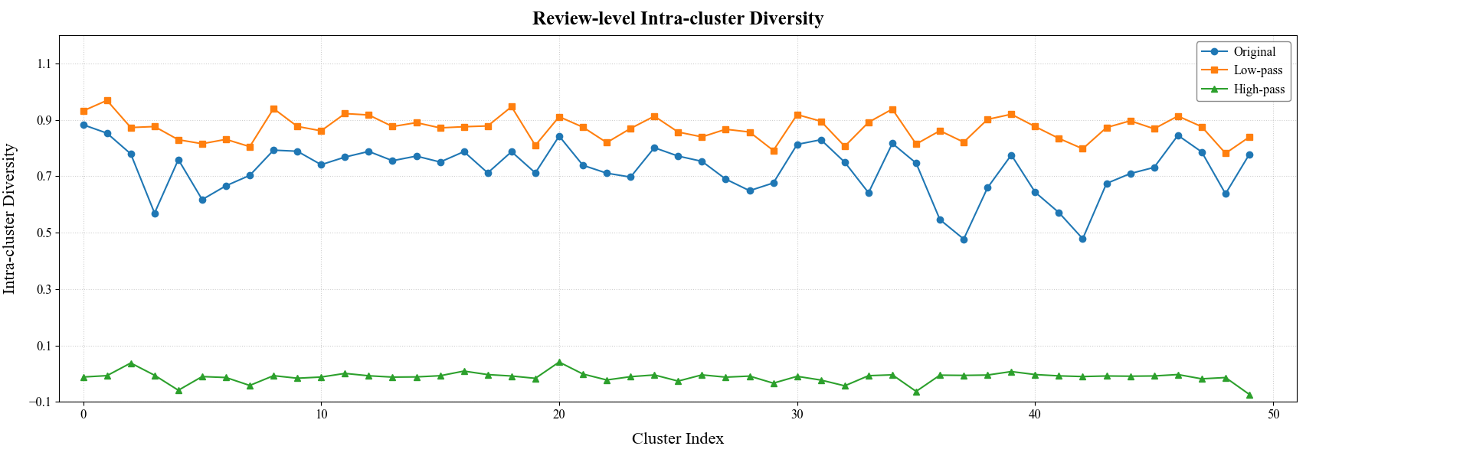
Figure C1. Variations in Intra-Cluster Knowledge Diversity.

Appendix C.3 Multi-Granularity Knowledge Retrieval Analysis
We randomly selected 200 instances from the dataset to examine users’ varying attention toward diverse and multi-granularity knowledge. Specifically, we first clustered these instances into six user groups. For each group, we then computed the mean granularity-wise cross-modal attention weights (i.e., $α_{L}^{mli}$ and $α_{H}^{mli}$) across textual (i.e., topic, review, and sentence) and visual (i.e., concept, review image, image patch) granularities.
As shown in Figure 8, users exhibited distinct attention allocations across knowledge granularities, with substantial heterogeneity observed across user groups even at the same granularity. Moreover, attention patterns systematically differed between high-pass (Figure 8a) and low-pass information (Figure 8b). Collectively, these findings highlight the importance of accounting for users’ differentiated attention patterns when retrieving diverse and multi-granularity knowledge.
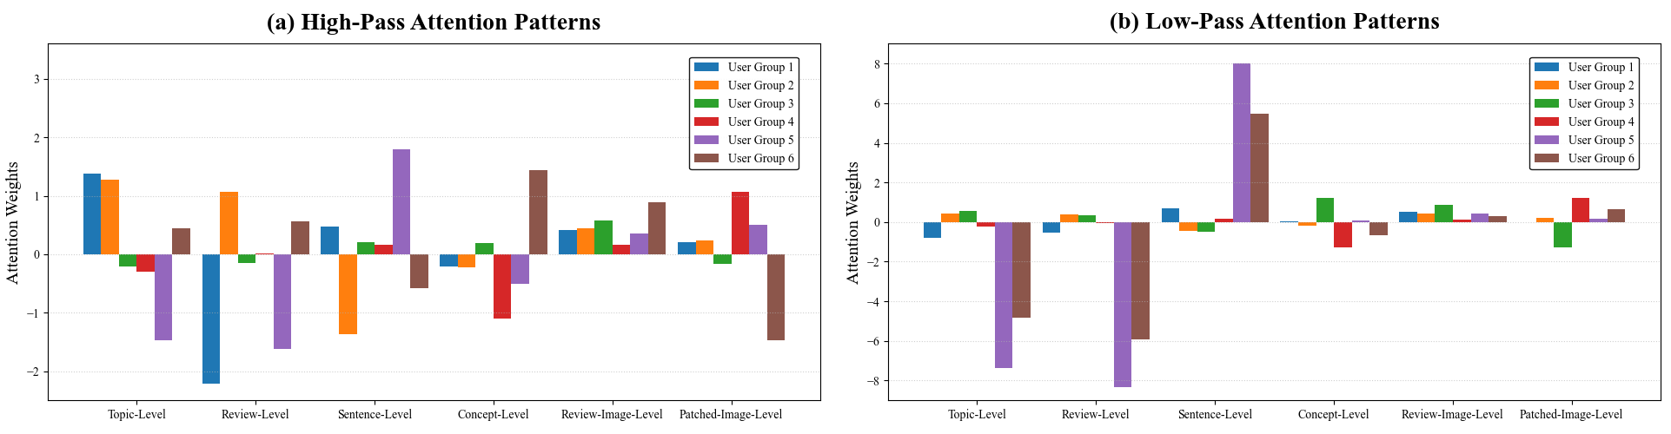
Figure C2. Users’ Attention Divergence Toward Diverse Multi-Granularity Knowledge.
Appendix C.4 Qualitative Tracing of Low-Pass and High-Pass Knowledge Selection
To qualitatively illustrate how UAP-DL retrieves diversified information through low-pass and high-pass filtering, we conducted a qualitative tracing analysis. We first identified the textual granularity receiving the highest cross-attention weight. Within the selected granularity, we then used the query-aware aspect attention weights to identify the most important clusters in the shared-information and differentiated-information channels. Finally, within each selected cluster, we traced the original knowledge nodes that contributed most strongly to the corresponding low-pass or high-pass representation through the graph-filtering matrix.
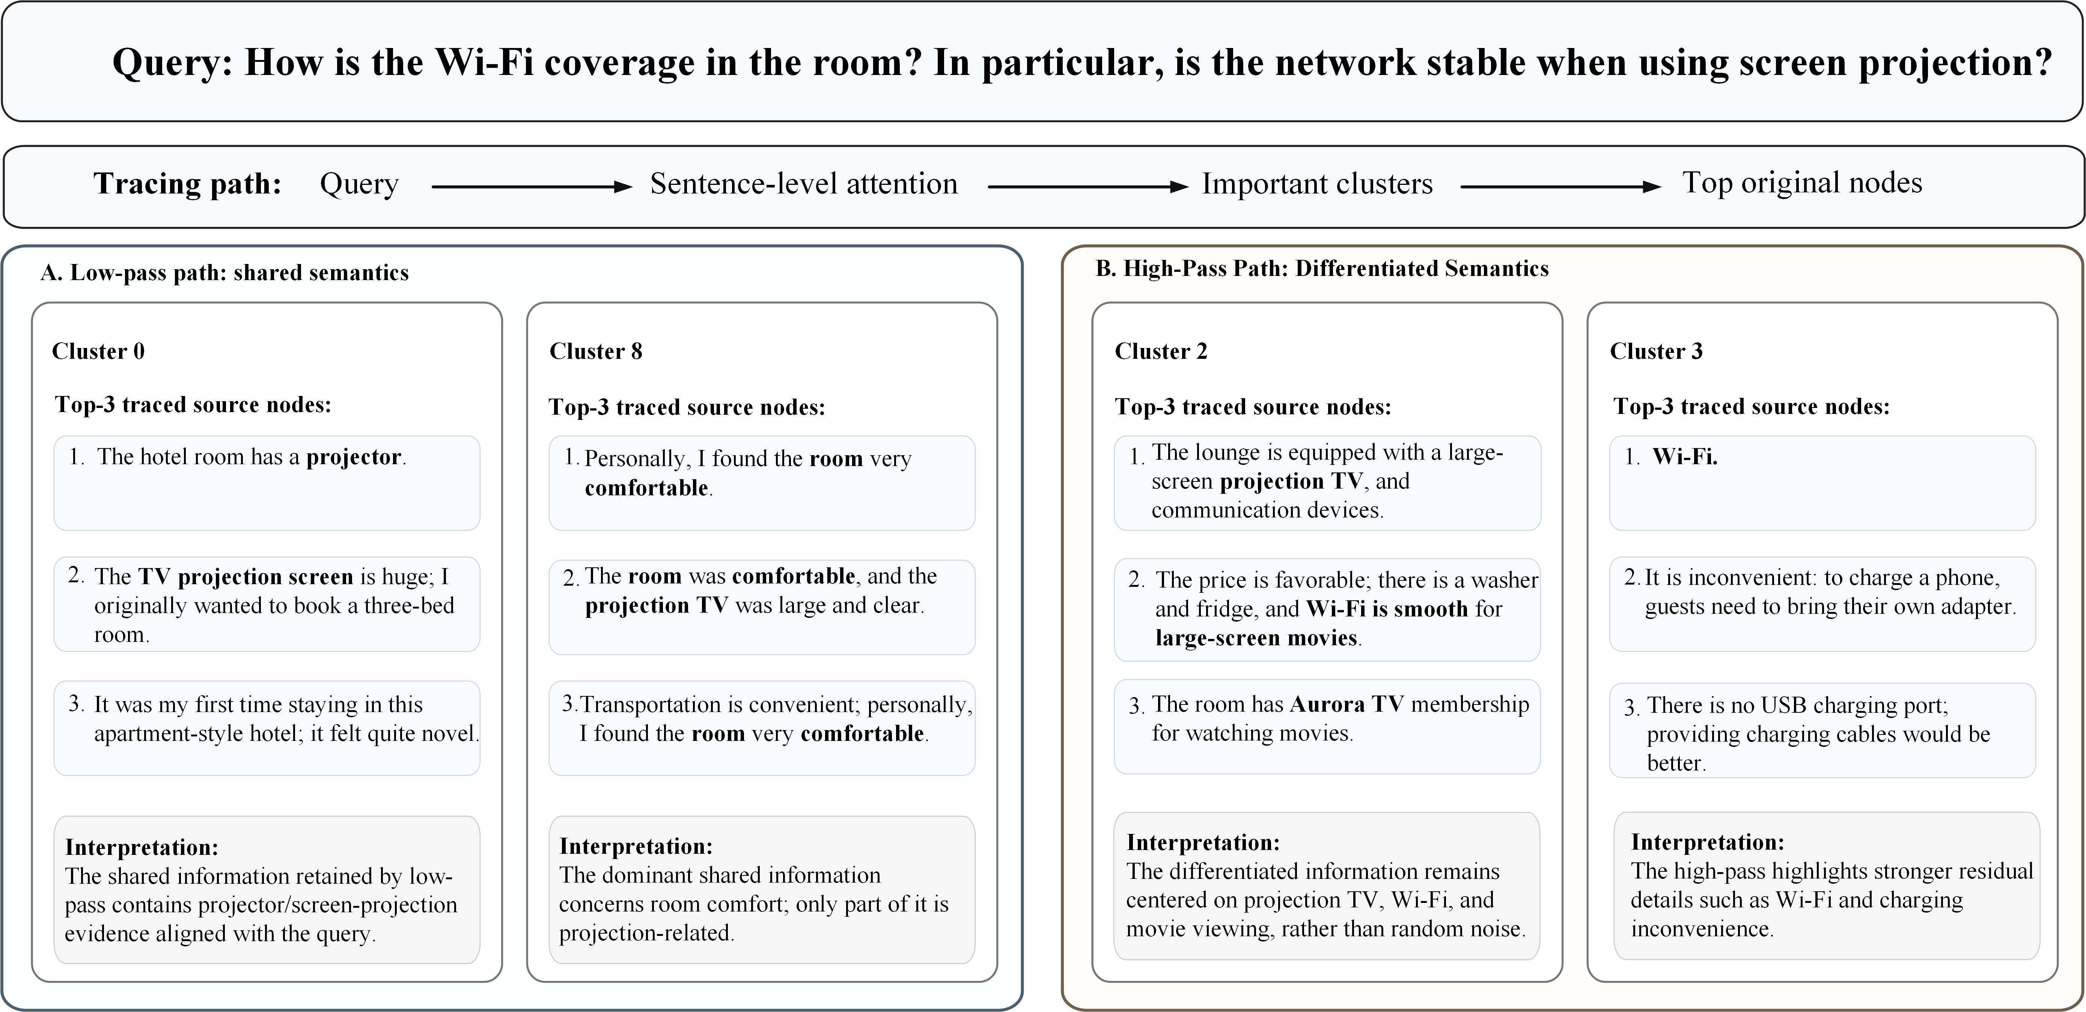
Figure C3. Qualitative Tracing of Low-Pass and High-Pass Knowledge Selection.
As shown in Figure C3, for the query “How is the Wi-Fi coverage in the room? In particular, is the network stable when using screen projection?”, the cross-attention weights showed that sentence-level knowledge contributes most to the final representation. Therefore, the subsequent tracing analysis was conducted at the sentence level.
In the low-pass path, Cluster 0 contributed most strongly to the low-pass representation. Although Cluster 8 exhibited higher intra-cluster similarity and therefore contains more internally consistent shared semantics, its main content concerned general room comfort and was only weakly related to Wi-Fi stability or screen projection. By contrast, the highly contributing nodes in Cluster 0, such as “the hotel room has a projector” and “the TV projection screen is huge,” collectively captured shared information about in-room projection facilities that is more relevant to the current query. Therefore, despite its lower intra-cluster similarity than Cluster 8, Cluster 0 received a higher contribution weight in the query-conditioned low-pass representation. These results indicate that the low-pass filtering mechanism of UAP-DL enables the model to retrieve valuable shared information that is relevant to the current query.
In the high-pass path, Cluster 2 contributed most to the high-pass representation. Its highly contributing nodes included differentiated information such as “large-screen projection TV” and “Wi-Fi is smooth for watching large-screen movies,” which are directly related to the current query and thus receive a higher weight. Cluster 3 also contained differentiated information, but only part of its content was directly relevant to the query. Therefore, its weight was lower than that of Cluster 2. These results indicate that the high-pass filtering mechanism enables UAP-DL to retrieve valuable query-relevant differentiated information, rather than merely selecting knowledge with low semantic similarity.
Overall, the tracing results provide qualitative evidence that the low-pass path aggregates query-relevant shared evidence across diversified nodes, whereas the high-pass path preserves complementary and differentiated evidence that is particularly informative for the current query.
Appendix D. Inference Efficiency Analysis
We measured the average single-sample inference time of UAP-DL, UAP-QAA, and all benchmark methods. The total inference time denotes the end-to-end inference time, and the online non-generation time refers to the online computation remaining after excluding LLM response generation from the end-to-end inference time. For UAP-DL and UAP-QAA, this includes query relevance estimation, graph construction, and multi-aspect and multi-granularity knowledge retrieval. The hotel knowledge base was constructed offline in advance, including review partitioning, representation encoding, and aspect clustering; these preprocessing costs are therefore excluded from online inference time.
As shown in Table D1, UAP-DL required an average end-to-end inference time of 4,181.89 ms, of which only 13.65 ms was attributable to online non-generation computation. UAP-QAA exhibited a comparable online non-generation time of 13.83 ms. These results indicate that query-conditioned graph construction and multi-aspect and multi-granularity knowledge retrieval introduce limited additional online overhead, and that most end-to-end latency is attributable to LLM response generation rather than the proposed knowledge-routing architecture.
Table D1. Single-Sample Inference Time (ms) of UAP-DL and the Benchmark Methods.
Method | Total Inference Time | Online Non-generation Time
EchoSight | 4,578.36 | 81.63
MORE | 3,046.58 | 4.25
G-Retriever | 2,957.04 | 32.99
GNP | 3,766.43 | 4.10
CoA | 10,533.54 | 5,249.90
ToG | 9,931.55 | 5,326.55
MiRAG | 4,428.92 | 7.36
VDocRAG | 4,348.25 | 310.94
Adaptive-RAG | 5,328.13 | 7.13
UAP-DL | 4,181.89 | 13.65
UAP-QAA | 4,085.55 | 13.83
Notes. All inference times are reported in milliseconds per sample.

References
[1] J. Li, M. Galley, C. Brockett, J. Gao, B. Dolan, A Diversity-Promoting Objective Function for Neural Conversation Models, in, (Association for Computational Linguistics, San Diego, California, 2016), pp. 110–119.

