Tutorial 1
Singleton Pattern
GoF (Gang of Four) Definition: Ensure a class only has one instance, and provide a global point of access to it.
Concept
A particular class should have only one instance. We will use only that instance whenever we are in need.
Real-Life Example
Suppose you are a member of a cricket team. And in a tournament your team is going to play against another team. As per the rules of the game, the captain of each side must go for a toss to decide which side will bat (or bowl) first. So, if your team does not have a captain, you need to elect someone as a captain first. And at the same time, your team cannot have more than one captain.
Computer World Example
In a software system sometimes we may decide to use only one file system. Usually we may use it for the centralized management of resources.

Question 1: Singleton
- In File Explorer, create a folder called “F:\YourName”.
- In Windows operating system, press “Windows + R” key.
- At ‘Open’ text field, type cmd to open command prompt.
- At the command prompt, type “F:”. Next, type “cd YourName”.
- At the F:\YourName> prompt, type “javac –version” to test your java compiler.
- In File Explorer, create subfolders of F:\YourName\singleton.
- Edit SingletonPattern.java so that the code listing is as follows:
public class SingletonPattern {
public static void main(String[] args) {
Singleton s1 = Singleton.getInstance();
System.out.println("Calling a method of a Singleton: " + s1.demoMethod());
Singleton s2 = Singleton.getInstance();
System.out.println("Calling a method of a Singleton: " + s2.demoMethod());
boolean b1 = (s1 == s2);
System.out.println("Object instance s1 and s2 are the same object: " + b1);
}
}
- Write Singleton.java as the following
public class Singleton {
private static Singleton singleton = new Singleton();
/** A private Constructor prevents any other class from instantiating. */
private Singleton() { }
/** Static 'instance' method */
public static Singleton getInstance() {
return singleton;
}
// other methods protected by singleton-ness would be here...
/** A simple demo method */
public String demoMethod() {
return "demo";
}
}
- At the command prompt, type “cd singleton”.
- Compile with “javac *.java” and run the project “java SingletonPattern”.
- What do you see in the Output window?
Calling a method of a Singleton: demo
Calling a method of a Singleton: demo
Object instance s1 and s2 are the same object: true
- Exercise: Draw a Class Diagram to show the relationship(s) between these two classes, plus the attributes and methods.
Hint: Please refer to Question 2 class diagram first

Question 2: Singleton (with package demo)
Illustration
In this example, we have made the constructor private first, so that we cannot instantiate in normal fashion.
When we attempt to create an instance of the class, we are checking whether we already have one available copy. If we do not have any such copy, we will create it; otherwise, we will simply reuse the existing copy.

- In File Explorer, create subfolders of F:\YourName\singleton\pattern\demo
- Within F:\YourName\singleton\pattern\demo, create SingletonPatternEx.java.
- Modify SingletonPatternEx.java to the following:
// SingletonPatternEx.java
package singleton.pattern.demo;

class MakeACaptain
{
private static MakeACaptain _captain;
//We make the constructor private to prevent the use of "new"
private MakeACaptain() { }

private static class SingletonHelper{
//Nested class is referenced after getCaptain() is called
private static final MakeACaptain _captain = new MakeACaptain();
} //end class SingletonHelper

public static MakeACaptain getCaptain()
{
return SingletonHelper._captain;
}
} //end class MakeACaptain

class SingletonPatternEx
{
public static void main(String[] args)
{
System.out.println("***Singleton Pattern Demo***\n");
System.out.println("Trying to make a captain for our team");
//Put your code here
}
}
- Exercise: Complete SingletonPatternEx.java, compile & run it to produce the following output.
F:\YourName\singleton>javac pattern\demo\SingletonPatternEx.java
F:\YourName\singleton>cd ..
F:\YourName>java singleton.pattern.demo.SingletonPatternEx
***Singleton Pattern Demo***
Trying to make a captain for our team
Trying to make another captain for our team
c1 and c2 are same instance

Sample solution:
// SingletonPatternEx.java
package singleton.pattern.demo;
//continue from the MakeACaptain class
class SingletonPatternEx
{
public static void main(String[] args)
{
System.out.println("***Singleton Pattern Demo***\n");
System.out.println("Trying to make a captain for our team");
MakeACaptain c1 = MakeACaptain.getCaptain();
System.out.println("Trying to make another captain for our team");
MakeACaptain c2 = MakeACaptain.getCaptain();
if (c1 == c2)
{
System.out.println("c1 and c2 are same instance");
}
}
}
- Exercise: Draw a Class Diagram to show the relationship(s) between these two classes, plus the attributes and methods (1m).
Tutorial 1 Question 2 No. 5 Class Diagram for SingletonPatternEx Exercise Guide
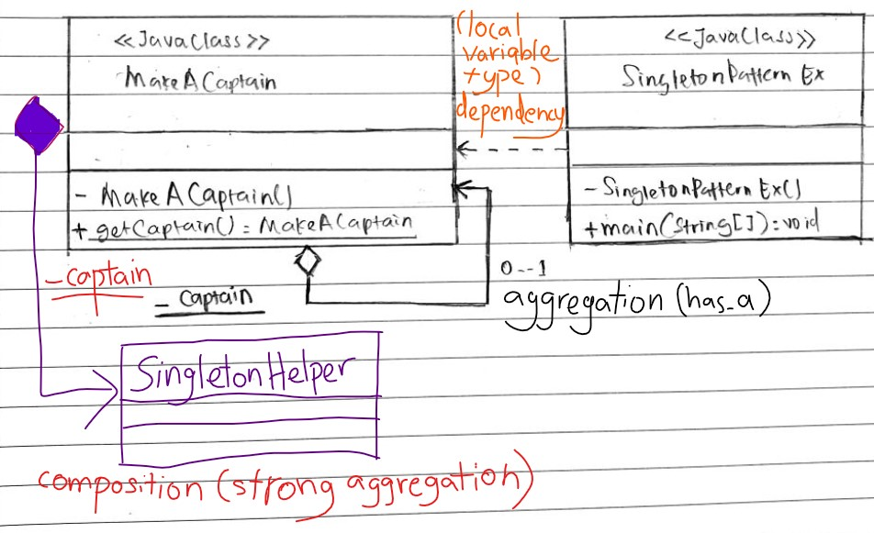
Question 3: Singleton
So, what do we need to do to incorporate thread safety in the above Q2 implementation?
Sample solution:
There are many discussions on this topic. People came up with their own solutions. But there are always pros and cons. I want to highlight some of them here:
Case (i): Use of “synchronized” keyword:
public static synchronized MakeACaptain getCaptain()
{
//our code
}
With the above solution of Q3-Case (i), we need to pay for the performance cost associated with this synchronization method.

Case (ii): There is another method called “Eager initialization” to achieve thread safety.
class MakeACaptain
{//Early initialization
private static MakeACaptain _captain = new MakeACaptain();
//We make the constructor private to prevent the use of "new"
private MakeACaptain() { }
// Global point of access: MakeACaptain.getCaptain() is a public static method
public static MakeACaptain getCaptain()
{
return _captain;
}
}
In the above solution an object of the singleton class is always instantiated.

Advantage: This method of Case (ii) does not need to use the synchronization technique and eager initialization. It is regarded as the standard method to implement singletons in Java.

