Lab Test 01 Low Level Design of Software
Student name
Student ID
1st line of address
2nd line of address
Telephone number, incl. country code
E-mail
23 November, 2021

Tut01 Section 2 Demo instructions

Instructions for Windows users ………………………………………………………………….... 2

Adding JDK path at the System Environment Variables ………………………………...... 6

Sample Run of Tut01 Section II ……………………………………………………………………… 9
JDK (Java Development Kit) installation instructions for Windows users

Using your student.mmu.edu.my id and password, you can find the following instructions at the JDK installation file at https://bit.ly/2Xigok7 or https://drive.google.com/drive/folders/1ysvPAvabgTLzyNIiMMyfHcVEakK8OjNe?usp=sharing .

The screenshots included in these instructions refer to a sample Software Design Tut01 Section II Application called ‘Singleton’.

Demo to Install JDK (Java Development Kit) to my hard disk

- Logout all the gmail id at the browser.
- Using your student.mmu.edu.my id and password, download the jdk-8u92-windows-x64.exe from https://bit.ly/2Xigok7 into the local drive.
- Locate your installation file on your computer.
- Double-click on installation file jdk-8u92-windows-x64.exe.

If you see a Security Warning asking you whether you are sure you want to run this software, click ‘Run’.

The installation software will come up in a few seconds (see Figure 1).
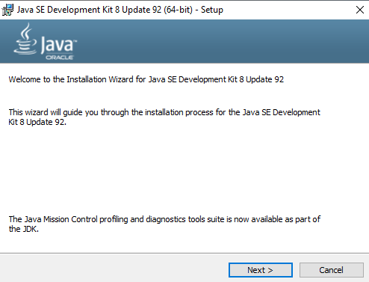
Figure 1. JDK Installation Wizard.
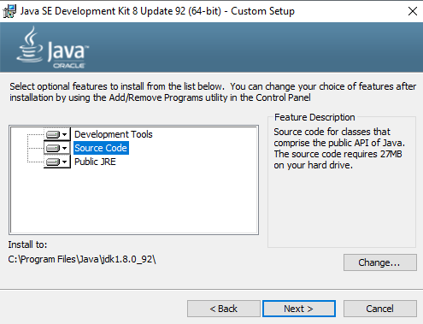
Figure 2. Maintaining JDK 8 Default Features.

In Figure 2, click Next. Follow the instructions of the installation software.

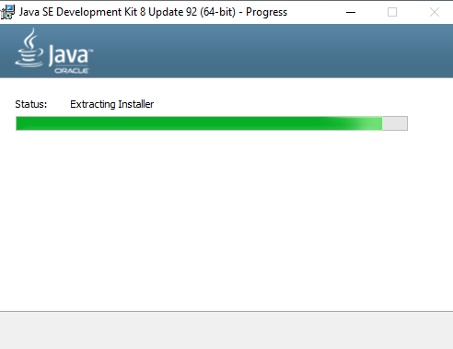
Figure 3. The JDK installation progress.

Please note: you need to have administrator rights on your computer to complete the installation. The installation progresses as shown in Figure 3.

Installation of Notepad++
After the installation of this JDK, please install notepad ++ by clicking npp.6.9.1.Installer.exe. In the following Figure 4 screen, click Next.

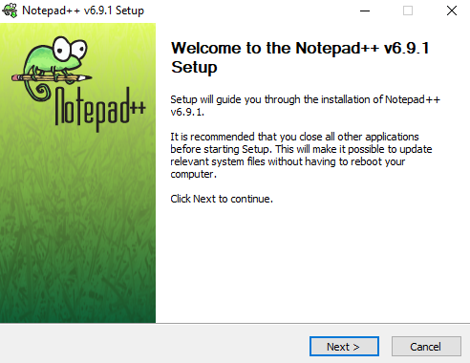
Figure 4. Notepad++ welcome screen.

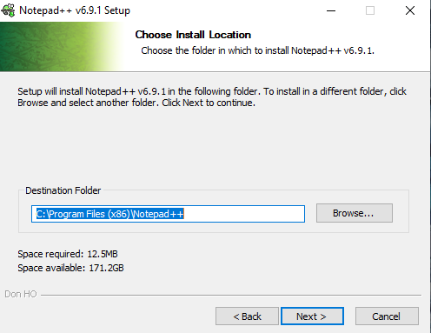
Figure 5. Notepad++ destination folder.

Maintain the default path recommendation as in Figure 5. In Figure 6, there is no need to check the checkboxes of the components, and click Install.
Please note that the copying of the content may take several minutes.

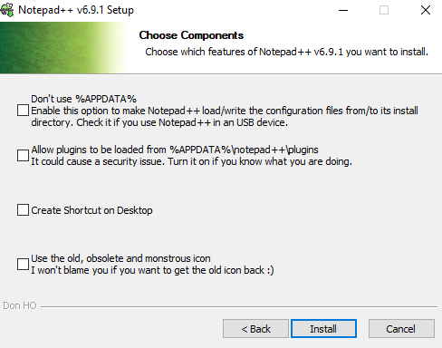
Figure 6. No need to check the checkboxes.

Once the content has been copied, you will see the following message in Figure 7.
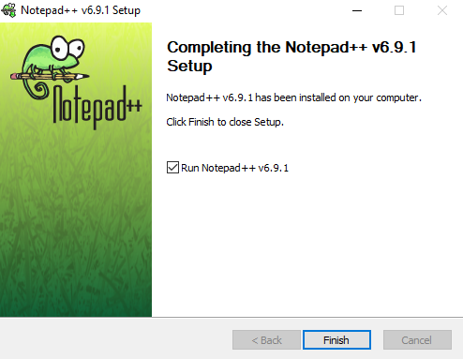
Figure 7. Completion of Notepad ++.
Setting my JDK path at the System Environment Variables

At the “Type here to search” field at the bottom left of Windows OS (operating system), type ‘edit the system environment variables’ to display the following system properties in Figure 8.

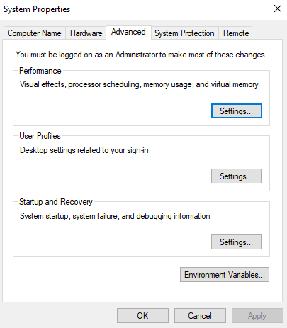
Figure 8. System Properties.

In Figure 8, click ‘Environment Variables’ button to edit the environment variables.

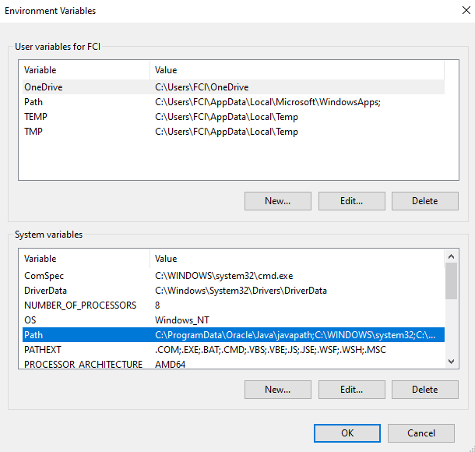
Figure 9. System variables.

At the “System variables” category in Figure 9 above, select ‘Path’ and click “Edit” button to add the JDK path. The following Figure 10 dialog box would be displayed.

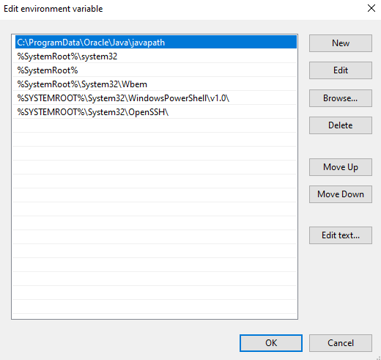
Figure 10. Edit environment variable dialog box

Under another window of ‘File Explorer’ of your Windows operating system, click the folder address bar, namely “C:\Program Files\Java\jdk1.8.0_92\bin”. Press ‘Control + C’ keys to copy this path location, as shown in Figure 11.

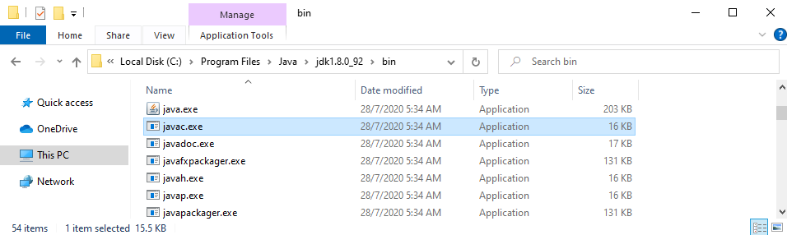
Figure 11. File Explorer to show JDK path.

Note: This location is where the java compiler (javac.exe) is located.

Navigate back to the “Edit environment variable” dialog box, click “New” button. Press “Ctrl + V” key to paste the JDK path of “C:\Program Files\Java\jdk1.8.0_92\bin”.

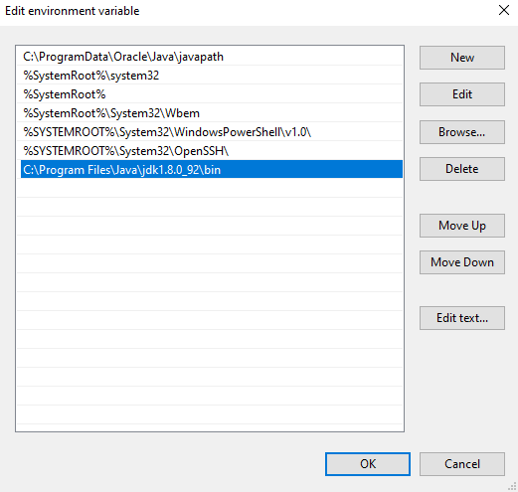
Figure 12. Added the JDK path t the environment variable.

Click all OK buttons to the save the environment variable as shown in Figure 12. The installation is now complete.

How to Test this Java Compiler (javac) in Command Prompt

The following instructions apply to Windows users. If you are using a different operating system (OS), please adjust accordingly. This is the folder location of my SingletonPatternEx.java.

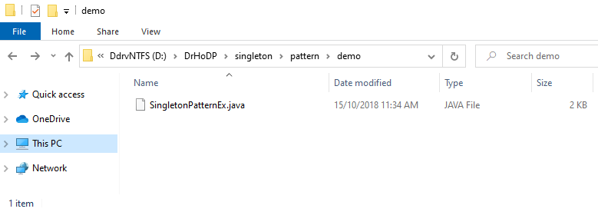
Figure 13. Folder location of my local SingletonPatternEx,java.

Figure 14 shows my SingletonPatternEx.java opened with Notepad++.
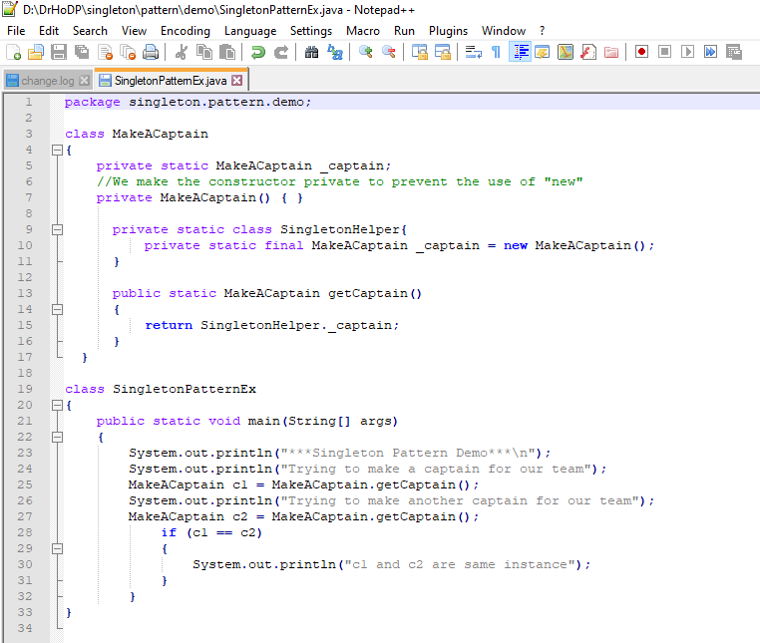
Figure 14. Contents of my local SingletonPatternEx,java.

At the “Type here to search” field at the bottom left of Windows OS, type ‘cmd’ to display the command prompt. Next, the following commands of Figure 15 is typed in to compile and interpret the code.
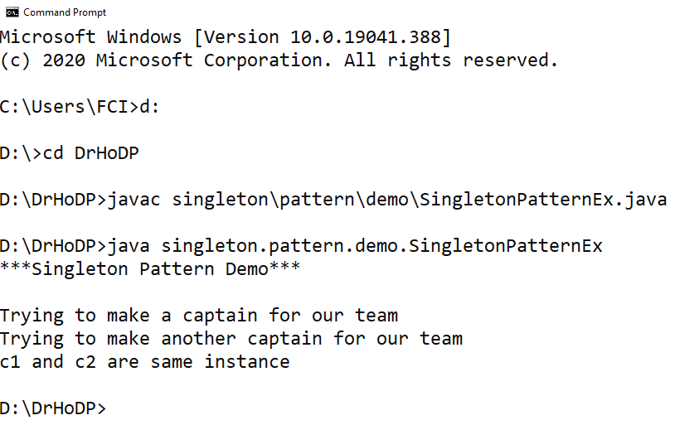
Figure 15. Compiling and running the Java code.

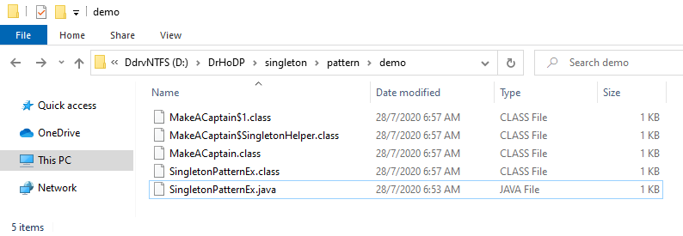
Figure 16. Outcome of compiled Java files.

The above Figure 16 shows how the outcome of my compiled java files.

