面向对象技术实验指导

实验一：solitaire纸牌游戏
单人纸牌游戏，牌桌上有7个堆共28张牌，第一堆1张牌，第二堆2张，。。。第7堆7张，每一堆的第一张牌朝上，其他朝下。牌桌上还有4个suitpiles，一个deck card堆和一个discard card堆，布局如下（参考windows的纸牌游戏）
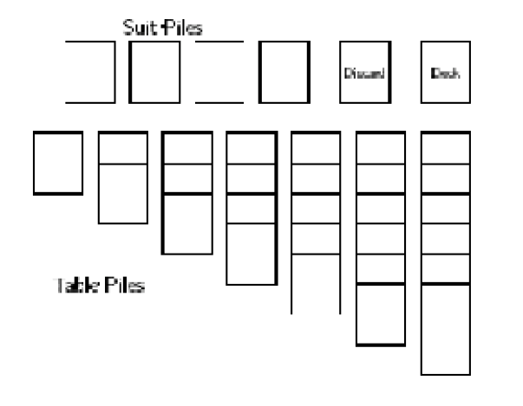
设计一个简单的CardGames程序，运用面向对象封装、继承、抽象类、抽象方法、多态、动态绑定等概念。

实验二：排序
设计一个负责排序的程序包，实现多种排序算法，至少包括插入排序、冒泡排序和快速排序算法。
要求：
1.可以对任何简单类型和任意对象进行排序
2.可以支持升序、降序、字典排序等多种顺序要求
3.可以随意增加排序算法和顺序要求，保证其他程序不修改
4.减少程序代码中逻辑上的冗余
5.至少用两种方案编程实现该程序包，并说明两个方案的优缺点
6.提交设计报告，包括：使用UML设计的类图；主要程序代码说明；方案优缺点比较。

实验三：上述排序过程演示
要求：
1.可以自动生成排序数据，也可以录入、修改排序数据
2. 演示速度可调整
3.可以单步，可以暂停，可以回退

实验四：播放器
模拟实现一个多功能电子设备，它既能播放mp3歌曲，同时还能够借助播放器的界面来监测脉动。
1.这个设备有一个屏幕，屏幕上可以显示两种界面：
界面1是显示视图，有一个进度条，可以显示当前所播放音乐的节拍或是脉动,以节拍为例，比如是100 BPM 还是 120BPM（BPM是节拍的度量单位）。还有一个文本，显示“Current BPM: xxx”.
界面2是控制视图，上面的控件有：
1）有一个菜单条，上面有一个菜单，菜单里有“start”、“stop”和“quit”命令。
2）有一个输入框，旁边的文本为"Enter BPM:"，可以在输入框内容输入特定的节拍。
3）有一个“set”按钮，可以改变每分钟的节拍数。
4）还有两个微调箭头按钮“<<”和“>>”,使用这两个按钮可以微调节拍的值。
注意，选择“start”开始产生节拍，选择“stop”停止产生节拍。在选择开始产生节拍时，stop都应该是无效的，但是节拍产生后，start应该是无效的。
2.该设备配有一个控制器，控制mp3播放，存储播放歌曲的数据和节拍状态，并包含播放mp3的逻辑。
3.该设备还可以监测脉动。
4.在播放MP3时，在界面2上调整节拍后，会调整mp3播放器歌曲的节拍，同时界面1上显示出当前歌曲的节拍状态。
5.在做监测脉动时，屏幕界面2上所有的设置按钮都是无效的，因为我们不能去设置脉动。

总之，希望界面可以复用，希望模型数据的变化能够反映到界面上
看看能不能使用观察者模式、策略模式、适配模式，另外设计时将界面显示view、控制controler、模型model分开

实验一设计参考：
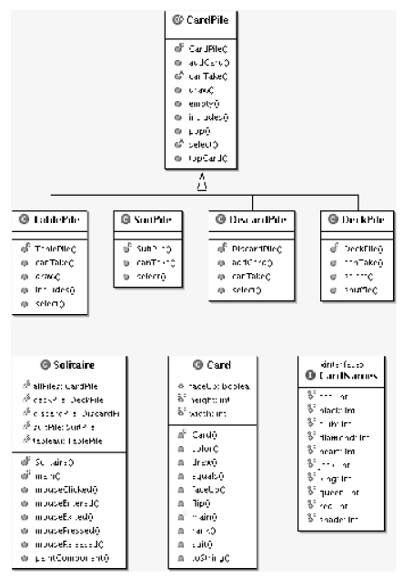
package solitaire;
import java.awt.Graphics;
import java.util.LinkedList;
import java.util.List;
public abstract class CardPile {
protected List pile;
protected int x;
protected int y;
/ ∗ ∗ ∗ Make an Empty P i l e ∗ /
public CardPile(int x, int y) {
pile = new LinkedList();
this.x = x;
this.y = y;
}
public boolean empty(){
return pile.isEmpty();
}
public Card topCard() {
if (!empty())
return (Card)pile.get(pile.size() − 1);
else
return null;
}
public Card pop() {
if (!empty())
return (Card)pile.remove(pile.size() − 1);
else
return null;
}
public boolean includes(int tx, int ty) {
return x<=tx && tx <= x + Card.width
&& y <= ty && ty <= y + Card.height;
}
public void addCard(Card aCard){
pile.add(aCard);
}
public void draw (Graphics g){
if (empty()) {
g.drawRect(x,y,Card.width,Card.height);
}
else
topCard().draw(g,x,y);
}
public abstract boolean canTake(Card aCard);
public abstract void select ();
}

package solitaire;
import javax.swing. ∗ ;
import java.awt. ∗ ;
public class Solitaire extends JPanel implements MouseListener {
static DeckPile deckPile;
static DiscardPile discardPile;
static TablePile tableau[];
static SuitPile suitPile[];
static CardPile allPiles[];
public Solitaire(){
setBackground(Color.green);
addMouseListener(this);
allPiles = new CardPile[13];
suitPile = new SuitPile[4];
tableau = new TablePile[7];
int deckPos = 600;
int suitPos = 15;
allPiles[0] = deckPile = new DeckPile(deckPos, 5);
allPiles[1] = discardPile =
new DiscardPile(deckPos − Card.width − 10, 5);
for (int i = 0; i < 4; i++)
allPiles[2+i] = suitPile[i] =
new SuitPile(suitPos + (Card.width + 10) ∗ i, 5);
for (int i = 0; i < 7; i++)
allPiles[6+i] = tableau[i] =
new TablePile(suitPos + (Card.width + 10) ∗ i,
Card.height + 20, i+1);
repaint();
}
public void paintComponent(Graphics g) {
super.paintComponent(g);
for (int i = 0; i < 13; i++)
allPiles[i].draw(g);
}
public static void main(String[] args) {
JFrame frame = new JFrame();
frame.setDefaultCloseOperation(JFrame.EXIT_ON_CLOSE);
frame.setVisible(true);
frame.setSize(800,600);
frame.setTitle( " S o l i t a i r e " );
Solitaire s = new Solitaire();
frame.add(s);
frame.validate();
s.repaint();
}
public void mouseClicked(MouseEvent e) {
int x = e.getX();
int y = e.getY();
for (int i = 0; i < 12; i++)
if (allPiles[i].includes(x, y)) {
allPiles[i].select();
repaint();
}
}
public void mousePressed(MouseEvent e) { }
public void mouseReleased(MouseEvent e) { }
public void mouseEntered(MouseEvent e) { }
public void mouseExited(MouseEvent e) { }
}
* the DeckPile Class This class extends the CardPile class. It must create
a full deck of cards (stored in its super class’s pile attribute.) The cards
should be shufﬂed after creation (use Collections.shuffle(...) ). You
never add cards to the DeckPile so its canTake method always returns false.
The select method removes a card from the deckPile and adds it to the
discardPile (In the Solitaire class).
* The DiscardPile Class This maintains a pile of cards that do not go into any
of the other piles. Override the addCard method to check ﬁrst if the card is
faceUp and ﬂip it if its not. Then add the card to the pile. You never add cards
to the DiscardPile so its canTake method always returns false. The select
method requires careful thought. Remember that this method runs when the
user selects this pile. Now, what happens when the user clicks on the topCard
in the discardPile? We must check if any SuitPile (4 of them) or any TablePile
(7 of them) (all in the Solitaire class) can take the card. If any of these piles can
take the card we add the Card to that pile. If not, we leave it on the discardPile.
* The SuitPile Class The select method is empty (Cards are never removed
from this pile). The canTake method should return true if the Card is the same
suit as all others in the pile and if its rank is one more that its topCard.
* The TablePile Class Write the constructor to initialize the table pile. The
constructor accepts three parameters, the x and y coordinates of the pile, and
an integer that tell it how many cards it contains. (remember that the ﬁrst
tablePile contains 1 card, the second 2 Cards etc.). It takes Cards from the deck-
Pile. The table pile is displayed differently from the other piles (the cards over-
lap). We thus need to override the includes the method and the draw method.
The canTake method is also different. The table piles will accept a card if its
suit is opposite in color and its rank is one less than the pile’s topCard. The
select method is similar to the one in DiscardPile. We must check if any
SuitPile (4 of them) or any TablePile (7 of them) (all in the Solitaire class) can
take the card. If any of these piles can take the card we add the Card to that
pile otherwise we leave it in this tabePile.

实验二设计参考：
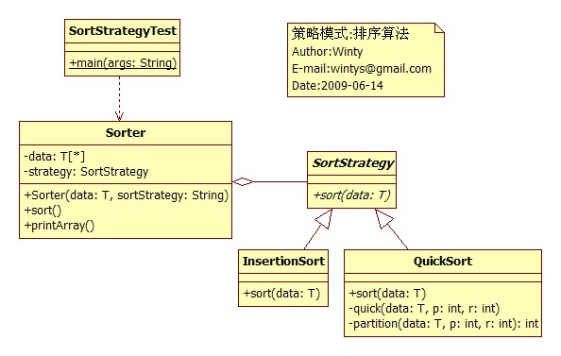
package pattern.strategy.sort;
/**
* 策略模式:Strategy Pattern
*
* 排序算法策略
*
*
*/
public class SortStrategyTest {
public static void main(String[] args) {
Sorter<?> sorter;
Integer[] data = new Integer[]{548,85,984,3,2,44,99};
sorter = new Sorter<Integer>(data , "QuickSort");
sorter.printArray();
sorter.sort();
sorter.printArray();
String[] strs = new String[]{"B","C","D","A","X","F","E"};
sorter = new Sorter<String>(strs , "InsertionSort");
sorter.printArray();
sorter.sort();
sorter.printArray();
}
}
class Sorter<T extends Comparable<T>>{
private T[] data;
private SortStrategy<T> strategy;
@SuppressWarnings("unchecked")
public Sorter(T[] data , String sortStrategy){
this.data = data;
//利用反射动态加载策略类
String pack = this.getClass().getPackage().getName();
pack += ".";
try {
Class<?> cl = Class.forName(pack + sortStrategy);
strategy = (SortStrategy<T>) cl.newInstance();//unchecked
} catch (InstantiationException e) {
e.printStackTrace();
} catch (IllegalAccessException e) {
e.printStackTrace();
} catch (ClassNotFoundException e) {
e.printStackTrace();
}
}
public void sort(){
strategy.sort(data);
}
public void printArray(){
for(int i=0;i<data.length;i++){
System.out.print(""+data[i]+" ");
}
System.out.println("");
}
}
/**
* 抽象排序算法类
* @author Winty
*
* @param <T> 实现了Comparable<T>接口的类
*/
abstract class SortStrategy<T extends Comparable<T>>{
public abstract void sort(T[] data);
}
/**
* 插入排序
* @author Winty
*/
class InsertionSort<T extends Comparable<T>> extends SortStrategy<T>{
@Override
public void sort(T[] data) {
int len;
T temp;
len=data.length;
for(int i=1;i<len;i++){
int k;
k=0;
temp=data[i];
for(int j=i-1;j>=0;j--){
k=i;
if(data[j].compareTo(temp) > 0){
data[j+1]=data[j];
k=j;
}
else if(data[j].compareTo(temp) < 0){
k=j+1;
break;
}
}
data[k]=temp;
}
}
}
/**
* 快速排序
* @author Winty
*/
class QuickSort<T extends Comparable<T>> extends SortStrategy<T>{
@Override
public void sort(T[] data) {
quick(data , 0 , data.length - 1);
}
private void quick(T[] data , int p , int r){
int q;
if (p < r){
q = partition(data , p , r);
quick(data , p , q - 1);
quick(data , q + 1 , r);
}
}
private int partition(T[] data , int p ,int r){
int i;
T pivot , temp;
i = p - 1;
pivot = data[r];
for(int j = p; j <= r - 1;j++){
if(data[j].compareTo(pivot) < 0){
i++;
temp = data[i];
data[i] = data[j];
data[j] = temp;
}
}
temp = data[i + 1];
data[i + 1] = data[r];
data[r] = temp;
return i + 1;
}
}
上述方案还没有考虑多种顺序

方案2

Sorter
Sort
SortStrategy
Sort

QuickSort
Sort
InsertionSort
Sort
Compare
Size
Swap

IntegerInsertionSort
EmployeeInsertionSort
Compare
Size
Swap

Compare
Size
Swap

方案3
Sorter
Sort
SortStrategy
Sort
QuickSort
Sort
InsertionSort
Sort
IntegerComparator
StringComparator
Comparator

Compare(o1:object; o2:object)

实验四设计参考：
