**Universal Basic Incomes versus Targeted Transfers:**

**Anti-Poverty Programs in Developing Countries**

Rema Hanna and Benjamin A. Olken

**October 2018**

Not all data used in Hanna and Olken (2018) are available for public distribution. Below, we describe steps for obtaining the necessary data and then describe the organization of files and programs contained herein.

**1. DATA SOURCES**

* Indonesian Survei Sosial Ekonomi Nasional (SUSENAS) data for 2010-2011 must be requested and purchased from Statistics Indonesia (BPS) [here](https://microdata.bps.go.id/mikrodata/index.php/catalog/SUSENAS#_r=&collection=&country=&dtype=&from=1971&page=1&ps=&sk=&sort_by=proddate&sort_order=desc&to=2017&topic=&view=s&vk=).
* Additional intermediate files for coding the SUSENAS data include poverty-related statistics and village-level characteristics. These data are included in the files contained herein. Source information is as follows:
  + Poverty statistics for both 2010 and 2011 are reported by BPS [here](https://www.bps.go.id/statictable/2009/07/02/1489/jumlah-dan-persentase-penduduk-miskin-garis-kemiskinan-indeks-kedalaman-kemiskinan-p1-dan-indeks-keparahan-kemiskinan-p2-menurut-provinsi-2007-2009-maret-2010-2011-2012-maret-dan-september-.html).
  + Village-level characteristics are taken from the Village Potential Statistics (PODES) survey for 2011.
* Peruvian Encuesta Nacional de Hogares (ENAHO) data for 2010-2011 can be downloaded [here](http://iinei.inei.gob.pe/microdatos/). Use the following dropdown menu options (see image below):
  + ENCUESTA: choose “ENAHO Metodología ACTUALIZADA”
  + Below, choose “Condiciones de Vida y Pobreza – ENAHO”
  + AÑO: choose 2010 and 2011 in turn
  + PERÍODO: choose choose “Anual” – (Ene-Dic)
  + The following modules should be downloaded: 01, 02, 03, 04, 05, 18, 34.
  + Place the downloaded modules in the year-appropriate folders as described in Section 2 below.

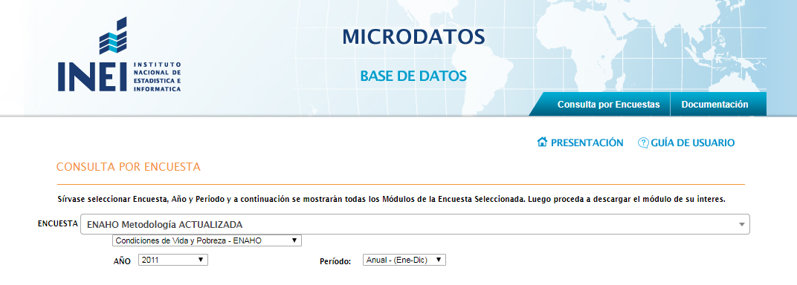

**2. FILE ORGANIZATION**

The enclosed folder contains the following subfolders:

* **Susenas Data**: will contain raw (un-coded) SUSENAS household data for 2010-2011.
  + Upon downloading, place raw survey data in the appropriate subfolder (e.g. “ssn11sep_k”, “ssn10feb_m”).
  + **podes2011-desakor_Ben** contains 2011 village-level characteristics from PODES in the file “**ppls11_pdsmay8_kd.dta**”.
  + **Coded** will contain coded intermediate data once coding .do files run
  + The files “**BPS_2010.csv**” and “**BPS_2011.csv**” contain province-level poverty statistics from BPS as noted above.
* **Peru ENAHO Data**: will contain raw (un-coded) ENAHO household data for 2010-2011.
  + Upon downloading, place each module of the ENAHO data in the appropriate year folder (see above for the list of modules to download). Each module should be enclosed in its own folder as obtained from the INEI website.
* **Coding do files**: contains several do files used to code raw SUSENAS and ENAHO data into usable datasets for analysis.
* **Data to use for analysis**: contains coded Indonesia SUSENAS data.
* **Data to use for Peru analysis**: contains coded Peru ENAHO data.
* **Analysis do files**: contains do files that take coded SUSENAS and ENAHO datasets and perform necessary calculations for paper figures.
* **Paper Figures Combined**: contains finalized figures for paper and appendix.

**3. PROGRAMS**

To replicate figures shown in the paper, run the following programs in order after all data has been obtained as described above. Note that each .do file will require specifying the local filepath on your computer.

* 1. Coding:
  + **Coding do files/181009 Indonesia Coding Master.do** will call all necessary .do files to clean and code SUSENAS data for 2010-2011, saving end datasets in “Data to use for analysis” folder.
  + **Coding do files/181009 Peru Coding.do** will clean and code ENAHO data for 2010-2011, saving end datasets in “Data to use for Peru analysis” folder.
* 2. Analysis/Calculations
  + **Analysis do files/181001 susenas paper figures.do** will perform necessary calculations on coded SUSENAS data and output the portion of Figure 7 specific to Indonesia, saving intermediate coded files in “Data to use for analysis” folder.
    - Note that the calculations in this .do file will take several hours to run.
  + **Analysis do files/181001 peru paper figures.do** will perform necessary calculations on coded ENAHO data and output the portion of Figure 7 specific to Peru, saving intermediate coded files in “Data to use for Peru analysis” folder.
    - Note that the calculations in this .do file will take several hours to run.
* 3. Outputting Figures and Tables
  + **Analysis do files/181001 consolidated paper figures.do** will use coded intermediate data to output Figures 3-6 as well as each panel of Appendix Figure 1. Locals at the beginning of the .do file give you the flexibility to output Figure 3 separately from Figures 4-6.
  + **Analysis do files/181001 predictive regression tables.do** will use coded SUSENAS and ENAHO data to output the predictive regressions shown in Appendix Tables 1 and 2.