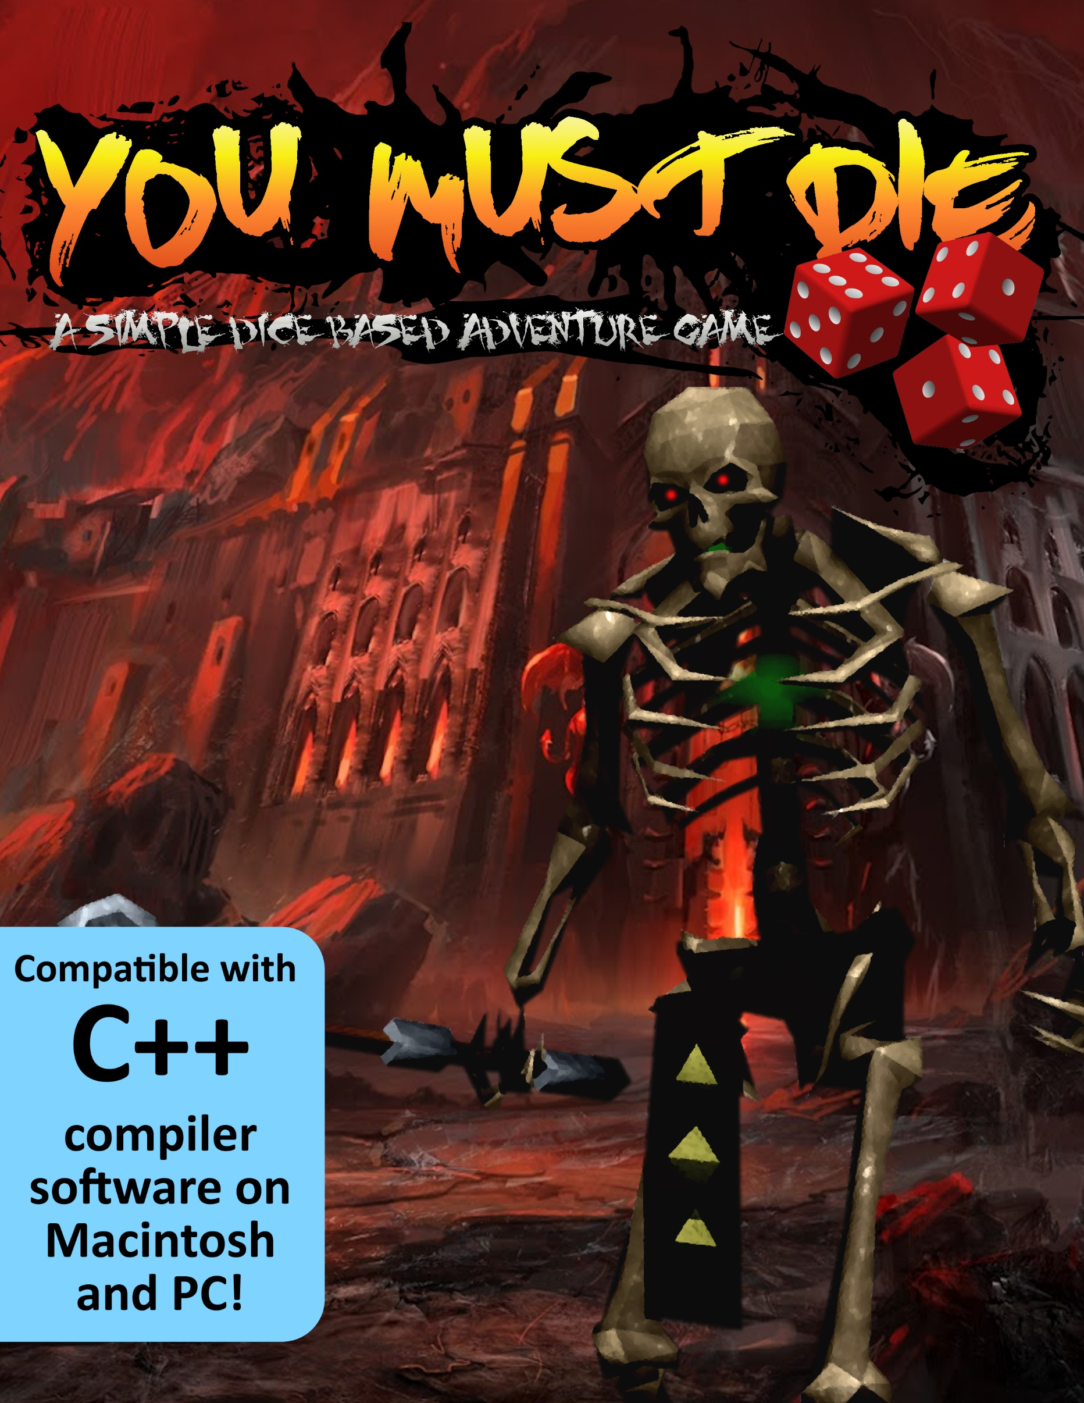

**PROJECT 1**

**(You Must Die – A Simple Dice Based Adventure Game)**

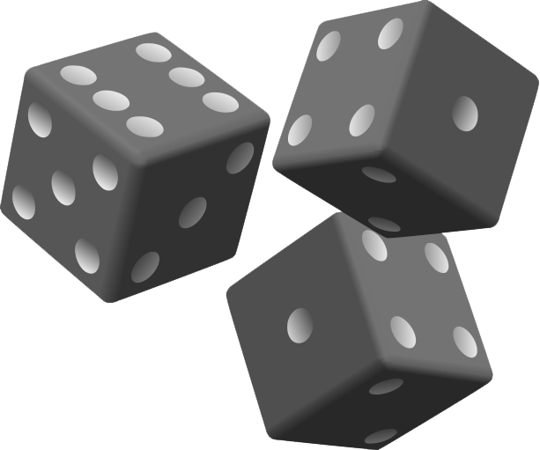

**CIS – 5 47471**

**Yokley, Jacob**

**11/05/2017**

**The Story**

Eons ago, there ruled one, mighty empire over multiple, puny colonies. This empire—once known as Grayshire—was known for its everlasting peace, equity, and self-sustainment—but only at the cost of all the colonies it ruled over. Weary of the constant infraction of human rights by the Empire, the colonies banded together an army of rags and bones to demolish Grayshire and build a truly unified kingdom of peace upon the rubble known as Sylvania.

As Sylvania celebrates its 100th annual Festival of Peace marking 100 years since the destruction of Grayshire, a massive structure has shot up into the middle of the town square resembling the Empire's former castle. Many warriors have entered, but none have returned.

It is now up to you, a young knight seeking an end to this injustice (and perhaps some loot along the way), to enter the dungeon and see an end to its army of undead. Choose how many rooms you want to traverse and roll a die in each one—will it earn you some hidden treasures, or a fight with Grayshire’s ghostly warriors? Only the highest rolls and the quickest wits will earn you the victory you seek in these battles—so enter, young hero, and gamble ‘til you drop.

**Introduction**

In You Must Die, all of the events that the player faces and how he or she responds to them is entirely based on the roll of a die. Players choose how many rooms they want to traverse in the dungeon, and then each room randomly selects if the player encounters an enemy, a treasure chest, or a trap. During these encounters, the player chooses what action they want to gamble on—whether the player attacks the enemy, defends against it, or chooses to open the treasure chest they stumbled across, the computer decides at random if these choices end up being beneficial to the player. The result is a simple adventure game that involves a basic amount of strategy to decide whether or not the odds are for or against the player.

**Development**

Project size: 427 lines

This project took about 18 hours to fully develop. Although I toiled with a few different ideas, it did not take long for me to settle on the concept for an adventure game. There was a lot of opportunity for passion to be put into this project because of my own love for adventure games and a lot of ways that the lessons we have covered in class could be utilized to make the gameplay more flavorful.

I began by jotting down some notes on what I wanted to see in the game and what it needed to achieve those goals. This was a good way for me to draw inspiration for the project and to cut my work out for myself before I actually began coding.

Once I was content with my ideas, I began working on version 1 of the game. This version was focused solely on creating what I believed would be the most complex and important part of the game: the battle sequence. This version only featured a title screen that immediately sent the user into a battle. I was hoping this would be the best way to start since I could iron out bugs from inside-out the program, but in retrospect, I think I might have had an easier time keeping track of everything if I built the “shell” of the game and then inserted all of the actual gameplay components where they needed to be. The main reason I believe this is because by the final versions, whenever I wanted to implement something ambititous outside of the projects requirements, I had a very difficult time finding all the issues to get rid of that would help me update the game.

This is a perfect segway to version 2, which implemented almost everything else I envisioned the game to be originally. I added a functioning menu that allowed the user to choose whether they wanted to play, read about the game, or quit. I also implemented all of the other gameplay features I wanted, such as scaling difficulty, treasure chests, traps, and custom dungeon size. I also took this time to fix some glaring bugs from the previous version.

Version 3 added everything else on the checklist that I missed with version 2 that I believed I could reasonably fit into the game. I added a score system using constants and allowed the player to name their hero. These both were implemented into the new file output system that created a file with the player’s previous game results in a formatted table.

The development wasn’t faced with any hugely frustrating struggles. There were some issues that I simply had to walk away from for a bit to finally think of the solution to. I was very pleased about this because I was worried about choosing a project that would be a bit overly ambitious, since I tend to do so in other classes and did not want to run that risk with my first computer science class. The result was a very rewarding development process that taught me a lot and provided a challenge without being a total pushover. I already have ideas for what I want to implement when updating this project for project 2, and some of these ideas can even be seen in the changelogs of each version of the game. I included these so I could list the issues that I wanted to fix and to show the issues I have overcome, and all I can really say in retrospect is that I have a lot to learn, but I’m excited to learn it so that I can make a more polished product.

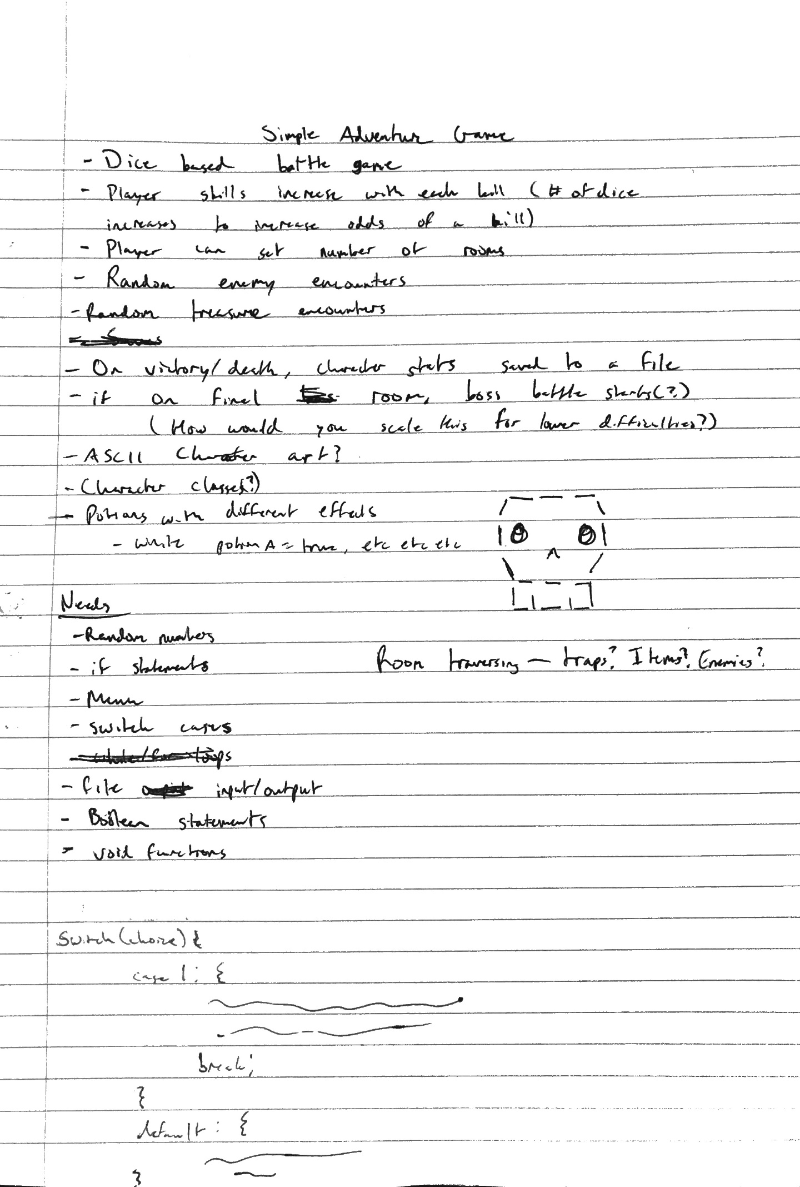

**Changelogs**

**Version 1**

List of known bugs:

- Does not display "You have been slain!" when player health drops to 0 or below 0

- I'm not yet sure how to cap the player's health to a maximum so that the maximum can be upgraded in game, but can't be crossed with healing during battle

- Default doesn't work properly (entering a number forces you to enter a correct one, just doesn't display the error message. Entering a character starts an infinite loop)

- If rolls are equal in defense, heal, and run, the game has no idea what to do and just awkwardly restarts the loop without saying anything

- Successfully running away doesn't actually do anything

**Version 2**

List of known issues:

- Having a hard time getting a special "final room sequence" begin. Setting conditional statements just causes the game to return to the title screen. Must be an issue with the for loop? Might have to implement in a future version

- Had a problem with cin.get() for waiting for the user to hit enter to continue, so I added cin.ignore() to flush the entry, but now the program sometimes requires the user to hit enter twice, which is a bit annoying but nothing game breaking

- Had a problem implementing voids to help clean up the main chunk of code behind the game. I wanted to have the battle sequence, title sequence, and room sequence be different bools that would run whenever they are true and then call to the code behind each sequence when those bools are true. The game works as intended without it, but it lacks polish

- General balancing could be better

Changes from V1:

- Added a working title menu with an option to start the game, read about the game and its story, and to quit

- Added the option to choose how many rooms the user wants to traverse

- Added an increase in enemy health with every fight to add to difficulty

- Lowered player base health for balancing and to give cmath a fair purpose when healing the player

- Added booby traps

**Version 3**

List of known issues:

- Room score is terribly incorrect and causes an overflow of some kind. I really have no idea what causes this and I've done everything I can to try to mitigate this, so I'm just going to very slyly interpret this as anexample of an overflow since I was able to identify it properly and since my file output at least works properly

Changes from V2:

- Added a working file system for outputting the score of the players last game

- Added the ability to name your hero

- Added the use of iomanip for formatting the score table

- Added counters and variables for keeping track of kills, rooms, score, etc.

|  |  |  |  |
| --- | --- | --- | --- |
|  |  |  |  |
|  |  |  |  |
| **Cross Reference for Project 1** | | | |
|  |  |  |  |
|  |  |  | **Where in Code** |
| **Chapter** | **Section** | **Topic** | **Line number (based on first appearance)** |
| 2 | 2 | cout | 78 |
|  | 3 | libraries | iostream, iomanip, cmath, cstdlib, fstream, string, ctime |
|  | 4 | variables/literals | 45 |
|  | 5 | Identifiers | 68 |
|  | 6 | Integers | 45 |
|  | 7 | Characters | 56 |
|  | 8 | Strings | 58 |
|  | 9 | Floats No Doubles | 57 |
|  | 10 | Bools | 55 |
|  | 11 | Sizeof ***** |  |
|  | 12 | Variables 7 characters or less | All variables at 7 characters max |
|  | 13 | Scope ***** No Global Variables | No global variables |
|  | 14 | Arithmetic operators | 125 |
|  | 15 | Comments 20%+ | 1 |
|  | 16 | Named Constants | 36 |
|  | 17 | Programming Style ***** Emulate |  |
|  |  |  |  |
| 3 | 1 | cin | 89 |
|  | 2 | Math Expression | 329 |
|  | 3 | Mixing data types **** |  |
|  | 4 | Overflow/Underflow **** | File output (results.txt) shows an overflow in rmclrs variable |
|  | 5 | Type Casting |  |
|  | 6 | Multiple assignment ***** | Some variables are categorized together, but not assigned together |
|  | 7 | Formatting output | 176 |
|  | 8 | Strings | 118 |
|  | 9 | Math Library | 26 |
|  | 10 | Hand tracing ****** |  |
|  |  |  |  |
| 4 | 1 | Relational Operators | 124 |
|  | 2 | if | 126 |
|  | 4 | If-else | 334 |
|  | 5 | Nesting | 160 |
|  | 6 | If-else-if | 170 |
|  | 7 | Flags ***** |  |
|  | 8 | Logical operators | 160 |
|  | 11 | Validating user input | 304 |
|  | 13 | Conditional Operator |  |
|  | 14 | Switch | 111 |
|  |  |  |  |
| 5 | 1 | Increment/Decrement | 124 |
|  | 2 | While | 95 |
|  | 5 | Do-while | 140 |
|  | 6 | For loop | 124 |
|  | 11 | Files input/output both | Output only - 177 |
|  | 12 | No breaks in loops ****** |  |
|  |  |  |  |
|  |  |  |  |
| ****** Not required to show |  |  |  |

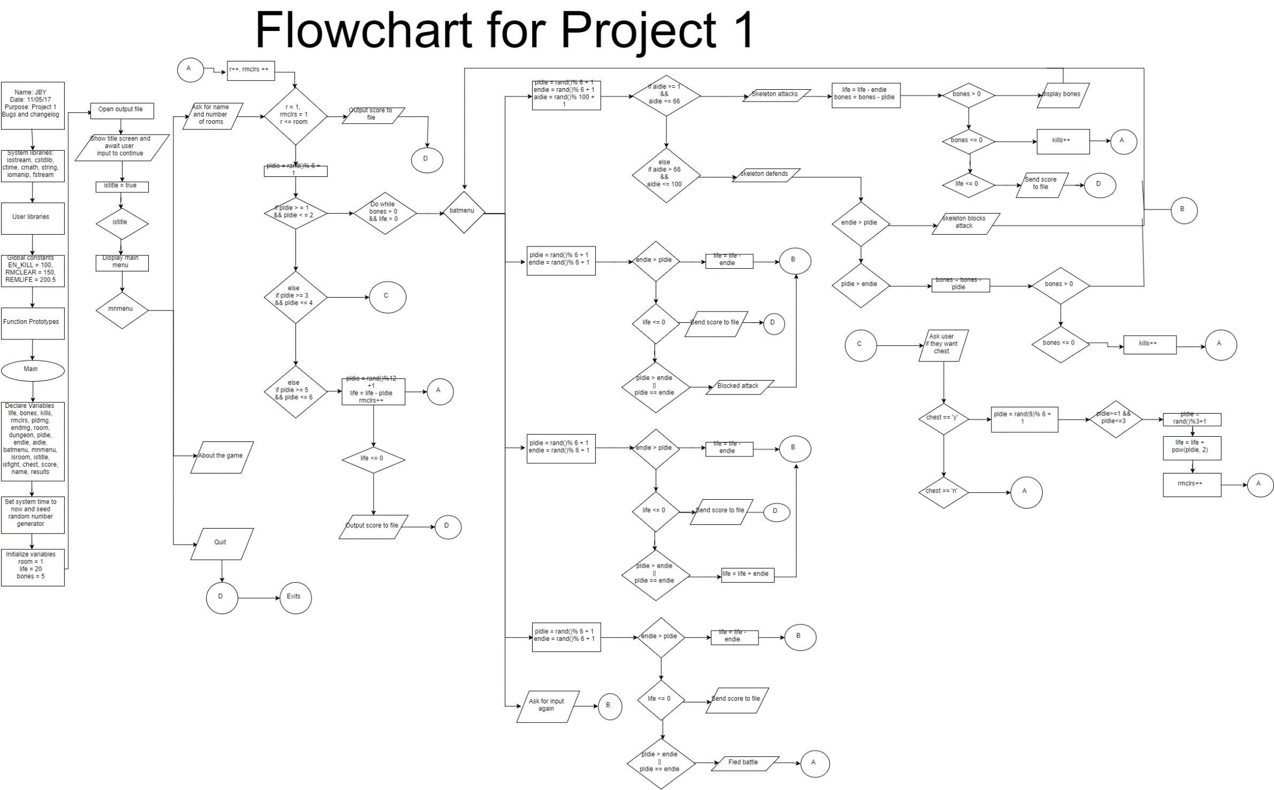

**Pseudo Code**

/*  
* File: main.cpp  
* Author: Jacob Yokley  
* Created on November 3, 2017, 2:45 PM  
* Purpose: Project 1: “You Must Die – A Simple Die-Based Adventure Game” V3  
*/

//System libraries  
//User libraries  
//Global Constants – Used as score multipliers: enemies killed, rooms cleared, life //remaining  
//Function prototypes  
//Main - Execution begins here!

//Variable declaration

//Set system time to now

//Seed random number generator

//Variable initialization

//Open output file

//Process Mapping – Inputs to Outpus

//Title Screen with lovely ascii art

//Main menu

//Loop switch case for menu

//Case 1 starts game

//Ask for users name and number of rooms

//For loop ends once max number of rooms is reached

//Random number generator for dice

//if dice is 1 or 2 a battle starts

//do a switch for the battle menu while //player life and enemy life are greater than //0

//case 1 is attack

//Both player and enemy roll a new //number on 6 sided die

//Simple AI picks from a random //number from 1- 100 to emulate //percentage

//If AIDie lands on anything from 1-//66 enemy attacks

//Rolls determine damage

//Killing enemy increases kill count

//If you are killed, game ends and score is sent to file

//Exits switch if enemy dies

//AI rolls from 67 – 100 for defense

//enemy die must be greater than //player’s to defend

//case 2 is defend

//Player die must be greater than //enemy’s to defend

//case 3 is heal

//Player die must be greater than //enemy’s to heal

//Absorbs enemy’s roll as health if //successful

//case 4 is run

//Player die must be greater than //enemy’s to run

//After battle ends, skeleton health is reset and   
//increases by number of rooms traversed * 2

//if player die is 3 or 4

//Finds an item in the room

//if player chooses to open chest

//if player die rolls a 1 – 3

//die rolls from 1-3

//heals by die roll^2

//Uses cmath

//else nothing is found

//chooses not to open chest moves //onward

//if player die is 5 or 6

//Encounters booby trap

//player die rolls from 1 to 12 and //takes as much damage as the amount //rolled

//When the game ends, score is sent to file

//Case 2 for main menu

//About the game

//Case 3 for main menu

//Quits the game

//Closes score file at end of program

//Exit function main, end of program